
Department of Computer Science and Engineering
ALGORITHMIC PROBLEM-SOLVING HACKATHON (APSH 2026)
PROJECT DOCUMENTATION
Date: 03-10-2026 | Venue: 3rd Floor, A & B Blocks
Field | Details
Project Title | Road Damage Reporting System
Team Name / Team No. | Team RoadFix / _06_____
Year / Semester / Section | II Year B.Tech / _02_ Sem / __01_
Algorithm Paradigm Used | Basic data processing: validation and linear search/filtering
Programming Language / Tools | TypeScript/JavaScript, React, Node.js, Express, browser localStorage; proposed MongoDB REST API
Faculty Mentor | ALEKHYA MAM
Team Members
S.No | Name of the Student | Roll No. | Role
1 | P.AUSHRAY | 25MVCSMR0522 | Team Lead
2 | M.MANIKANTHA | 25MVCSMR0513
3 | B..VIJAY KUMAR | 25MVCSMR0471
4 | MD.SHOAIB | 25MVCSMR0515

1. Problem Statement
Road damage such as potholes, cracks, waterlogging, broken dividers, and missing manhole covers can create safety risks. The project provides a web interface where users can submit the damage type, location, severity, description, and an optional photo. Reports can be viewed, searched, filtered, edited by permitted users, and assigned a status. Input: report details and optional image. Output: a saved report card and its current status. The supplied demo code stores reports in browser localStorage; a MongoDB-backed API is described as the target architecture.

2. Objectives
1. Make road-damage reporting simple and organized.\n2. Store and display location, type, severity, description, photo, reporter, and status.\n3. Demonstrate create, read, update, and delete (CRUD) operations and search/filtering.\n4. Show how a React interface can be connected to backend APIs and a database.

3. Proposed Approach
The application uses form validation and basic data-processing steps. When a user searches or filters reports, the program scans the report list and selects matching records; this is linear search/filtering, not a graph algorithm. This approach is suitable for a small demo because it is easy to implement and explain. A future MongoDB/Express API can persist records centrally. Alternatives include map/GPS-based search and spatial indexing for larger datasets.

4. Algorithm / Pseudocode
Algorithm: Submit and manage a road-damage report\n1. Start the application and load saved reports; show demo records if none exist.\n2. User signs in with a display name and selects Citizen or Admin demo role.\n3. For a new report, collect location, damage type, severity, description, and optional image.\n4. Check that location and description are not empty. If missing, do not submit.\n5. Create a report with a unique ID, timestamp, and initial status “reported”.\n6. Save the updated report list and refresh the UI.\n7. To browse reports, apply the chosen status filter and search text to each record.\n8. Allow the reporter or demo admin to edit permitted fields; allow demo admin to update status or delete.\n9. End.\nNote: the supplied code is a frontend demo using localStorage; it does not itself prove that a live MongoDB/Express backend is connected.

5. Complexity Analysis
For n stored reports and a search/filter operation, the program checks each report at most once: best/average/worst time is O(n) for this simple scan. Adding a report to the front of the array is O(n) because existing entries shift; updating or deleting by ID also scans the list and is O(n). Space is O(n) for storing n reports. These are algorithmic estimates for the browser demo, not measured runtime benchmarks.
Complexity | Best Case | Average Case | Worst Case
Time (search/filter) | O(n) | O(n) | O(n)
Space (stored reports) | O(n) | O(n) | O(n)
6. Implementation
Main modules in the supplied code: useStore manages report/user state and browser localStorage; Home displays report counts and workflow; Login stores a demo display name and role; Report form captures location/type/severity/description/image and can request GPS coordinates; Reports page searches, filters, edits, changes status for admin, and deletes for admin; Project page explains objectives and API design. Data structure: array of Report objects with ID, location, damageType, severity, description, optional image, status, reporter, and timestamp. Tools: React + TypeScript, CSS/Tailwind styling, browser localStorage. The project documentation and presentation describe a future/target Node.js, Express, and MongoDB REST API.

7. Results and Test Cases
Sample test cases (illustrative expected results):\nTest 1 — valid report: location “MG Road, near Metro Pillar 42”, type Pothole, severity High, description “Large pothole near junction”, photo road-damage.jpg → report appears in the list with status “reported”.\nTest 2 — missing location or description → form should not submit.\nTest 3 — search “Ring Road” → only matching report(s) are shown.\nTest 4 — filter “resolved” → only resolved reports are shown.\nTest 5 — demo admin changes status from reported to in-progress → status label updates.\nThe screenshots below are illustrative UI mockups based on the supplied project code, not captures from a running application. Verify each test in the actual app before claiming it passed.\nSample Output 1: Dashboard\n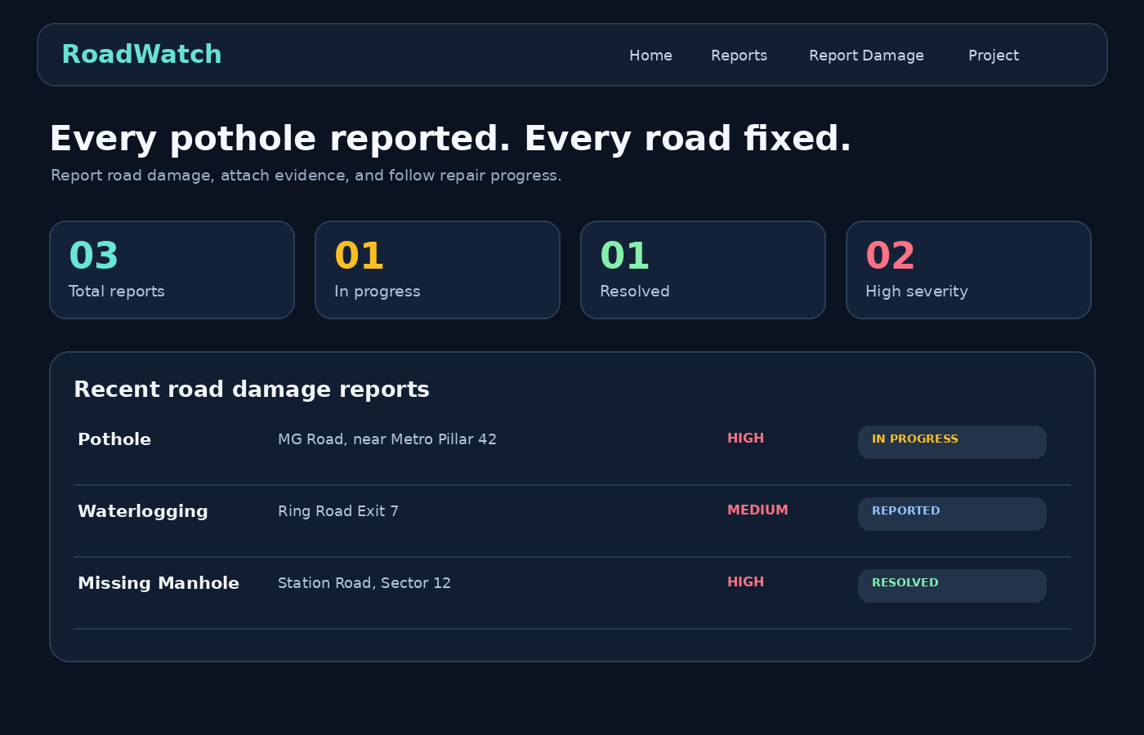\nSample Output 2: Report submission form\n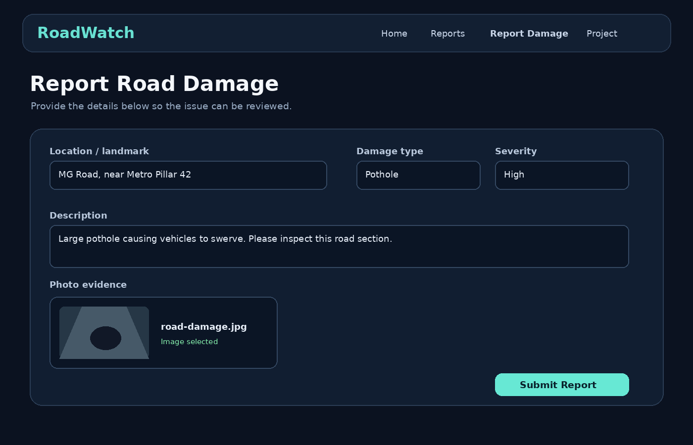\nSample Output 3: Reports list and filters\n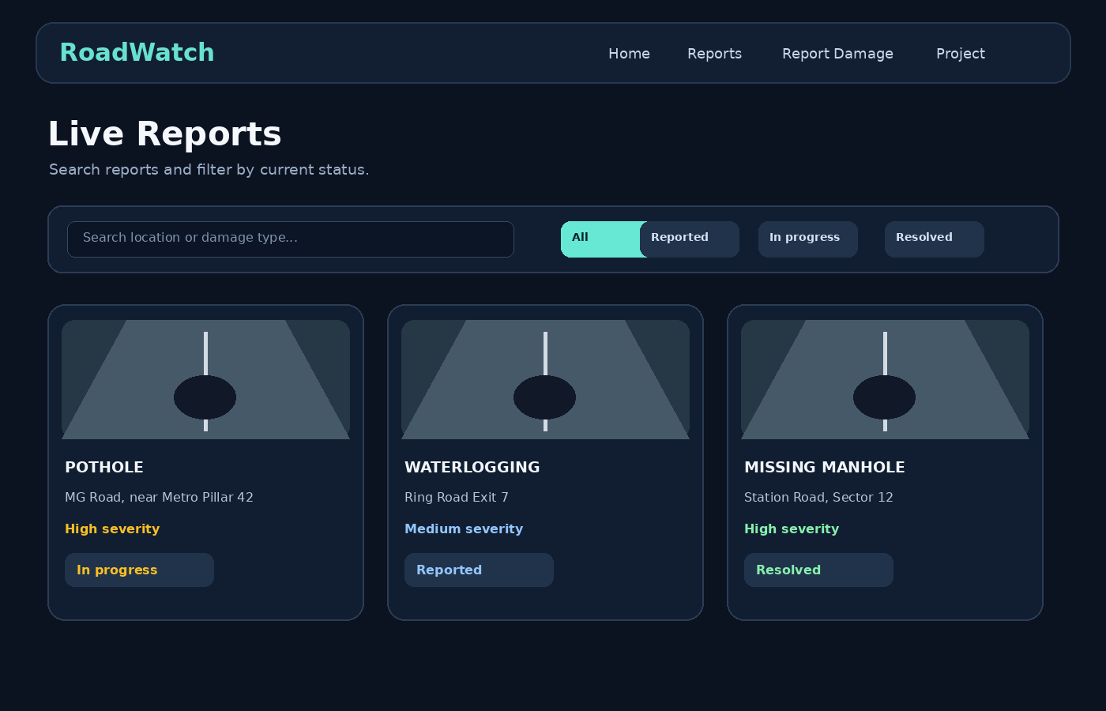

8. Conclusion and Future Scope
The Road Damage Reporting System organizes road issue reports and demonstrates the main user flow: submit details, browse/search reports, and follow status. The supplied code uses browser localStorage for demo persistence. Future work: connect the UI to Express REST endpoints and MongoDB, add real authentication/authorization, validate and securely store image uploads, integrate map/GPS location, prevent duplicate reports, and provide notifications and analytics. Road repairs themselves remain the responsibility of local authorities.

9. References
References\n[1] React, “React Documentation.” [Online]. Available: https://react.dev/\n[2] Node.js, “Node.js Documentation.” [Online]. Available: https://nodejs.org/docs/\n[3] Express.js, “Express Documentation.” [Online]. Available: https://expressjs.com/\n[4] MongoDB, “MongoDB Documentation.” [Online]. Available: https://www.mongodb.com/docs/\n[5] Supplied project source file, “roadwatch-all-code.txt,” accessed Oct. 10, 2026.

