NIP Project — Submission Template
Pega Platform project · This document is your complete submission
Read this before you start:
1. Fill in Section 1 completely. The Pega application name must follow the format NIP-[Project]-[YourName].
2. Create a new Operator in Pega with your full name and log in as that operator before taking any screenshot.
3. When you create your test case, enter YOUR FULL NAME in the Issue Description (Vehicle) or Movie Name (Movie) field.
4. Complete only the section for your chosen project. Delete the other project section.
5. Paste one screenshot per user story (10 total). Follow the screenshot rules in your selected project section.
6. Answer every question in Sections 3 and 4 in your own words.
7. Save the file using this format: ProjectName_FirstName_LastName.docx. Use VehicleService or MovieTicket as the ProjectName. Examples: VehicleService_Ravi_Kumar.docx or MovieTicket_Ravi_Kumar.docx.

Section 1 — Your Details
Full Name | Raunak Maurya
Email ID (registered on NIP) | raonakmaurya2004@gmail.com
Phone Number | 6307731808
College Name | Maharishi University Of Information And Technology
Course (e.g. IT, CS) | BCA
State | Uttar Pradesh
Project Chosen (Vehicle Service OR Movie Ticket Booking) | Movie Ticket Booking
Pega Application Name (e.g. NIP-VehicleService-YourName) | NIP_Movie Ticket Booking Management Application_Raunak_Maurya
Case Type Name (exact) | Movie Ticket Request
Pega Instance URL | https://obdnvell.pegaacademy.net/prweb/app/movie-ticket-booking-management-application-1/
Operator Name (created in Pega with your full name) | Raunak Maurya

Section 2B — Movie Ticket Booking Management Application
Complete this section only if you selected this project. Delete the other project section before submitting.

Screenshot rules — IMPORTANT before you start:
1. Name your Pega application as: NIP-VehicleService-YourName OR NIP-MovieTicket-YourName
2. Create a new Operator in Pega with your full name (Security → Operators) and log in as that operator.
3. When you create your test case, enter YOUR FULL NAME in the Issue Description (Vehicle) or Movie Name (Movie) field.
4. The logged-in operator name must be visible in every screenshot wherever the Pega interface displays it.
5. The student's full name must be visible in all running-case screenshots.
6. Configuration screenshots must clearly show the relevant application or rule name.
Screenshots that do not show these will not be accepted.

US-001 — Submit Movie Ticket Request
What is expected:
Case created, customer submits Movie Name, Show Date, Show Time, Number of Tickets. Validation applied.
Screenshot — paste your screenshot below this line:
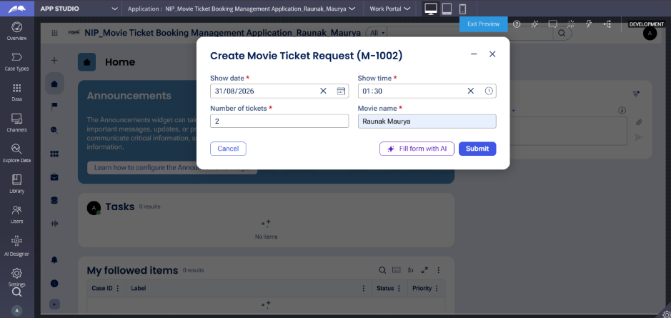
[ Paste screenshot here - follow the screenshot rules above ]

What I built for this (1–2 lines in your own words):
Built the Request Intake form with Movie name, Show date, Show time, and Number of tickets, all marked required.

US-002 — Check Show Availability
What is expected:
Availability stage. Seat Availability Status and Available Seats Count captured. Booking proceeds only if available.
Screenshot — paste your screenshot below this line:
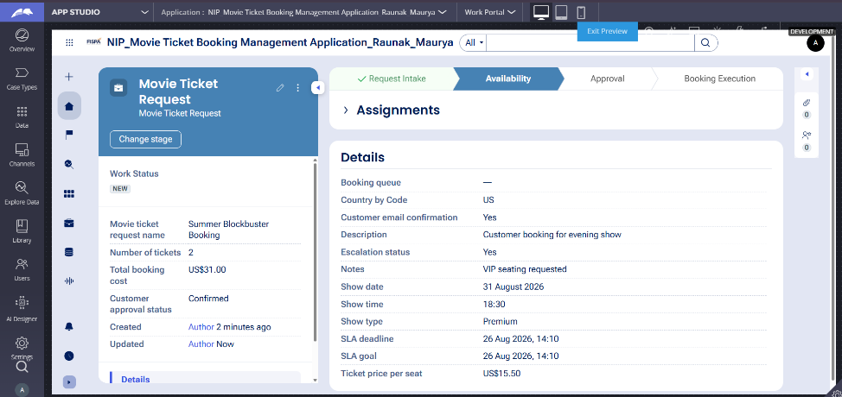
[ Paste screenshot here - follow the screenshot rules above ]

What I built for this (1–2 lines in your own words):
System checks seat availability and displays Seat Availability Status and Available Seats Count in the Availability stage.

US-003 — Calculate Booking Cost
What is expected:
Total Cost calculated automatically from Ticket Price and Number of Tickets using a business rule.
Screenshot — paste your screenshot below this line:
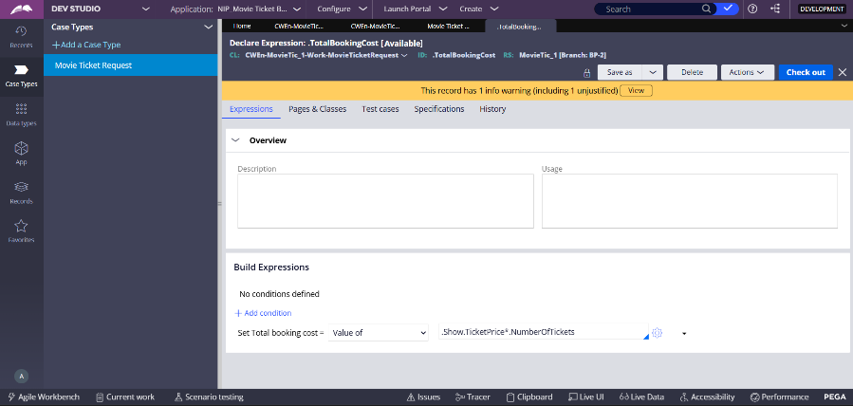

What I built for this (1–2 lines in your own words):
Total Cost is calculated automatically using Ticket Price and Number of Tickets via a business rule.

US-004 — Confirm Booking Request
What is expected:
Approval stage assigned to Customer. Booking Status captured. Flow branches on confirm/cancel.
Screenshot — paste your screenshot below this line:
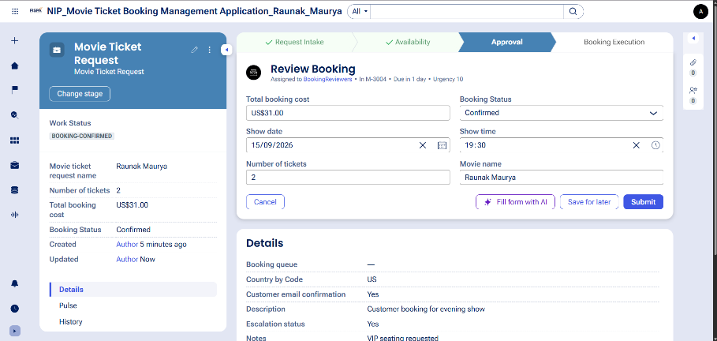
[ Paste screenshot here - follow the screenshot rules above ]

What I built for this (1–2 lines in your own words):
Customer confirms or cancels the booking in the Approval stage using the Booking Status field

US-005 — Maintain Movie and Show Data
What is expected:
Reusable Movie and Show data objects created with Movie Name, Genre, Show Date, Show Time, Seat Capacity — linked to case.
Screenshot — paste your screenshot below this line:
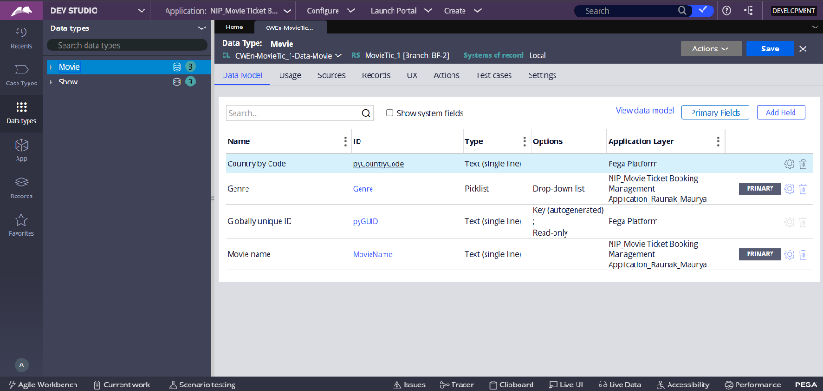

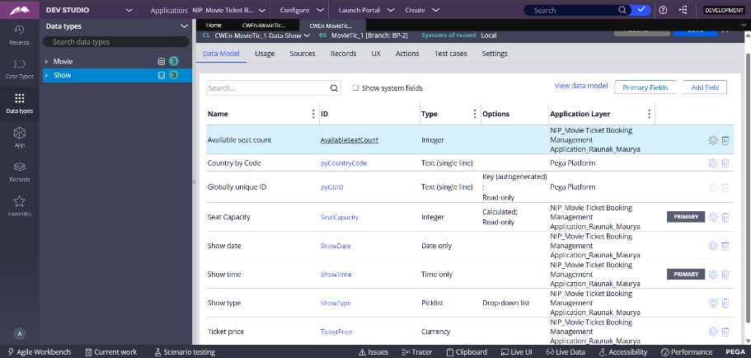

What I built for this (1–2 lines in your own words):
Movie and Show are maintained as reusable data objects with properties like Movie Name, Genre, Show Date, Show Time, and Seat Capacity

US-006 — Review Booking Details
What is expected:
Confirmation screen shows Movie Name, Show Timing, Number of Tickets and Total Cost clearly.
Screenshot — paste your screenshot below this line:
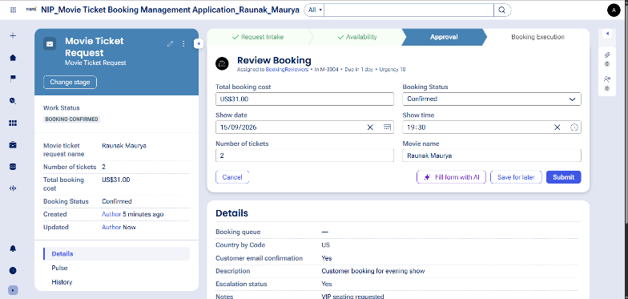

What I built for this (1–2 lines in your own words):
Booking details — Movie Name, Show Timing, Number of Tickets, and Total Cost — are displayed for customer review before confirmation

US-007 — Process Ticket Booking
What is expected:
Booking Execution stage. Seat Numbers, Ticket ID and Booking Confirmation Status maintained.
Screenshot — paste your screenshot below this line:
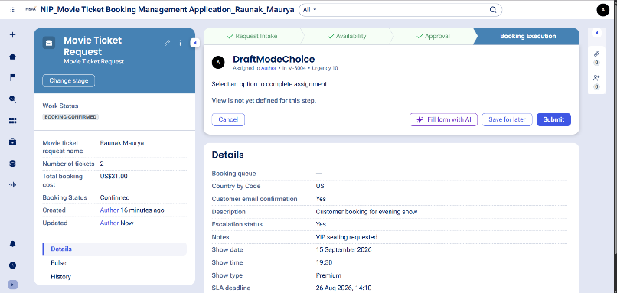

What I built for this (1–2 lines in your own words):
System allocates seats and updates Booking Confirmation Status, Seat Numbers, and Ticket ID during Booking Execution

US-008 — Notify Booking Confirmation
What is expected:
Correspondence rule triggered on case resolution. Email includes movie, show, seat and cost details.
Screenshot — paste your screenshot below this line:
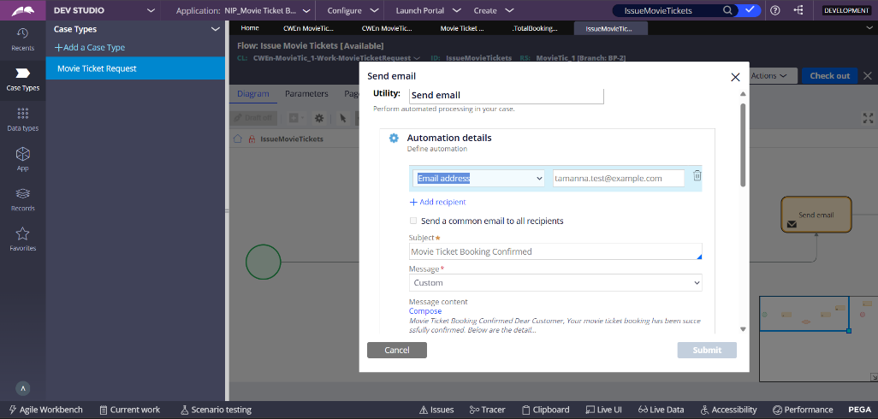

What I built for this (1–2 lines in your own words):
A correspondence rule sends a booking confirmation email to the customer with Case ID, Movie Name, Show Date/Time, Seat Numbers, and Total Cost upon resolution

US-009 — Define Booking SLA
What is expected:
SLA configured on the case type. Goal: 1 day. Deadline: 2 days. Priority increases on breach.
Screenshot — paste your screenshot below this line:
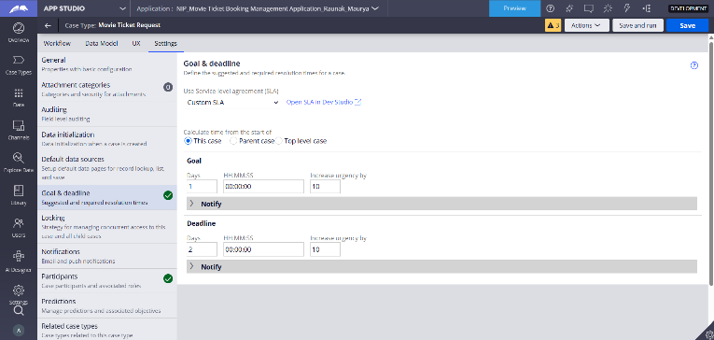

What I built for this (1–2 lines in your own words):
SLA is configured with a Goal of 1 day and Deadline of 2 days; case priority increases automatically if the deadline is missed

US-010 — Route by Show Type
What is expected:
Routing rule or Decision Table routes to PremiumShowQueue or StandardShowQueue based on Show Type property.
Screenshot — paste your screenshot below this line:
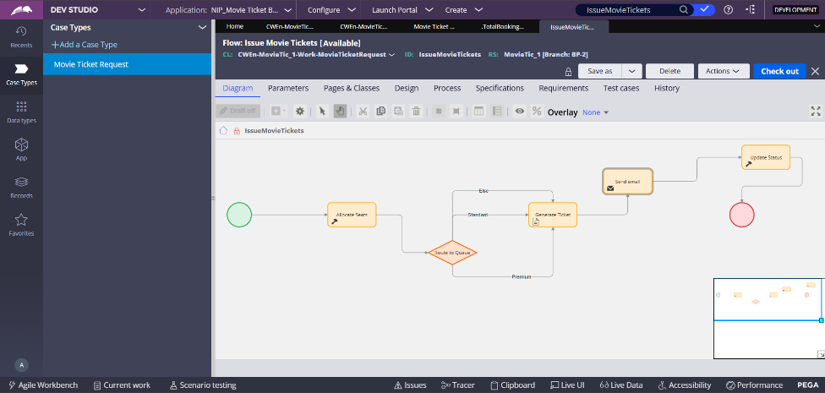
]

What I built for this (1–2 lines in your own words):
Booking requests are automatically routed to PremiumShowQueue or StandardShowQueue based on the Show Type property.

Section 3 — About Your Application
These answers are checked against your screenshots. Write exactly what is in your application.

Q1. List your stages in the order they appear in your case lifecycle.
Stage names in order, separated by commas.
Request Intake, Availability, Approval, Booking Execution Cancellation

Q2. Name the data object(s) you created and the properties inside them.
Data object name and its properties.
Movie – Movie Name, Genre
Show – Show Date, Show Time, Show Type, Seat Capacity, Available Seat Count, Ticket Price
Q3. What is the exact name and type of the rule you used to calculate Total Cost?
Provide:
• Rule Name
• Rule Type
• Properties used in the calculation
• Formula used
Rule Name: CalculateBookingCost
Rule Type: Declare Expression
Properties used: Ticket Price, Number of Tickets
Formula: Ticket Price × Number of Tickets

Section 4 — Your Understanding
Short, honest and specific answers score well.

Q4. What did Blueprint generate for you, and what did you add or change yourself afterwards?
Be specific about what was already there and what you built or modified on top.
Blueprint generated the base case type with four stages, the initial steps inside each stage, and placeholder flows for approval and ticket issuance. I added the actual property configuration (renamed the approval field to Booking Status), fixed the Else branch in the Issue Movie Tickets flow so it routes through ticket generation and email before ending, configured the Send email correspondence with a subject line and message content pulling live case data, and turned off Draft Mode so the flow could actually run instead of showing placeholder steps.

Q5. Was there anything Blueprint created that you had to correct or configure further? Describe one example.
A real example from your own work.
Yes. The Else branch in the Issue Movie Tickets flow, as generated by Blueprint, connected directly to the Update Status step, skipping Generate Ticket and Send email entirely. This meant a booking that fell into that branch would be marked complete without ever getting a ticket or a confirmation email. I reconnected the Else path so it merges into the same Generate Ticket step used by the Standard and Premium branches.

Q6. Explain your case flow from creation to resolution, in order.
What happens first, who does what, when the case closes.
The case starts when a customer submits a movie ticket request with the movie name, show date, show time, and number of tickets during Request Intake. The system then checks seat availability and calculates the total booking cost during the Availability stage. In the Approval stage, the customer confirms or cancels the booking, which is captured in the Booking Status property. If confirmed, the case moves into Booking Execution, where seats are allocated, a ticket is generated, a confirmation email is sent to the customer, and the booking status is updated before the case resolves.

Q7. Pick two design choices you made in your application and explain why you made them.
For each design choice, provide:
• What you implemented
• Why you chose that approach
• What benefit it provides to the application
First, I renamed the approval status property to Booking Status to match the exact property name required by the project specification, keeping the data model consistent with what was documented. Second, I used dynamic property references such as .pyID, .Movie.MovieName, .ShowDate, and .TotalBookingCost inside the confirmation email instead of static placeholder text, so each customer receives an email that reflects their actual booking details rather than a generic message.

Q8. What was the hardest part, and how exactly did you fix it?
Specific and honest. A real challenge scores much better than a generic answer.
The hardest part was diagnosing an UnresolvedAssemblyError that appeared when a case reached the Request Intake step. The error pointed to a flow action step, but the flow diagram itself showed no errors. I eventually found that the step's Section field was still set to a system placeholder used for Draft Mode instead of an actual generated view. I fixed it by going into App Studio and explicitly building out the form fields for that step, which forced Pega to generate a real section in place of the placeholder

Q9. If the approval step was only needed when Total Cost is above a certain amount, what would you change in your application?
Explain what you would change and where. You do not need to build this.
I would add a decision step right after the Calculate Booking Cost step in the Availability stage, checking whether Total Cost exceeds the defined threshold. If it does, the flow would continue into the existing Approval stage as it does now. If it does not, the flow would bypass Approval and connect directly into Booking Execution, skipping the customer confirmation step for lower-cost bookings

Q10. List three exact rule names from your application that you personally created or modified.
Include the rule name and rule type for each one (for example: CalculateTotalCost - Declare Expression).
EnterMovieDetails - Flow Action
IssueMovieTickets - Flow
CalculateBookingCost - Declare Expression

Q11. List all personas used in your application.
List the persona names exactly as they appear in your application.
Customer, Booking Reviewer

Q12. List all work queues used in your application and explain when each one is used.
For each work queue, provide its exact name and the condition or type of work routed to it.
BookingReviewers - handles bookings during the Review Booking step in the Approval stage
PremiumShowQueue - receives bookings where Show Type is Premium, routed during Booking Execution
StandardShowQueue - receives all other bookings during Booking Execution

Before You Submit — Check These
Read through once before uploading.
1. Section 1 filled in. Application named as NIP-[Project]-[YourName]. Names match the actual application.
2. New Operator created in Pega with my full name. I logged in as that operator for all screenshots.
3. Only my chosen project section remains — the other project section is deleted.
4. All 10 user story screenshots are pasted and follow the operator, running-case, application, and rule-name evidence requirements.
5. Every question in Sections 3 and 4, including Q10, Q11, and Q12, is answered in my own words.
6. This file is named using the required format: ProjectName_FirstName_LastName.docx (for example, VehicleService_Ravi_Kumar.docx or MovieTicket_Ravi_Kumar.docx) and uploaded as required.

