https://medium.com/@raoofnaushad7/indian-danceforms-image-classification-using-transfer-learning-and-tuning-with-pytorch-b6cbe7a0fc78

Checkout the draft of the blog.

How did I tried to increase accuracy?
- I tried different pre trained models and concluded with wide_resnet50.
- Pretrained model I chose was from ImageNet competition. So I chosed the normalization like that. (You can see it in data augmentation section).
- Proper data augmention
- Learning rate scheduler ## Later switched it off
- gradient clipping
- Early stopping
- Saving the best generalised model with lowest score in validation loss.
- Used test data as validation data to get more training data and also to make analysis easy.
- Added more data from internet.
- Choosing right optimizer.
- Choosing right loss function.
- Other hyper parameters.
- Freezing and unfreezing the models.
- Choosing right activation layer, drop outs and regularizations.

Atlast using trained with whole data..
Check work done below

First thoughts:
- Small amount of data for an image classification problem.
- I have to work with transfer learning for such a small set. (finding the best pre-trained model)
- Have to work with Data Augmentation.
- Various accuracy boosting methodologies could be tried out.

Here the images were available at a folder called train and its labels were available in a csv along with the image name. I already mentioned you about data augmentation. So when loading the dataset for training or testing or whatever processing like comparing images, seeing augmented image etc can be called by creating a custom dataset using Pytorch.

Loading the data
Here the images were available at a folder called train and its labels were available in a csv along with the image name. I already mentioned you about data augmentation. So when loading the dataset for training or testing or whatever processing like comparing images, seeing augmented image etc can be called by creating a custom dataset using Pytorch.
Below I will show you how and what it is?
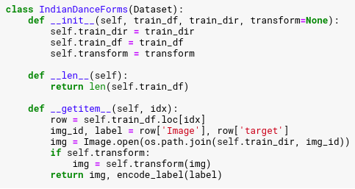
Here we define a custom dataset by extending Pytorch Dataset class. Let’s see how to use Pytorch Dataset Class.
In Pytorch Dataset you have to override two of the subclass functions.
- __len__ : function returns the size of the dataset.
- __getitem__ : function returns the data given an index we can also add transforms (Data augmentation on the fly such that whenever each image is loaded through the class it will transform it and return.
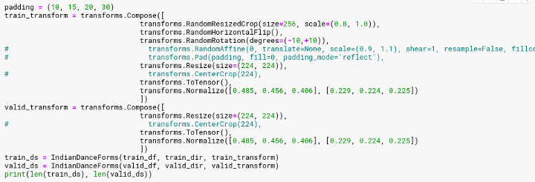

Now the train_ds and valid_ds can be used to call our dataset. We have the dataset and now we need to load the data as batches for each cases I mentioned earlier. To the train, test , preprocess, compare etc. For that we use Dataloader class. In Dataloader class we can specify batch size, shuffle, workers etc. as parameters.
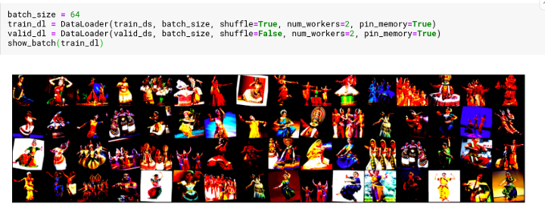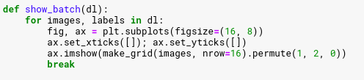
Here I also used a show_batch function to show the transformed pictures so as it will be easier for me to compare various transformations.

We need to create the model.
But before creating the model let’s write some functions for training and validation.
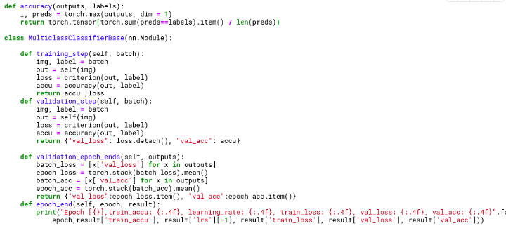
Here we create a class called MulticlassClassifierBase by nn.Module. You can see that here are 4 functions.
- training_step : This take a batch of image and label -> Predict with model -> Calculate loss with given loss function -> find accuracy -> return acc and loss.
- validation_step : Same as above.
- validation_epoch_ends and epoch_end are used to calculate and stack losses and accuracy after each batch and each epochs.
Now we can create a model.
Here we create a model by extending MulticlassClassifierBase class.
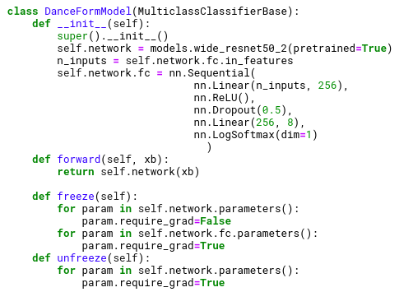
Here you can see that there are 4 functions to be exact and the class is derived from the MuliclassClassifierBase. I created the model as transfer learning model with wide_resnet50_2. When I read blogs I always had doubt how do people know which pre trained model to choose from. What I can say is learn about each model for example Resnet are residual networks which are small. For a smaller dataset may be this will not overfit. Rather than this I tried out almost all pretrained models and finally concluded here. I removed the last layer added a sequential layer. With Linear, Dropout and LogSoftmax layers. Which is good for multi class image classifier. Then there is forward function that is called when we do process with the model send each batch of datas to the network and return outputs.
Then there is freeze and unfreeze function which is used to freeze all except last sequential layer (fine tuning) for training. Unfreeze make all layers trainable (But this overfits in my case).
model = DanceFormModel() Thus we created our model. Now if you want to use GPU you can load your data and model to GPU. it is described in my notebook but I am not going to describe it here.
Like I said before since the dataset was so small I did some trick as well. I created accurate test labels for the submission data and used it for validation and used whole training data for training. This actually helped me a lot.

What all have we done?
- We created Dataset using Dataset class
- loaded the data with along with augmentatio using torch Dataloader
- Created classifier class with training, validation steps.
- Created model.
Now we need to fit and evaluate and also to visualize the results.
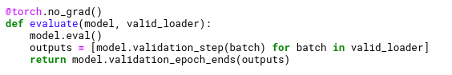
Here we create evaluate function that puts the model into evaluation mode and take model and valid_loader as inputs and calls validation_epoch_ends function for returning the loss and accuracy for a batch of data.
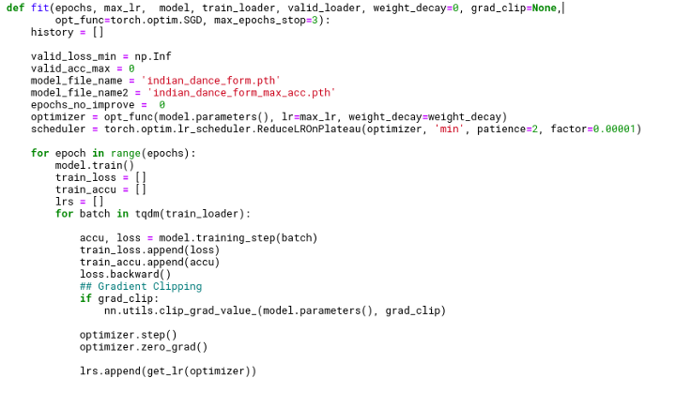
The above image shows model fitting function that gives defines variables. Use optimizer function with defined learning rate and weight decay. And learning rate scheduler (Which I removed later because not much use for my case). Then we start each epoch with train loader as input and putting the model to training mode. Using the training_step we get model predicted accuracy and loss and using loss.backward we get the gradients. We use the optitmizer to optimize the weights for the model for the given loss.
Here If you want you can also use scheduler learning rate which helps greater way sometimes. What it do is like the one mentioned here ReduceLROnPlateau it reduce the lr when there is no change in score. More optimization is the result.
Here I also used gradient_clipping which prevents exploding and vanishin gradient. This results in every gradient to have a norm greater than the threshold.
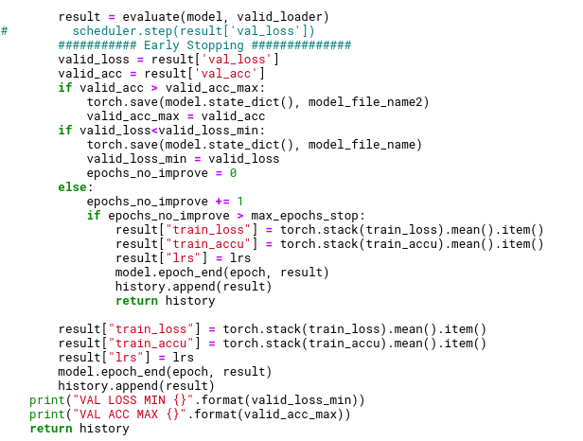
This is the continuation of model fit function.
Here I use 3 techniques.
- Since I already have the submission dataset as my validation dataset. I consider accuracy as a criteria and saves the model with best accuracy each time.
- I also use this same technique to save model everytime when validation loss is less. Thus saving only the most generalized data.
- Early Stopping. If there is no improvement for number of periods mentioned as a parameter. It will stop training.

Advantages: I can give epoch size as I like. It will stop running if there is no improvement and only save good model.
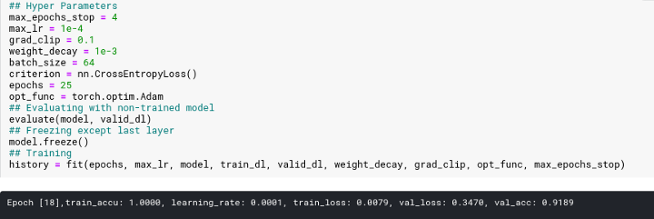
There is nothing much here. I define the parameters and start training and wait for it to finish.

Visualizing Training
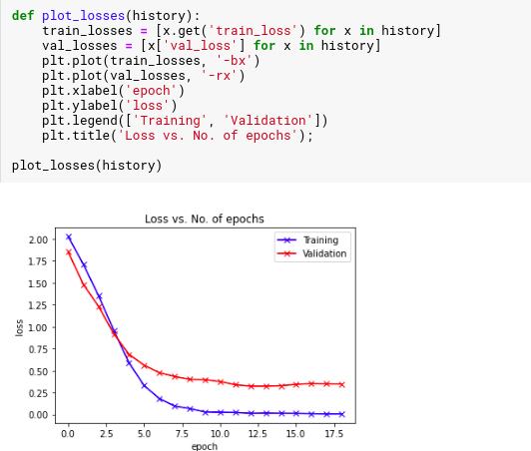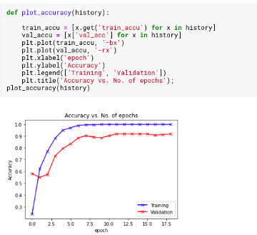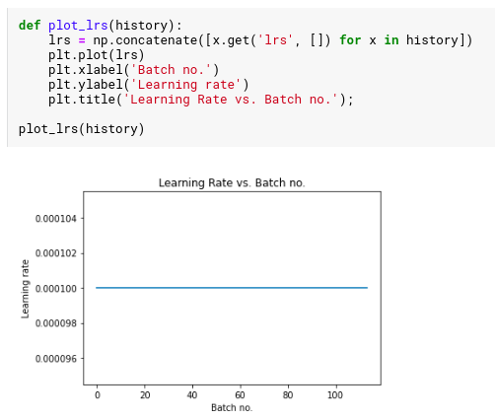
This gives you an idea about your training time. Since I didn’t use the learning rate scheduler otherwise you could have seen the change in lr.

Now what?

Prediction and Submission
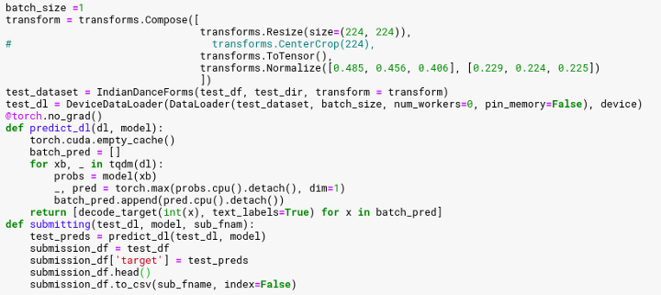
Here we do the same creating test dataset, test data loader, prediction and converting it to the required csv format.
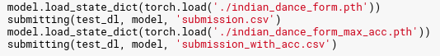
Point to Note: You have to do whatever transformation or data augmentaion you did to your validation dataset to the test dataset in order to get the expected accuracy.

