Spring 2024: CS5720   
Neural Networks and Deep Learning - ICP-2  
Sai Deva Pranay Kumar Rao Guddity (700745063)

Github Link: https://github.com/raopranay1999/Neural-Networks-Assignment-2

1. Write a program that takes two strings from the user: first name, last_name. Pass these variables to fullname function that should return the (full name).

* For example:
* First_name = “your first name”, last_name = “your last name”
* Full_name = “your full name”

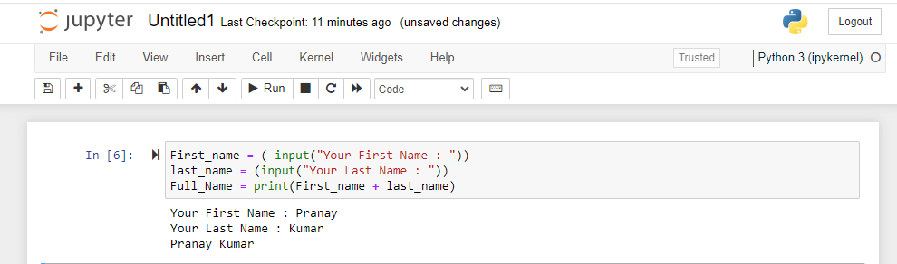

* Write function named “string_alternative” that returns every other char in the full_name string. Str = “Good evening”   
  Output: Go vnn

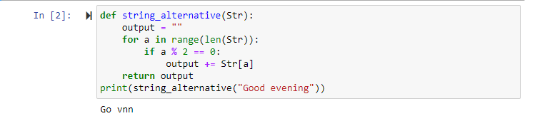

1. Write a python program to find the wordcount in a file (input.txt) for each line and then print the output. o Finally store the output in output.txt file.   
   Example:  
   Input: a file includes two lines:   
   Python Course  
   Deep Learning Course

Output:   
Python Course   
Deep Learning Course   
Word_Count:   
Python: 1   
Course: 2   
Deep: 1   
Learning: 1

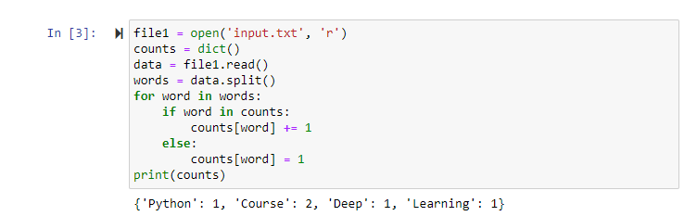

1. Write a program, which reads heights (inches.) of customers into a list and convert these heights to centimeters in a separate list using:   
   1) Nested Interactive loop.  
   2) List comprehensions Example:   
   L1: [150,155, 145, 148]  
   Output: [68.03, 70.3, 65.77, 67.13]

