**Spring 2024: CS5720 Neural Networks & Deep Learning - ICP-1**

**Sai Deva Pranay Kumar Rao, Guddity(700745063)**

GitHub Link: https://github.com/raopranay1999/Neural-Networks.git

1. **Write a python program for the following: – Input the string “Python” as a list of characters from console, delete at least 2 characters, reverse the resultant string and print it.**

**Sample input:**

**python**

**Sample output:**

**ntyp**

**-Take two numbers from user and perform at least 4 arithmetic operations on them.**

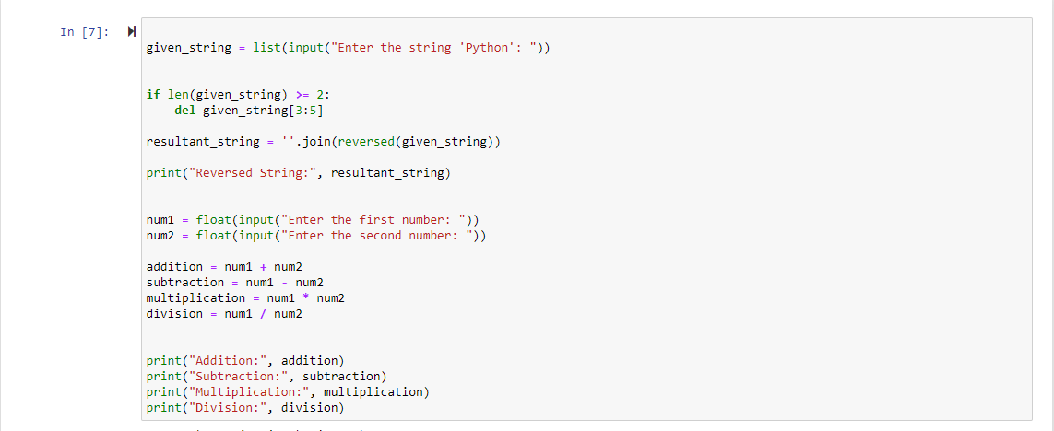

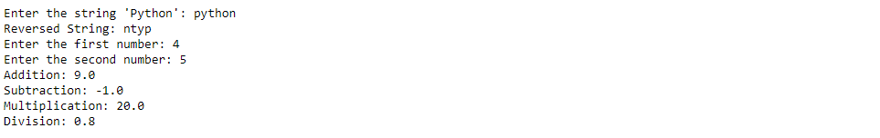

1. **Write a program that accepts a sentence and replace each occurrence of ‘python’ with ‘pythons’. •Sample input: •I love playing with python •Sample output: •I love playing with pythons**

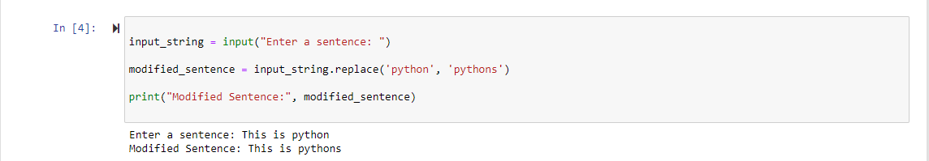

1. **Use the if statement conditions to write a program to print the letter grade based on an input class score. Use the grading scheme we are using in this class.**

