Algorithm Design and Visualization
(GitHub Link)

Student: Rajat Yadav
Project: Data Structures and Algorithms Visualization
Date: May 2, 2026
1. Algorithm Design Summary
1) Selected Algorithm
I designed and implemented a 2D Kd-Tree algorithm.
Problem Definition (Input/Output)
Input: A sequence of 2D points `(x, y)` with a short label, for example `(120, 85, "P3")`.
Output:
1) A Kd-tree structure built by recursive insertion with alternating split axes.
2) Query result for exact search: either the matching point node or `None`.
Design Approach Using the Required Guidelines
1) Understanding the Problem
a) I first defined what each operation must do:
1) `insert(x, y, label)` should place/update a point in the tree.
2) `findExact(x, y)` should follow Kd-tree decision rules and return a match if present.
b) I manually traced a small example of 5 points to verify alternating axis behavior:
1) depth 0 compares x,
2) depth 1 compares y,
3) depth 2 compares x, and so on.

2) Exploring Simple Approaches
- A brute-force approach would store all points in a list and linearly scan for every query (`O(n)` search).
- This is simple but not scalable for repeated queries and does not expose spatial partitioning.
3) Identifying Relevant Techniques
a) I selected a divide-and-conquer spatial tree approach:
- each level splits the plane on one axis,
- recursive insertion partitions points into left/right subspaces,
- search follows one path determined by axis comparisons.
b) This is directly aligned with efficient data-structure design principles for multidimensional data.
4) Evaluating Constraints
a) Coordinates are bounded by the visualization region.
b) Labels are short and validated for readability.
c) Expected behavior:
- Insert updated labels if coordinates already exist.
- Exact search returns deterministic results.
d) Complexity expectations:
- Average insert/search near `O(log n)` for balanced-like input.
- Worst case `O(n)` for highly ordered/inadvisable insertion sequences.

Key Design Decisions
1. Axis by depth: `axis = depth % 2` for clean alternation (`x`, then `y`).
2. Node stores bounding box: each node keeps the user-space region it governs, enabling accurate split-line drawing.
3. Left/right semantics:
a) At x-split nodes: left if `x < n.x`, else right.
b) At y-split nodes: left if `y < n.y`, else right.

2. Implementation Overview
Files Implemented/Modified
a) Added: `PythonVisualizations/KdTree.py`
b) Updated menu integration: `PythonVisualizations/runAllVisualizationsMenu.py`

Core Components in the Code
1. Node model
python
class KDNode(object):
def __init__(self, x, y, label, axis, bbox):
self.x = x
self.y = y
self.label = label
self.axis = axis
self.bbox = bbox
self.left = None
self.right = None

2. Recursive insertion
python
axis = depth % 2
if axis == 0:
if x < n.x:
n.left = self.__insert(...)
else:
n.right = self.__insert(...)
else:
if y < n.y:
n.left = self.__insert(...)
else:
n.right = self.__insert(...)

3. Recursive exact search
python
if not n: return None
if n.x == x and n.y == y: return n
axis = depth % 2
recurse left/right based on axis comparator

4. Input validation and UI handlers
- `clickInsert`, `clickFindExact`, `clickRandomFill`
- argument validation for coordinate range and label format

Challenges and How They Were Addressed
1. Correct recursive traversal
a) Challenge: ensuring child recursion does not accidentally reset to root.
b) Fix: implemented `iterNodes` with a root sentinel parameter, so recursive `None` children terminate correctly.
2. Visualization/model synchronization
a) Challenge: keeping drawn lines/points consistent after updates.
b) Fix: separated drawing into `redrawTree()` and rebuilt node canvas items from current tree state after operations.
3. Framework consistency
a) Challenge: integrating with operation buttons, code highlighting, and animation controls.
b) Fix: used framework patterns:
  - `createCallEnvironment(...)`
  - `highlightCode(...)`
  - `addOperation(...)`
  - `addAnimationButtons(...)`

3. Visualization Description
How the Kd-Tree is Visualized?
The visualization uses a 2D point region and renders:
1) Points as circles with labels,
2) Split lines per node:
  - vertical line for x-split nodes,
  - horizontal line for y-split nodes,
3) Root ringto identify the tree root,
4) Temporary traversal arrows and crosshair during algorithm steps.

How Visualization Reflects Algorithm Behavior?
1. Insertion path visibility
a) During insert, an arrow labeled `n` marks the current recursive node.
b) Code lines are highlighted as each comparison and branch decision is made.
2. Alternating axis decisions
a) The code pane highlights `axis = depth % 2` and the respective branch condition (`x < n.x` or `y < n.y`).
b) The final tree shows these decisions geometrically as alternating vertical/horizontal splits.
3. Exact search traversal
a) Search highlights each recursive check:
- empty node check,
- coordinate match,
- left/right decision.
b) This gives a direct visual trace of the search path.
User Interaction Supported
  - `Insert(x, y, label)`
  - `Find Exact(x, y)`
  - `Random Fill(n)`
  - `New`
  - `Show Splits` toggle
  - Canvas click populates coordinate inputs; double-click inserts a generated point label.
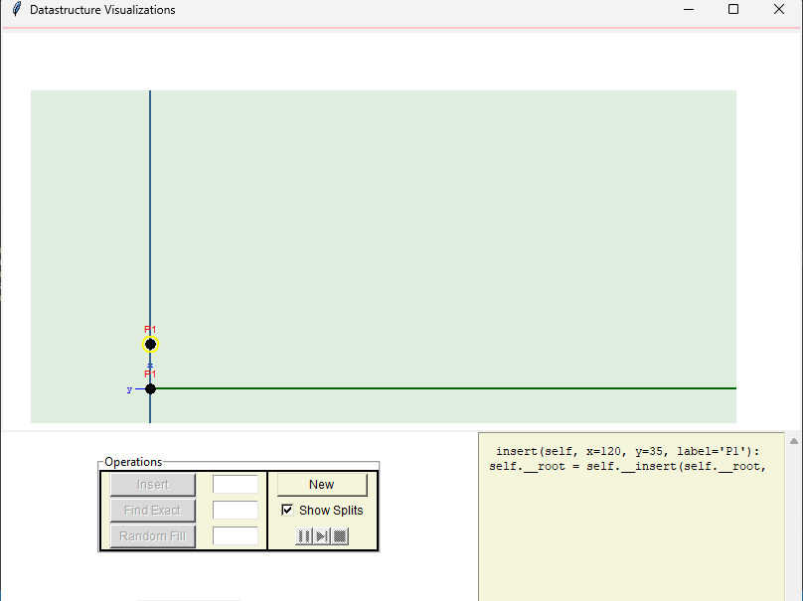
Short Verification Notes
  - The new files compile successfully with Python syntax check.
  - `KdTree` is discoverable in the framework launcher and grouped with spatial structures.

