| **Experiment No. 10** | | | | |
| --- | --- | --- | --- | --- |
| **Date of Performance:** | **13.02.25** | | | |
| **Date of Submission:** | **21.02.25** | | | |
| **Program Execution/ formation/**  **correction/ ethical practices**  **(06)** | **Timely**  **Submission**  **(01)** | **Viva Answer to**  **Sample questions**  **(03)** | **Experiment**  **Total (10)** | **Sign with Date** |
|  |  |  |  |  |

**Experiment No. 10**

**10.1 AIM:** Construction of Bayesian Network using virtual lab.

**10.2 LABORATORY OUTCOME:**

**CO 1:** Define need of Artificial Intelligence and Machine Learning and explain working of Artificial Intelligence and Machine Learning algorithms.

**CO 2:** Make use of machine learning techniques to solve problems in different domains using scientific programming.

**10.3 OBJECTIVE(Virtual Lab):**

The key objectives of the Artificial Intelligence I Virtual Lab are:

1. To provide students with hands-on experience in foundational and advanced AI concepts such as search algorithms, Bayesian networks, and reinforcement learning.
2. To enhance comprehension of AI methodologies through interactive simulations that allow for visualization, experimentation, and exploration of various algorithms.
3. To align with AI curricula in academic institutions, supporting learning objectives and augmenting theoretical understanding with practical applications.
4. To understand what Bayesian Networks are and how they are useful.
5. Constructing Bayesian Network for a given problem statement.

**LAB LINK:** [**https://ai1-iiith.vlabs.ac.in/**](https://ai1-iiith.vlabs.ac.in/)

**10.4 PROBLEM STATEMENT: Choose any one Problem Statement given in the virtual lab and perform the procedure.**

**10.5 RELATED THEORY:**

## **Introduction**

Most real world applications involve many random variables, which makes computation of probability hard. For answering any query in a domain we need to have joint probabilities of the random variables. Notice that defining joint probabilities for all the random variables is a tedious task(especially when there are large numbers of random variables). Bayesian Network is a way of expressing these complicated probabilities using compact structure, which requires us to define a smaller number of probabilities.

Bayesian Network compactness is based on the application of conditional independence probabilities. We form a graph which satisfies few properties and we store some information on each node (we will see the exact details).

Bayesian Network: Nodes in the graph represent random variables in the domain. Each edge from random variable X to Y, represents the fact X has a direct influence on Y. We store P(X/Parent(X)) for each node in the graph.

Using the conditional probabilities we defined on each node we can calculate the joint probabilities on these random variables.

## **Algorithm**

Order the nodes (nodes in the graph are random variables) X1, X2, X3, … For each Xi, add an edge from Xj to Xi if there is a direct influence of Xj on Xi. This will make sure that the condition: P(Xi/Parent(Xi)) = Parent(Xi/Xi-1, Xi-2, … 1) Which is important for the proof to hold. For full proof please read Chapter 14 in Artificial Intelligence: A Modern Approach [Third Edition]. Now for each node define P(Xi/Parent(Xi))

## **Disadvantages**

You need to have domain knowledge to know the relation between random variables. The order in which you choose random variables will affect the compactness of the Network. In the worst case we might define a huge number of probabilities. So there is no single correct answer for Bayesian Network. Depending on the order we choose the optimality and compactness of the graph changes.

## **Advantages**

We need to define a smaller number of probabilities. Because of the compact nature of Bayesian Network the inference comes handy.

## 

## 

## 

## 

## 

## 

## 

## 

## **10.6 PROCEDURE:**

## **Construction of Bayesian Network**

## **Step 1:** Understand the Problem statement provided, understand the relations between different variables

## **Step 2:**Add necessary components (nodes which are part of the domain the problem statement is discussing).Addition of any irrelevant nodes will lead to a wrong Bayesian Network.

## **Step 3:**You will be provided hints about relation between random variables based on which you need to add edges between the components. You need to use these hints because there can be many correct answers but for the practical purposes of this experiment you are restricted to provide us an answer based on provided hints.

## **Step 4:** Once you construct the graph click on submit, depending on whether your construction is correct or not you will be shown a message.

## **Step 5:** After getting success messages hover over the nodes to get CPT tables of them.

## **Step 6:** Some of them are incomplete, tap on them and complete the table.

## 

## **10.7 RESULT/OUTPUT:**

1) BURGLARY ALARM

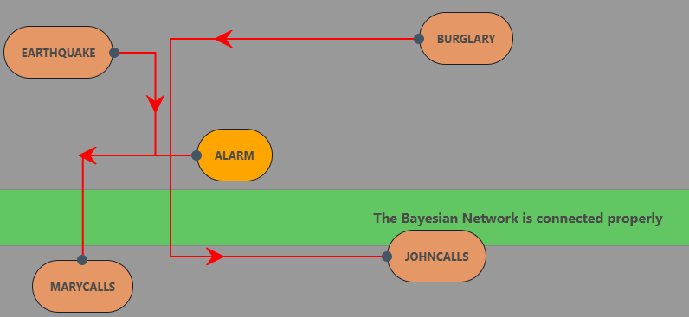

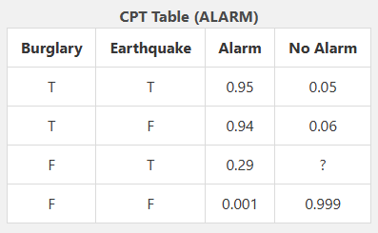

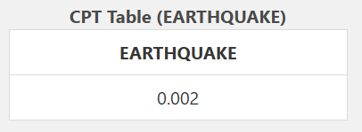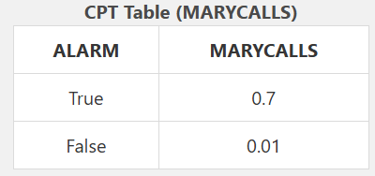

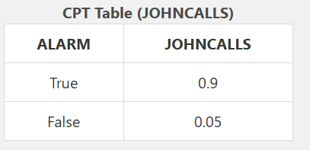

2) Malfunctioning AC

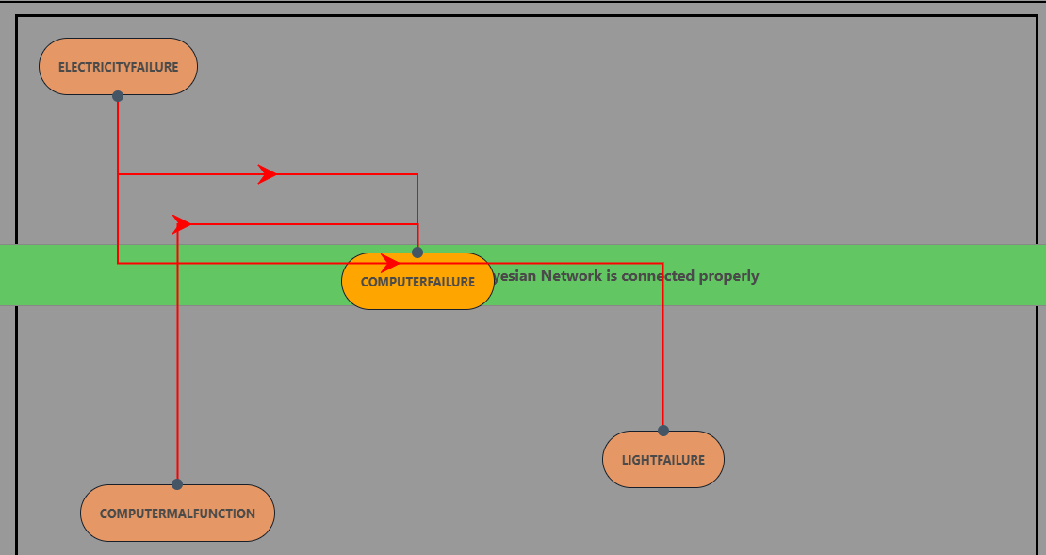

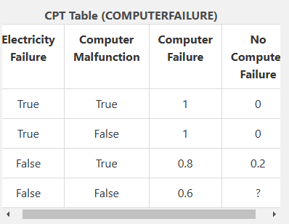

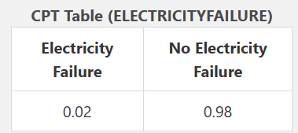

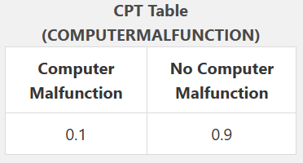

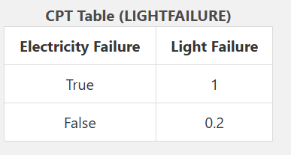

3) MARKS IN A EXAM

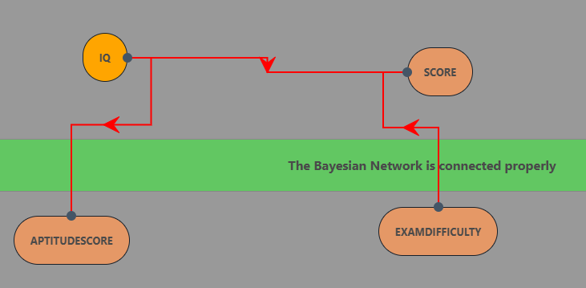

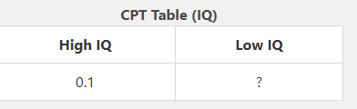

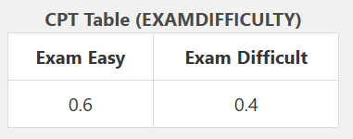

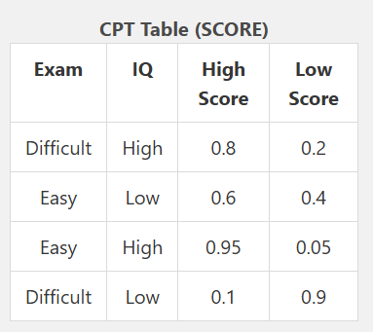

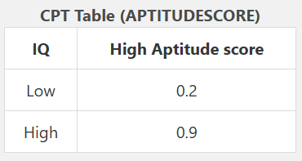

4)RAIN INTERRUPTION

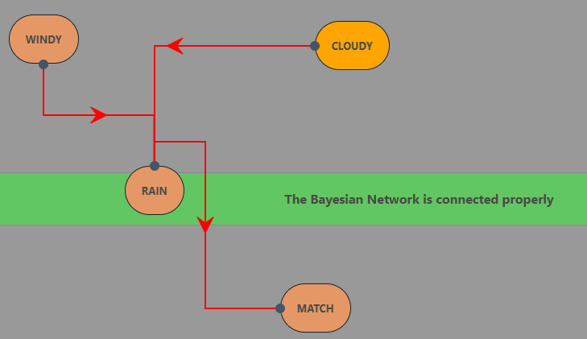

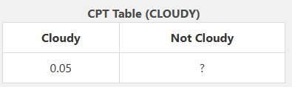

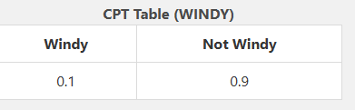

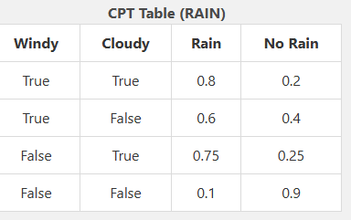

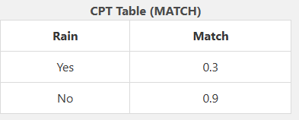

5)RED CARD

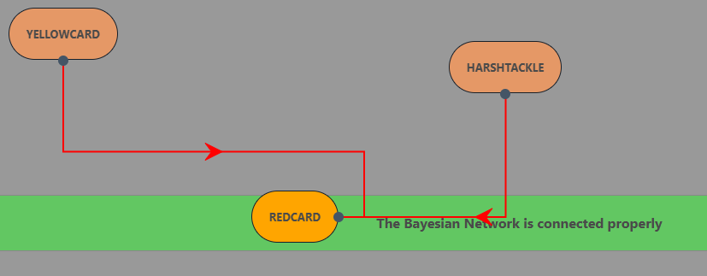

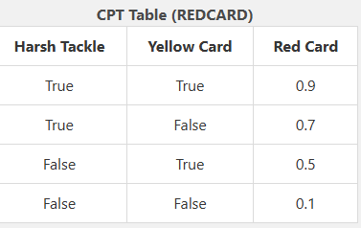





**10.8 CONCLUSION:**

Thus, we have successfully constructed a Bayesian Network using a virtual lab.

**10.9 QUESTIONS:**

#### **What is a Bayesian Network?**

A) A type of artificial neural network  
**B) A probabilistic graphical model that represents a set of variables and their conditional dependencies**  
C) A supervised learning algorithm  
D) A rule-based expert system

#### **In a Bayesian Network, what do the nodes represent?**

A) Conditional probabilities  
**B) Random variables**C) Decision trees  
D) Hidden layers

#### **What do the edges in a Bayesian Network represent?**

**A) Causal or probabilistic dependencies between variables**  
B) Independent relationships  
C) Direct observations  
D) Neural connections

#### **If two nodes in a Bayesian Network are independent given a third node, what is this property called?**

A) Markov Property  
**B) Conditional Independence**C) Bayesian Inference  
D) Chain Rule

#### **What is the primary mathematical tool used to perform inference in Bayesian Networks?**

A) Maximum Likelihood Estimation  
**B) Bayes’ Theorem**C) Gradient Descent  
D) K-Nearest Neighbors