|  |  |  |  |  |
| --- | --- | --- | --- | --- |
| **Experiment No. - 1** | | | | |
| **Date of Performance:** |  | | | |
| **Date of Submission:** |  | | | |
| Program Execution/ formation/ correction/ ethical practices  (06) | Timely Submission (01) | Viva Answer to sample questions (03) | Experiment Total (10) | Sign with Date |
|  |  |  |  |  |

## Experiment No. 1

## Algorithm to develop Square using Indian Knowledge System

* 1. **Aim: Algorithm to develop Square using Indian Knowledge System**
  2. **Course Outcome:**. Implement algorithms developed by Ancient Mathematicians

## Related Theory:

## Square of a Number- Aryabhata identifies the geometric aspect and the mathematical operation of the square in his definition. As pe his definition3 varga is a square and is also a geometric object whose sides are equal. Bhaskara-1 (629 CE) in his commentary on Aryabhatiya provides an algorithm forfinding the square of any umber. The verse that explains the algorithm is given below:

## 

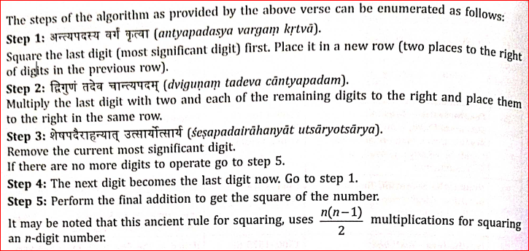

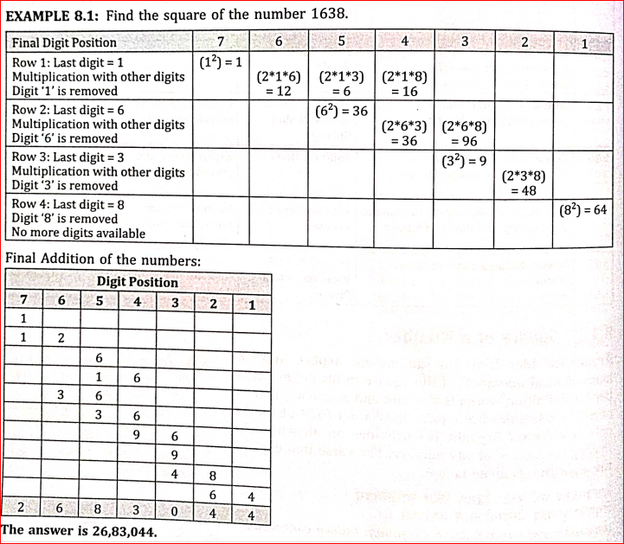

**1.4 Problem** -

Q1. FIND SQUARE OF 1328

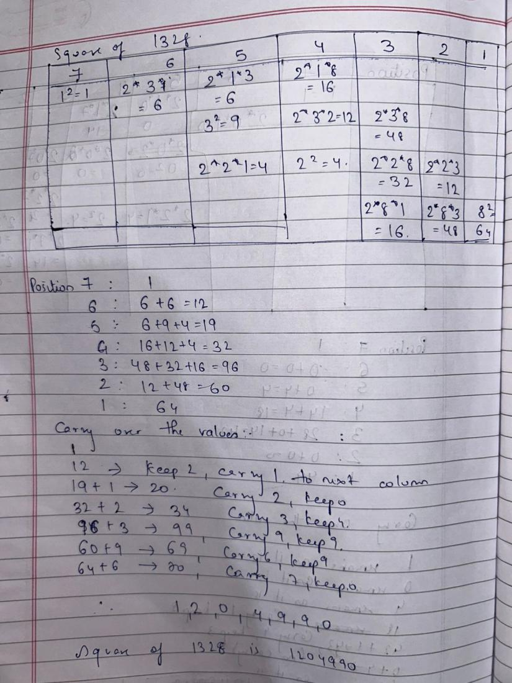

Q2. FIND SQUARE OF 1027

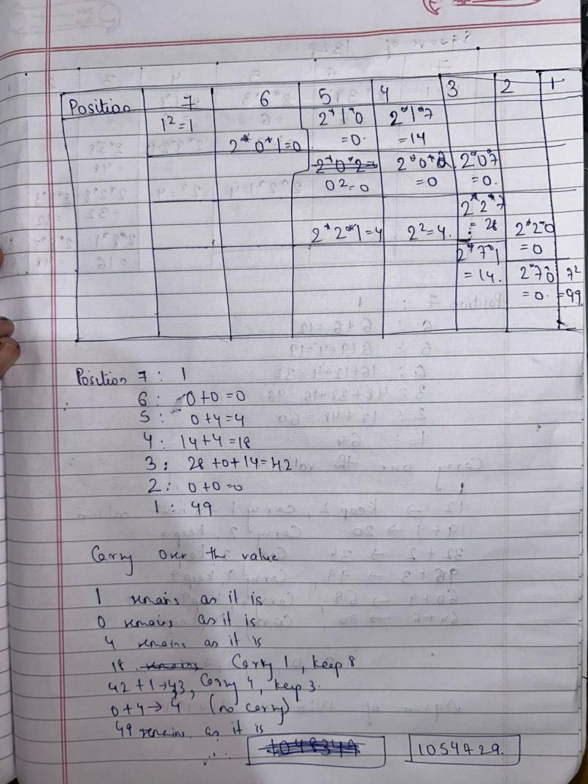

**1.4 Conclusion:**

Finding the square of large numbers using **Vedic Mathematics** is a highly efficient and systematic approach that simplifies complex calculations. The **Duplex Method (Dwandwa Yoga)** and other Vedic techniques break down the process into smaller, manageable steps, reducing the reliance on lengthy traditional multiplication. By leveraging symmetry and mental calculations, these methods enhance speed, accuracy, and confidence in mathematical problem-solving. Mastering these ancient techniques not only improves computational efficiency but also fosters a deeper appreciation for the brilliance of Vedic Mathematics in modern applications.