Project Report on E-Commerc Shoes

By,
ABCHCHHCHHC

OBJECTIVES
An online e-commerce Shoes site which will manage end to end display and sale of its products. Customers to buy shoes online. Further employees would manage shoes and orders
Introduction
Electronic Commerce is exactly analogous to a marketplace on the internet. Electronic commerce (also referred to as EC, e-commerce) consist primarily of the distributing, buying, selling, marketing and servicing of products or services over electronic systems such as the internet and other computer networks. E-commerce follows – that is, buyers and sellers exchange and transport goods from one place to another. But rather than conducting business in the tradition way-in stores and other “brick and mortar” buildings or through mail order catalogs and telephone operators- in e-commerce buyers and sellers transact business over networked computers.
E-commerce also has some disadvantages, however. Consumers are reluctant to buy some products online. Online furniture business, for example, have failed for the most part because customers want to test the comfort of an expensive item such as a sofa before they purchase it. Consumers also need to be reassured that credit card transaction are secure and that their privacy is respected.

What do you mean by commerce
Commerce is the exchange of goods, & services, usually for money. When you buy something at a score you are participating in commerce. When one things of different ways, he/she immediately recognize several different players of the commerce such as:

Buyers: These are the people or organization with money who want to purchase goods and service products.
Sellers: These are the people organization that create the products & services that seller’s offer to buyers. Producers may is classified in the category of a seller. They can sell their products to any category to customers.

What is E-Commerce:
- It is a business strategy.
- It uses technology to achieve business goals.
- It improves external business relationship.
- It is an evolution in the way companies internet.
- It provides information to facilitate delivery of goods and services.

User of this System:
- Administrator
- Customer

Functions done in this project:
- Provide role based access to system.
- Application should be accessible over the internet.
- Customer to perform the following activities:
- Browse the store to view products.
- Add and remove products from an online shopping basket.
- Place a shopping order by providing delivery information.
- Provide an authentication mechanism to verify the credential of an employee assigned with the administrator role.
- Provide an authorization mechanism to restrict access to administrative functions based on the fact whether the current user in an administrator or not.
- An admin should be able to perform following activities:
Add new product
Edit information of products and Stock.
Non Functional requirements:
- Secure access of confidential data (user’s details)
Tools and Technology used in this project:
J2EE Technology: Thymeleaf, Spring MVC, spring security, Hibernate.
Application Server: Apache Tomcat
Database: MYSQL
STYLE: Bootstrap.
Bootstrap:
Bootstrap is the most popular HTML, CSS, and JavaScript frameworks for developing responsive, mobile-first web sites.
Thymeleaf:
Thymeleaf is a Java XML/XHTML/HTML5 template engine that can work both in web (servlet-based) and non-web environments. It is better suited for serving XHTML/HTML5 at the view layer of MVC-based web applications, but it can process any XML file even in offline environments. It provides full Spring Framework integration.
In web applications Thymeleaf aims to be a complete substitute for JavaServer Pages (JSP), and implements the concept of Natural Templates: template files that can be directly opened in browsers and that still display correctly as web pages.

Spring MVC:
The Spring Framework is an application framework and inversion of control container for the Java platform. The framework's core features can be used by any Java application, but there are extensions for building web applications on top of the Java EE (Enterprise Edition) platform. Although the framework does not impose any specific programming model, it has become popular in the Java community as an addition to the Enterprise Java Beans (EJB) model
Spring MVC is the web component of Spring's framework. It provides a rich functionality for building robust Web Applications. The Spring MVC Framework is architected and designed in such a way that every piece of logic and functionality is highly configurable.
Spring Security:
Spring Security is a powerful and highly customizable authentication and access-control framework. It is the de-factor standard for securing Spring-based applications. Spring Security is a framework that focuses on providing both authentication and authorization to Java applications.
Hibernate:
(Hibernate in short) is an object-relational mapping framework for the Java language. It provides a framework for mapping an object-oriented domain model to a relational database. Hibernate solves object-relational impedance mismatch problems by replacing direct, persistent database accesses with high-level object handling functions.
Apache Tomcat:
Apache Tomcat is an open-source web server and servlet container developed by the Apache Software Foundation (ASF). Tomcat implements several Java EE specifications including Java Servlet, JavaServer Pages (JSP), Java EL, and WebSocket, and provides a "pure Java" HTTP web server environment for Java code to run in.
MYSQL Database:
A relational database organizes data into one or more data tables in which data types may be related to each other; these relations help structure the data. SQL is a language programmers use to create, modify and extract data from the relational database, as well as control user access to the database. In addition to relational databases and SQL, an RDBMS like MySQL works with an operating system to implement a relational database in a computer's storage system, manages users, allows for network access and facilitates testing database integrity and creation of backups

Business - to – Consumer (Models)
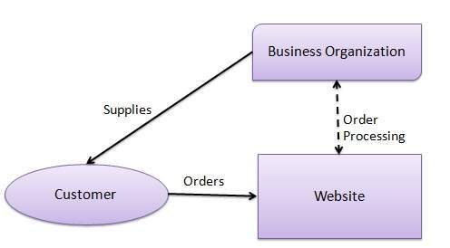
A website following the B2C business model sells its products directly to a customer. A customer can view the products shown on the website. The customer can choose a product and order the same. The website will then send a notification to the business organization via email and the organization will dispatch the product/goods to the customer.

UML DIAGRAM:
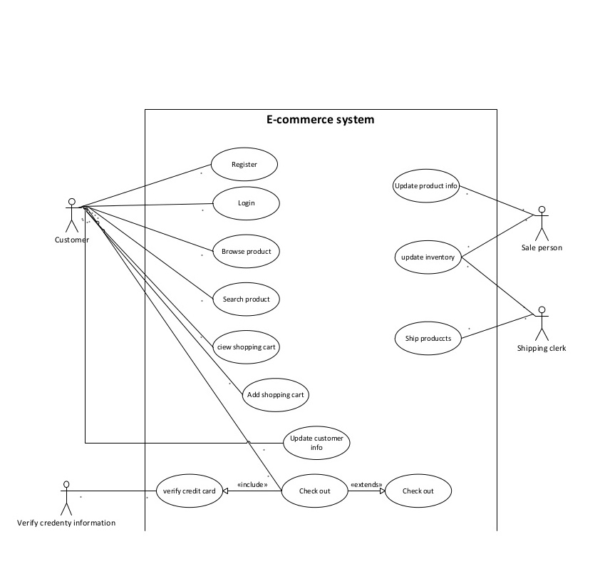

Screenshots:
Home Page:
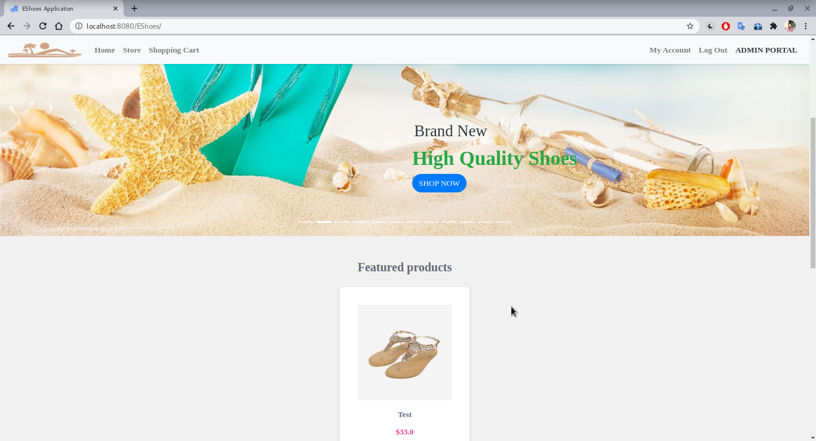
Login Page:
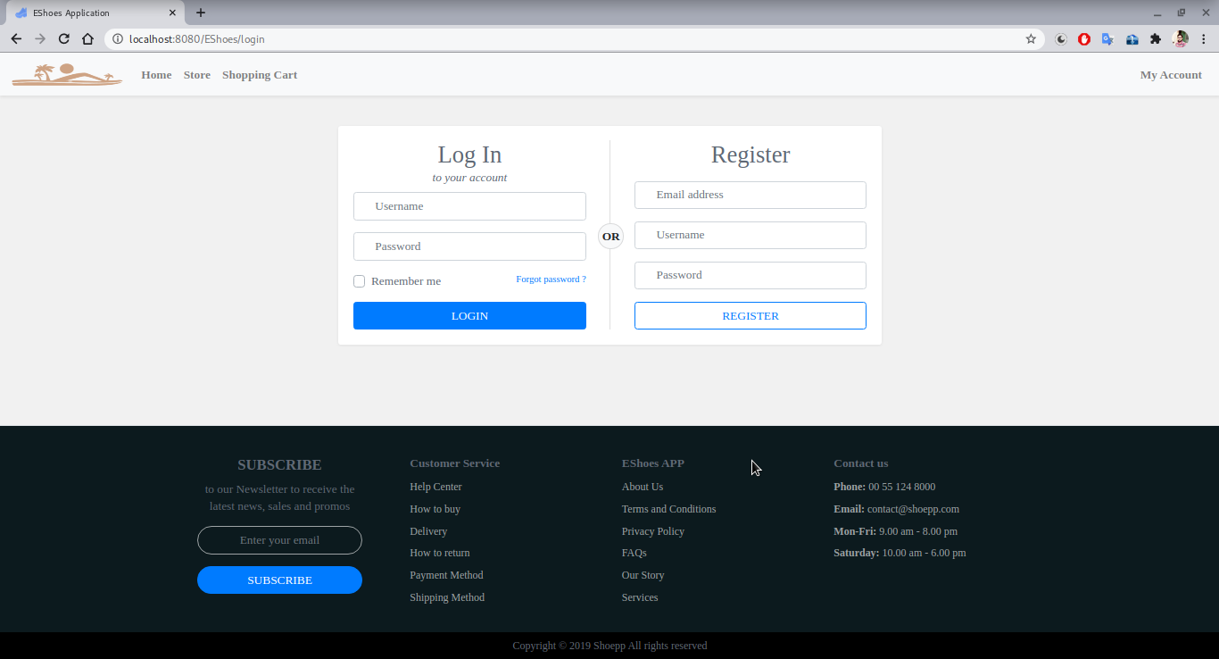

Admin Page:
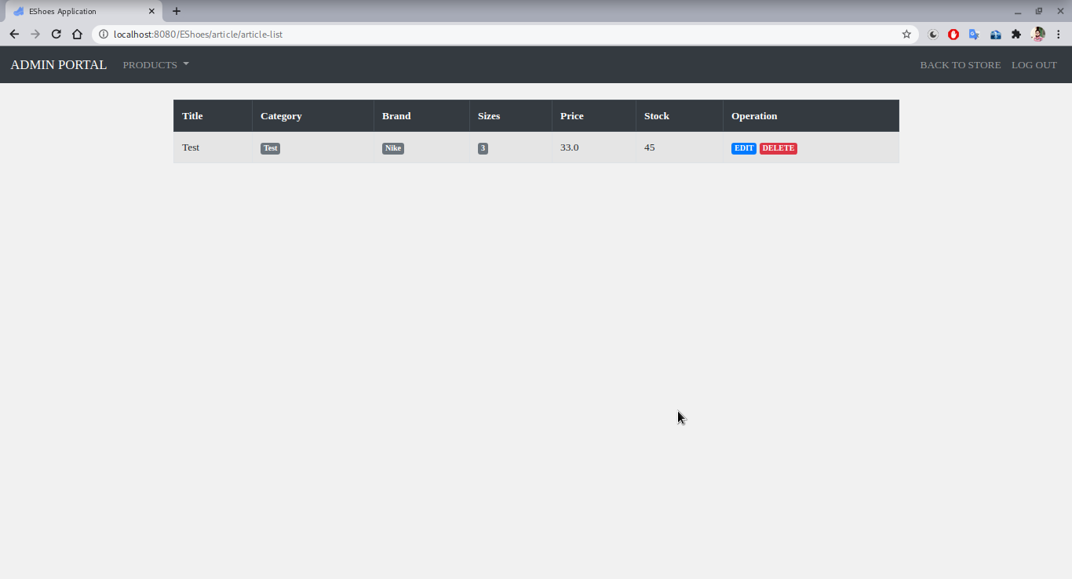
User Page:
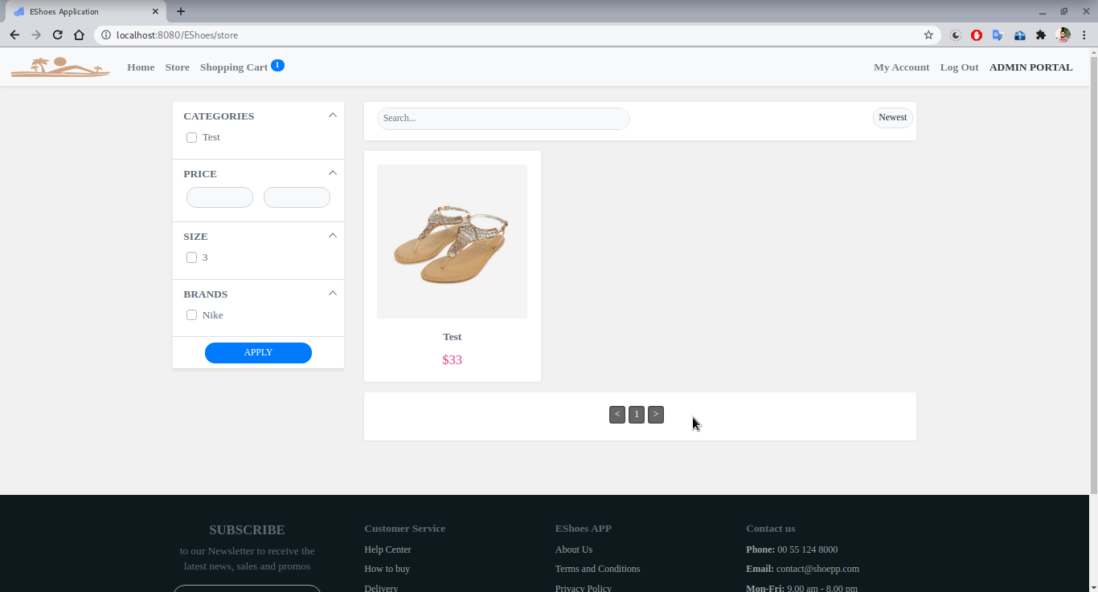

Adding Product:
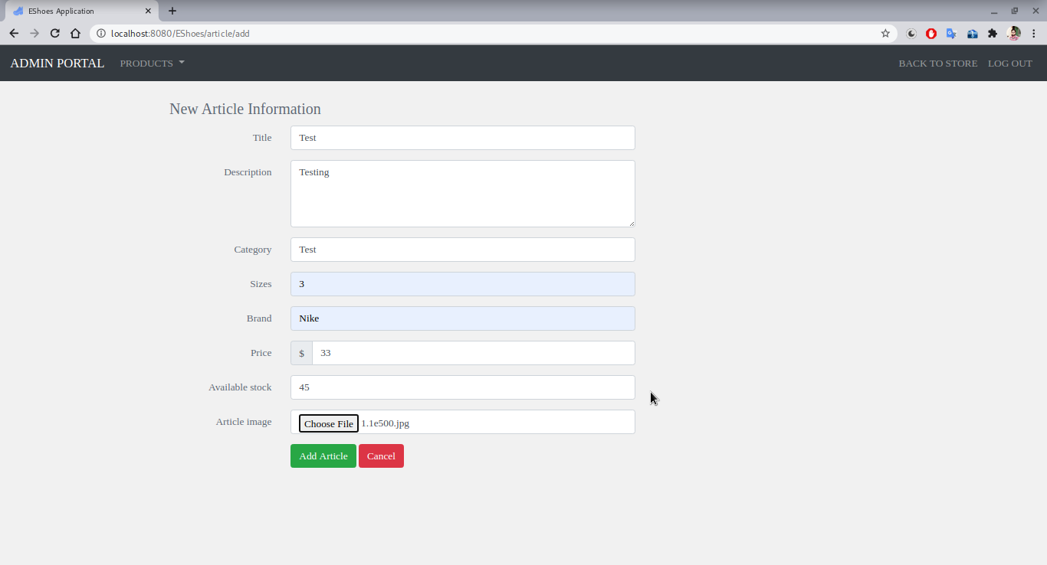
Order Page:
