**USER INTERFACE AND DESIGN**

**5.1 Homepage:**

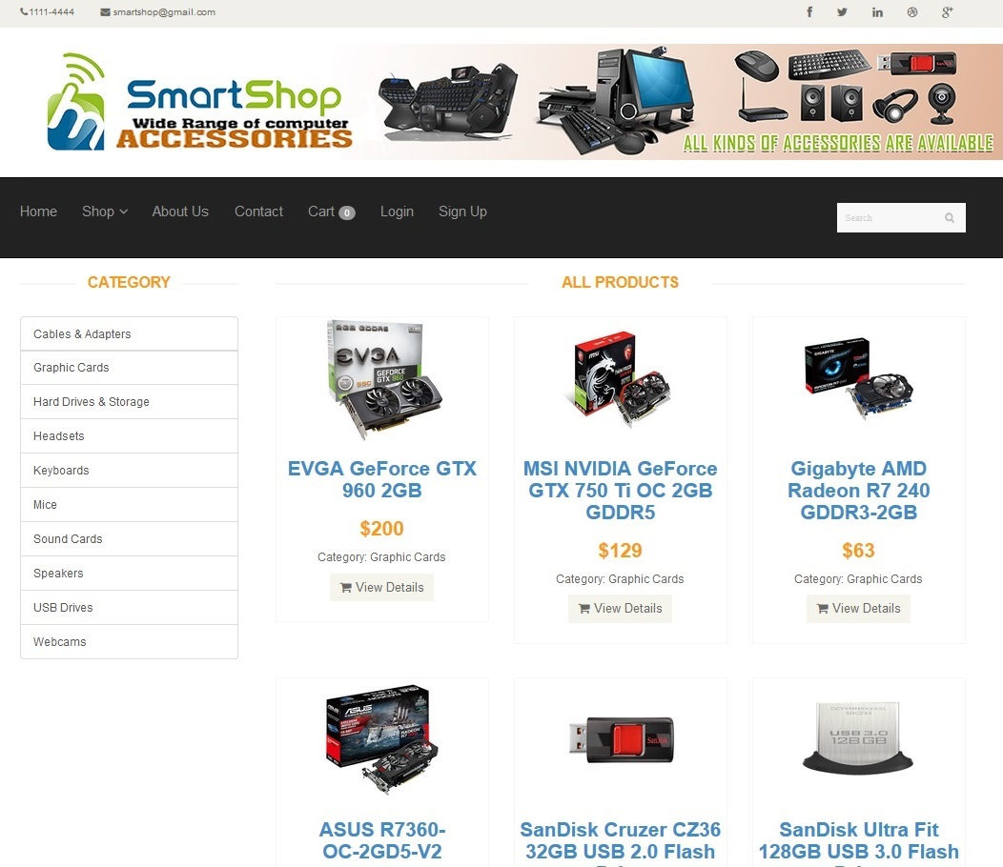

**5.2 Login Screen:**

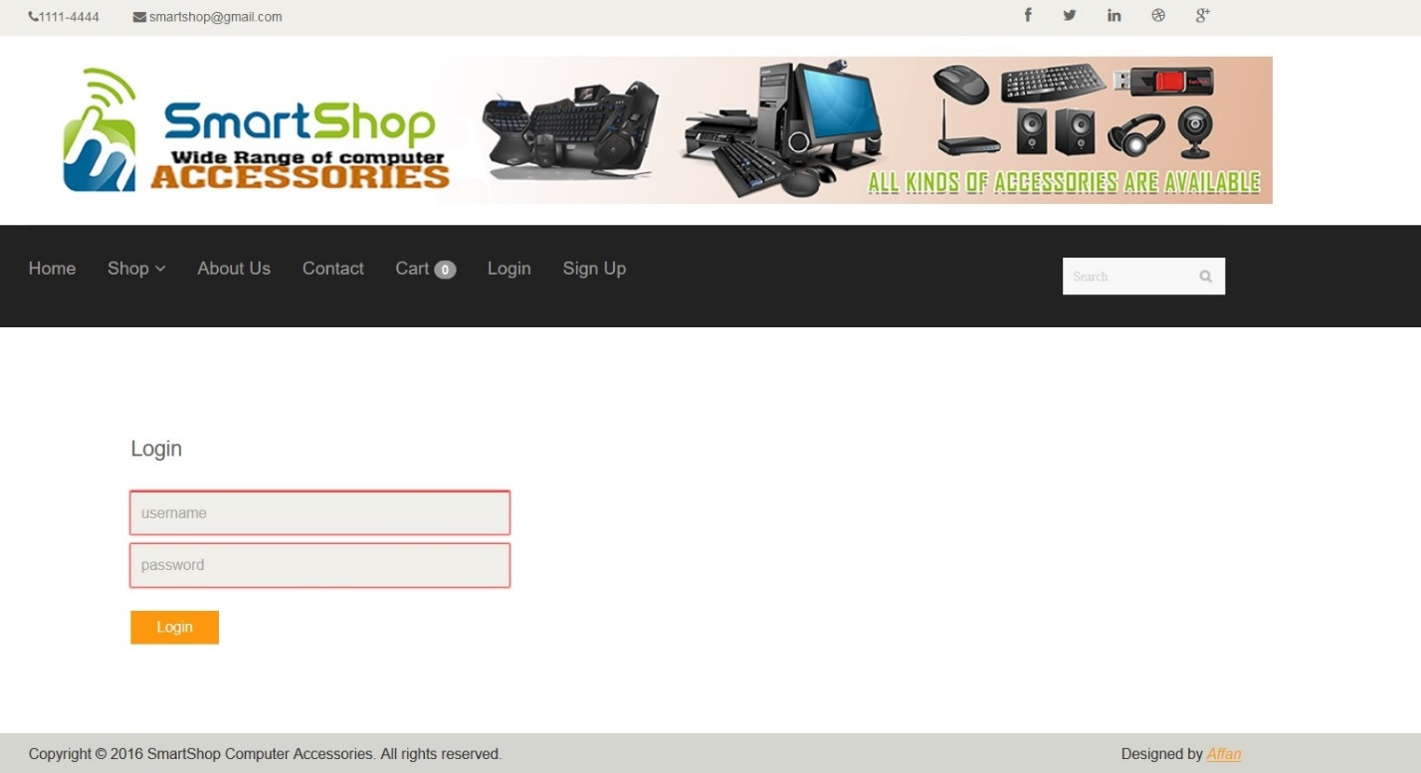

**5.3 Categories Screen:**

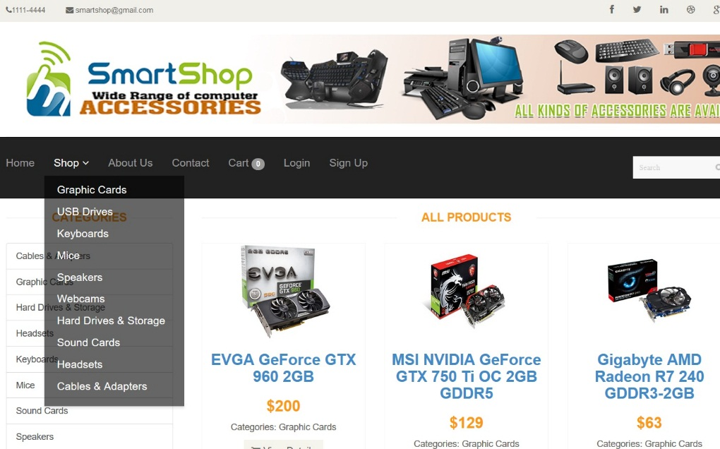

**5.4 Inside Specific Category View 1:**

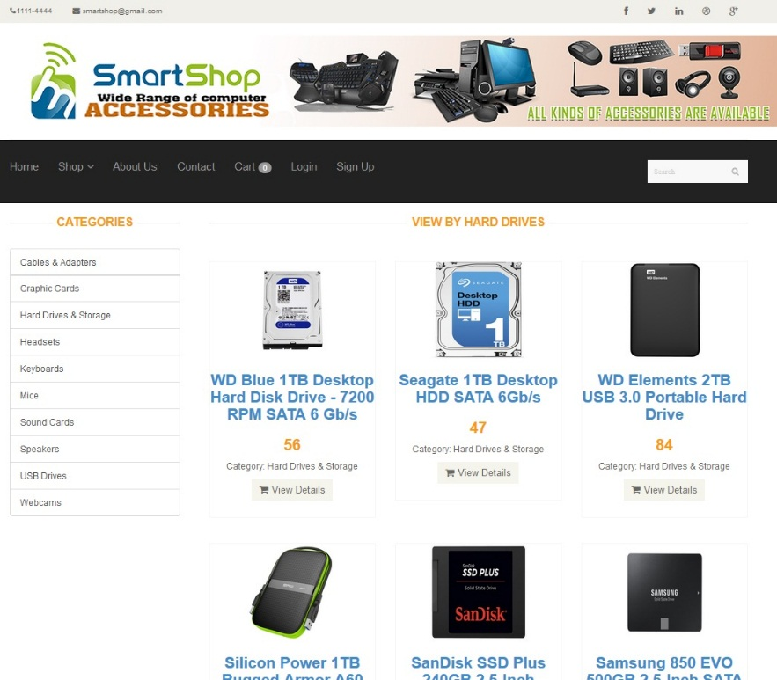

**5.5 Inside Specific Category View 2:**

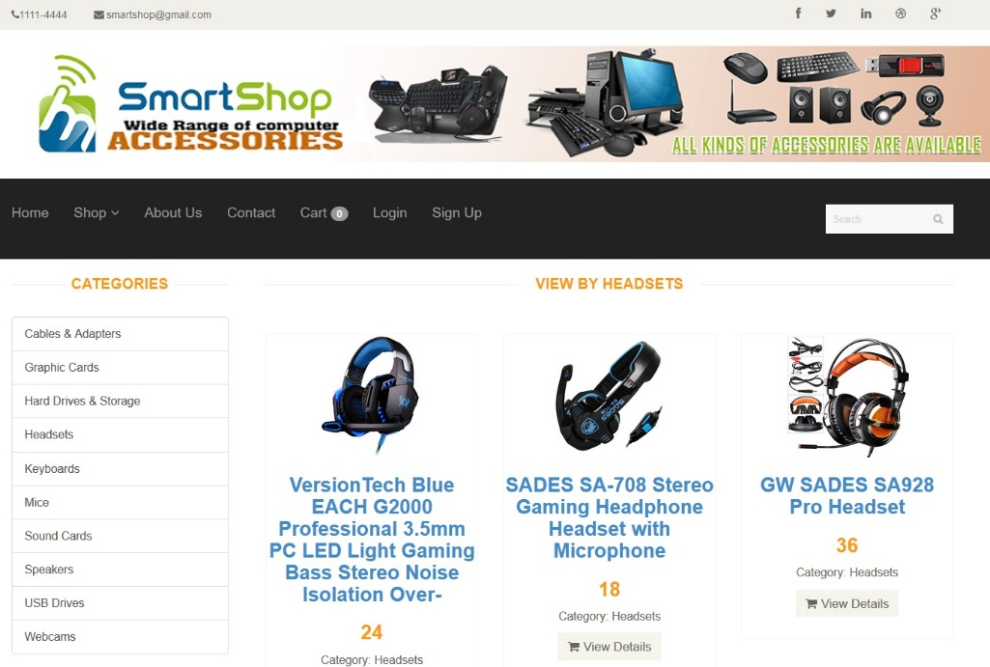

**5.6 Product Details View 1:**

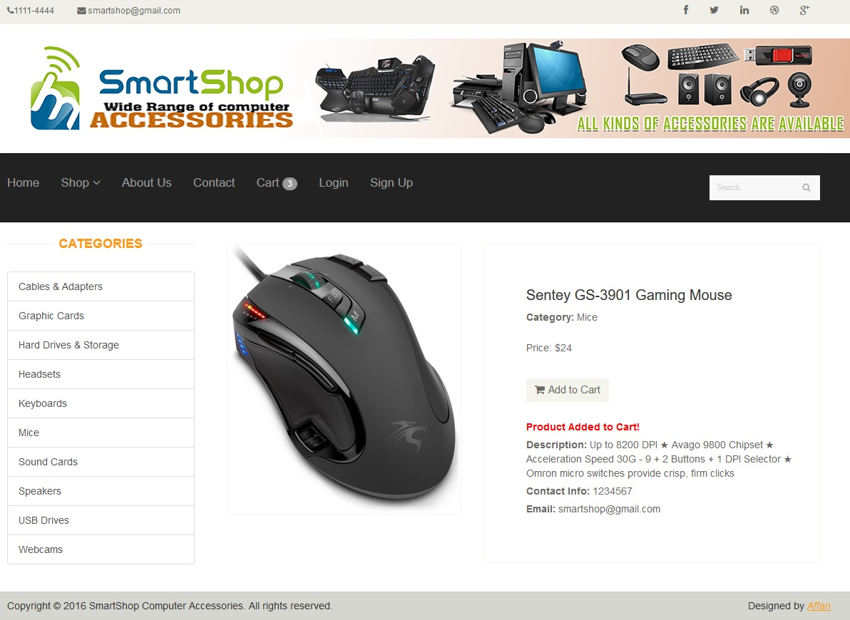

**5.7 Product Details View 2:**

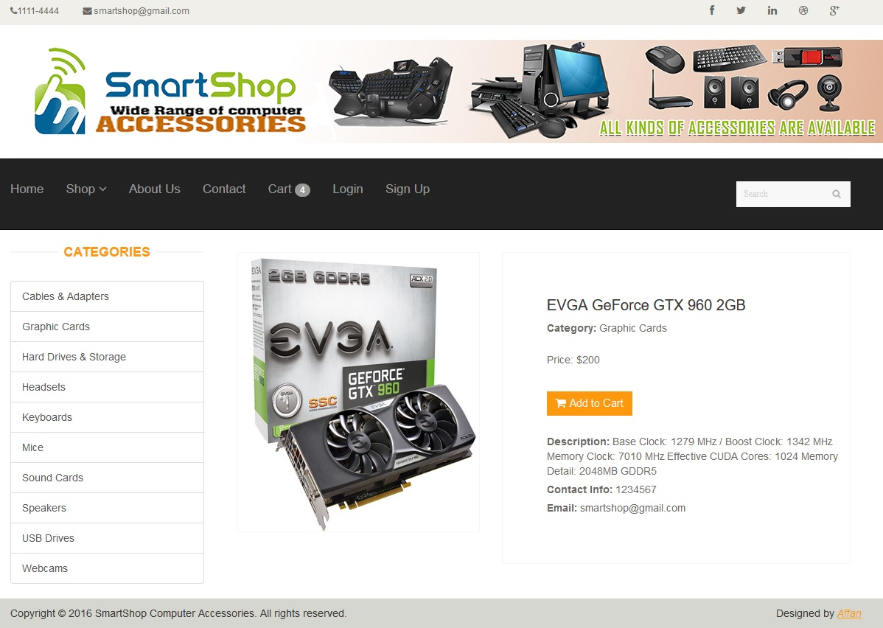

**5.8 Shopping Cart View:**

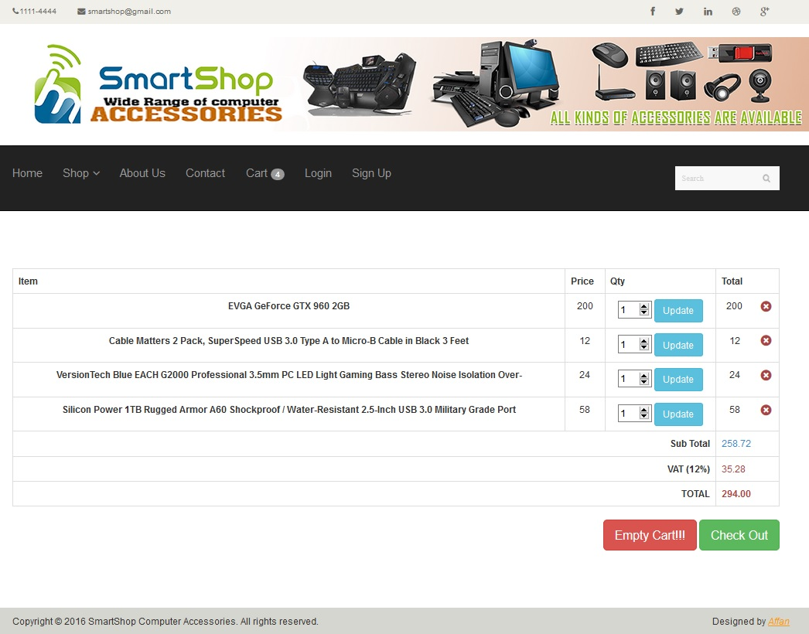

**5.9 Checkout Screen:**

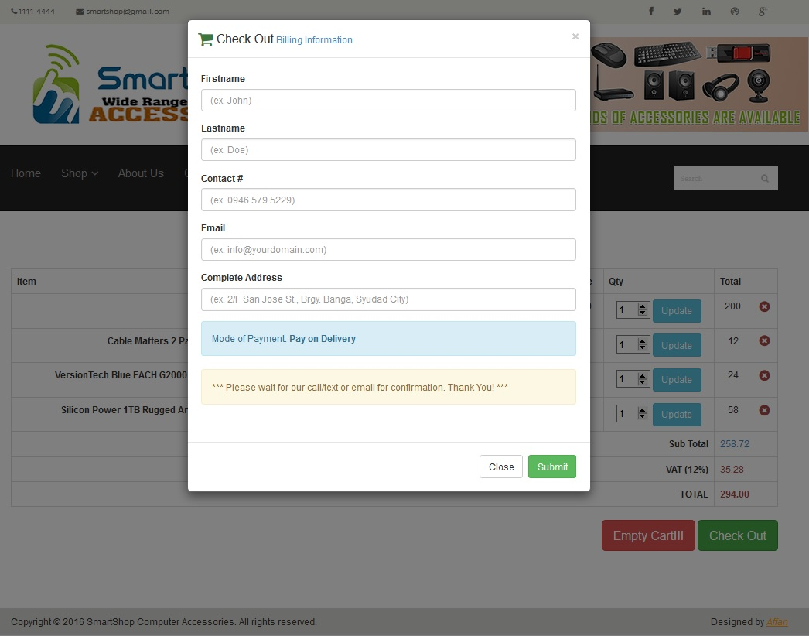

**5.10 Order Submitted Screen:**

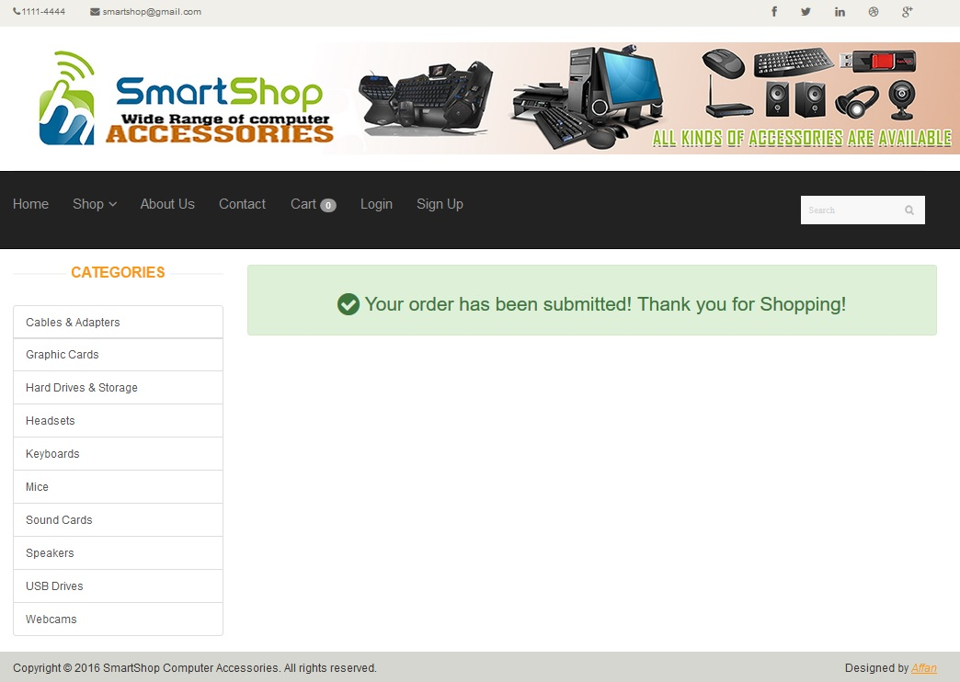

**5.11 Contact Section:**

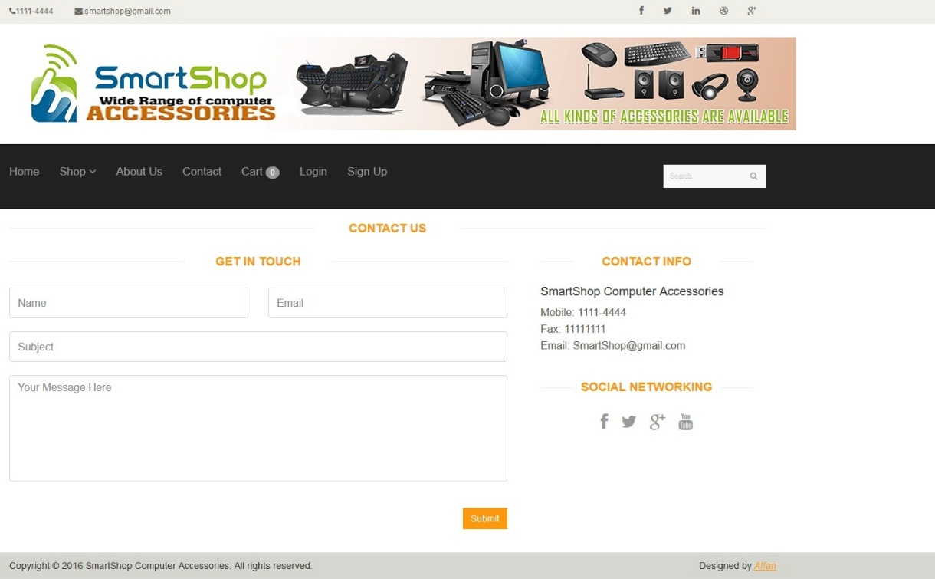

**5.12 About Screen:**

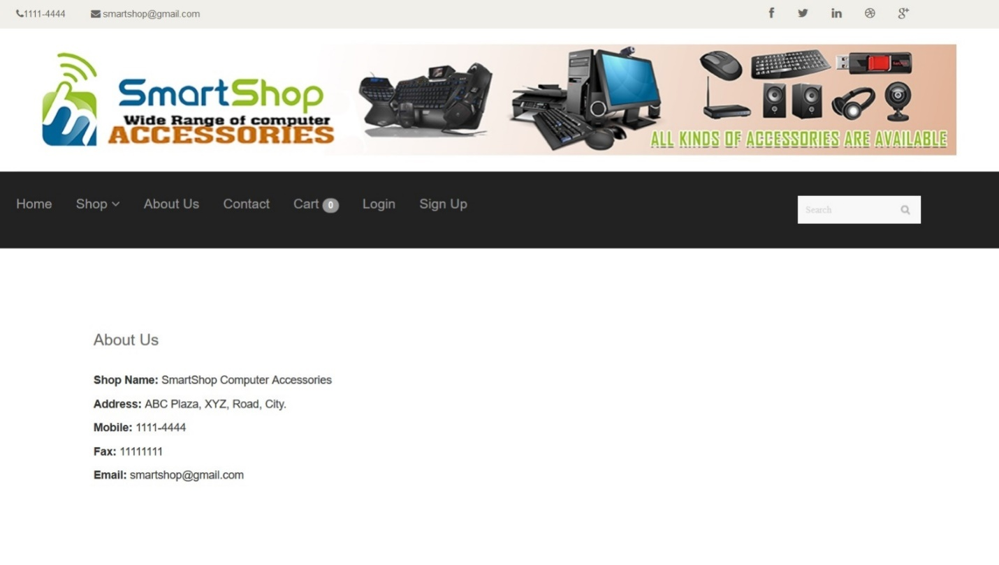

**5.13 Admin Panel View:**

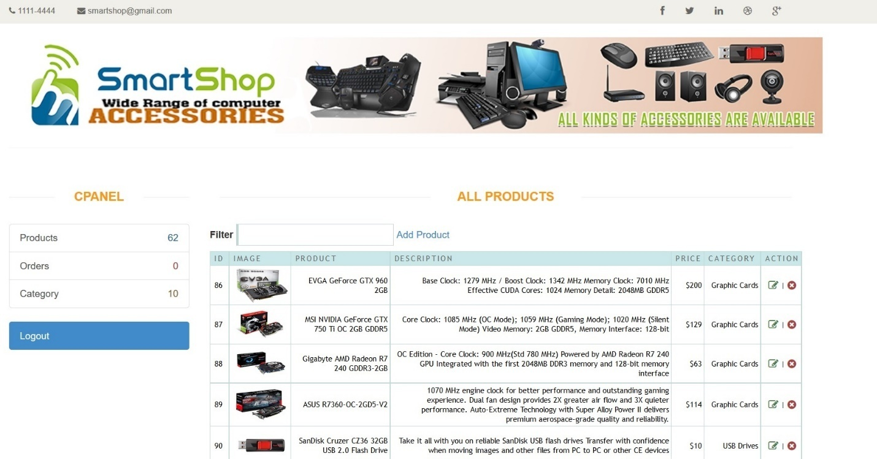

**5.14 Admin Categories Management View:**

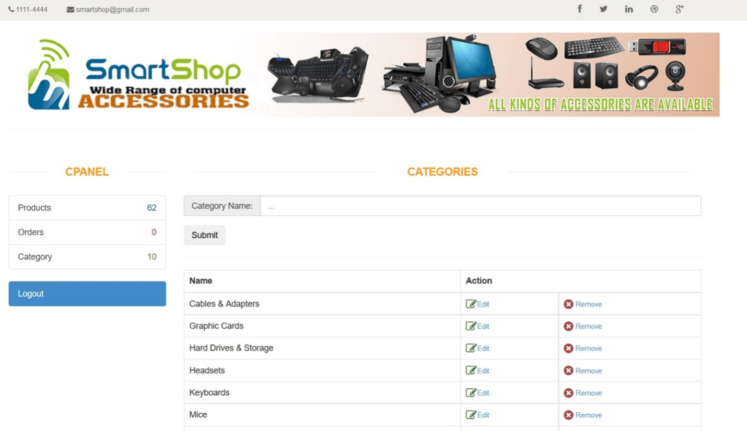

**5.15 Admin Order Details View:**

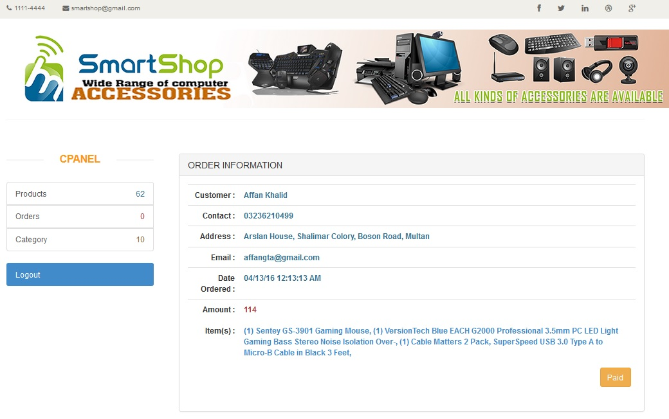

**5.16 Admin Orders Section View 1:**

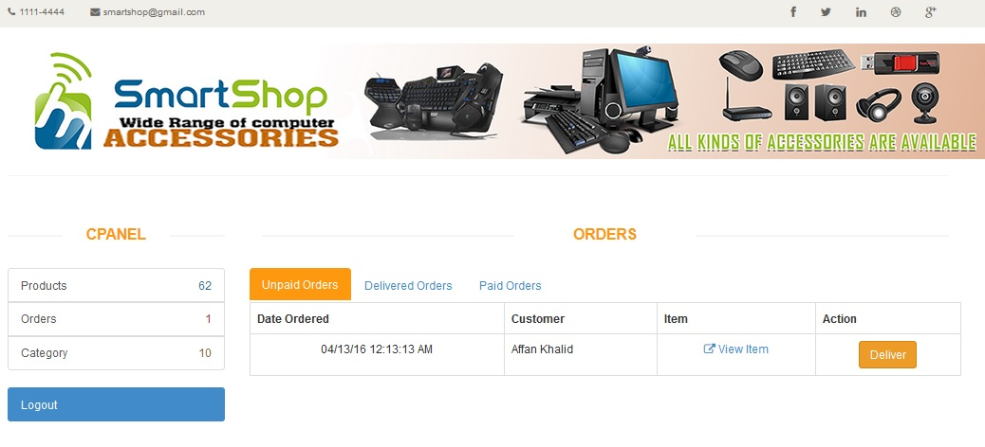

**5.17 Admin Orders Section View 2:**

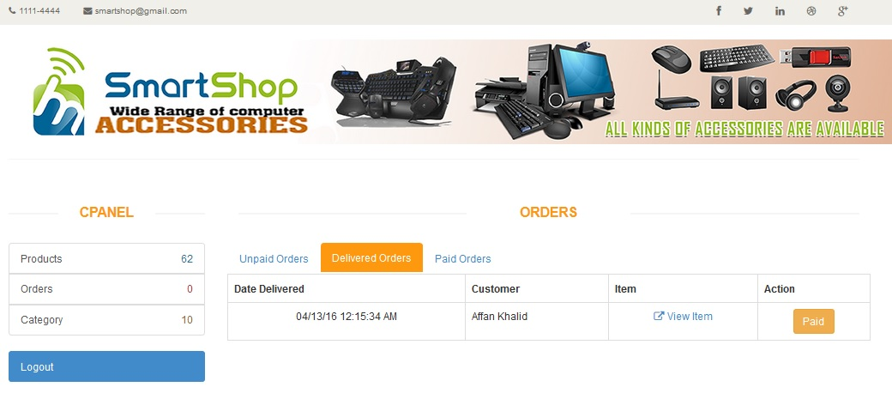

**5.18 Admin Product Management View 1:**

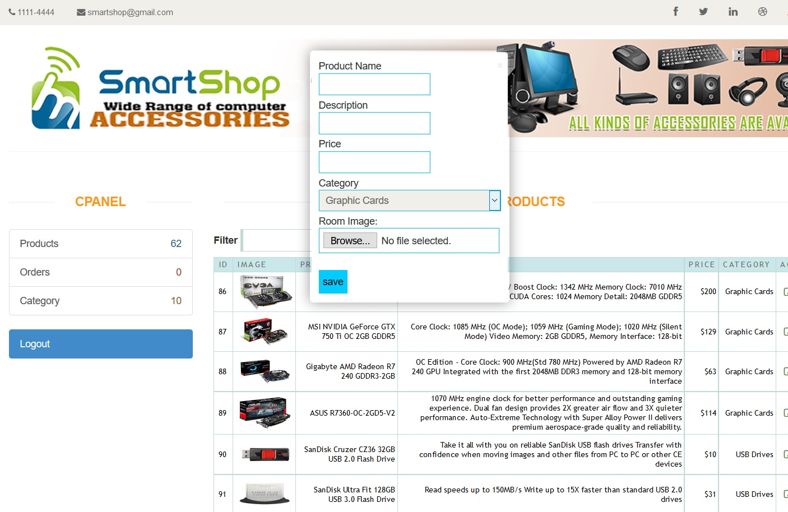

**5.19 Admin Product Management View 2:**

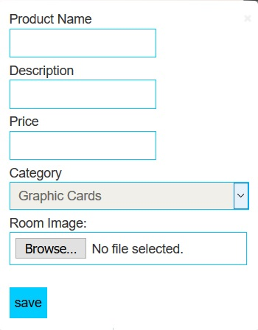

**5.20 Database Management Screen:**

