# Summary Report: Key Insights from Machine Learning Applications in E-Commerce

Presented By: Mehar Sukthi Buruguru, Shyamalan Kannan Rupeshwar Rao, Nandan Varma Pericharla

### Focus Areas: Customer Churn Prediction, Fraud Detection, and Recommendation Systems

## 1. Introduction

The rapid growth of e-commerce has intensified challenges such as customer retention, fraud mitigation, and personalized user experiences. Machine learning (ML) has emerged as a transformative tool to address these issues, offering data-driven solutions for businesses to optimize operations. This report summarizes three technical papers that explore ML applications in:

* Customer Churn Prediction using hybrid ensemble models,
* Fraud Detection through systematic literature analysis,
* Product Recommendation Systems leveraging dimensionality reduction and ML algorithms.

These studies highlight advancements in accuracy, scalability, and practical implementation, while addressing shared challenges like data imbalance and computational complexity.

## 2. Paper Summaries

### 2.1. Hybrid Ensemble-Fusion Model for Customer Churn Prediction

**Source**: [[Nature Scientific Reports](https://www.nature.com/articles/s41598-024-71168-x)]

Objective: Improve churn prediction accuracy using ensemble techniques.

Methodology:

* Combines 17 ML algorithms (e.g., SVM, Random Forest, Neural Networks) into a hybrid Ensemble Fusion framework.
* Evaluates performance via accuracy (95.35%), AUC (91%), and F1-score (96.96%).

Key Contributions:

* Outperforms standalone models (e.g., Logistic Regression, Gradient Boosting).
* Reduces overfitting through diversity in base learners.

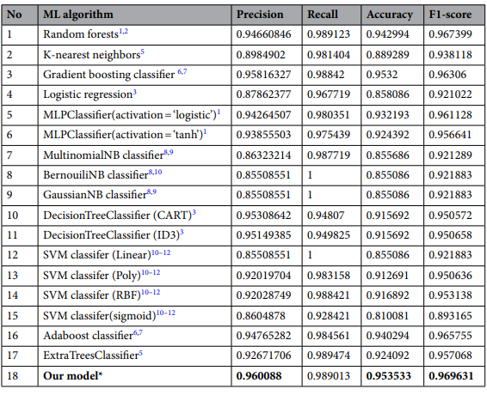

### 2.2. E-Commerce Fraud Detection: A Systematic Review

**Source**: [[IEEE Xplore](https://ieeexplore.ieee.org/stamp/stamp.jsp?tp=&arnumber=10506811)]

Objective**:** Identify trends and gaps in ML-driven fraud detection.

Methodology**:**

* PRISMA framework applied to analyse 101 studies (2013–2023).
* Highlights Artificial Neural Networks (ANNs) as a dominant approach.

Key Findings:

* Data scarcity and class imbalance limit model generalizability.
* Platform-specific fraud patterns (e.g., eBay vs. Amazon) require tailored solutions.

Visualization:

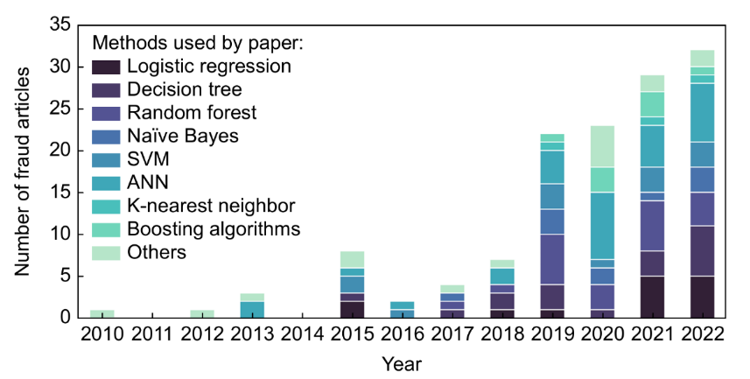

### 2.3. Product Recommendation System Using PCA and ML

**Source**: [[IJCA](https://www.ijcaonline.org/archives/volume186/number28/rahman-2024-ijca-923795.pdf)]

Objective**:** Enhance recommendation accuracy with feature reduction.

Methodology:

* Applies Principal Component Analysis (PCA) to reduce dimensionality.
* Tests four ML models; Random Forest (RF) achieves 99.6% accuracy.

Key Contributions:

* RF outperforms Gaussian Naive Bayes and Logistic Regression.
* PCA minimizes computational costs without sacrificing performance.
* The study demonstrates that applying Principal Component Analysis (PCA) for dimensionality reduction in product recommendation systems effectively minimizes computational costs without sacrificing performance.

Visualization:

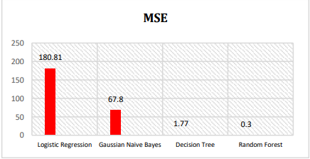 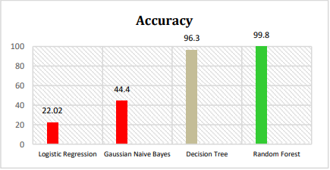

## 3. Comparative Analysis

### 3.1. Key Techniques and Performance

|  |  |  |  |
| --- | --- | --- | --- |
| **Aspect** | **Churn Prediction** | **Fraud detection** | **Recommendation Systems** |
| **ML Algorithms** | Hybrid Ensembles | ANNs, Random Forests | Random Forest, PCA |
| **Top Accuracy** | 95.35% | Varies (ANN~90%) | 99.6% (Random Forest) |
| **Data Challenges** | Class Imbalance | Data Scarcity, Imbalance | High Dimensionality |
| **Preprocessing** | Resampling, Normalization | Synthetic data generation | Feature Scaling, PCA |

### 3.2. Common Themes and Challenges

Data Quality: All studies emphasize the need for balanced datasets.

Solutions: Synthetic data (fraud detection), resampling (churn prediction).

Model Complexity:

* Ensemble methods improve robustness but increase computational costs.
* PCA mitigates complexity in recommendation systems.

Real-World Scalability:

* Fraud detection requires real-time processing; churn prediction needs proactive alerts.

## 4. Conclusion

The three papers demonstrate ML’s pivotal role in solving critical e-commerce challenges:

* **Hybrid Ensemble-Fusion Models** achieving superior accuracy in churn prediction, outperforming standalone classifiers with a **95.35% accuracy and 96.96% F1-score** [7].
* **Systematic Reviews on Fraud Detection**, emphasizing the dominance of **Artificial Neural Networks (ANNs)** while addressing challenges like class imbalance and data scarcity [16].
* **PCA-Enhanced Recommendation Systems**, where **Random Forest models with PCA** achieved **99.6% accuracy**, optimizing performance while reducing computational costs [5].

Future Directions:

* **Integration of Deep Learning for Real-Time Fraud Detection** – ANN-based models are increasingly utilized for fraud detection, offering high accuracy and adaptability in identifying fraudulent transactions in real-time
* **Personalized AI-driven Recommendations** – Combine reinforcement learning with customer behaviour analysis for dynamic and adaptive product suggestions.
* **Standardized Datasets and Evaluation Metrics** – Establish industry-wide benchmarks for fraud detection models to improve comparability and reliability.
* **Bias and Fairness in AI** – Implement techniques to detect and mitigate bias in fraud detection and credit scoring models to ensure fair decision-making.