**2023 Causal Inference Workshop: Stata, R, and Python Sessions**

**Day 1. Assess balance between no_insurance_wave_1 and control groups**

Underlying Paper: Black, Espin-Sanchez, French, and Litvak, *The Long-term Effect of Health Insurance on Near-Elderly Health and Mortality*, 3 **American Journal of Health Economics** 281-311 (2017)

**Answer Sheet**

1. **Question**: Create propensity scores for all insured versus uninsured.

The treatment used in the paper is **un**insurance at wave 1 in 1992. Variable name = no_insurance_wave_1.

Logit: All insured (1 =uninsured) regressed on quadratic in age, gender, race, age-gender-race interactions, comorbidities, quintiles of log income and earnings, comorbidities, CESD depression score, self-reported health status, mobility limit, years of schooling, household size, and employment status dummies.

Extract predicted values (predict pscore, pr) and calculate IPW.

Initial Sample Size is 8203 for insured, and 1440 for uninsured.

**STATA Code for Step 1**:

**\*Create local variables for regressions**

local two_power_age = "age c.age#c.age" //quadratic in age

local comorbidities = "i.diabetes_wave_1 i.cancer_wave_1 i.high_blood_pressure_wave_1 i.lung_disease_wave_1 i.heart_disease_wave_1 i.stroke_wave_1 i.psychiatric_disease_wave_1 i.arthritis_wave_1 i.ulcer_wave_1 i.CESD_wave_1”

local money = "i.hh_logincome_quintile_wave_1 i.hh_earning_quintile_wave_1" //quintiles of logincome and earnings

local labor = "i.not_in_laborforce_wave_1 i.partly_retired_wave_1 i.fully_retired_wave_1 i.unemployed_wave_1 i.employed_pt_wave_1 i.employed_ft_wave_1 i.veteran_wave_1"

**\*Tabulate no_insurance_wave_1**

tab no_insurance_wave_1

**\*Use relative age values to avoid scale problems**

replace age=age-51 //age now starts at 0 and ends at 10

**\*Logit regression**

logit no_insurance_wave_1 `two_power_age' i.gender i.race `money' `labor' `comorbidities' i.gender#i.race i.gend er#c.(`two_power_age') i.race#c.(`two_power_age'), robust

**\*Predict propensity score**

predict pscore, pr //propensity to be uninsured

**\*Generate inverse propensity weights**

gen ipw=1/pscore if no_insurance_wave_1==1 //weights for those who are not insured

replace ipw=1/(1-pscore) if no_insurance_wave_1==0 //weights for those who are insured

1. **Question**: Replicate Black et al. Table 1 for uninsured versus all insured (ok to do this only for selected covariates)

The table below reports summary statistics table before and after IPW weighting for selected variables

|  |  |  |  |  |  |  |  |  |
| --- | --- | --- | --- | --- | --- | --- | --- | --- |
| **Covariate** | **Unweighted** | | **IPW** | | **t-test on Difference** | | **Normalized Difference** | |
|  | Uninsured | Insured | Uninsured | Insured | Unweighted | IPW | Unweighted | IPW |
| Age | 55.52 | 55.85 | 55.89 | 55.81 | -3.716 | 0.875 | -0.106 | 0.025 |
| Gender | 44.03 | 47.78 | 46.99 | 47.17 | -2.639 | -0.127 | -0.075 | -0.004 |
| White | 52.29 | 75.11 | 72.27 | 71.62 | -16.290 | 0.506 | -0.488 | 0.014 |
| Black | 21.81 | 16.25 | 16.17 | 17.05 | 4.780 | -0.835 | 0.142 | -0.024 |
| Hispanic | 22.57 | 6.78 | 9.14 | 9.16 | 13.896 | -0.022 | 0.458 | -0.001 |
| Other | 3.33 | 1.87 | 2.42 | 2.17 | 2.959 | 0.577 | 0.092 | 0.017 |
| Log(Income) | 9.17 | 10.40 | 10.19 | 10.26 | -19.426 | -1.484 | -0.653 | -0.045 |
| Diabetes | 11.11 | 9.08 | 9.19 | 9.54 | 2.287 | -0.422 | 0.067 | -0.012 |
| Cancer | 3.61 | 4.94 | 5.04 | 4.75 | -2.425 | 0.468 | -0.066 | 0.013 |
| Employed FT | 36.81 | 58.42 | 52.75 | 55.11 | -15.628 | -1.660 | -0.443 | -0.047 |
| Veteran | 17.85 | 27.05 | 26.67 | 25.66 | -8.201 | 0.805 | -0.222 | 0.023 |

**STATA Code to generate the summary statistics table above**

**\*Generate single dummies for race**

tab race, gen(race_)

**\*Bring back age to its initial value**

replace age=age+51

**\*Generate weight equal 1 for unweighted (gives a weight of 1 to all observations)**

* Not necessary, but allows a single loop and makes it easier to generate table in Excel

gen unwgtd=1

**\*Calculate t-test and normalized difference for control and treatment for selected variables**

local weights = "unwgtd ipw"

local vars = "age gender race_1 race_2 race_3 race_4 log_income_wave_1 diabetes_wave_1 cancer_wave_1 employed_ft_wave_1 veteran_wave_1"

**\*Loop to build summary stats table**

foreach y of local weights { //loop over unweighted and IPW

foreach j of local vars { //loop over selected vars

**\*Calculate the mean and standard deviation for the insured, and save to local variables**

quietly sum `j' if no_insurance_wave_1==0 [aw=`y']

local mean_insured = r(mean) //save mean

local sd_insured = r(sd) //save sd

local sample_insured = r(N) //save sample size

**\*Calculate mean and standard deviation for the uninsured, and save to local variables**

quietly sum `j' if no_insurance_wave_1==1 [aw=`y']

local mean_uninsured = r(mean) //save mean

local sd_uninsured = r(sd) //save sd

local sample_uninsured = r(N) //save sample size

**\* This code computes the normalized difference manually, and then closes the loops**

gen ttest_`j'_`y' = (`mean_uninsured' - `mean_insured')/(((`sd_uninsured'^2/`sample_uninsured' + `sd_insured'^2/`sample_insured'))^(1/2))

gen ndiff_`j'_`y' = (`mean_uninsured' - `mean_insured')/(((`sd_uninsured'^2 + `sd_insured'^2)/2) ^(1/2))

}

}

**\* Alternative using covbal.ado:**

ssc install covbal //to install the covbal package

*Reference: (Linden, Ariel (2016). covbal: Stata module for generating covariate balance statistics. <https://ideas.repec.org/c/boc/bocode/s458188.html>)

* covbal does not generate t-values, and does not allow direct export to Excel

local vars = "no_insurance_wave_1 age gender race_1 race_2 race_3 race_4 log_income_wave_1 diabetes_wave_1 cancer_wave_1 employed_ft_wave_1 veteran_wave_1"

* the first variable in the list must be the treatment

covbal `vars', wt(ipw) format(%9.3f) saving(“$path\summary_stats_using_covbal_ipw.dta”)

covbal `vars', wt(unwgtd) format(%9.3f) saving(“$path\summary_stats_using_covbal_unweighted.dta”)

**\*Generate summary stats**

foreach y of local weights{

preserve

*Collapse mean

collapse (mean) age gender race_* log_income_wave_1 diabetes_wave_1 cancer_wave_1 employed_ft_wave_1 veteran_wave_1 ttest_*`y' ndiff_*`y' [aw=`y'], by(no_insurance_wave_1) //generate means of each variable using different weights based on whether an individual is uninsured or insured.

*Cleaning

replace gender=gender*100

replace race_1=race_1*100

replace race_2=race_2*100

replace race_3=race_3*100

replace race_4=race_4*100

replace diabetes_wave_1=diabetes_wave_1*100

replace cancer_wave_1=cancer_wave_1*100

replace employed_ft_wave_1=employed_ft_wave_1*100

replace veteran_wave_1=veteran_wave_1*100

*Rename

rename no_insurance_wave_1 insured

*Export summary stats to excel

export excel "$desktop\summary_stats_`date'", sheet("`y' no trim", replace) firstrow(variables)

restore

}

**\*Drop ttest values as we need to calculate them later again after trim.**

drop ttest_* ndiff*

1. **Question**: Create kernel density plots, similar to Black et al. Figure 1, but without trimming to common support

First step Propensity Score using Kernel Density command in Stata

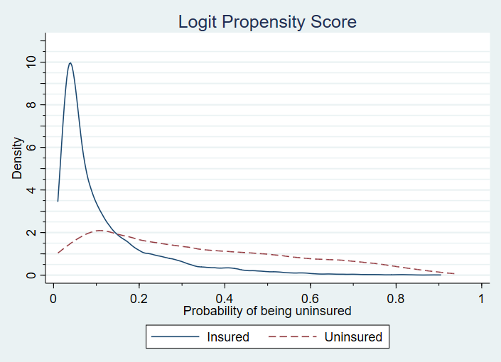

1. **Question**: Now trim to *p* between 0.05 and 0.95 (or to common support if narrower). What is remaining sample size for each comparison?

Remaining sample size after first trim: 5185 insured, 1336 uninsured

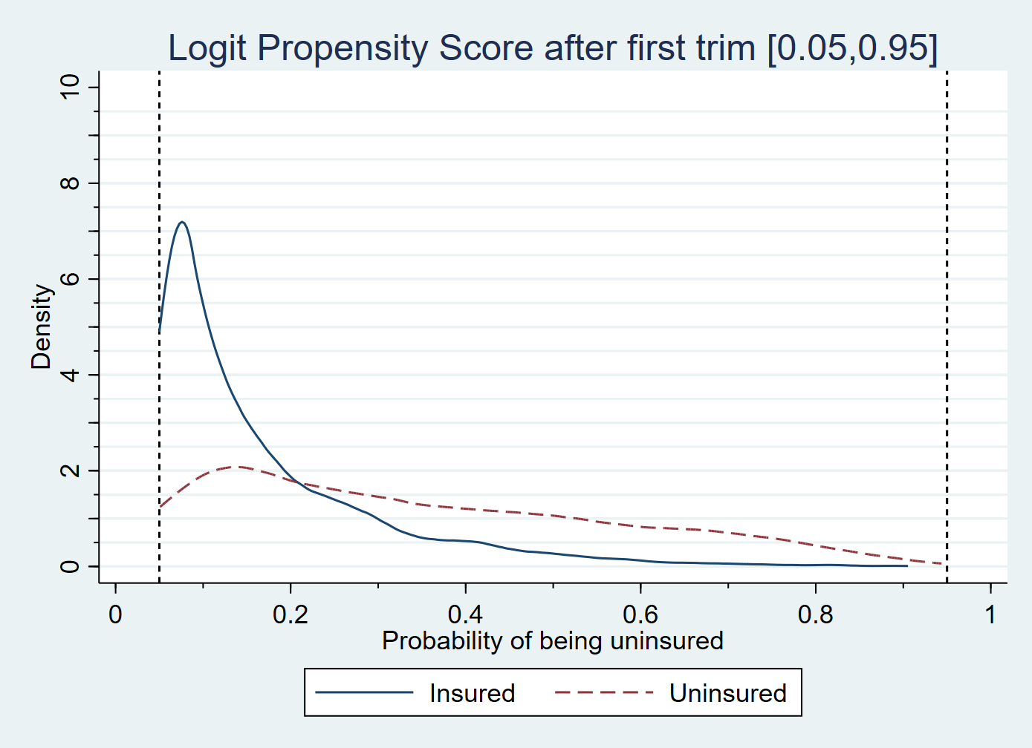

**STATA code for Steps 3 and 4:**

**\*Use kernel density for propensities**

twoway (kdensity pscore if no_insurance_wave_1==1, lpattern(dash) lcol(red)) (kdensity pscore if no_insurance_wave_1==0, lcol(blue)), /*

*/ legend(label( 1 "Uninsured") label( 2 "Insured")) /*

*/ xtitle("Probability of being uninsured") /*

*/ ytitle("Density") /*

*/ title("Logit Propensity Score") /*

*/ ytick(0(1)11, grid) ymtick(0(0.5)11, grid) ylab(0 "0" 2 "2" 4 "4" 6 "6" 8 "8" 10 "10")/*

*/ xmtick(0(0.1)1) xlabel(0 "0" 0.2 "0.2" 0.4 "0.4" 0.6 "0.6" 0.8 "0.8" 1 "1")

1. **Question**: Re-estimate propensity scores; create new kernel density plots

Remaining sample after recomputing propensity score and second trim: 5174 insured, 1333 uninsured.

