Medical Store Management System

A Thesis Presented

By

Sobia Islam

MCS-013R14-15

To

The Committee on Academic Degrees in partial fulfillment of the requirements for a degree

MCS



Department of Computer Science,

Institute of Southern Punjab, Multan

(10/09/2016)

**FINAL YEAR PROJECT UNDERTAKING FORM**

*(Institute of Southern Punjab)*

I hereby affirm that the originality and authenticity of the Final Year Project to be undertaken will be upheld. The report and / or the system that I submit at the conclusion of the Final Year Project will be the result of my own investigations and effort.

I understand that cheating and plagiarism constitute a serious violation of the university regulations, which will not only result in a failing grade for the Final Year Project but subject me to further disciplinary actions.

Signature of Student:

___­­­­_______

Name: Sobia Islam

Date: 10/09/2016



Student Name : Sobia Islam

Student ID : MCS-013R14-15

Contact No : +92308-5215296

Email Address : sobia_islam@gmail.com

Discipline : COMPUTER SCIENCE

Year of Study : 2014-2016

Area of Study : COMPUTER SCIENCE

Proposed Project Title : Medical store management System

Signature of Supervisor:

___________________

Name:

Date:

***DEDICATION***

*TO*

*ENDLESS LOVE OF OUR PARENTS,*

*BROTHERS, SISTERS,*

*AND WELL WISHERS*

*WHOSE PRAYERS HAVE ENABLED US*

*TO COMPLETE OUR PROJECT*

**Acknowledgement**

Earliest in time and order I gratitude to almighty **ALLAH**, as nothing can be done without his will and help, for empowering me to complete this project successfully.

At that occasion I would like to pay thanks to my parents, my sisters, my brother and my relatives. I cannot forget their encouragements, prays, cares, punishes and live nights that they did for me. I especially thank to my super senior class fellow and my beloved teacher Ma’am Maliha. Their guidance, help, encouragement and prayers made me able to continue my education and to get this bachelor’s degree in computer science. They helped me in every time in every possible way during my study. I cannot forget their help and guidance. I also express sincere and heartiest thanks to all my teachers because whatever I am now is all because of them.

I find myself very lucky to have a supervisor Mam Maliha who guided me throughout my project, without her help it was not easy for me. She is a best teacher because of her logically approaches towards the solution of the problem that I have faced, not in project but also throughout the session. I am thankful to her for giving me her precious time and ideas.

I am much thankful to my Super seniors and my class fellows whose co-operation helped me in completing my studies and project.

**ABSTRACT**

Medical store management system is computerized software which manages the medicine. Through this software user can search the medicine in efficient way and user can manage the all medicine and can get information about medicine and can add information about medicine like uses of medicine in which condition this medicine can be used. This software will notify the user of medical store’s owner which medicine near to expire and when medicine will have low stock. This software will deal with sales, user can make transection of medicine and can print out printed bill of customer and user can make crystal report of medicine with single button. This software deal with medical store’s activity in efficient way.

**TABLE OF CONTENTS**

1 CHAPTER 1 7

1.1 Introduction 7

1.2 Problem statement 8

1.3 Scope of project 8

1.4 Project aim and objectives 9

2 CHAPTER 2 10

2.1 BACKGROUND AND LITERATURE REVIEW 10

2.2 Background of Application 10

2.3 Literature Review 11

2.3.1 Project Name: Medical Store Management System 11

2.3.2 Project Name: Medical Shop Management ( Pharmiz) 12

2.3.3 Project Name: Medical Store Management System 13

2.3.4 Project Name: Medical Store Management System 14

2.4 Comparison Table 15

3 Chapter 3 16

3.1 SYSTEM REQUIREMENT 16

3.1.1 Functional Requirement 16

3.1.2 Nonfunctional Requirement 17

3.2 Hardware and Software 18

3.3 SOFTWARE DESIGNING PHASE 19

3.4 USE CASE DIAGRAM 20

3.5 Use Case Description 21

3.6 Class Diagram 30

3.7 Sequence Diagrams 31

3.7.1 Sequence Diagram of Medicine 31

3.7.2 Sequence Diagram of Sale 32

3.7.3 Sequence Diagram of Damage Medicine 33

3.7.4 Sequence Diagram of Company 34

4 Chapter 4 35

4.1 Database Design 35

4.1.1 Entity of Application 35

4.1.2 ER Diagram 36

4.2 Tables in Database 37

5 Chapter 5 40

5.1 Implementation 40

6 Chapter 6 47

Conclusion 47

# CHAPTER 1

This chapter will give explain introduction, aim, objectives background, problem statement of projects

## Introduction

Medical store is shop where the people purchase the medicine which is prescribe by the doctor and also have over the counter. Medical store mostly have all medicine which mostly people needs. Existing system of medical store manually working .This system required more time to do any work like calculate the price of medicine and management the medicine and keep the record of sales man who provide the medicine .Dealing with customer these work required more time and there is chance of error

Searching of medicine required more time there is chance this medicine is not available on the store .All this work is doing Register which is not easy to maintain. Existing system is not user friendly.

New system will provide the many facility which can reduce the man power and there will be no chance of error. Proposed medical system manages the stock in proper manners. Computerized system required less time to search the medicine and calculate the bill faster as compared to previous system. New system will generate the report of bill and other item which is not possible in previous

My aim is to provide the system which will provide the ease to user to manage the medical store

## Problem statement

Medical store owner facing the problem to manage medical shop. Dealing with customer required more like searching specific medicine and after searching there is chance of medicine is not available or has expire and customer have to wait during searching which cause the rush in medical store this is most critical situation . Management of medicine in the shop is also critical; arrange the medicine in standard way so Owner can easily search the medicine when he needed. They are facing in maintaining the records of the sold ones and that of the available and also to

Track down the details of the Payments done to the distributors, received from the

Customers, etc. and also to track down the information of the quantity of the stock

Available and that of the purchasable.

## Scope of project

This application will be helpful for medical store owner to keep the record for daily sales of medicines and maintain the stock of all medicines. Whenever, stock of a medicine reaches to minimum predefined level. This application will inform the user I am maintaining the sales record of customer side and also tell the description of medicine. That who bought what medicines and inform the user which medicine has high demand and every medicine the information related to it. User can easily search the medicine easily.

User can manage the stock and sales and salesman.

## Project aim and objectives

My main objective is to develop system software for medical store for managing the records of medicines and other utilities of medical.

* Maintain the medicine stock by company
* Can search a medicine by name and by company name
* Have description of medicine like its uses
* Inform the user on low stock
* Inform the user which medicine near to expire
* Can generate the monthly report
* Can generate the yearly report
* Can generate the report as user defined
* Manage the daily sale record
* Keep the record of damage medicine
* different level of access like admin and user
* Admin have full access and user have limited access on software
* Can generate the bill of customer
* Keep the record of all kind of sale
* Give discount on specific amount
* Manage medicine as its company
* Add damage and expire stock

# CHAPTER 2

## BACKGROUND AND LITERATURE REVIEW

## Background of Application

Medical store mostly manage on register. Customer purchases the medicine from the shop. Owner of medical calculate the bill manually. Owner of medical store have to keep the record of medicine which medicine is low stock and which have high demand. Keep the record of company’s medicine which was supplied by salesman or directly by company and all these work is going manually. Owner creates the report on register which required more time there is chance of flaws in reports.

## Literature Review

The literature of existing system given below. Here i will explain the feature of existing and what they have limitation in their feature

### Project Name: Medical Store Management System

Reference link: http://www.freestudentprojects.com/vb-net-projects/medical-shop-management-system/

**Medical Shop Management System:**

* **Login:** Using this module user enters user name and password and the system checks whether it is valid. If it is valid user can log in, otherwise invalid user name and password message is displayed.
* **Purchase:** This module allows purchasing medicines from the supplier. It contains fields such as batch number, manufacture date, expiry date, company name, etc.
* **Sales module:** This module consists of customer sales information. When sale is made proper fields in the sale form should be filled such as patient name, address, doctor’s name, medicine details etc.
* **Stock module:** This module manages the inventory. Stock is updated when purchase, sale or replace is made.
* **Medicine:** This module consists of information of medicines available in the Medical.
* **Organize:** This module allows the user to store medicine in an organized manner. So that the distributor can find the required medicines effortlessly.
* **Report generation:** Using this module user can generate different kinds of reports such as sales details, purchase details, etc.

**Limitation:**

* Does not have information about medicine usage
* Does not maintain damage item’s data
* Does not inform on low stock
* Does not inform which item near to expire

.

### Project Name: Medical Shop Management ( Pharmiz)

Reference link**:** http://www.indiamart.com/cybrosys-technologies/software-services.html#medical-shop-management-pharmiz

**Pharmiz Features:**

* Multiple companies with different financial year can be created.
* Keeps record of daily customers.
* Keeps record of sales man.
* Handle all transactions like purchase, sales, purchase return and sales return.
* Better search option for finding available products of company.

**Limitation:**

* Does not have information about medicine usage
* Does not maintain damage item’s data
* Does not inform on low stock
* Does not inform which item near to expire

### Project Name: Medical Store Management System

Reference link**:** http://www.slideshare.net/hani2253/medical-store-management-system-software-enginee

**Medical Store Management System:**

* Maintain the records of purchase
* Sales and stock details with cash transaction maintenance
* maintain day to day transactions in computer
* Customer management
* Transition management
* Sales management
* Reporting

**Limitation:**

* Does not have information about medicine usage
* Does not maintain damage item’s data
* Does not inform on low stock
* Does not inform which item near to expire
* Does not have different account like admin and user access

### Project Name: Medical Store Management System

Reference link: http://www.freestudentprojects.com/vb-net-projects/medical-shop-management-system/

**Medical Shop Management System:**

* Provides the searching facilities based on various factors. Such as Inventory, Stocks, Medical Shop, Company
* It tracks all the information of Sells, Medicines, and Medical Shop etc.
* Manage the information of Sells
* Shows the information and description of the Inventory, Stocks
* To increase efficiency of managing the Inventory, Sells
* It deals with monitoring the information and transactions of Medical Shop.
* Manage the information of Inventory
* Editing, adding and updating of Records is improved which results in proper resource management of Inventory data.
* Manage the information of Medical Shop
* Integration of all records of Company.

**Limitation:**

* Does not have information about medicine usage
* Does not maintain damage item’s data
* Does not inform on low stock
* Does not inform which item near to expire.
* Does not have reporting system.
* Does not have different access level like admin and user account

## Comparison Table

|  |  |  |  |  |  |  |  |  |
| --- | --- | --- | --- | --- | --- | --- | --- | --- |
| Name | Medicine  Usage | User  Account | Reporting | Damage  Medicine | Inform  Low  stock | Inform  Expiry  Date | Inform  High  demand | Stock  management |
| 2.1Medical Store Management System | No | Yes | Yes | No | No | No | No | Yes |
| 2.2Medical Shop Management ( Pharmiz) | No | No | Yes | No | No | No | No | Yes |
| 2.3Medical Store Management System | No | No | Yes | No | No | No | No | Yes |
| 2.4Medical Store Management System | No |  | No | No | No | No | No | Yes |
| Proposed  System | Yes | Yes | Yes | Yes | Yes | Yes | Yes | Yes |

# Chapter 3

## SYSTEM REQUIREMENT

### Functional Requirement

* Medicine can be add in System
* Medicine can be delete from System
* Medicine data can be updated
* Can make Transection
* Can be view the medicine list
* Sale history can be viewed
* User will be informed on low stock
* Separated Account for admin and User
* Discount can be given on purchase of item
* Medicine can be manage by Company name
* Damage item can be added in system
* Sales can be view by day ,month and yearly
* Report can be generated
* User have limited Access on data
* Admin have full Access over data
* User will be informed on those which is near to expire

### Nonfunctional Requirement

* Ease of use: The software easy to used and use by its intend user
* Performance of software must be efficient
* Data which will be entered into system must be protected
* Software must perform the work accurate and effective
* Software should not lose any information
* Software should available every time
* Admin have full access
* User have limited access as compared to Admin
* Software must be password protected
* Software will not accept irrelevant data
* Software only allow authentic user only
* Database will be password protected
* Software will be reliable
* Software will be easy to deploy
* Easy to maintain
* Software easy to extended
* Software will run on windows Operating System

## Hardware and Software

|  |  |
| --- | --- |
| **Programming Language** | C# |
| **Software Tools** | Visual Studio 2012 |
| **Database** | Microsoft SQL Server 2012 |
| **End User System Requirements** | |
| **Hardwsare** | Intel dual core and above |
| **Operating System** | Windows 7,8.1 ,10 |
| **Storage Capacity** | 5GB |

## SOFTWARE DESIGNING PHASE

**Actor:** Admin, User

Use case of following actor

**Admin**: Add medicine, Delete medicine, Update medicine data, Search medicine, View history, Add damage medicine, Bill calculation, Editing existing bill, Add medicine description, Add company, delete Company, Add medicine type, Delete medicine type, generate report,

**User**: Add medicine, Update medicine data, Search medicine, View history, Add damage medicine, Bill calculation, Editing existing bill, Add medicine description, Add company, Add medicine Type, generate report,

## USE CASE DIAGRAM

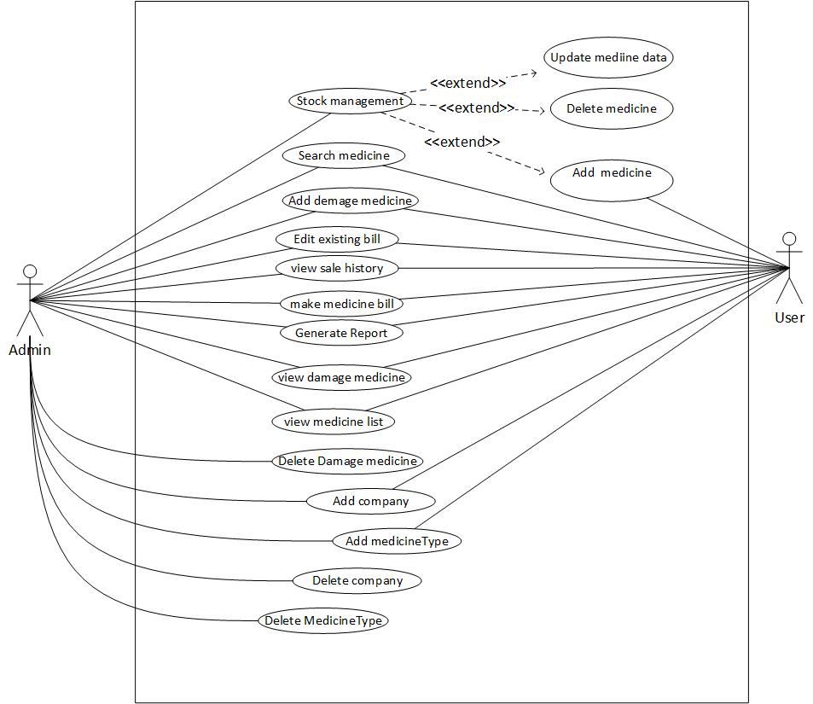

## Use Case Description

|  |  |
| --- | --- |
| Use Case Name | Login |
| Description  Primary Actor | Admin and user can login into system  Admin and user |
| Trigger  Pre-Condition | Click on login button to login  User name and Password |
| Assumption  Failed End Conditions | User and admin can log in to system to perform their task  Admin and user can use application |
| Action | New windows will appears |
| Main Scenario | * User enter the user Name and password * Application will check the user name and password * If password is correct the then application will open new window |
| Action | N/A |
| Alternative Scenario | N/A |
| Success Scenario | Main window will show up |
| Note and Open Issue | N/A |

|  |  |
| --- | --- |
| Use Case Name | Manage the stock |
| Description  Primary Actor | Admin and user can manage the stock by Adding, Updating and Deleting  Admin and user |
| Trigger  Pre-Condition | User click on manage menu bar the select required action  User name and Password |
| Assumption  Failed End Conditions | User and admin can manage the data  User name and password is present |
| Action | New windows will appears |
| Main Scenario | * Window will appears * User enter data * Press command button |
| Action | N/A |
| Alternative Scenario | N/A |
| Success Scenario | Window will display |
| Note and Open Issue | N/A |
| Use Case Name | Add stock |
| Description  Primary Actor | Admin and user can add stock  Admin and user |
| Trigger  Pre-Condition | User click on add stock menu bar  User name and Password |
| Assumption  Failed End Conditions | User and admin can manage the data  User name and password is present |
| Action | New windows will appears |
| Main Scenario | * Window will appears * User enter data * Press save button |
| Action | N/A |
| Alternative Scenario | N/A |
| Success Scenario | Data will save in database |
| Note and Open Issue | N/A |

|  |  |
| --- | --- |
| Use Case Name | Update stock |
| Description  Primary Actor | Admin can update stock  Admin |
| Trigger  Pre-Condition | User click on update button that will be on data grid view panel  User name and Password |
| Assumption  Failed End Conditions | admin can update the data  User name and password is present |
| Action | New windows will appears |
| Main Scenario | * Window will appears * User enter data * Press update button |
| Action | N/A |
| Alternative Scenario | N/A |
| Success Scenario | Data will update in database |
| Note and Open Issue | N/A |

|  |  |
| --- | --- |
| Use Case Name | delete stock |
| Description  Primary Actor | Admin can delete stock  Admin |
| Trigger  Pre-Condition | User click on delete button that will be on data grid view panel  User name and Password |
| Assumption  Failed End Conditions | admin can delete the data  User name and password is present |
| Action | New windows will appears |
| Main Scenario | * User click on delete button * Confirmation dialog will appear * If ok button press then application delete the data else no |
| Action | N/A |
| Alternative Scenario | N/A |
| Success Scenario | Data will be deleted from database |
| Note and Open Issue | N/A |

|  |  |
| --- | --- |
| Use Case Name | Search medicine |
| Description  Primary Actor | Admin and user can search stock  Admin and user |
| Trigger  Pre-Condition | User enter text in text box to search data  User name and Password |
| Assumption  Failed End Conditions | admin and user can search the data  User name and password is present |
| Action | New windows will appears |
| Main Scenario | * User enter text in text book * If data found then display result * Otherwise display nothing |
| Action | N/A |
| Alternative Scenario | N/A |
| Success Scenario | Data will be displayed |
| Note and Open Issue | N/A |

|  |  |
| --- | --- |
| Use Case Name | Generate medicine bill |
| Description  Primary Actor | Admin and user can make bill  Admin and user |
| Trigger  Pre-Condition | User click on generate bill menu bar  User name and Password |
| Assumption  Failed End Conditions | admin and user can make bill  User name and password is present |
| Action | New windows will appears |
| Main Scenario | * User enter medicine code or name * System will search * Add into bill |
| Action | N/A |
| Alternative Scenario | N/A |
| Success Scenario | Transection will be performed |
| Note and Open Issue | N/A |

|  |  |
| --- | --- |
| Use Case Name | Edit existing bill |
| Description  Primary Actor | Admin and user can edit bill if user return some medicine  Admin and user |
| Trigger  Pre-Condition | User click on view bill menu bar  User name and Password |
| Assumption  Failed End Conditions | admin and user can make bill  User name and password is present |
| Action | New windows will appears |
| Main Scenario | * User press view bill every bill has edit button user click on it * User edit information and save the data |
| Action | N/A |
| Alternative Scenario | N/A |
| Success Scenario | Edit data will be save |
| Note and Open Issue | N/A |

|  |  |
| --- | --- |
| Use Case Name | Add damage medicine |
| Description  Primary Actor | Admin and user can add damage medicine to click on add damage menu bar  Admin and user |
| Trigger  Pre-Condition | User click on add damage menu bar  User name and Password |
| Assumption  Failed End Conditions | User and admin can manage the data  User name and password is present |
| Action | New windows will appears |
| Main Scenario | * Window will appears and search medicine * User enter data * Press save button |
| Action | N/A |
| Alternative Scenario | N/A |
| Success Scenario | Data will save in database |
| Note and Open Issue | N/A |

|  |  |
| --- | --- |
| Use Case Name | Generate Report |
| Description  Primary Actor | Admin and user can make crystal reporting  Admin and user |
| Trigger  Pre-Condition | User and admin click on print button to get reporting  User name and Password |
| Assumption  Failed End Conditions | User and admin can print out reporting  User name and password is present |
| Action | New windows will appears |
| Main Scenario | * User select data and press print button * Application will check and display the report |
| Action | N/A |
| Alternative Scenario | N/A |
| Success Scenario | Report will be displayed |
| Note and Open Issue | N/A |

|  |  |
| --- | --- |
| Use Case Name | View medicine list |
| Description  Primary Actor | Admin and user can view the medicine list  Admin and user |
| Trigger  Pre-Condition | User and admin click on view medicine to view medicine  User name and Password |
| Assumption  Failed End Conditions | User and admin can view medicine list  User name and password is present |
| Action | New windows will appears |
| Main Scenario | * User click on view medicine menu bar * New window will have list of medicine |
| Action | N/A |
| Alternative Scenario | N/A |
| Success Scenario | Medicine list be displayed |
| Note and Open Issue | N/A |

|  |  |
| --- | --- |
| Use Case Name | View sale history |
| Description  Primary Actor | Admin and user can view the medicine sale history  Admin and user |
| Trigger  Pre-Condition | User and admin click on view sale history menu bar to view sale history  User name and Password |
| Assumption  Failed End Conditions | User and admin can view medicine sale history  User name and password is present |
| Action | New windows will appears |
| Main Scenario | * User click on view sale history menu bar * New window will have list of medicine’s sale |
| Action | N/A |
| Alternative Scenario | N/A |
| Success Scenario | Medicine sale list be displayed |
| Note and Open Issue | N/A |

|  |  |
| --- | --- |
| Use Case Name | View damage medicine |
| Description  Primary Actor | Admin and user can view the damage medicine  Admin and user |
| Trigger  Pre-Condition | User and admin click on view damage medicine menu bar to view damage medicine list  User name and Password |
| Assumption  Failed End Conditions | User and admin can view damage medicine  User name and password is present |
| Action | New windows will appears |
| Main Scenario | * User click on view damage medicine menu bar * New window will have list of damage medicine |
| Action | N/A |
| Alternative Scenario | N/A |
| Success Scenario | Damage Medicine list be displayed |
| Note and Open Issue | N/A |

|  |  |
| --- | --- |
| Use Case Name | Add Company |
| Description  Primary Actor | Admin and user can add Company  Admin and user |
| Trigger  Pre-Condition | User click on add Company menu bar  User name and Password |
| Assumption  Failed End Conditions | User and admin can manage the data  User name and password is present |
| Action | New windows will appears |
| Main Scenario | * Window will appears * User enter data * Press save button |
| Action | N/A |
| Alternative Scenario | N/A |
| Success Scenario | Data will save in database |
| Note and Open Issue | N/A |

|  |  |
| --- | --- |
| Use Case Name | Add medicine Type |
| Description  Primary Actor | Admin and user can Medicine Type  Admin and user |
| Trigger  Pre-Condition | User click on add medicine Type menu bar  User name and Password |
| Assumption  Failed End Conditions | User and admin can manage the data  User name and password is present |
| Action | New windows will appears |
| Main Scenario | * Window will appears * User enter data * Press save button |
| Action | N/A |
| Alternative Scenario | N/A |
| Success Scenario | Data will save in database |
| Note and Open Issue | N/A |

|  |  |
| --- | --- |
| Use Case Name | delete Company |
| Description  Primary Actor | Admin can delete Company  Admin |
| Trigger  Pre-Condition | User click on delete button that will be on data grid view panel  User name and Password |
| Assumption  Failed End Conditions | admin can delete the data  User name and password is present |
| Action | New windows will appears |
| Main Scenario | * User click on delete button * Confirmation dialog will appear * If ok button press then application delete the data else no |
| Action | N/A |
| Alternative Scenario | N/A |
| Success Scenario | Data will be deleted from database |
| Note and Open Issue | N/A |

|  |  |
| --- | --- |
| Use Case Name | delete medicine Type |
| Description  Primary Actor | Admin can delete Medicine Type  Admin |
| Trigger  Pre-Condition | User click on delete button that will be on data grid view panel  User name and Password |
| Assumption  Failed End Conditions | admin can delete the data  User name and password is present |
| Action | New windows will appears |
| Main Scenario | * User click on delete button * Confirmation dialog will appear * If ok button press then application delete the data else no |
| Action | N/A |
| Alternative Scenario | N/A |
| Success Scenario | Data will be deleted from database |
| Note and Open Issue | N/A |

|  |  |
| --- | --- |
| Use Case Name | delete Damage medicine |
| Description  Primary Actor | Admin can delete Damage Medicine  Admin |
| Trigger  Pre-Condition | User click on delete button that will be on data grid view panel  User name and Password |
| Assumption  Failed End Conditions | admin can delete the data  User name and password is present |
| Action | New windows will appears |
| Main Scenario | * User click on delete button * Confirmation dialog will appear * If ok button press then application delete the data else no |
| Action | N/A |
| Alternative Scenario | N/A |
| Success Scenario | Data will be deleted from database |
| Note and Open Issue | N/A |

## Class Diagram

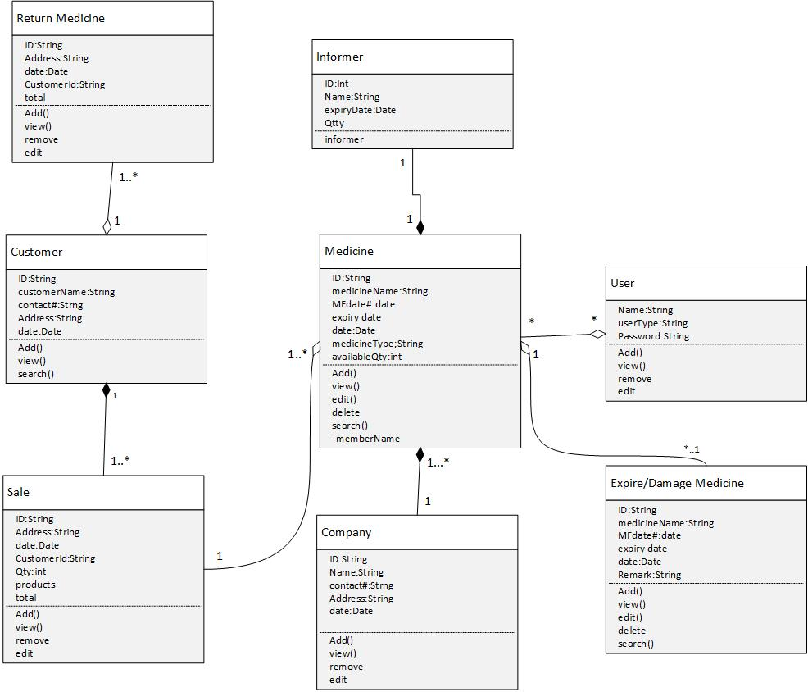

## Sequence Diagrams

### Sequence Diagram of Medicine

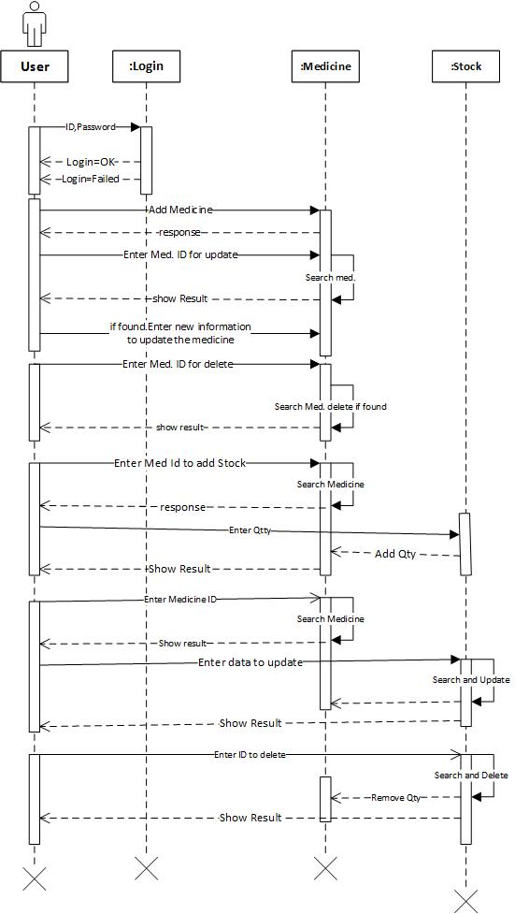

### Sequence Diagram of Sale

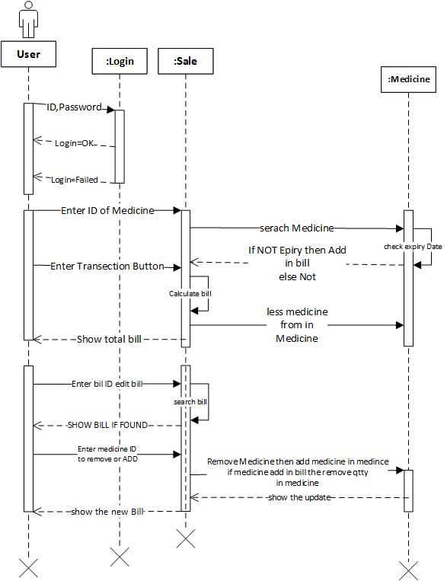

### Sequence Diagram of Damage Medicine

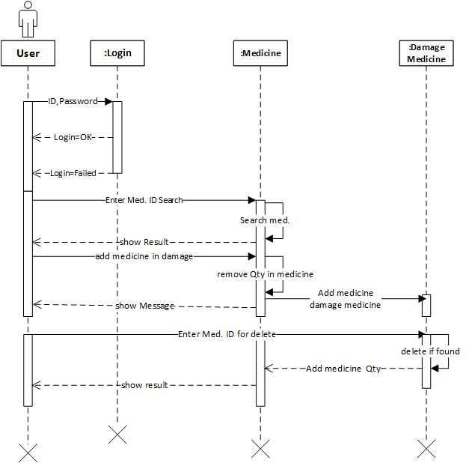

### Sequence Diagram of Company

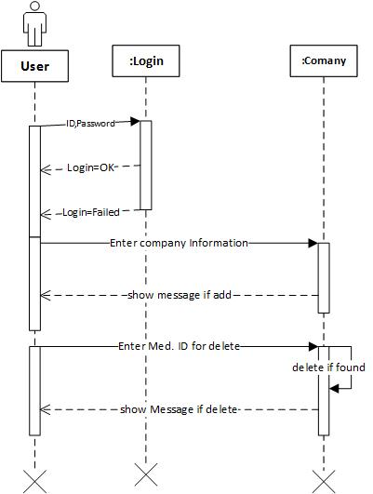

# Chapter 4

## Database Design

### Entity of Application

* User
* Medicine
* Medicine Type
* Master Sale
* Child Sale
* Stock
* Damage Stock
* Company Name

### ER Diagram

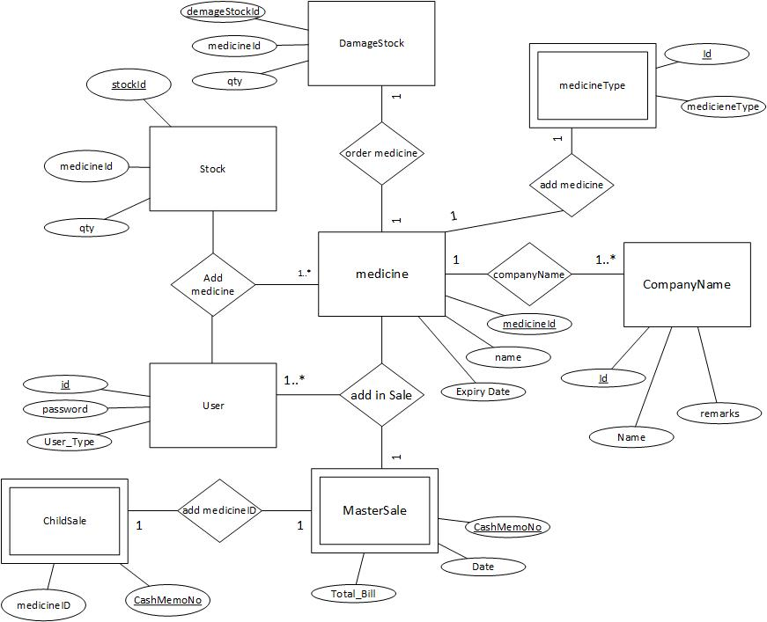

## Tables in Database

These following tables used in this application

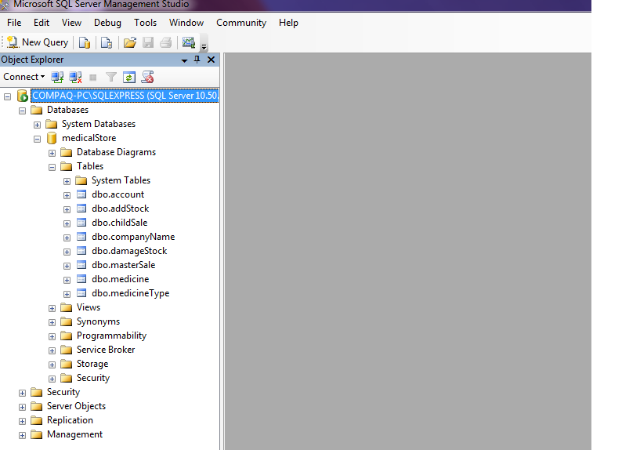

**Table Name: User**

User’s user name and password will be in this table

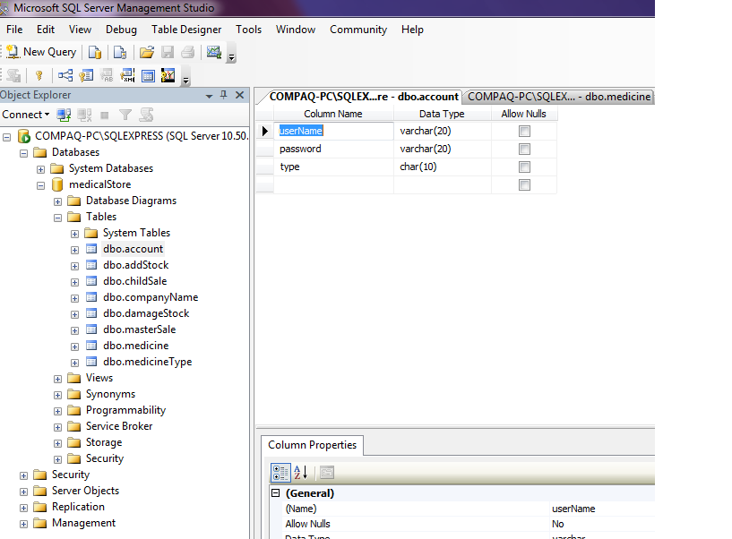

**Table Name: Medicine**

Medicine record will be in this table

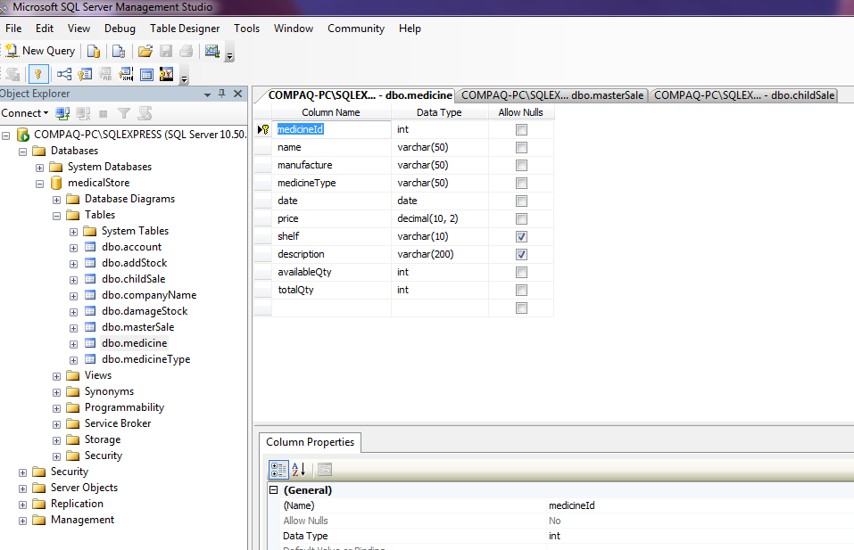

**Table Name: Master Sale**

This is master table which store information about customer and save customer’s medicine record in its child table.

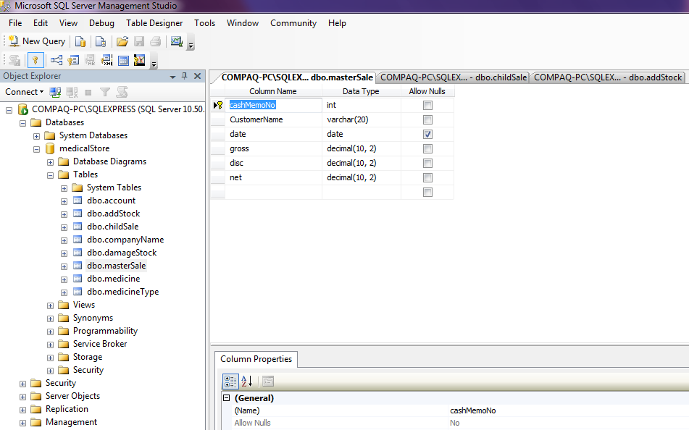

**Table Name: Child Sale**

This table stores the information of customer’s medicine it is child table of master table

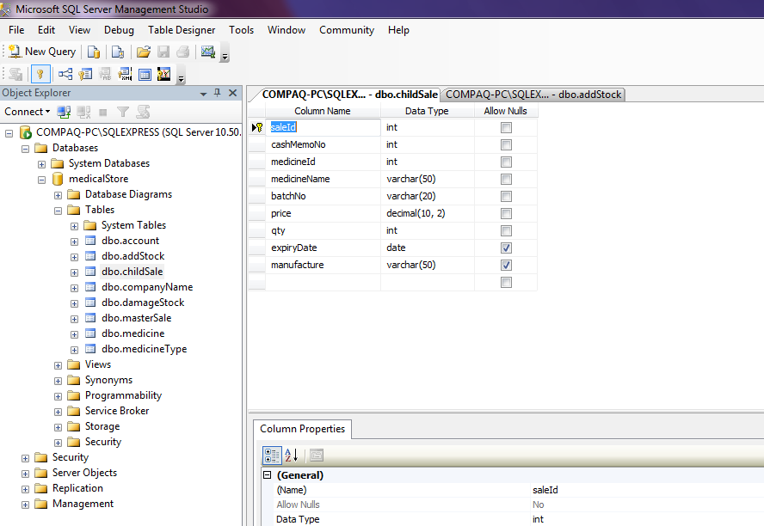

**Table Name: Stock**

This table stores stock of medicine

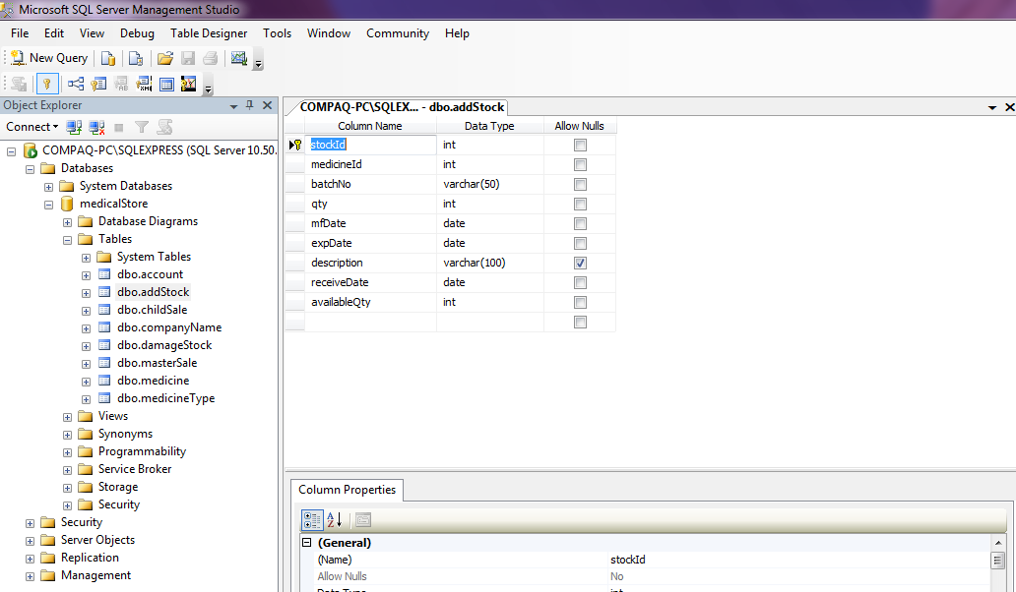

# Chapter 5

## Implementation

**Login Windows**

User can login from this window

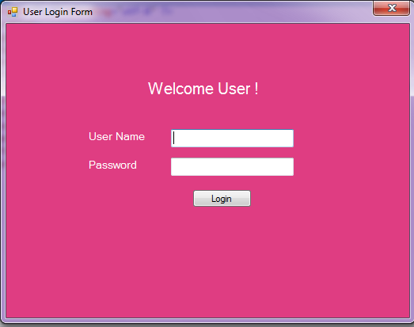

**Code of login button:** Check the user Name and password for login

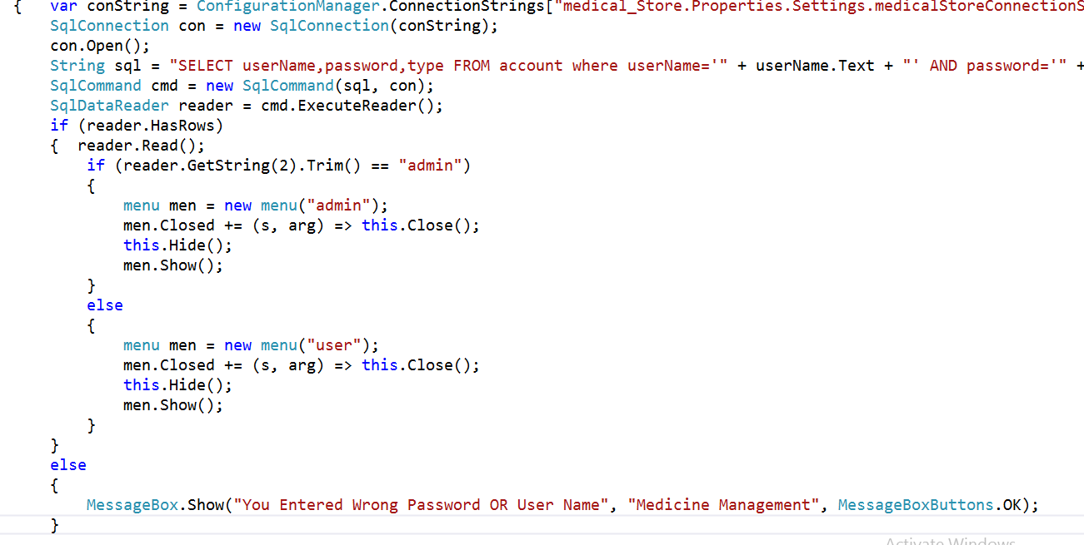

**Menu Window**

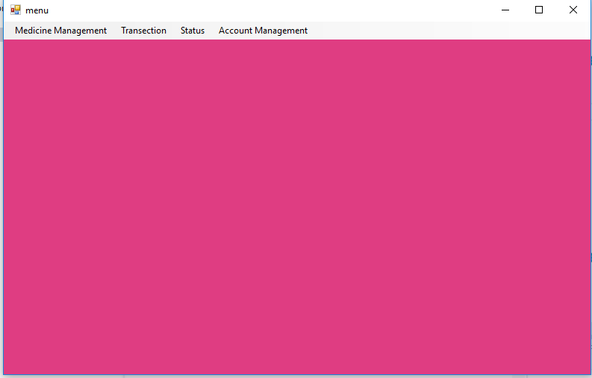

**Code of this window**

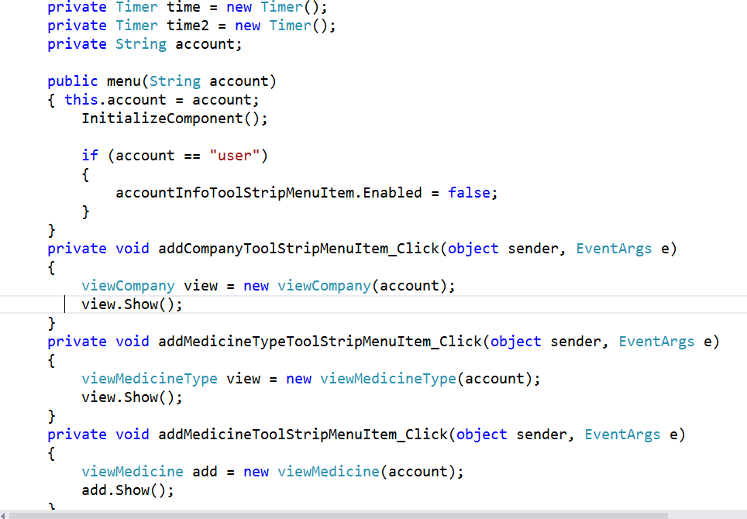

**View medicine’s information**

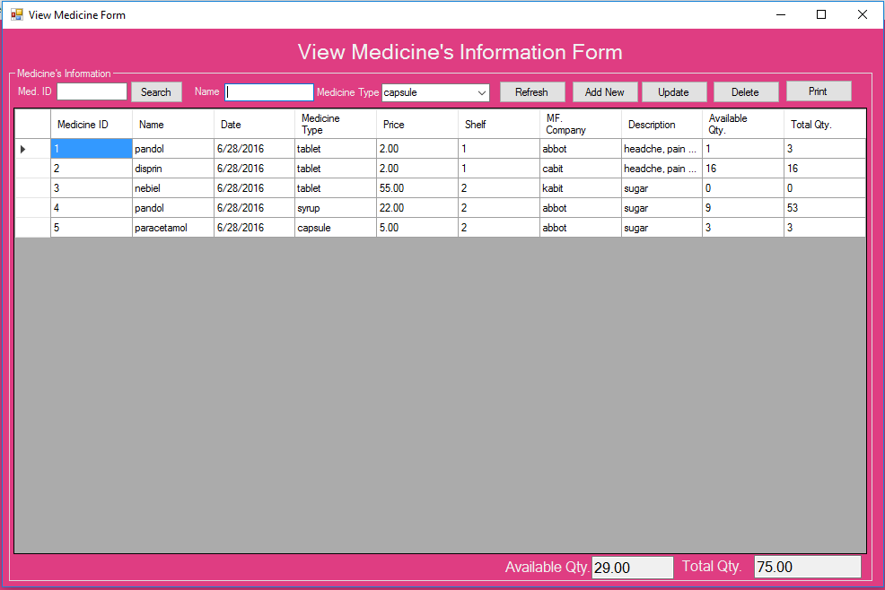

**Following code will load in the form**

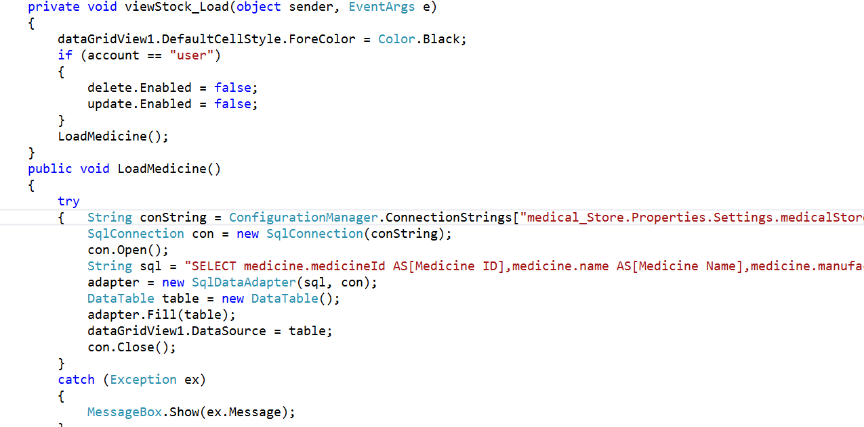

**Low Stock Window**

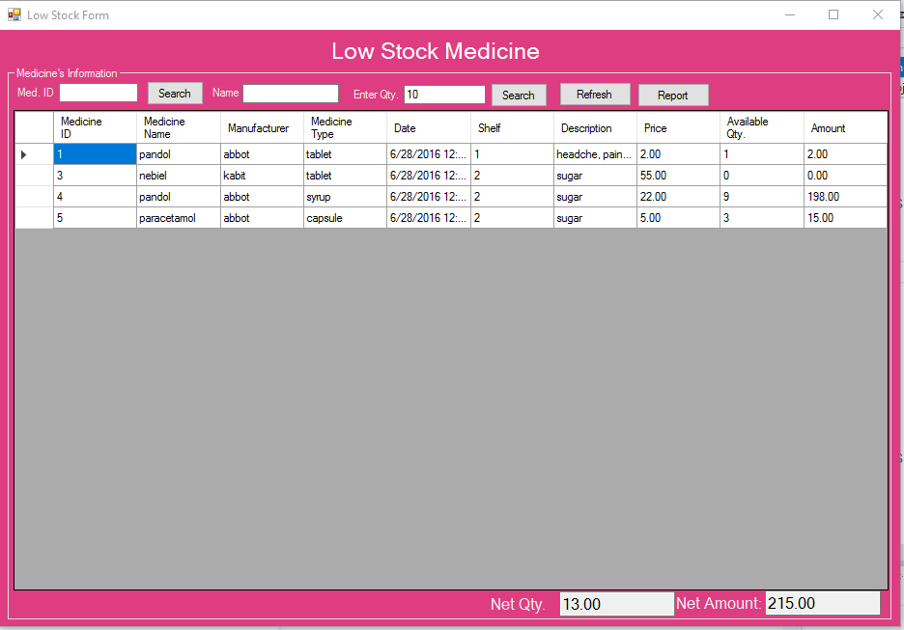

Following code will this form with data those have low stock and low stock quantity defined by user

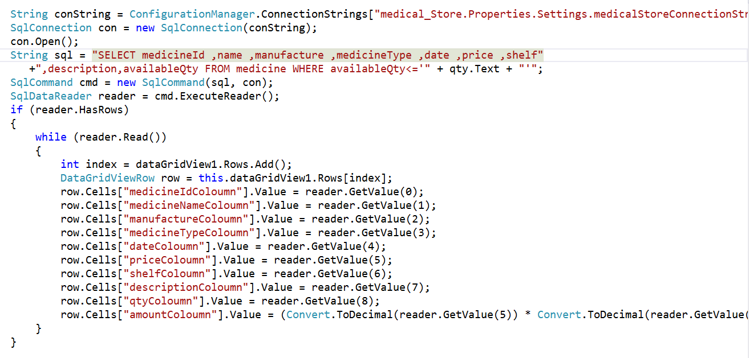

**Transection Window:** User can make transection From this windows

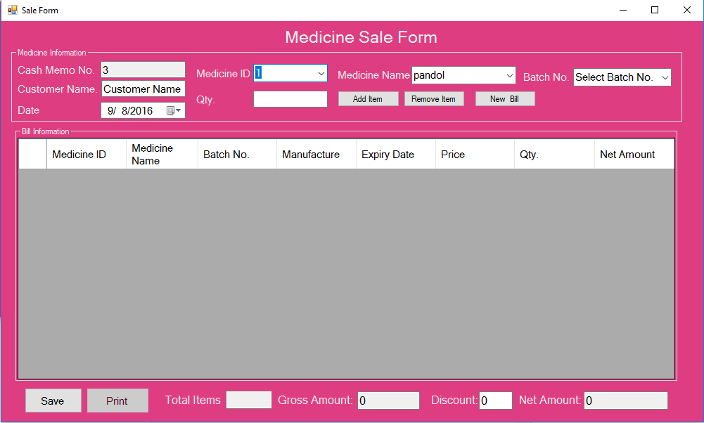

Save Button Code will save the transection in database

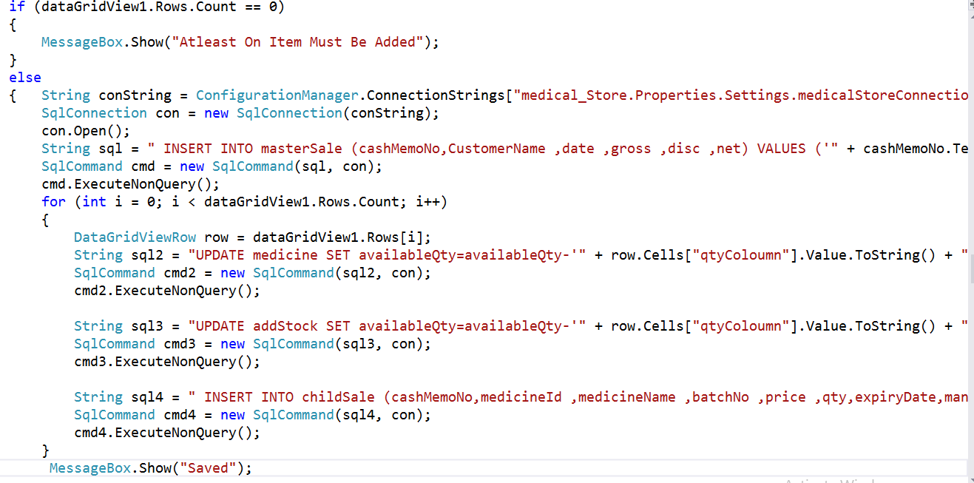

**Expire Medicine Window**

This window will show those medicine which are near to expire in three months

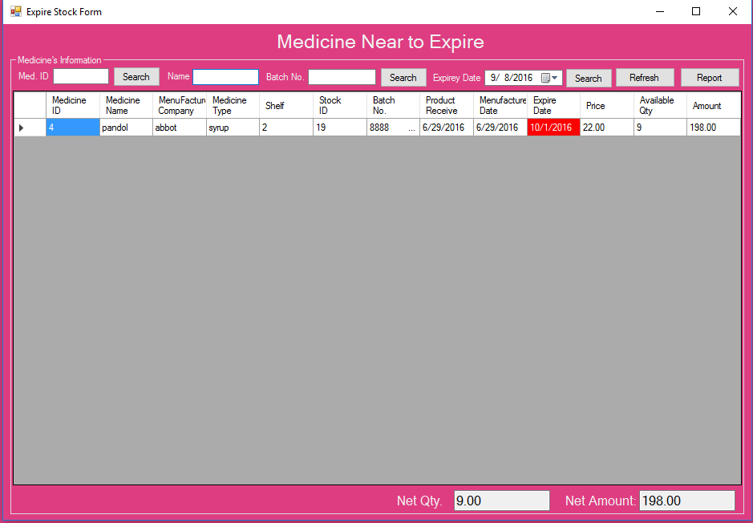

Following Code will fill data in windows those which are near to expire 3 months

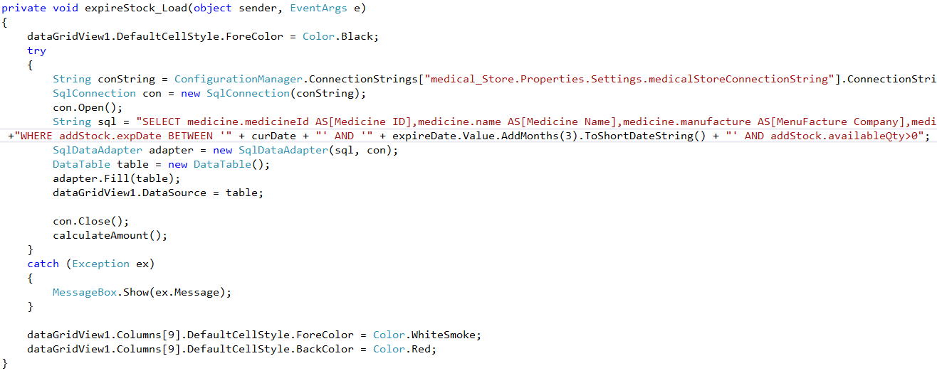

# Chapter 6

Conclusion  
Medicine is essential part of our life and we purchase medicine daily from medical shore. Medical store mostly have all the medicine which we acquired. Medical store has much medicine and medical store’s owner has to maintain the all medical and maintaining of all medicine is not easy thing. He has to keep the record of all medicine which is near to expire and which are damage and which medicine have low stock in medical shop these thing are very important for every medical store. Create a bill for customer is not thing human can do mistake that’s mistake lead to loss in medical shop.

This application will try to solve the problem of medical store like management of medicine in systematic way through this application of searching of medicine is very easy user can easy how much quantity is available how much I have sold. This application will notify user when quantity is very low and also notify the user when medicine near to expire and calculation of bill is very easy and user can add discount while making bill. This application will provide the ease to user