- 搭建xxl-job-admin web后台

- 执行sql，添加表
- 配置项目
- 部署项目到Tomcat中
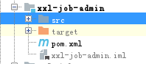

- 搭建客户端执行器
- 引入xxl-job-core依赖
<dependency>
<groupId>com.xuxueli</groupId>
<artifactId>xxl-job-core</artifactId>
<version>1.9.1</version>
</dependency>

- 定义注册执行器
@Bean(name = "xxlJobExecutor",initMethod = "start",destroyMethod = "destroy")
public XxlJobExecutor getXxlJobExecutor(){
XxlJobExecutor xxlJobExecutor = new XxlJobExecutor();
xxlJobExecutor.setAdminAddresses(adminAddresses);
xxlJobExecutor.setAppName(appName);
xxlJobExecutor.setIp(ip);
xxlJobExecutor.setPort(port);
xxlJobExecutor.setAccessToken(accessToken);
xxlJobExecutor.setLogPath(logPath);
xxlJobExecutor.setLogRetentionDays(logRetentionDays);
return xxlJobExecutor;
}

- 定义job
@JobHandler(value="simpleJobHandler")
@Component
public class SimpleJobHandler extends IJobHandler {
public ReturnT<String> execute(String s) throws Exception {
XxlJobLogger.log("XXL-Job execute SimpleJobHandler");
System.out.println("asdfsafsafasdfsadf");
return ReturnT.SUCCESS;
}
}
- 在admin web后台添加执行器和任务
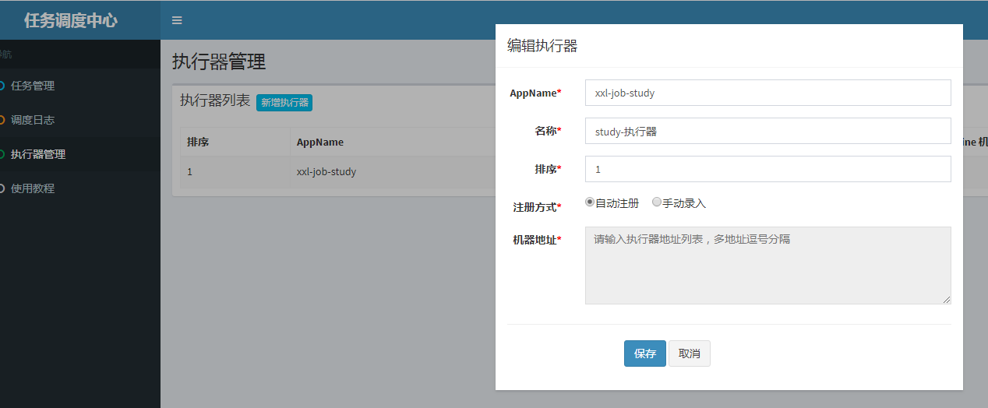

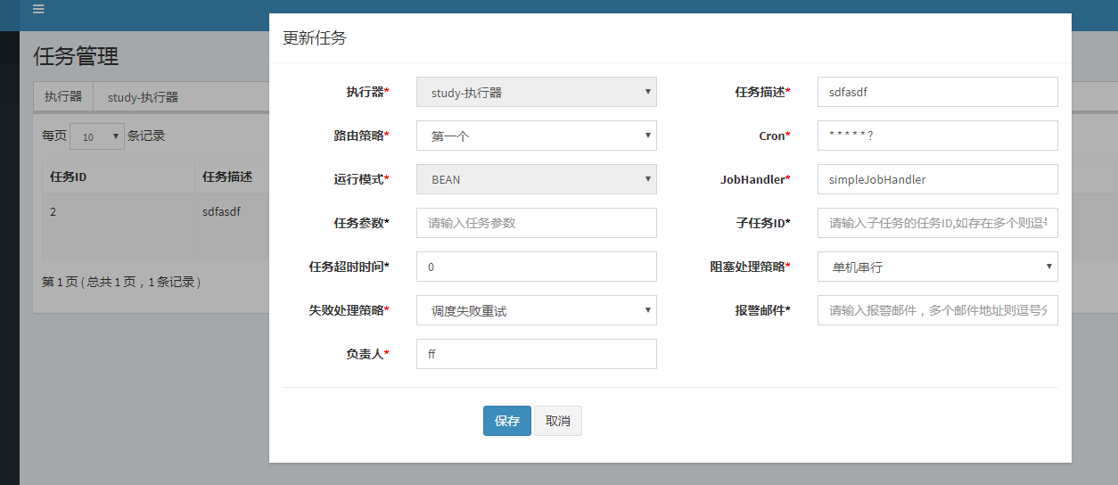

配置正确后，就会调用客户端的任务

