OS-JACKFRUIT
Srishti Rao -PES1UG24CS470
Sharvari Naik-PES1UG24CS431
MULTI CONTAINER RUNTIME
Create rootfs and create container copies
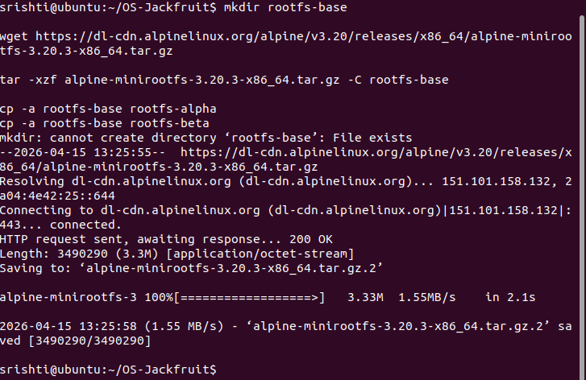
Supervisor start
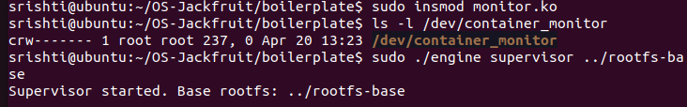
Terminal 2
First container start
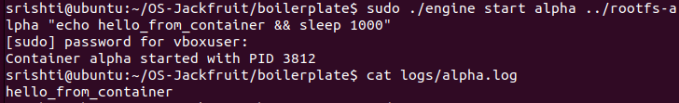
Metadata tracking (ps) (Single Container) and stop container

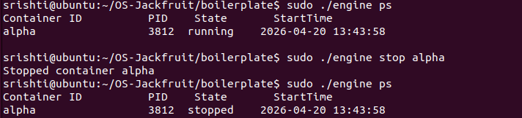
Stopping the container and checking its status
Multicontainer execution and logs
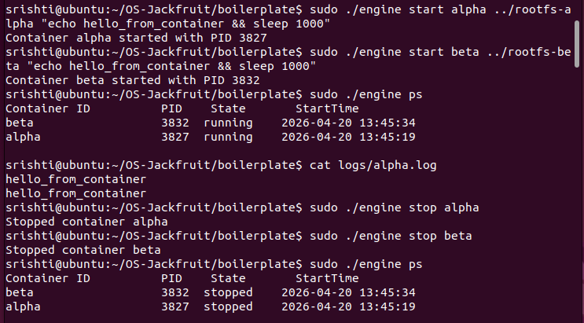
Stress Testing (Memory Test)
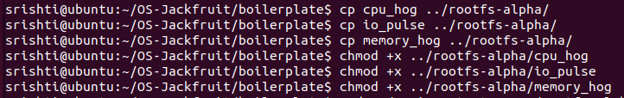
Task 5- Scheduler Experiments
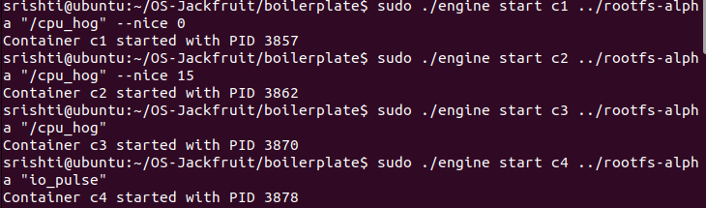
CPU usage
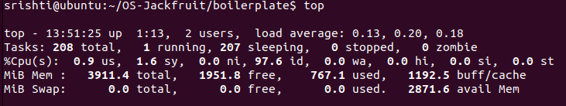
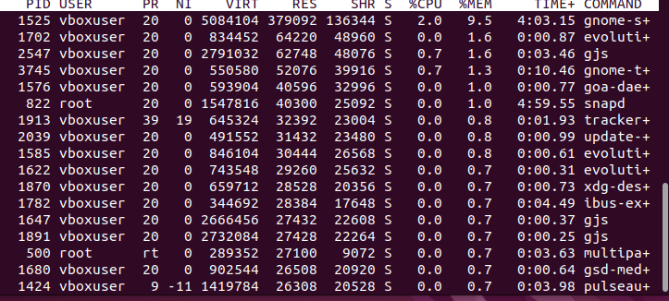
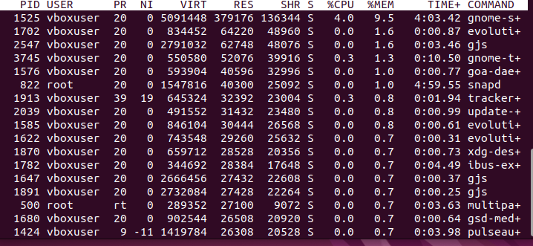
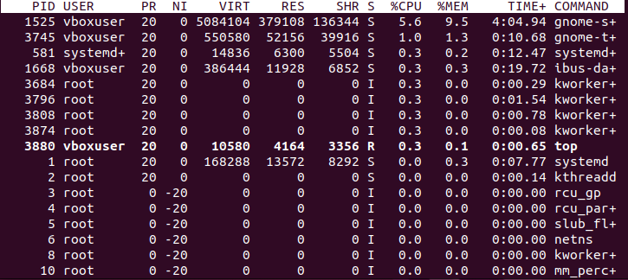
Memory Monitoring (Soft + Hard Limit Setup)
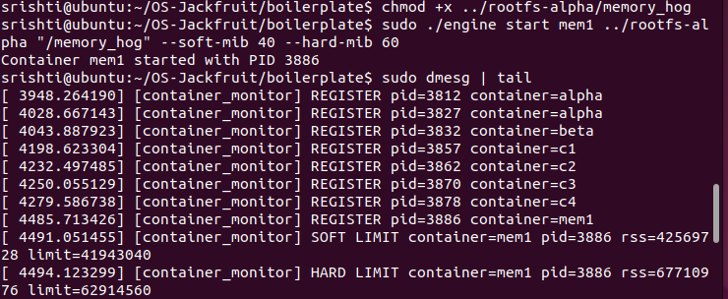
Command that waits until container finishes (Foreground)
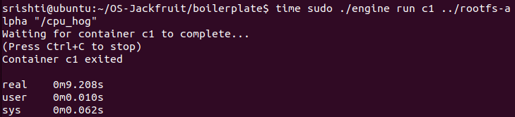
Stop + Zombie Check
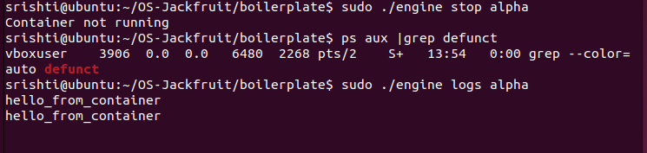
Echo Containers

