Zach Luciano & Daniel Rao

September 24, 2020

Homework 2 Question 2

1. Both functions are in the same order with multiplicative constant of 2000
2. 0.01n^3 grows at a faster rate than 100n^2
3. Both functions grow at the same order with multiplicative constant of log­2(e)
4. Log22(n) grows at a faster rate than log2(n2) with multiplicative constant of log2(n)
5. Both functions grow at the same order with multiplicative constant of 0.5
6. 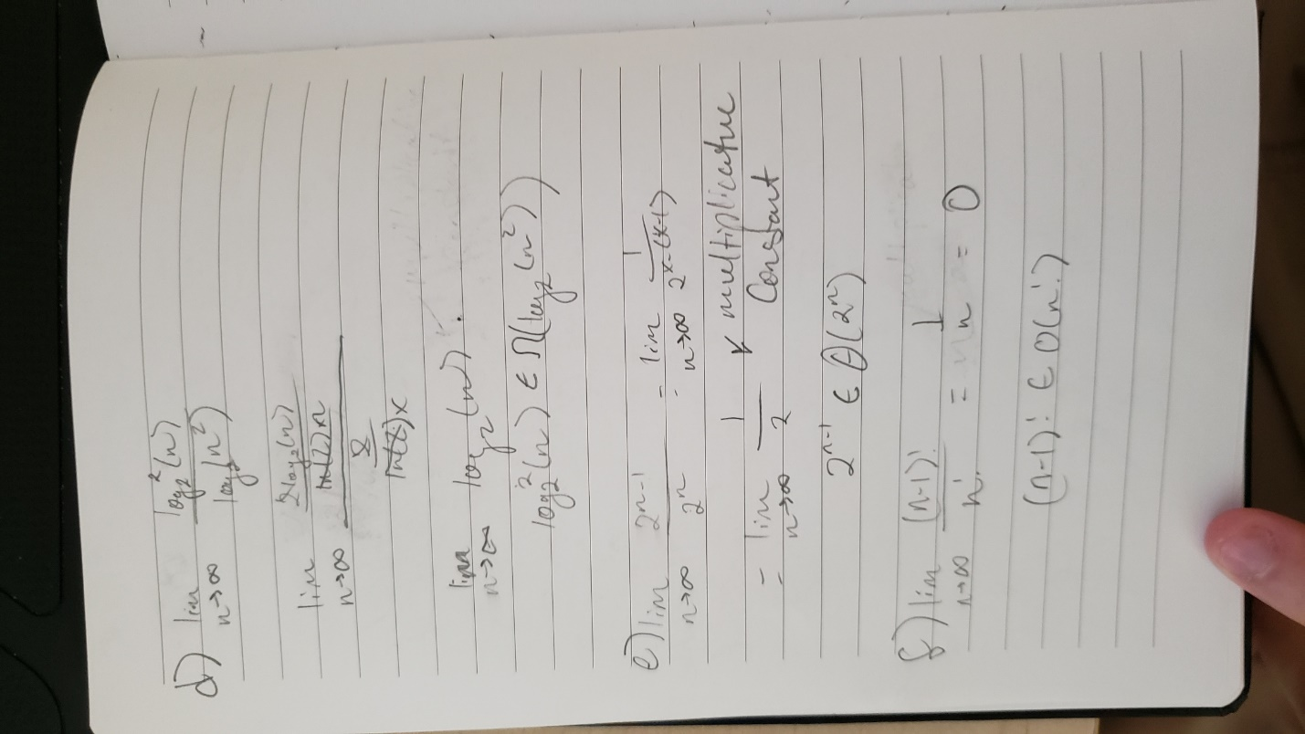N! grows at a higher order than (n-1)! At a multiplicative order of n