Zach Luciano & Daniel Rao

September 24, 2020

Homework 2 Question 5

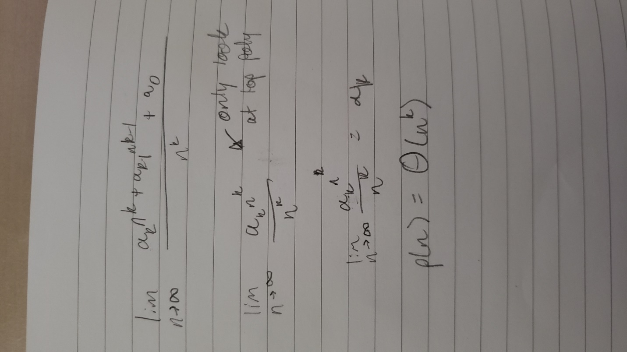Work is shown below. Steps bullet pointed

1. Write out p(n) and nk in limit form
2. Limit only worries about highest order in a polynomial so we keep aknk and get rid of everything else
3. Get rid of like elements, in this case nk is shared in both factors
4. All we are left with is a constant of ak meaning that the functions will grow at the same rate.