**Functional Requirements of Event Management**

**System**

**Abstract:**

The Event Management System is a comprehensive software solution designed to simplify and streamline the planning, organization, and execution of various types of events. This system offers a wide range of features and functionalities to cater to the diverse needs of event organizers and attendees, providing a seamless and efficient event management experience. Key features of the Event Management System include event registration, venue management, theme, seating and marketing. These features are designed to automate manual processes, improve communication and collaboration, and enhance overall event productivity and success. It simplifies attendee management by providing tools for tracking registrations, managing attendee profiles, and sending personalized event communications. In summary, the Event Management System offers a comprehensive solution to simplify and enhance the entire event management process. By leveraging its advanced features, event organizers can save time, reduce manual effort, improve attendee experiences, and achieve greater success in planning and executing a wide range of events, from conferences and trade shows to concerts and festivals.

**Types of users:**

**Private-Event Organizer :**

* 1. Create Event
  2. Remove Event
  3. Manage Event

**Event Co-Ordinator :**

* 1. Create Event
  2. Remove Event
  3. Manage Event
  4. Add Event Organizer

**Event Organizer :**

* 1. View his Events
  2. Request changes

**Admin :**

* 1. View Past Events
  2. View Present Events

**Features available to Private Event Organizer user:**

1. Login
2. Add event.
3. Remove event.
4. Manage existing event**.**

**User Workflow-**

*Homepage > user login > user landing page > Add Event > Enter Event details > Add*

*and*

*Homepage > user login > user landing page > Remove Event > Enter Event id(number) > Remove*

*and*

*Homepage > user login > user landing page > Manage Event >Enter Event id > Manage*

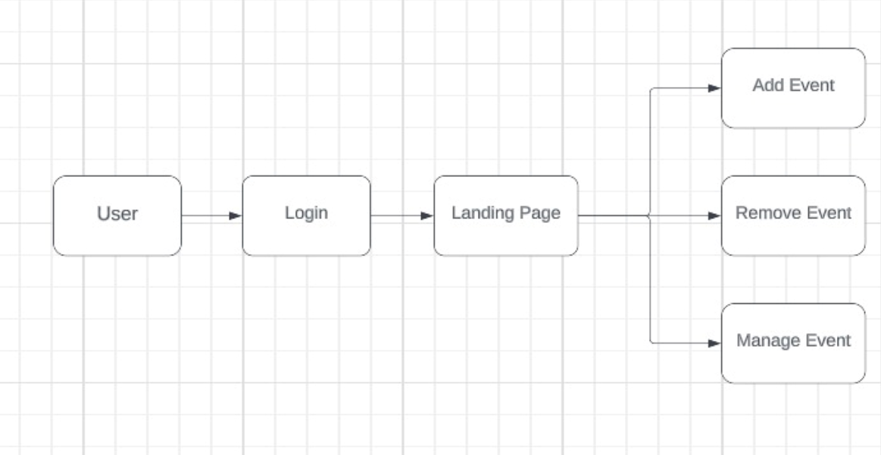

**2.Add event**

The User has the capability to add a new event by providing the following details.

* **Basic Details**: it typically includes essential information about the event itself, such as the event name, date, time, location, and any pertinent details. These details serve as the foundation for organizing and coordinating the event effectively.
* **Guest Detail**s: Guest details refer to the information about the individuals who will be attending an event as guests or participants. These details are important for event organizers to keep track of attendees, communicate with them effectively.
* **Program Details**: Program details for an event typically refer to the schedule, agenda, or program outline that outlines the activities, sessions, and timeline for the event. These details help attendees and participants understand what will take place during the event and when.
* **Marketing Details**: Marketing details for an event encompass the strategies, tactics, and activities undertaken to promote and publicize the event to the target audience. Effective marketing plays a crucial role in attracting attendees, generating buzz, and maximizing event participation.

**3. Remove Event**

* The User can remove a event from the system by providing the event ID and password associated with that event. This authentication ensures that only authorised personnel can perform the task of deleting the event.

**4.Manage Event**

The user has the capability to manage events by performing the following actions:

* **Edit Event Details**: The user can modify the existing details of an event, including the event name, date, time, location, and other pertinent information. This feature allows for flexibility in updating event information as needed. The user can modify the following details of an event:
* **Event Name**: The user can update the name of the event. This could be useful if there are changes in the event's branding, theme, or if the initial name needs to be revised.
* **Date and Time**: The user can change the date and time of the event. This feature is essential for rescheduling an event or adjusting the event's start and end times.
* **Location**: The user can update the venue or location where the event will take place. This is particularly useful if there is a change in the event's venue or if the initial location becomes unavailable.
* **Manage Guest Details**: The user can view and manage the guest details for an event. This includes the ability to add, edit, or remove guest information, such as names, contact details, and RSVP status. Effective management of guest details helps in communication and making appropriate arrangements for attendees.
* **Update Program Details**: The user can update the program details for an event. This feature enables modifications to the event schedule, agenda, or program outline. It allows the user to add, edit, or remove activities, sessions, and their respective timelines. Keeping the program details up-to-date helps attendees and participants understand the event's structure and plan their participation accordingly.
* **Manage Marketing Details**: The user can manage the marketing details for an event. This includes updating and implementing strategies, tactics, and activities to promote and publicize the event to the target audience. The user can edit event descriptions, update promotional materials, and track the effectiveness of marketing efforts. Efficient management of marketing details contributes to attracting attendees, generating buzz, and maximizing event participation.

**Features available to co-ordinate event:**

**Co-ordinator:**

1. Create Event
2. Manage Event
3. Remove Event
4. Add Event Organizer

**Event organizer:**

1. Login
2. View event

**Co-ordinate event workflow:**

**Co-ordinator:**

*Homepage>user login>co-ordinator Homepage>Add Event*

*and*

*Homepage>user login>co-ordinator Homepage>Manage Event*

*and*

*Homepage>user login>co-ordinator Homepage>Remove Event*

**Event organizer:**

*Homepage>event organizer>login>view events.*

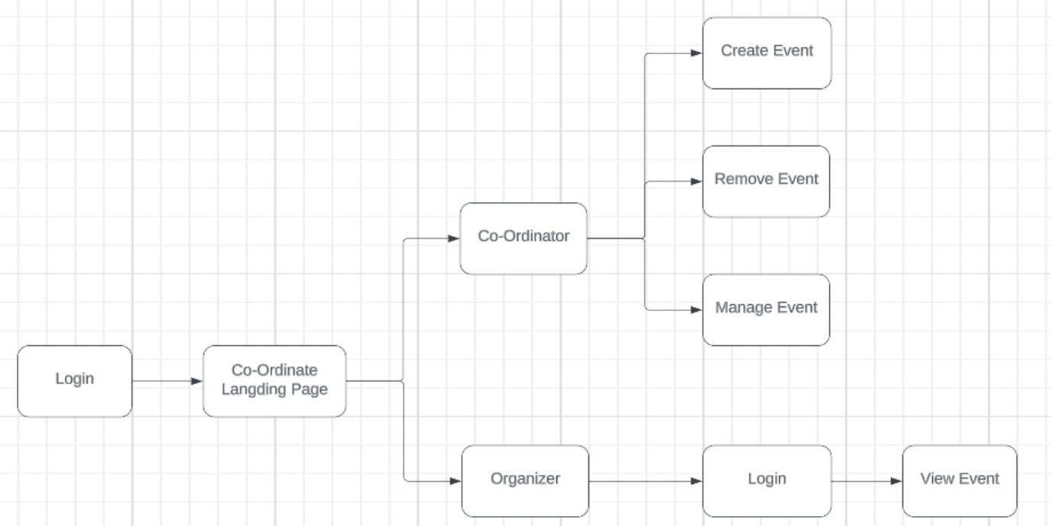

**Co-ordinator**

**1.Create event**

The User has the capability to add a new event by providing the following details.

* **Basic Details**: it typically includes essential information about the event itself, such as the event name, date, time, location, and any pertinent details. These details serve as the foundation for organizing and coordinating the event effectively.
* **Guest Details**: Guest details refer to the information about the individuals who will be attending an event as guests or participants. These details are important for event organizers to keep track of attendees, communicate with them effectively, and make appropriate arrangements.
* **Program Details**: Program details for an event typically refer to the schedule, agenda, or program outline that outlines the activities, sessions, and timeline for the event. These details help attendees and participants understand what will take place during the event and when.
* **Marketing Details**: Marketing details for an event encompass the strategies, tactics, and activities undertaken to promote and publicize the event to the target audience. Effective marketing plays a crucial role in attracting attendees, generating buzz, and maximizing event participation.

**2.Manage Event**

The user has the capability to manage events by performing the following actions:

* **Edit Event Details**: The user can modify the existing details of an event, including the event name, date, time, location, and other pertinent information. This feature allows for flexibility in updating event information as needed. The user can modify the following details of an event:
* **Event Name**: The user can update the name of the event. This could be useful if there are changes in the event's branding, theme, or if the initial name needs to be revised.
* **Date and Time**: The user can change the date and time of the event. This feature is essential for rescheduling an event or adjusting the event's start and end times.
* **Location**: The user can update the venue or location where the event will take place. This is particularly useful if there is a change in the event's venue or if the initial location becomes unavailable.
* **Manage Guest Details**: The user can view and manage the guest details for an event. This includes the ability to add, edit, or remove guest information, such as names, contact details, and RSVP status. Effective management of guest details helps in communication and making appropriate arrangements for attendees.
* **Update Program Details**: The user can update the program details for an event. This feature enables modifications to the event schedule, agenda, or program outline. It allows the user to add, edit, or remove activities, sessions, and their respective timelines. Keeping the program details up-to-date helps attendees and participants understand the event's structure and plan their participation accordingly.
* **Manage Marketing Details**: The user can manage the marketing details for an event. This includes updating and implementing strategies, tactics, and activities to promote and publicize the event to the target audience. The user can edit event descriptions, update promotional materials, and track the effectiveness of marketing efforts. Efficient management of marketing details contributes to attracting attendees, generating buzz, and maximizing event participation.

**Event organizer:**

Here only the valid event organizers can be logged in to see their respective event.

* **Login:** The organizer can use their credentials for login purposes and only view the events created by their co-coordinator.
* **View:** Here organizes is supposed only to see the details in the form but no authority to alter it.

**Features available to Admin:**

1. Past Events
2. List of Events

**Admin Workflow:**

*Homepage > Admin login > Admin landing page >check for past events*

*and*

*Homepage >Admin login > Admin landing page >check for list of events*

**Past events:**

* The admin can check past events that have occurred, including the event name and the date on which each event took place.

**List of events:**

* The admin can check the list of events currently available for users.