Quarto Basics

Raoul Bruens

Table of contents

## Polar Axis

For a demonstration of a line plot on a polar axis, see Figure 1.

import numpy as np  
import matplotlib.pyplot as plt  
  
r = np.arange(0, 2, 0.01)  
theta = 34 * np.pi * r  
fig, ax = plt.subplots(  
 subplot_kw = {'projection': 'polar'}   
)  
ax.plot(theta, r)  
ax.set_rticks([0.5, 1, 1.5, 2])  
ax.grid(True)  
plt.show()

|  |
| --- |
| Figure 1: A line plot on a polar axis |

This is some stated fact (Graham et al. 1989).

Use the following command to generate the requirements document. Make sure to exclude all Windows-related packages. I.e. Ctrl + F > “win” and delete all hits.

pip freeze > requirements.txt

## Placing Colorbars

Colorbars indicate the quantitative extent of image data. Placing in a figure is non-trivial because room needs to be made for them. The simplest case is just attaching a colorbar to each axes:[1].

import matplotlib.pyplot as plt  
import numpy as np  
  
fig, axs = plt.subplots(2, 2)  
fig.set_size_inches(20, 8)  
cmaps = ['RdBu_r', 'viridis']  
for col in range(2):  
 for row in range(2):  
 ax = axs[row, col]  
 pcm = ax.pcolormesh(  
 np.random.random((20, 20)) * (col + 1),  
 cmap=cmaps[col]  
 )  
 fig.colorbar(pcm, ax=ax)  
plt.show()

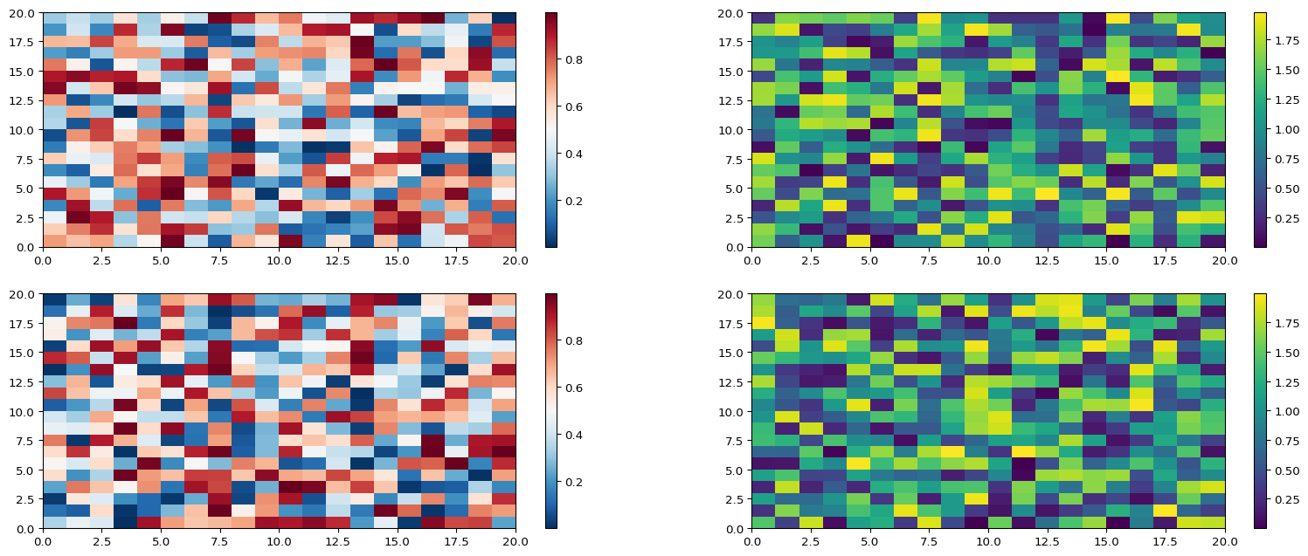

## Widgets

from ipyleaflet import Map, Marker, basemaps, basemap_to_tiles  
m = Map(  
 basemap=basemap_to_tiles(  
 basemaps.NASAGIBS.ModisTerraTrueColorCR, "2017-04-08"  
 ),  
 center=(52.204793, 360.121558),  
 zoom=4  
)  
m.add_layer(Marker(location=(52.204793, 360.121558)))  
m

Map(center=[52.204793, 360.121558], controls=(ZoomControl(options=['position', 'zoom_in_text', 'zoom_in_title'…

## References

Graham, Ronald L, Donald E Knuth, Oren Patashnik, and Stanley Liu. 1989. “Concrete Mathematics: A Foundation for Computer Science.” *Computers in Physics* 3 (5): 106–7.

1. See the [Matplotlib Gallery](https://matplotlib.org/stable/gallery/subplots_axes_and_figures/colorbar_placement.html) to explore colorbars further