|  |  |  |
| --- | --- | --- |
| Write an application to read atleast 3 or more command line arguments, where every argument consists of servername and port number (0-1023) pair separated by a colon. You need to parse, extract and display all server names and port numbers. Concatenate all server names using ‘_’ and display the concatenated string. | | |
| Requirement Tag | Requirement Description | Comments |
| CARG/01 | Validate the received arguments. | Hint: Use argc to validate if enough arguments are received |
| CARG/02 | Validate every word received. It should contain a Server name and a port number in range 0-1023 | Hint: Use isalpha(), isdigit() to validate server name and port numbers |
| CARG/03 | Write a function to receive a word, to extract and display server name and port number. Should store and a return pointer to server name. | Hint: Allocate dynamic memory for server name and copy extracted server name |
| CARG/04 | Write a function to receive an array of pointers to server names, concatenate names and return the concatenated string | Hint: Calculate the required length for final string, allocate adequate memory and use it for concatenation |
| CARG/05 | Write a function to release all the allocated memory | Hint: Release allocated memory for server names and concatenated string |

**CARG/01**

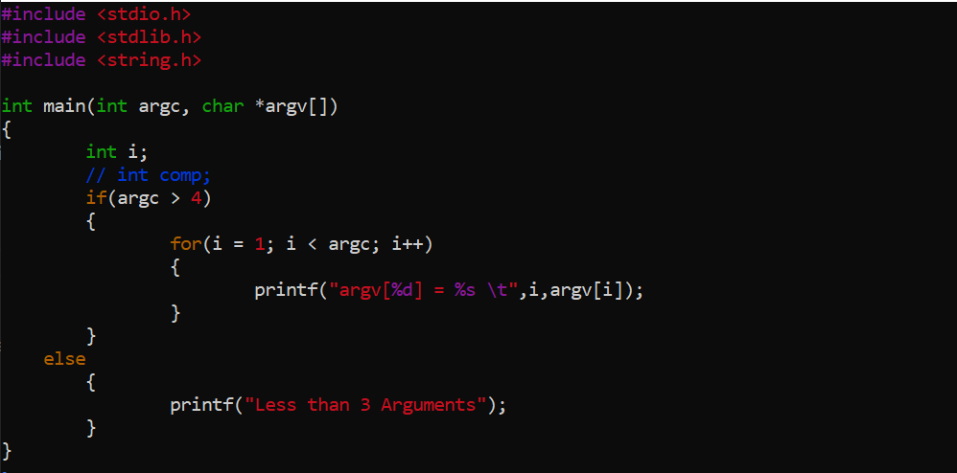



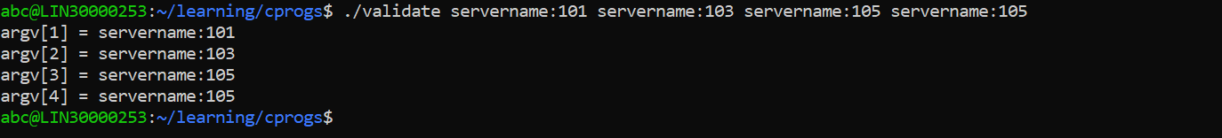

**CARG/02**

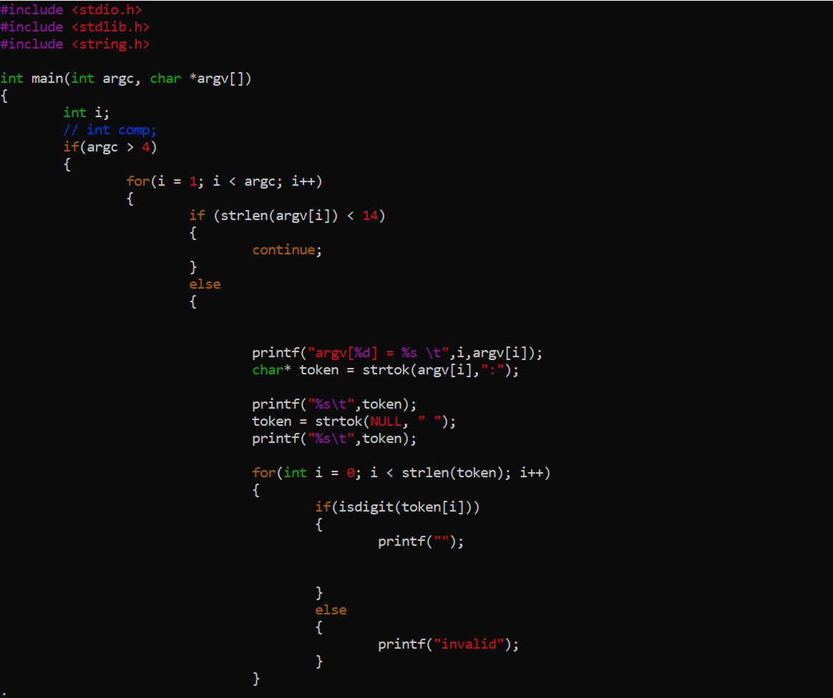

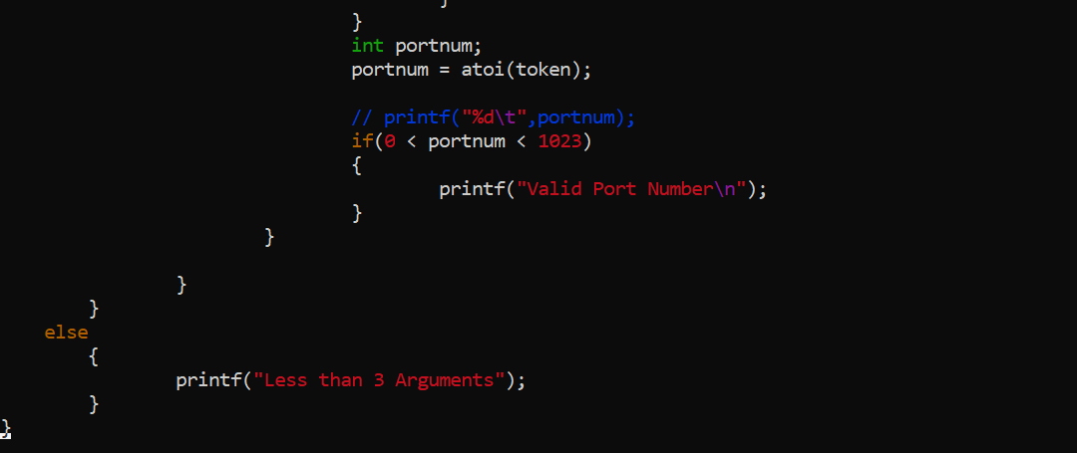



**CARG/03**

