**C Assignment 3**

Snippet of the code in VI Editor

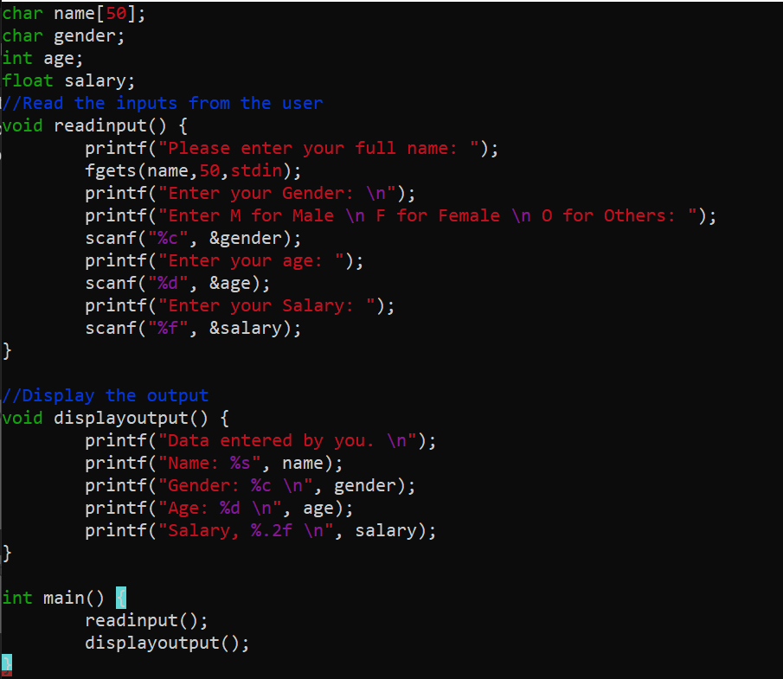

Output for the code

