1. Fill in the missing part to create a “string” named **greetings**, and assign it the value “Hello”

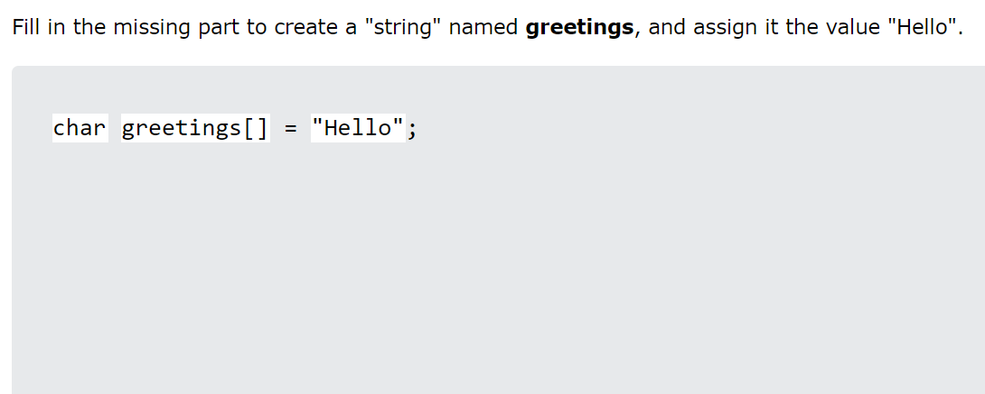

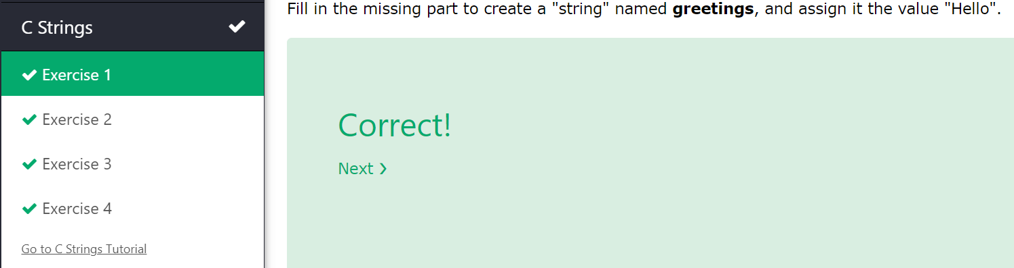

1. Fill in the missing part to create a “string” named **greetings**, and assign it the value “Hi”

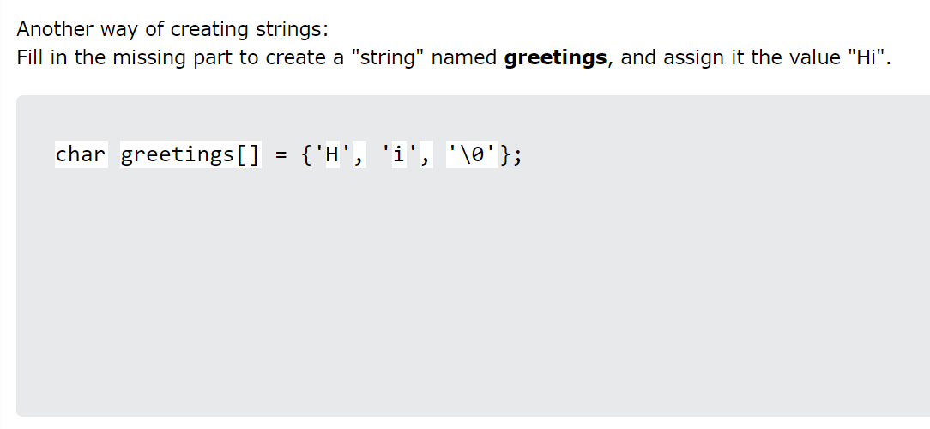

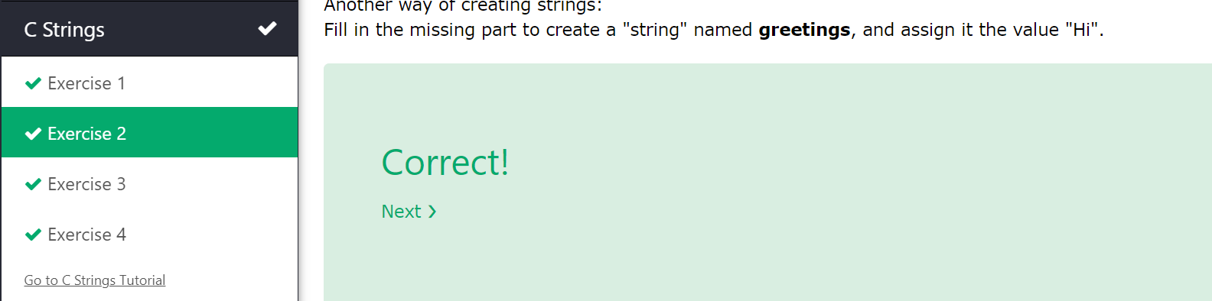

1. Use the correct format specifier to output the string

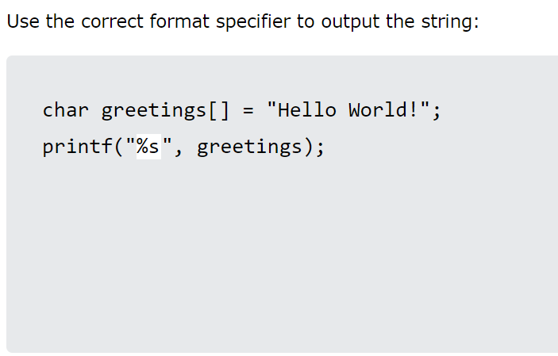

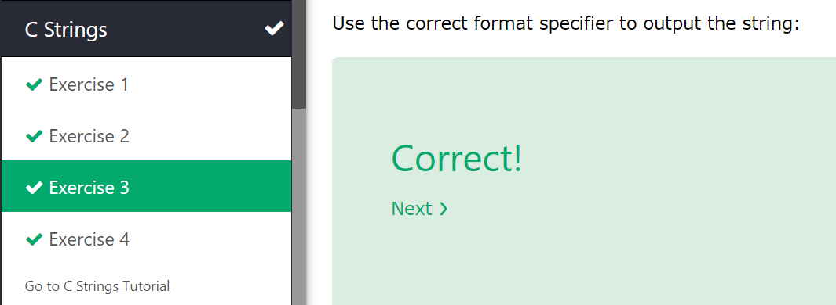

1. Print the first character in the greetings string

