**VI Editor Assignment**

1. Invoke the vi editor with a filename (which is to be created)



1. Type a few lines(at least 10) in the editor. Let one or more lines contain the words given below.

Delhi, Mumbai, Chennai, Pune

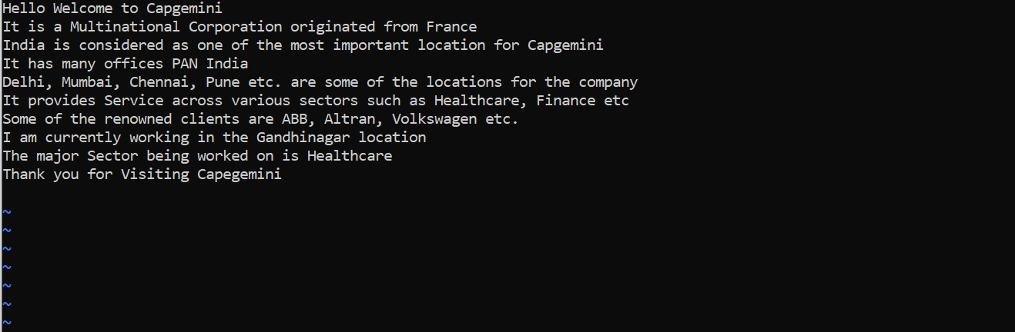

1. Save the file without exiting the editor

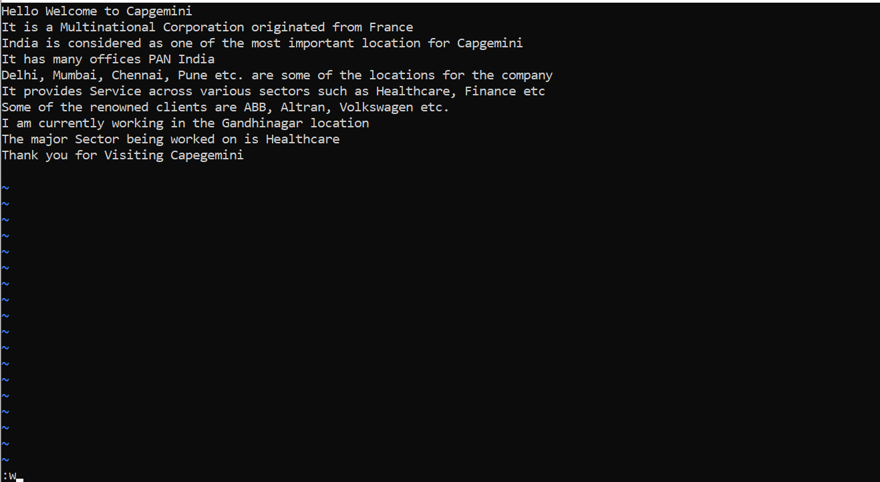

1. Navigate quickly to the beginning and the end of the file

Ans. Use g to navigate the beginning and G to navigate to the end

1. Delete the first two lines and paste it at the end

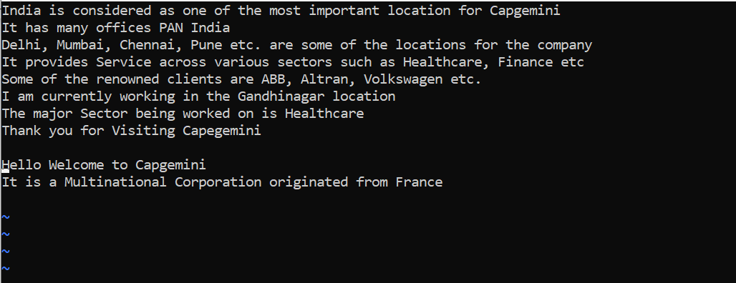

1. Copy the last two lines and paste it on the starting

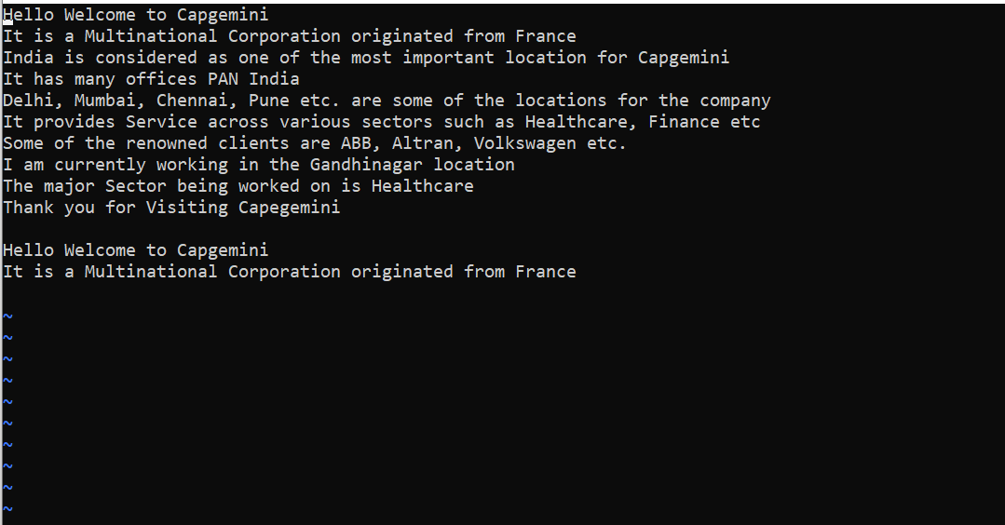

1. Combine the last two lines of the file in a single file

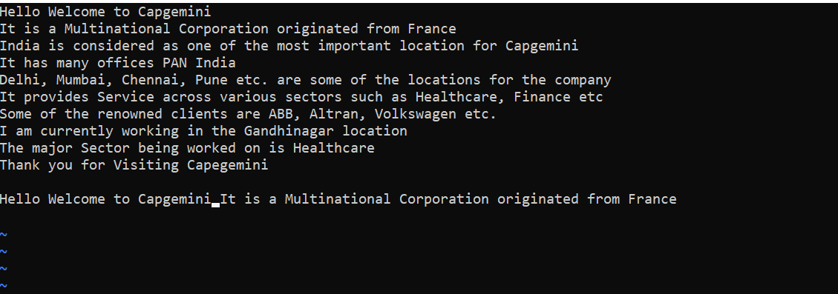

1. How will you insert a line before the first line? (Hint: Find such an option in the tutorial document)

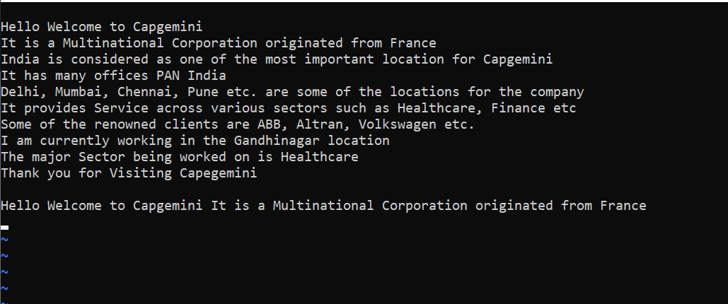

1. How will you paste a yanked buffer before the current line?

Ans. p

1. Search for the document for a string “Delhi:

Ans. /Delhi

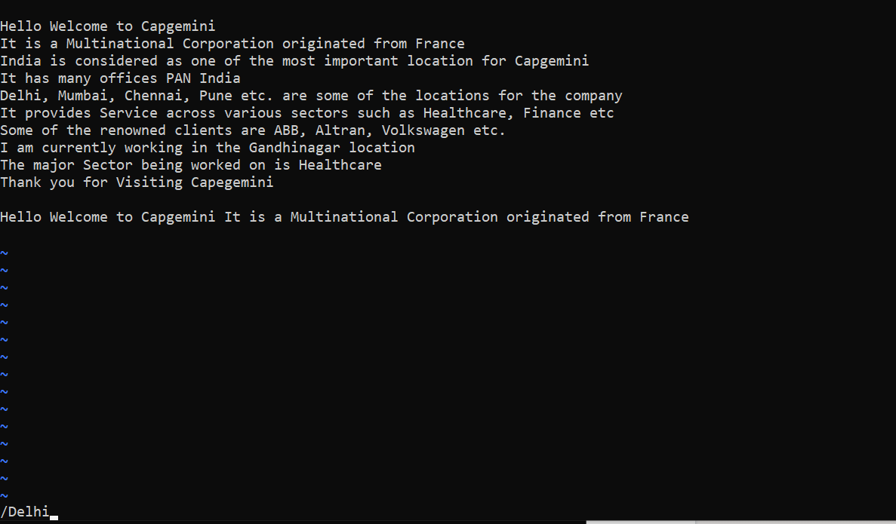

1. Replace a single occurrence of “delhi” with “Mumbai”

Ans. s/Delhi/Mumbai

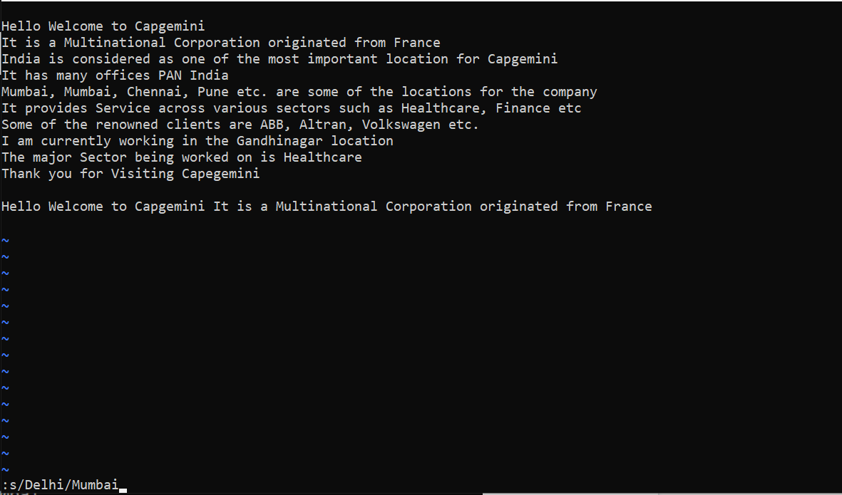

1. Replace all occurrences of “delhi” on a particular line with “Mumbai” using one command

Ans. s/Delhi/Mumbai/g

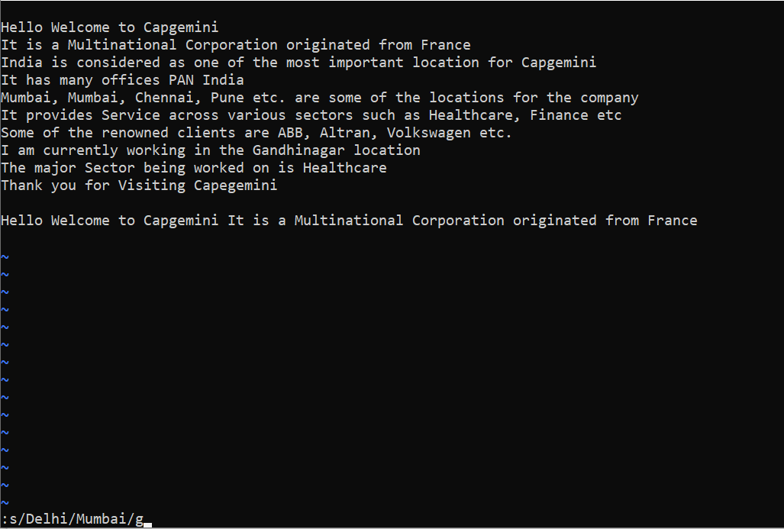

1. Replace “delhi” with “mumbai” for the entire document using one command.

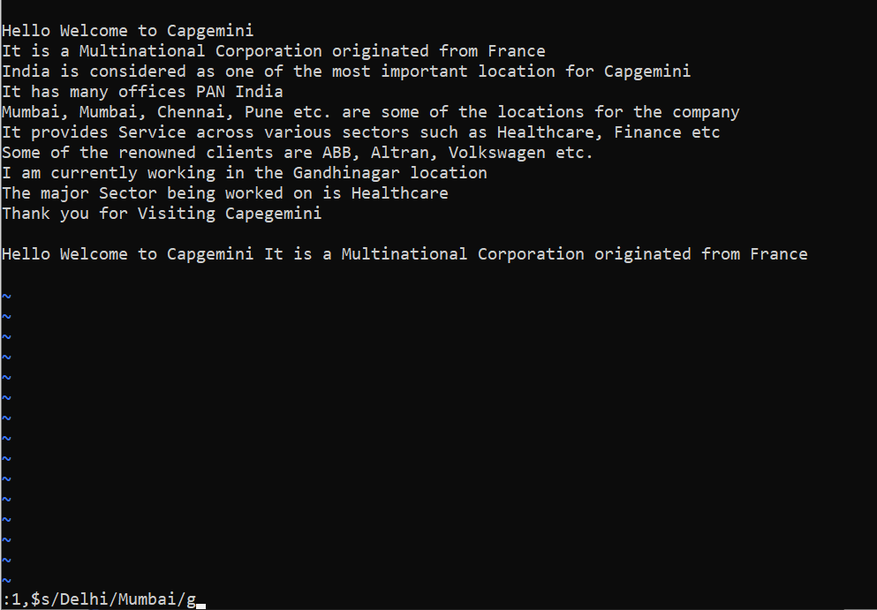

1. Replace all occurrences of “delhi” with “mumbai” for part of a document (e.g. line number 13 to 37).

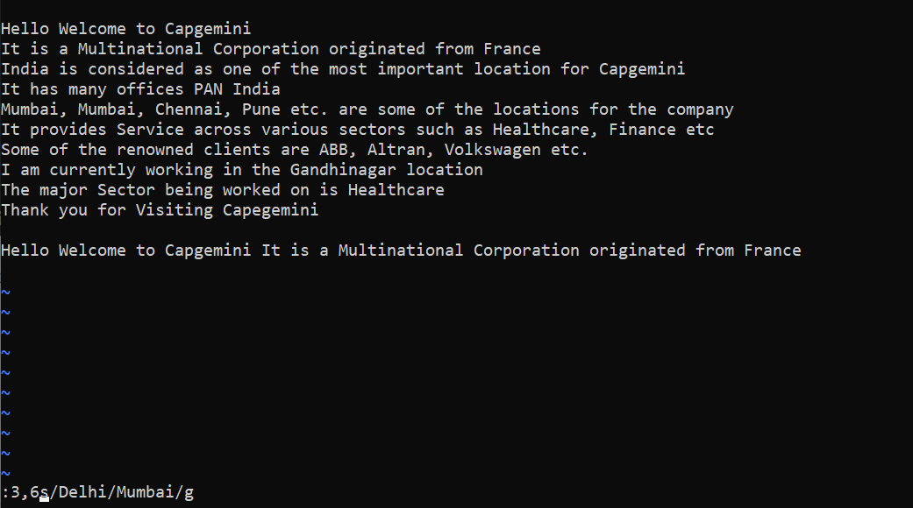

1. Undo the above command

Ans. u

1. Replace only the first occurrence of “delhi” with “mumbai” in each line, for part of a document (e.g. line number 13 to 37)

Ans. 3,6s/delhi/Mumbai/gc

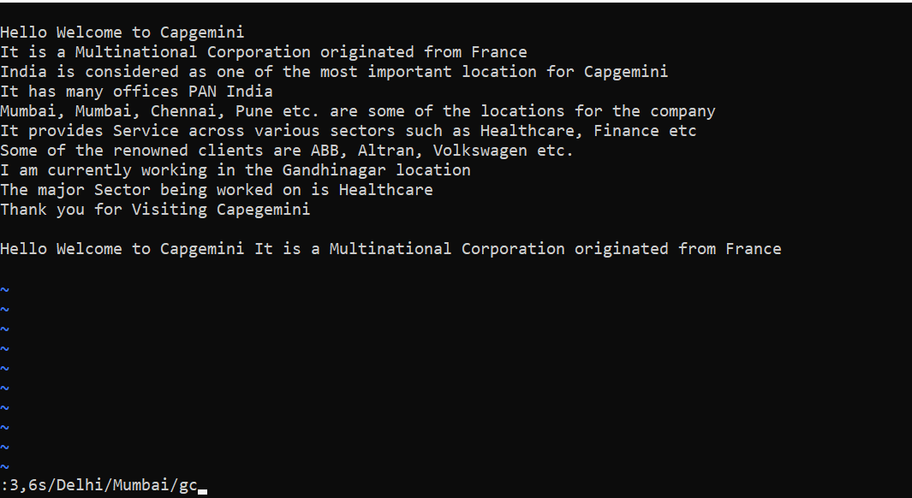

1. Undo the above comment. Redo it. Undo it again

Ans. Use the command u to Undo.

To Redo the given comment, Press the upper arrow key two times

Use u To Undo Again

1. Replace all occurrences of “delhi” with “mumbai” for complete file interactively.

Ans. 3,6s/delhi/mumbai/gc (same as 16 question)

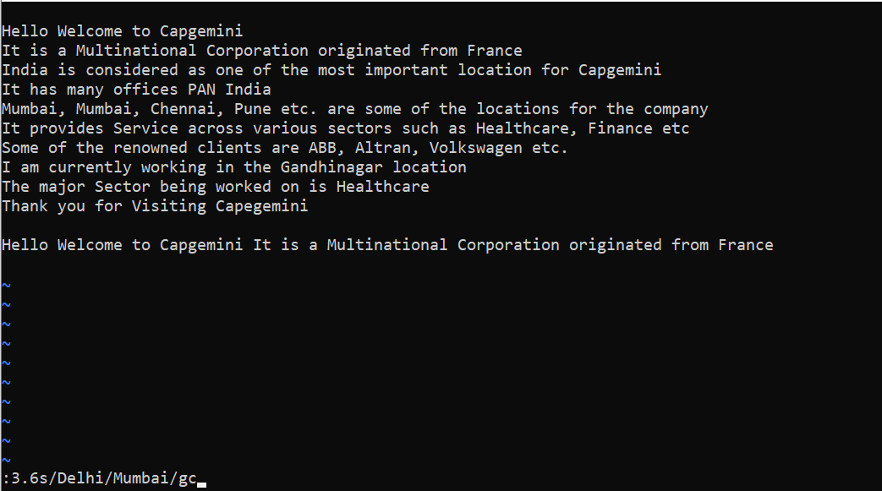

1. Search for a word backwards. Loop through all matches.

Ans. Use ?string name

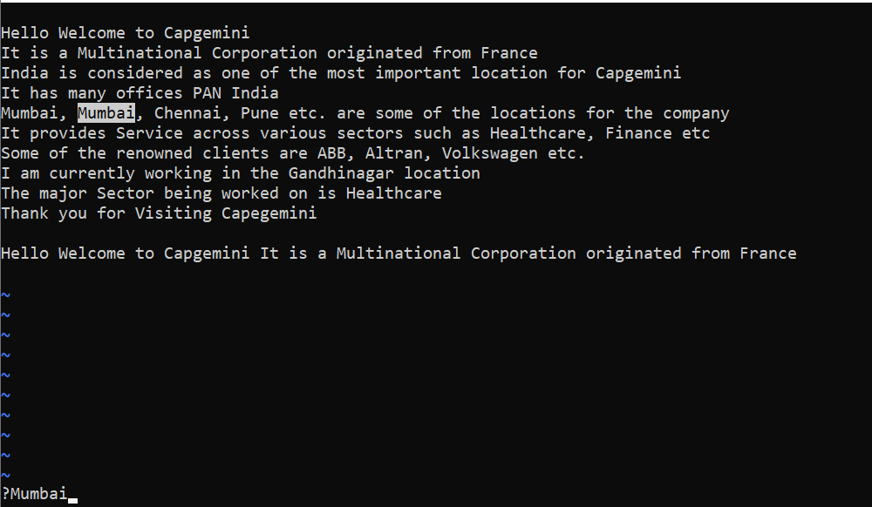

1. Search for a word forwards. Loop through all matches

Ans. /Mumbai

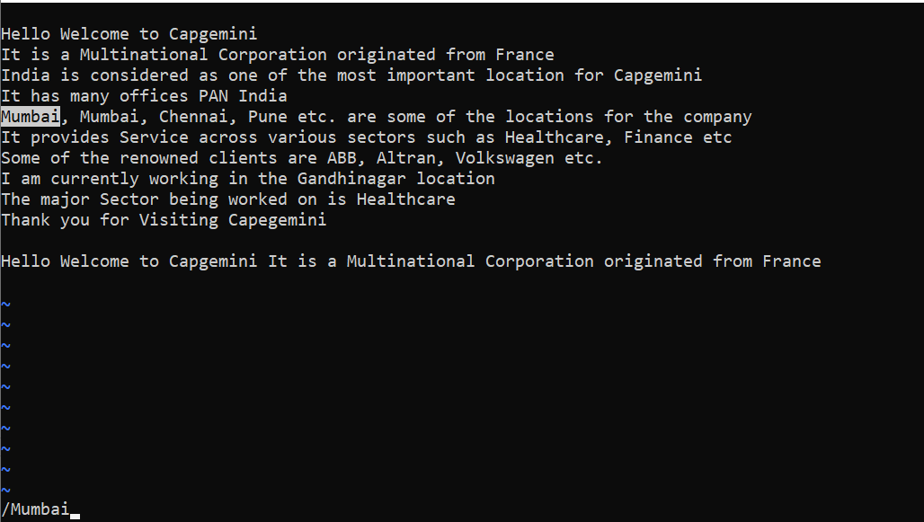

1. Join two lines together

Ans. J

1. Enable line numbering and then delete it

Ans. : set number

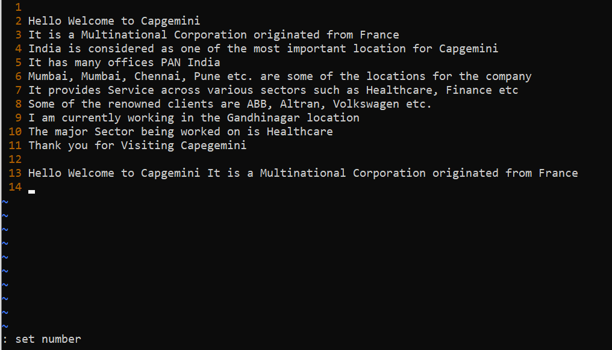

: set nonumber

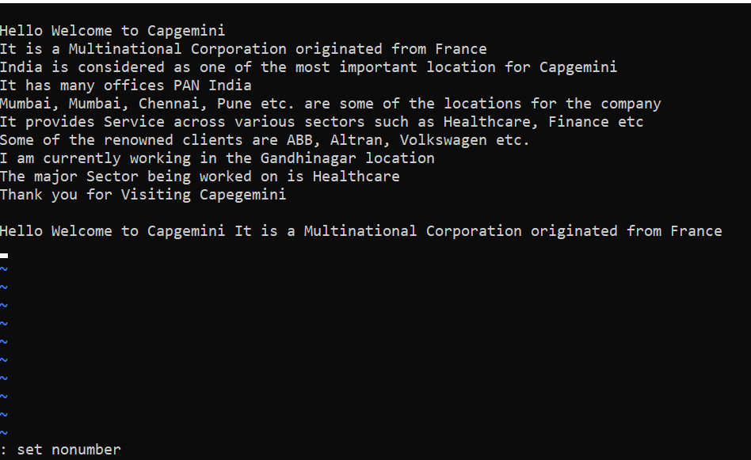

1. Make the search case insensitive

Ans. : set ic

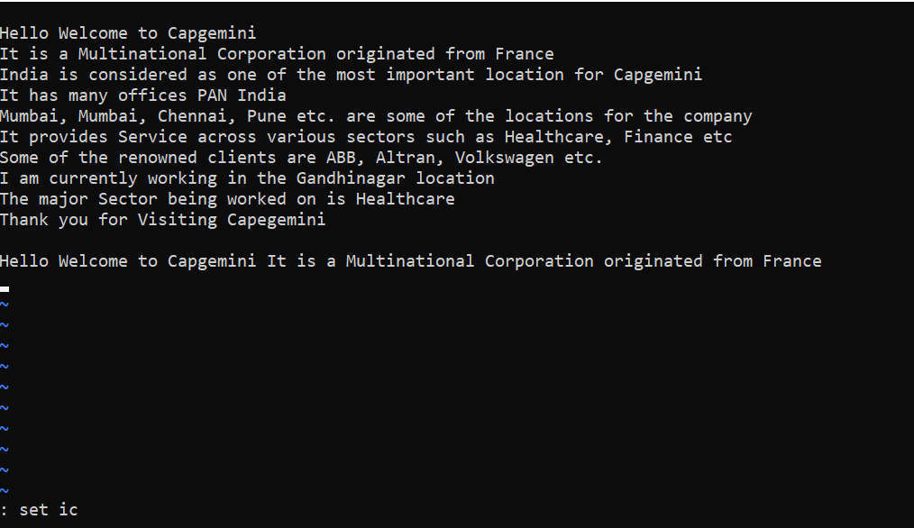

1. Delete 4 lines (and then paste them somewhere else)

Ans. Select the lines with V and then d to delete and p for paste

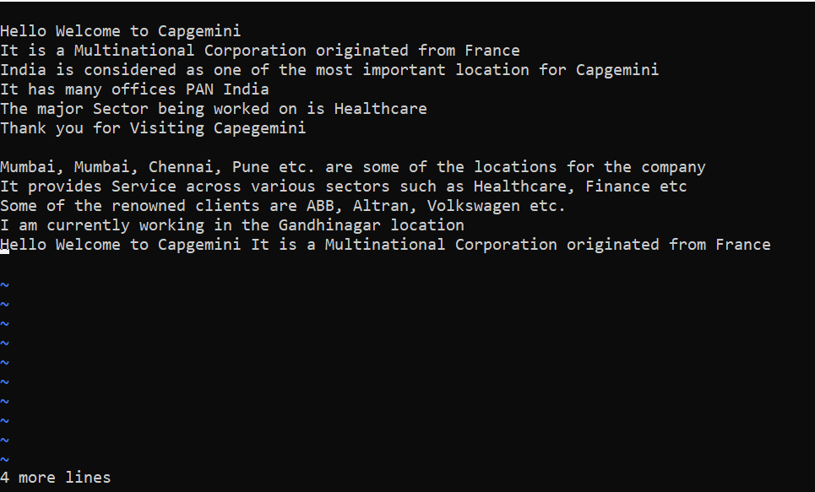

1. What is the command to delete part of the line starting from the current cursor position?

Ans. d$

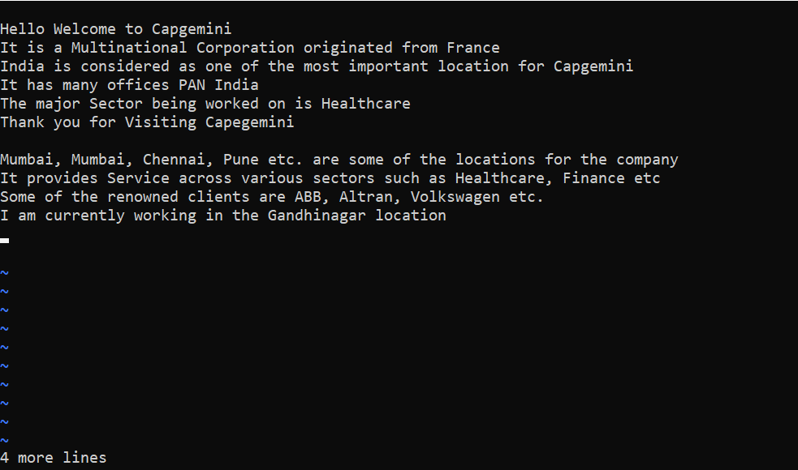

1. What is the command to delete the current word?

Ans. dw

