# String Functions Assignment

**Mandatory**

1. WAP to prompt and read a line of text with words separated by space. Tokenise and extract the words. Display them. Impement the following functions for this.
   1. int tokenise(char *arr); //tokenise and display tokens , return number of tokens to the caller

[Use strtok() to tokenise]

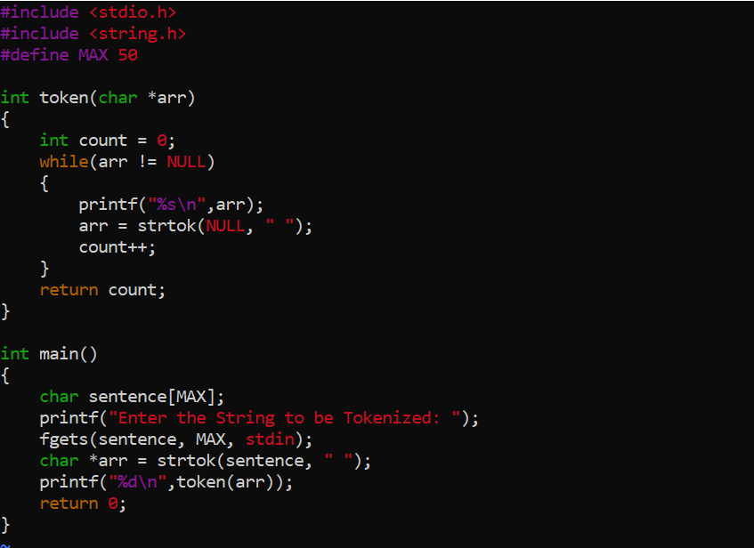

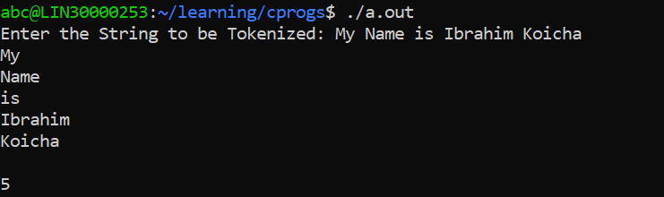

1. Implement your own strncat() which shall concatenate n characters from src to dest.

char *strncat(char *dest, const char *src, size_t n)

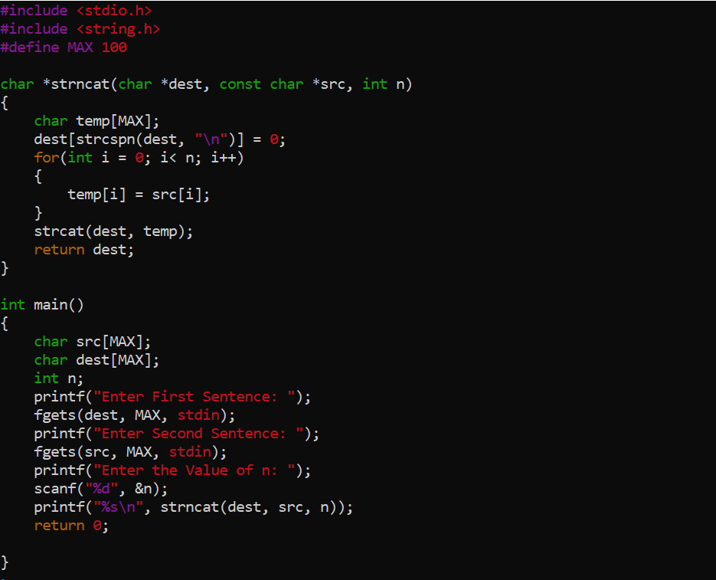

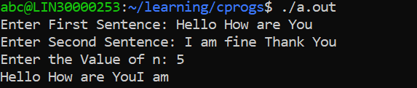

1. WAP to
   1. Search for and replace the vowel characters (upper and lower case) with “ay” in a word read from user. Consider a maximum word length of 40 characters.
   2. Identify the test inputs to be used
   3. Display updated string

