1. Which command is used to know the current working directory?

* **pwd**
* 

1. How would you find out its contents?

* **ls -l**
* 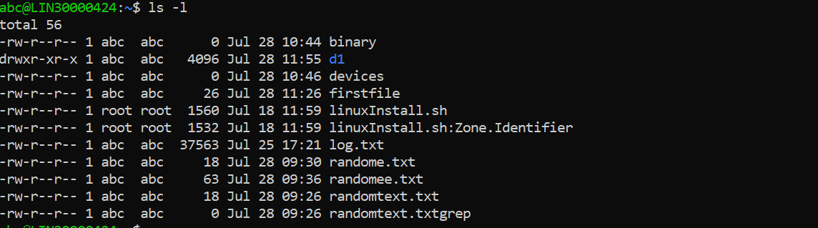

1. Identify the commands with inputs to do the following
   1. create a directory d1

* **mkdir d1**
* 
  1. create a subdirectory d2 in d1
* **mkdir d1/d2**
* 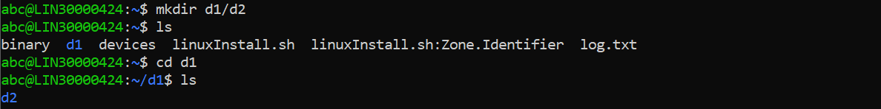
  1. change to directory d2
* **cd d2**
  1. create an empty file “f1.txt”
* **cat > f1.txt**
* 
  1. display the contents of “f1.txt”
* **cat ~/f1.txt**
* 
  1. view the contents of d1 from current directory d2
* **ls ..**
* 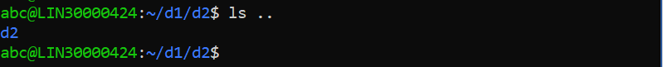

1. Use the Is command with its options. How will you identify directories from listing?

* **ls -1**
* 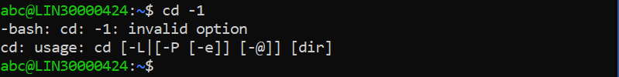

1. Use Is to do the following
   1. List files with single character names.

* **ls -d f\***
* 
  1. List hidden files also.
* **ls -a**
* 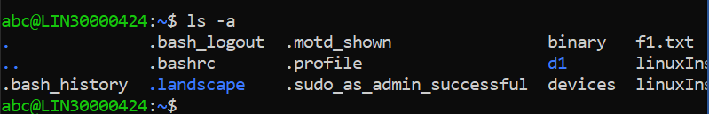
  1. Suppose there are files tb1.1, tb2.1, tb3.1, ...tb10.1. Write command to list all the files
* **ls tb\***
* 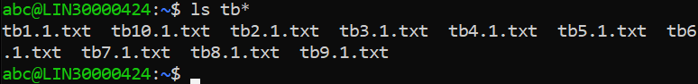

1. Write the command to list all files in descending order of their size.

* **ls -lS**
* 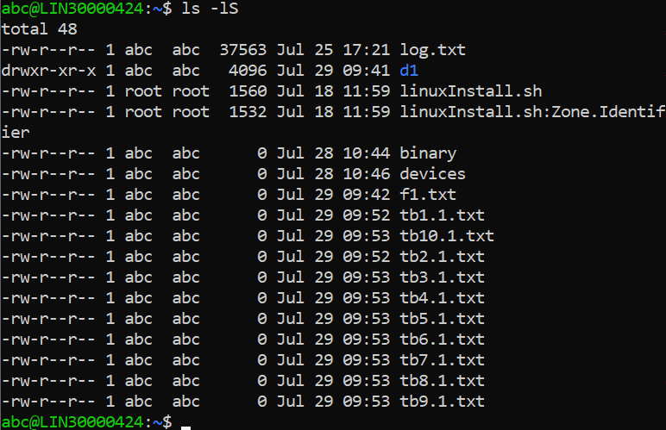

1. Suppose there are files temp1, temp2, temp3. Write command to remove the files without listing them explicitly.

* **rm temp\***
* 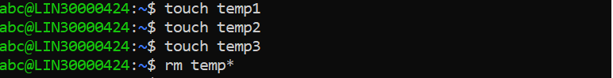

1. Which command is used to list top few lines in the file?

* **head filename**

1. Create a directory “testdir”

* **mkdir testdir**

1. Use cp command to do the following
   1. Copy the file tb1.1 (created above) in the same directory.

* **cp tb1.1 testdir**
* 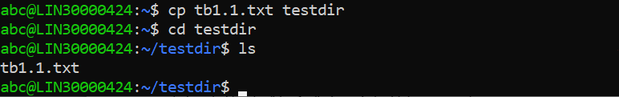
  1. Write a command to copy all the files i.e tb1.1,tb2.1,tb3.1,…..tb10.1 in a new directory –“new”
* **mkdir new && cp tb* new**
* 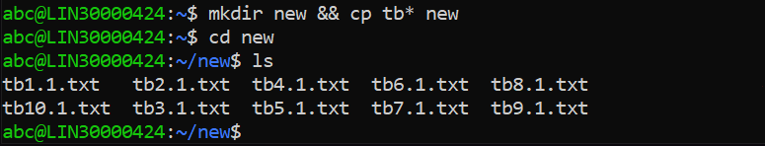
  1. Create a subdirectory in new in named “new1”.
* **mkdir new/new1**
* 
  1. Write a command to copy selectively only tb2.1, tb6.1, tb7.1 and tb10.1 in the directory new1.
* **cp tb2.1.txt tb6.1.txt tb7.1.txt tb10.1.txt new1**
* 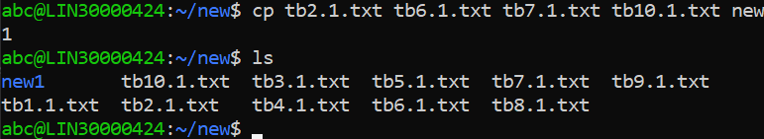
  1. Write a command to copy the entire directory “new” to a directory “newprogs.”
* **mkdir newprogs && cp -r new newprogs**
* 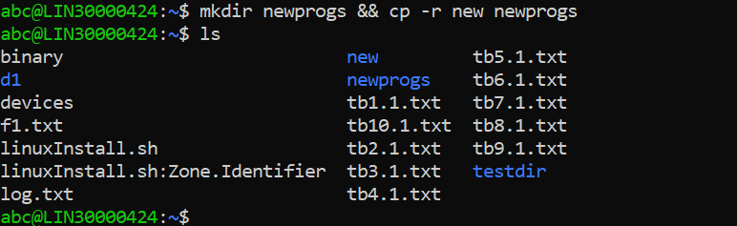

1. Find out the difference between

a. “mv” & “cp”

* **The “mv” command will move the files but it will delete the original files while moving and the “cp” command will copy the files keeping the original files intact.**

b. “rm,” “rmdir”

* **The “rm” command removes complete directories, including subdirectories and files and the “rmdir” command empty directories.**

c. “mkdir” and “mkdir -p”

* **The “mkdir” command creates a new, empty directory whose name is defined by the path and “mkdir -p” will create a parent directory** **first if it** **does not exist.**

1. Use a single command rmdir once to remove “testdir” and all its sub directories and files created above.

* **rmdir testdir**

1. Which command is used to get the manual information of a command?

* **“man” command is used to get the manual information of a command.**

1. If you are not able to change to a directory what could be the likely cause?

* **The** **probable cause for not being able to change a directory is that we do not own that file or the directory.**

1. Explain the differences among the following commands:

a. cd /

* **Changes current directory to root directory**

b.  cd ..

* **Changes current directory to one level**

c.  cd

* **Changes current working directory**

d.  cd ../..

* **command to list the contents of the parent directory two level above**.