C question:-

Make a function’s for store and display a data. STR/01 + STR/02

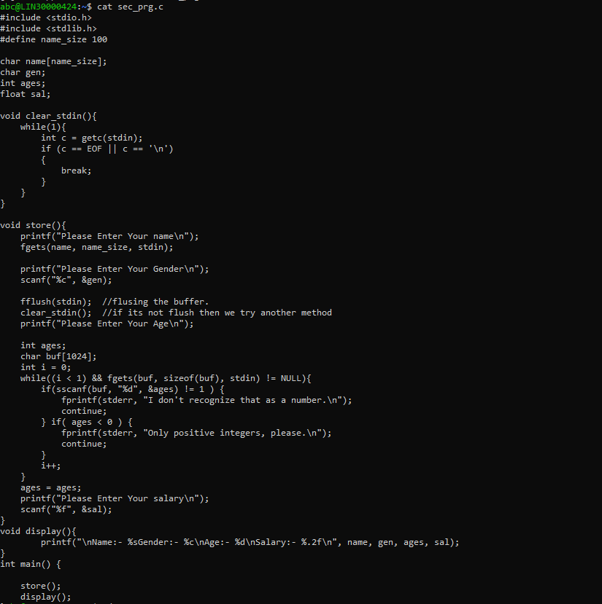

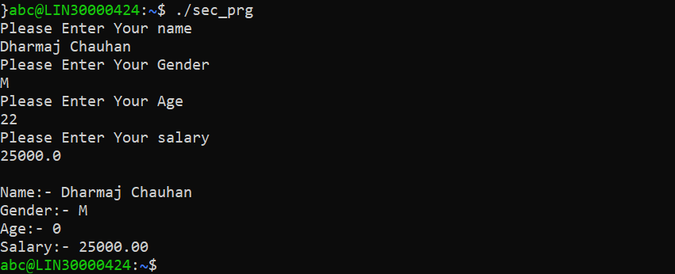

Make a structure for store and display a data. STR/01 + STR/02

