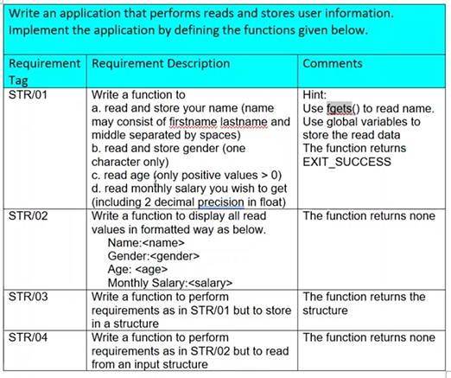

STR/01 and STR/02

CODE:

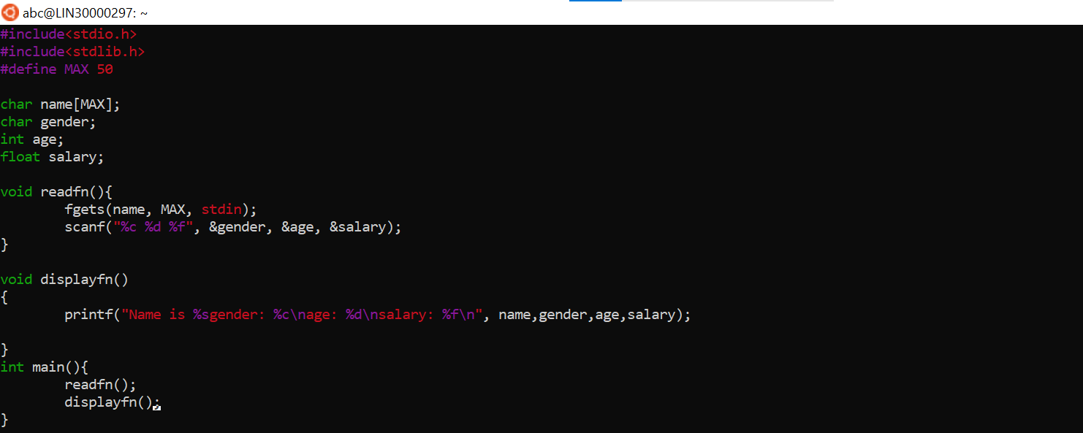

OUTPUT:

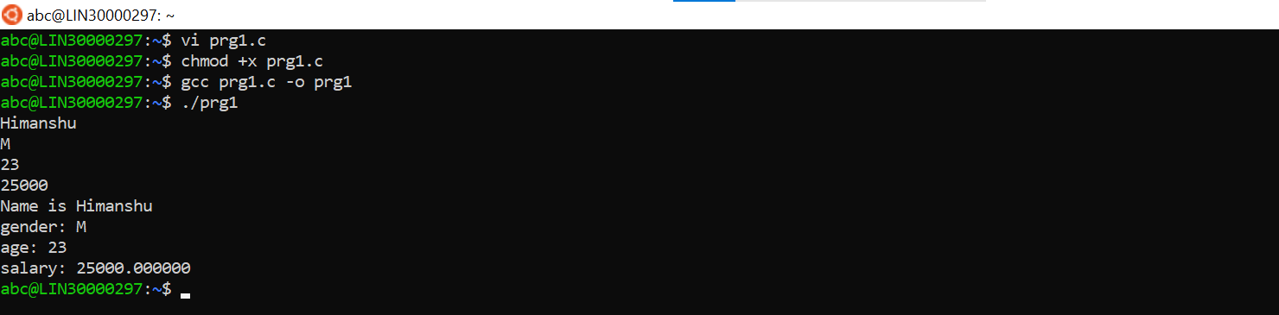

STR/03 and STR/04

CODE:

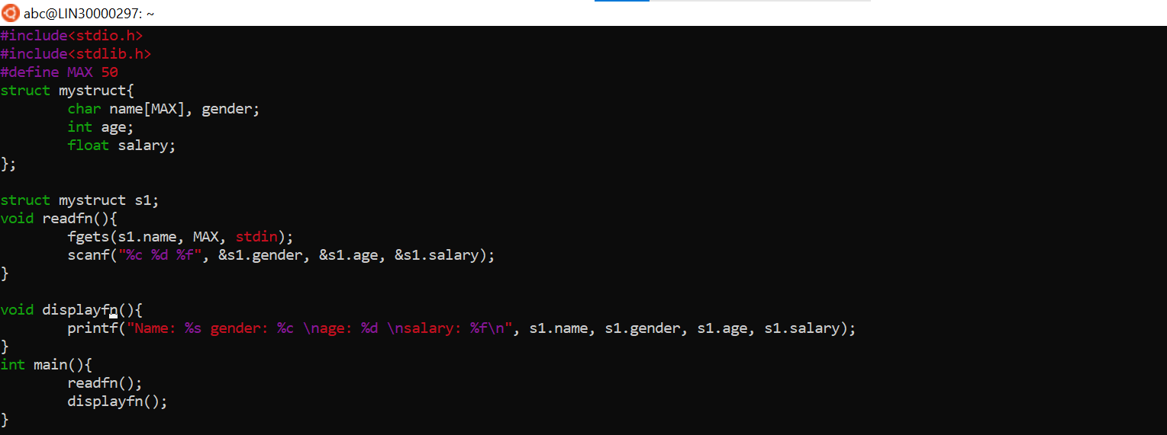

OUTPUT:

