## Vi Editor - Assignments

1. Invoke the vi editor with a filename (which is to be created)



1. Type a few lines(at least 10) in the editor. Let one or more lines contain the words given below.

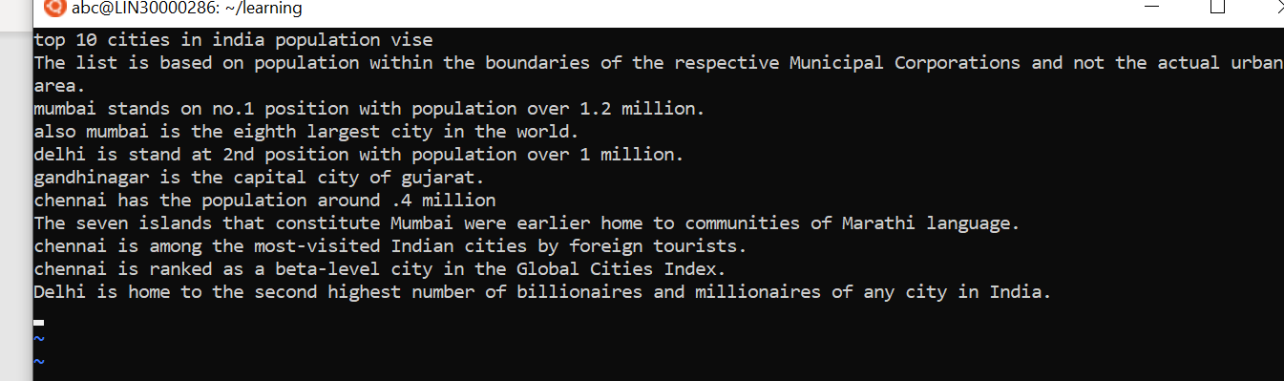

delhi mumbai chennai Mumbai

1. Save the file without exiting the editor



1. Navigate quickly to the beginning & end of the file





1. Delete first two lines & copy it after the last line.

By using 2**dd** and then go to last line and paste using **p**

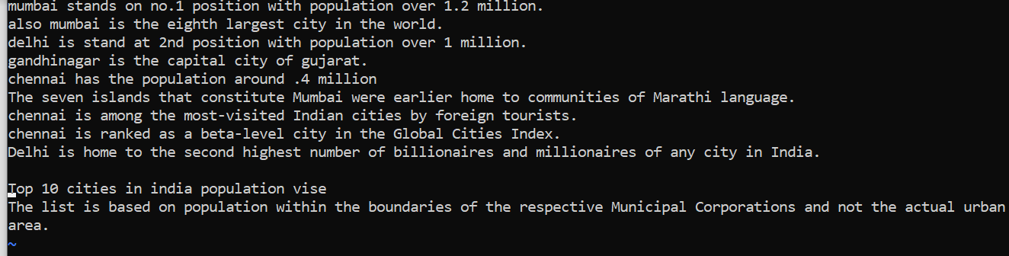

1. Now Copy the last two lines & paste them before the first line.

Using 3yy and p

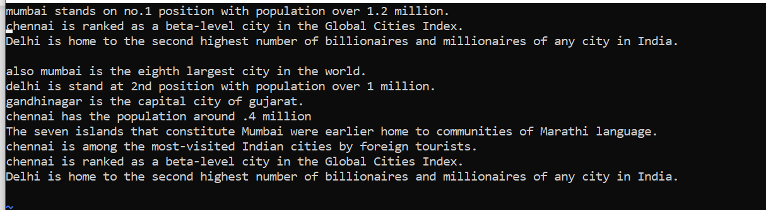

1. Combine last two lines of the file in a single line.

* **position the cursor anywhere on the last line and press J to join the two lines**.



1. How will you insert a line before the first line? (Hint : Find such an option in the tutorial document)

* Use :1 to go to the first line
* Use ctr + V to enter the visual mode
* Hit shift + Enter to shift position and type the line you want to insert

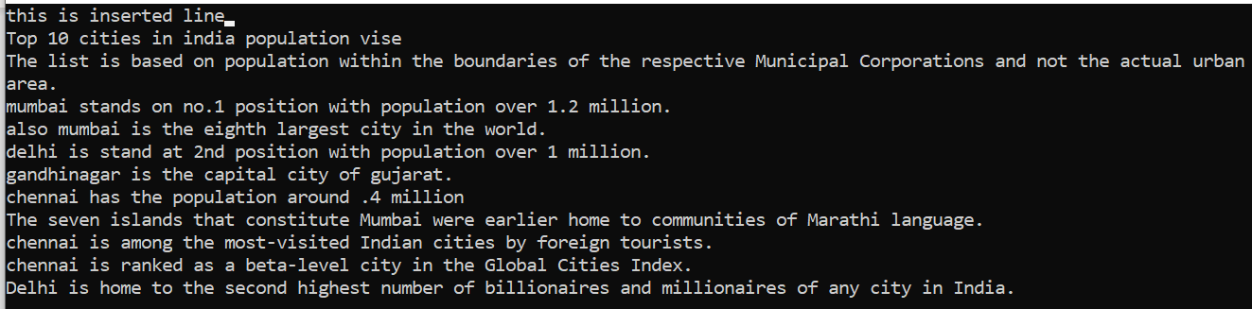

1. How will you paste a yanked buffer before the current line?

* By using **P**

1. Search the document for a string “delhi”



1. Replace a single occurrence of “delhi” with “Mumbai”

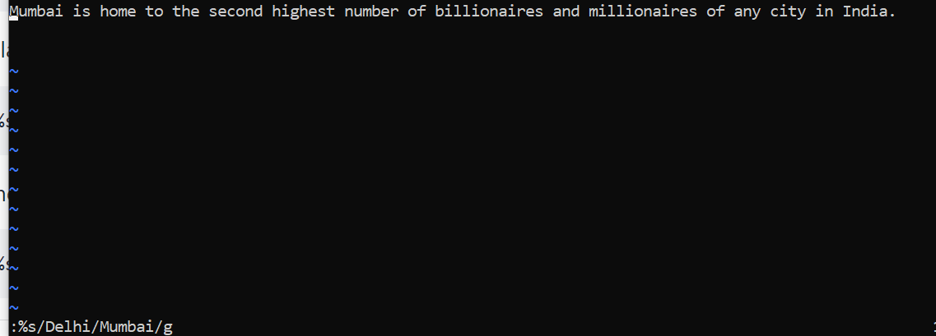

1. Replace all occurrences of “delhi” on a particular line with “Mumbai” using one command.

* **:6s/delhi/Mumbai/g**

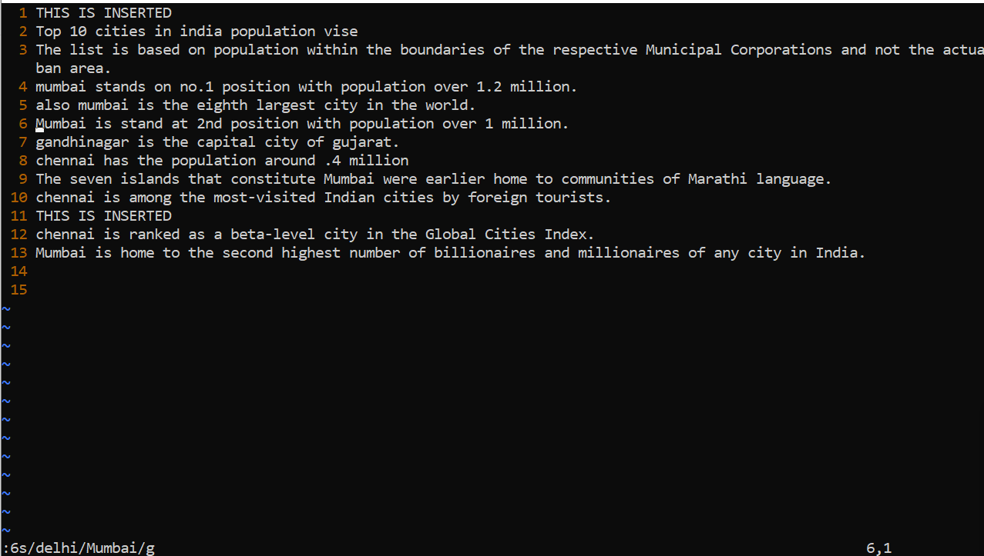

1. Replace “delhi” with “mumbai” for the entire document using one command.

* **:.,$s/delhi/Mumbai/g**

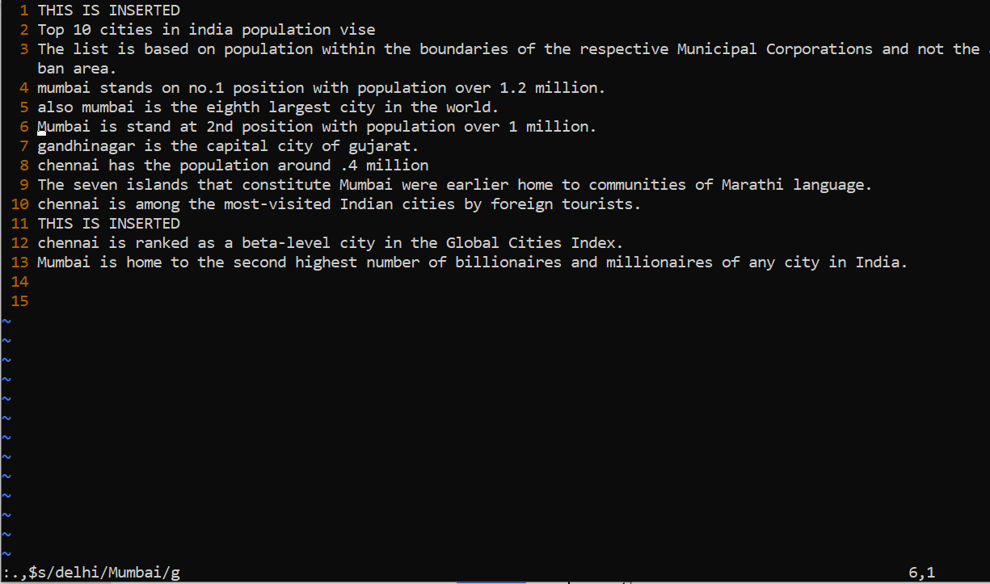

1. Replace all occurrences of “delhi” with “mumbai” for part of a document (e.g. line number 13 to 37).

* **:13,37s/delhi/Mumbai**

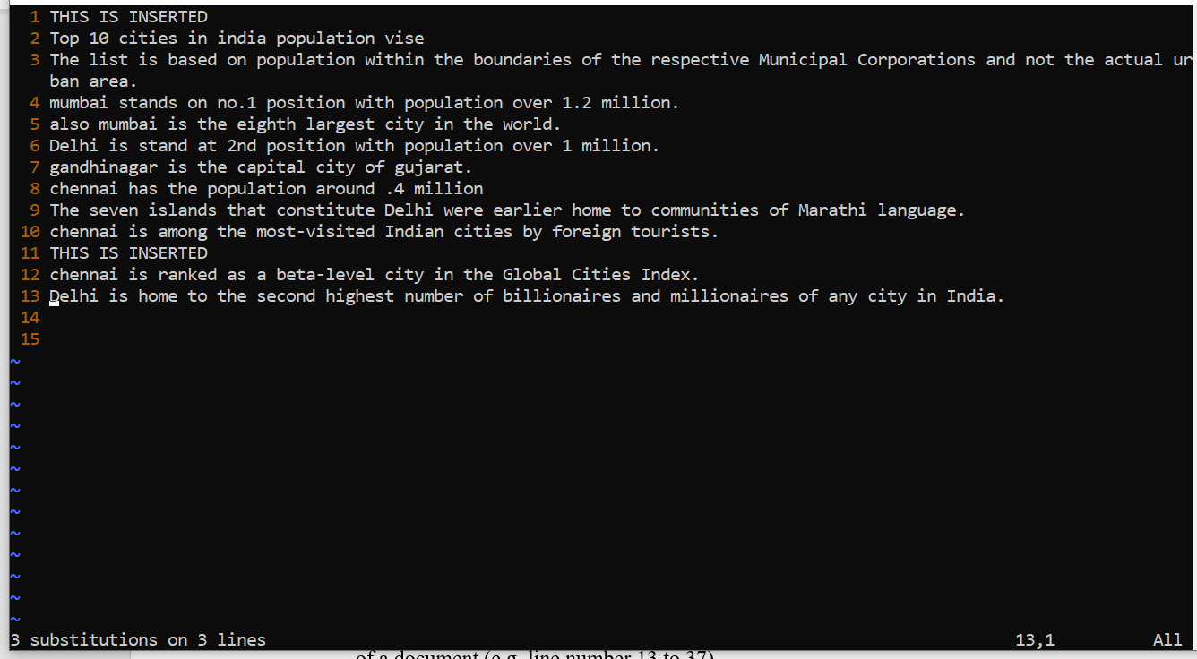

1. Undo the above command

* On command mode hit **u**

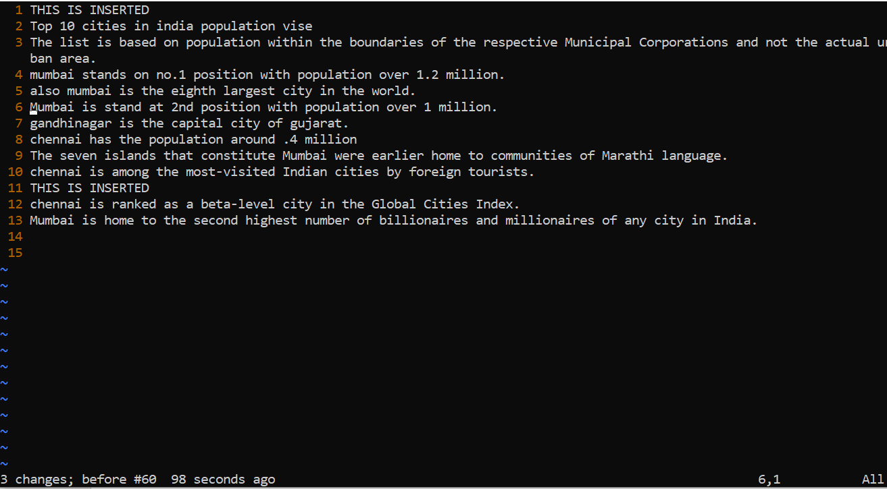

1. Replace only the first occurrence of “delhi” with “mumbai” in each line, for part of a document (e.g. line number 13 to 37).

* **:13,37s/<delhi>/Mumbai/g**
* 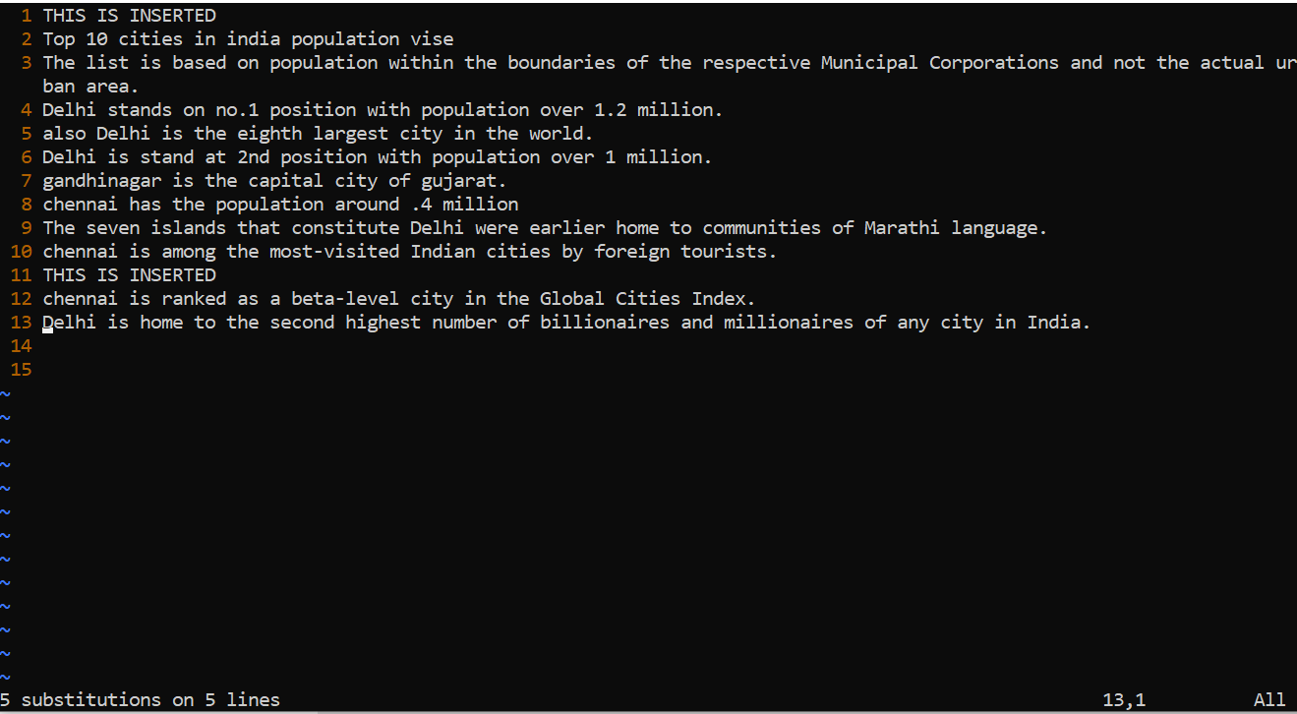

1. Undo the above comment. Redo it. Undo it again.

* Press **u**
* Hold **Ctrl and press r**
* Press **u**

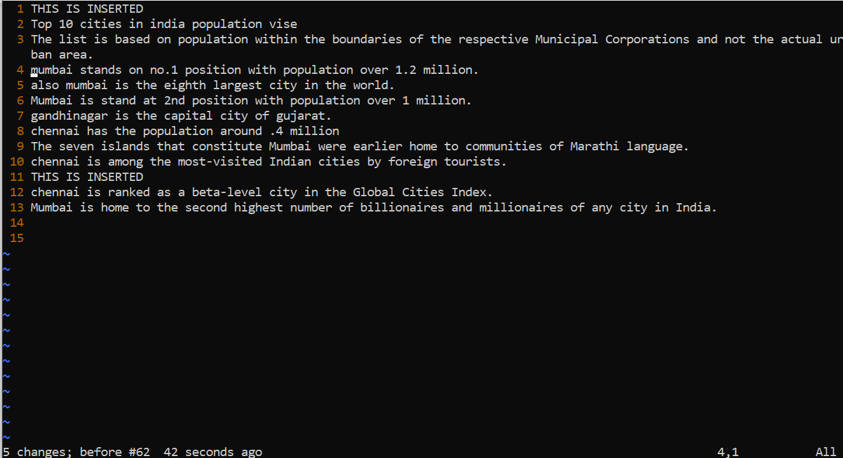

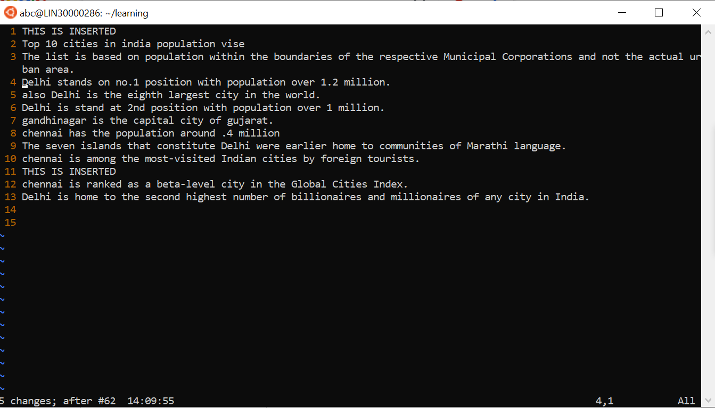

1. Replace all occurrences of “delhi” with “mumbai” for complete file interactively.

* **:.,$s/delhi\|Delhi/Mumbai/g**
* 

1. Search for a word backwards. Loop through all matches.

* **?Delhi**

1. Search for a word forwards. Loop through all matches

* **/Delhi**

1. Join two lines together.

* **position the cursor anywhere on the last line and press J to join the two lines**

1. Enable line numbering and then disable it

* Set nu

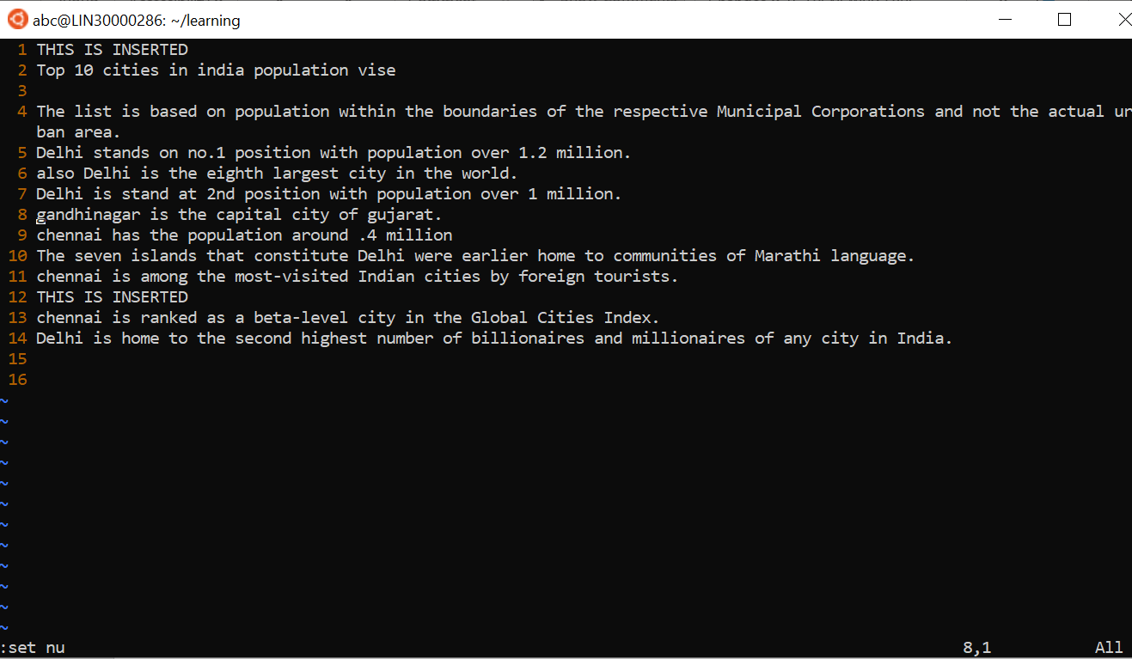

1. Make the search case insensitive

* **:set ignorecase**

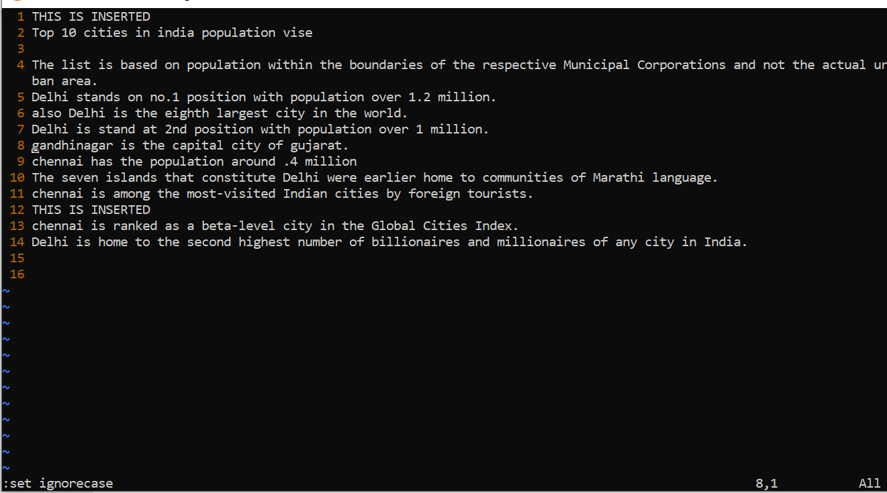

1. Delete 4 lines (and then paste them somewhere else)

* By using **4dd**

And press **p** to paste somewhere else

* 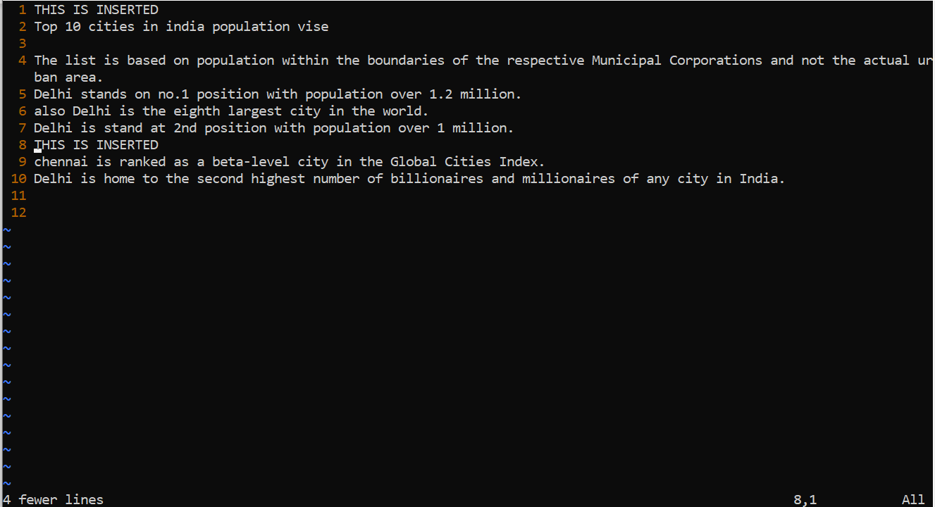

1. What is the command to delete part of the line starting from the current cursor position?
   * Press **Esc** come to command mode
   * press **v** enter visual mode
   * **Shift + g** "selects everything from current position to EOF"
   * **DEL** "delete selected"
2. What is the command to delete the current word?

* **dw**