**USING STRUCTURES IN C – NOTES**

* Structure:
* Structures (also called structs) are a way to group several related variables into one place. Each variable in the structure is known as a **member** of the structure.
* Create Structure:

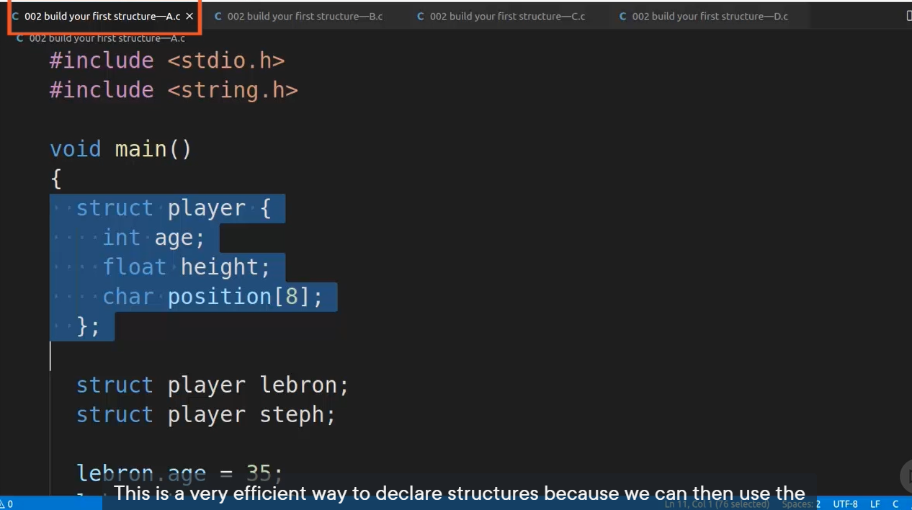

* To access the structure, you must create a variable of it.

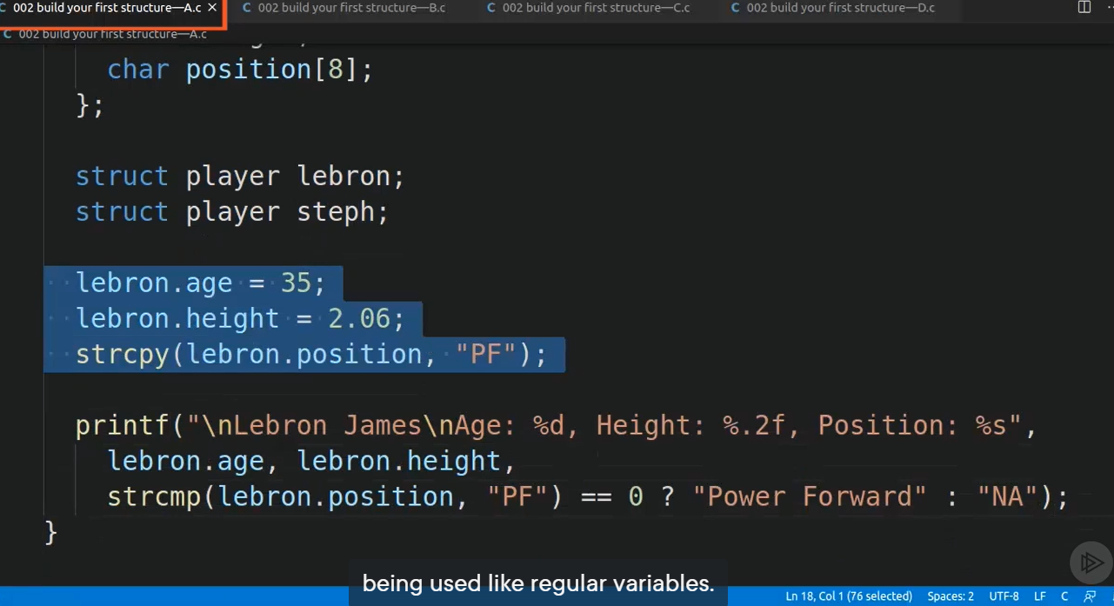

* Nested Structure:

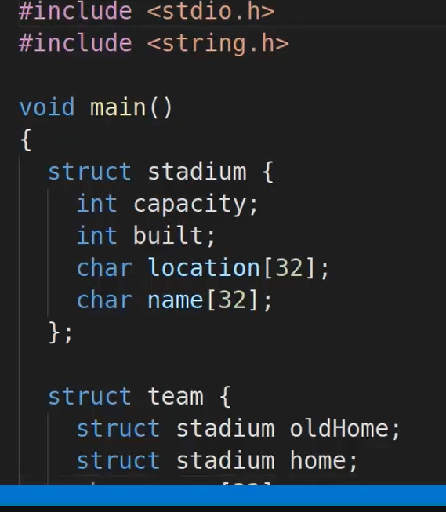

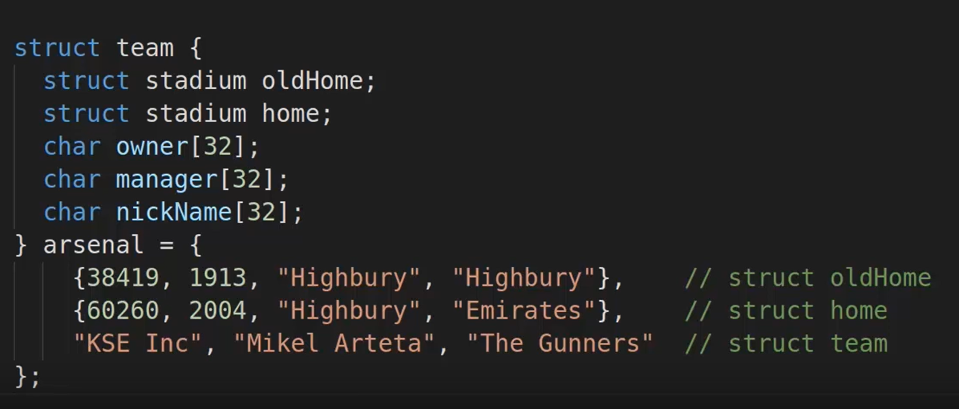

* Array of Structure declaration:

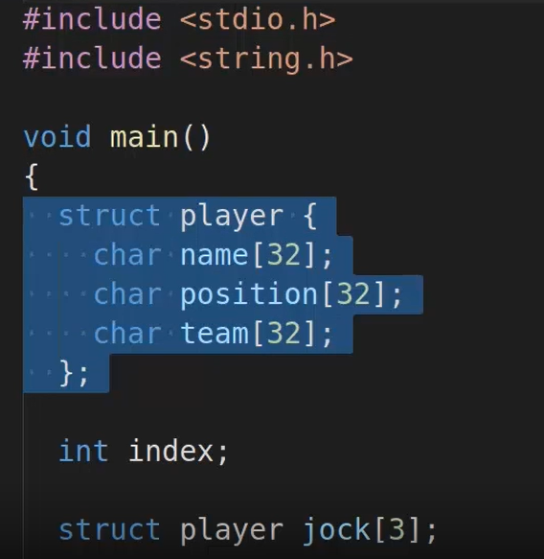

* Pass a structure to a function:

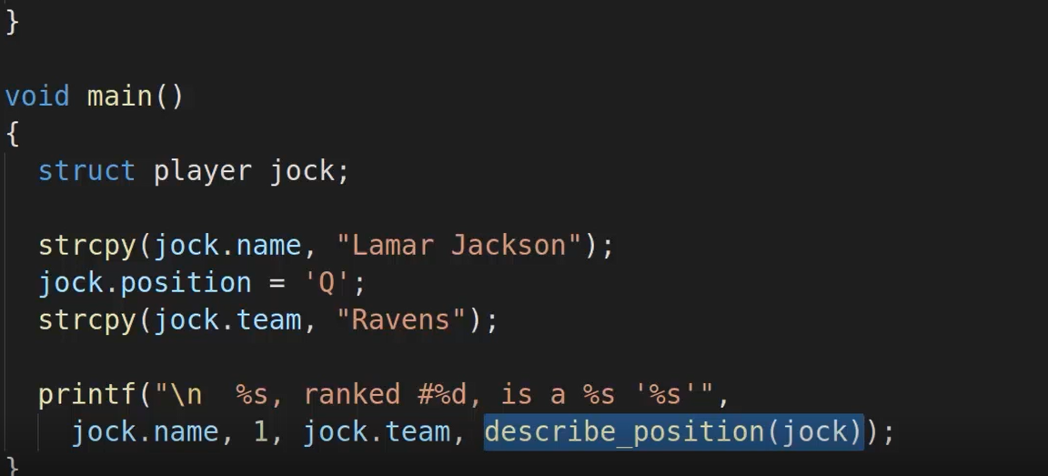

* Pointers: Hold address of another variables.

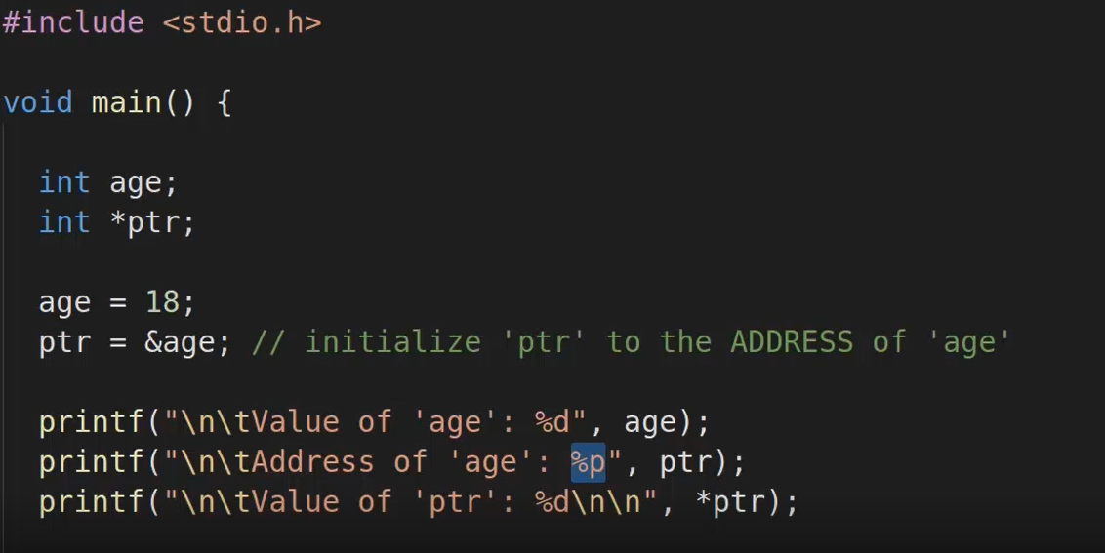

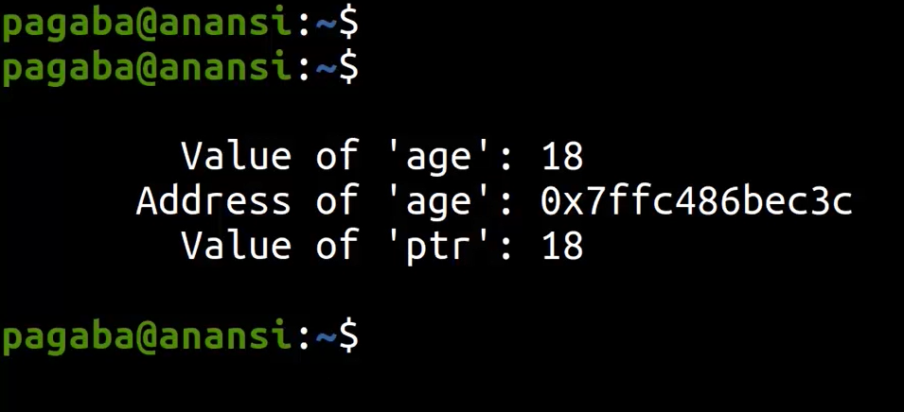

* Pointers with arrays:

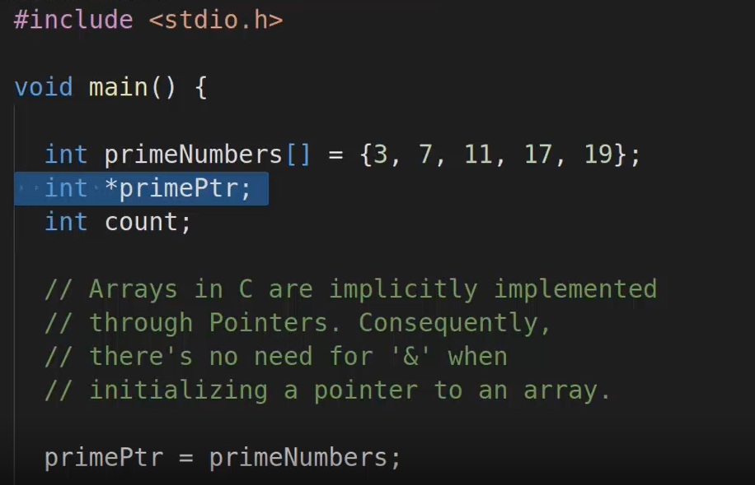

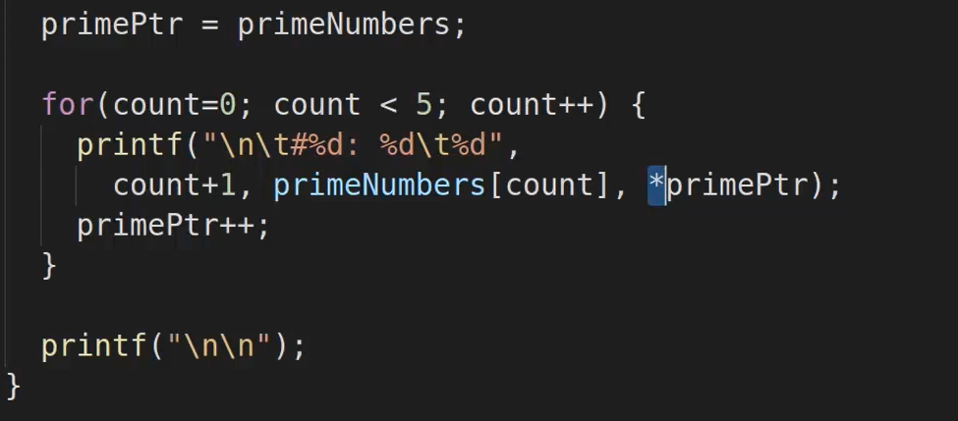

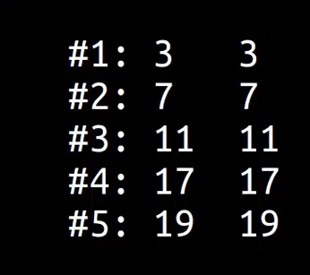

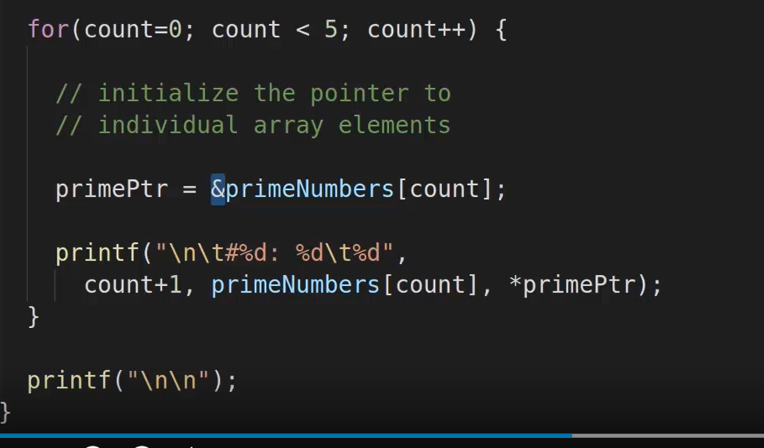

* Use pointers with structures:

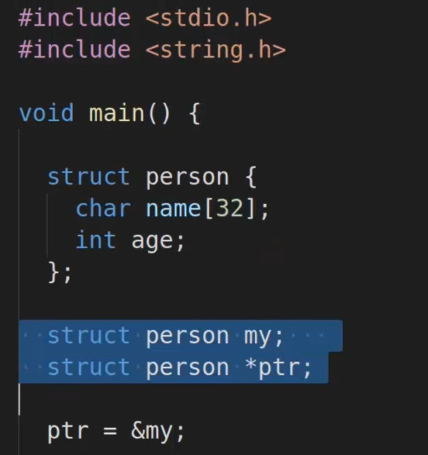

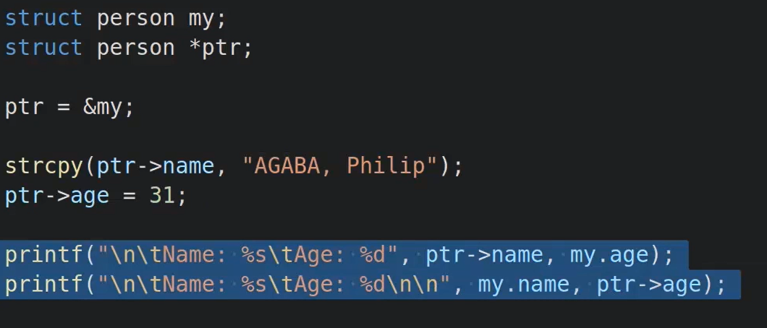

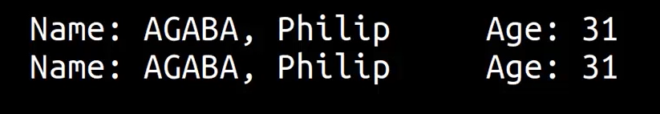

* Managing memory with bit fields:

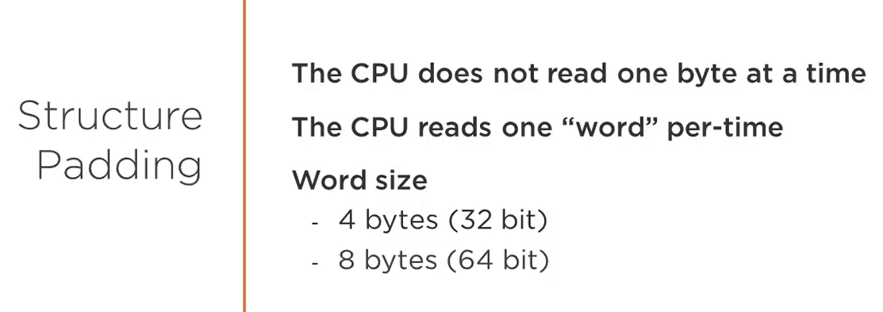

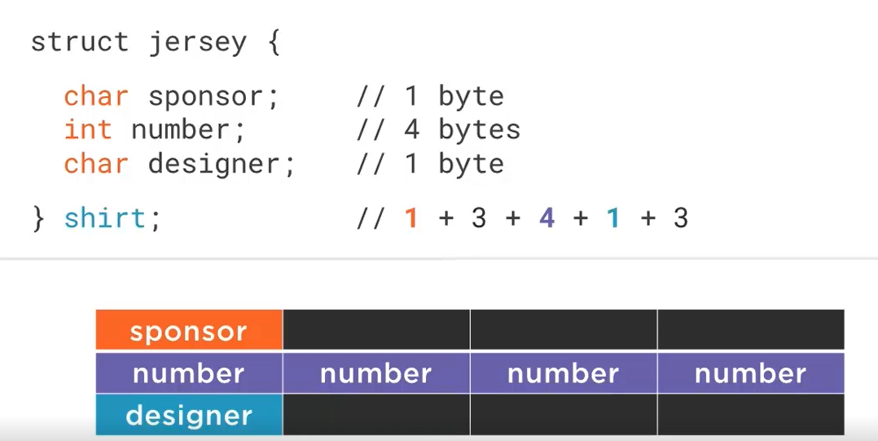

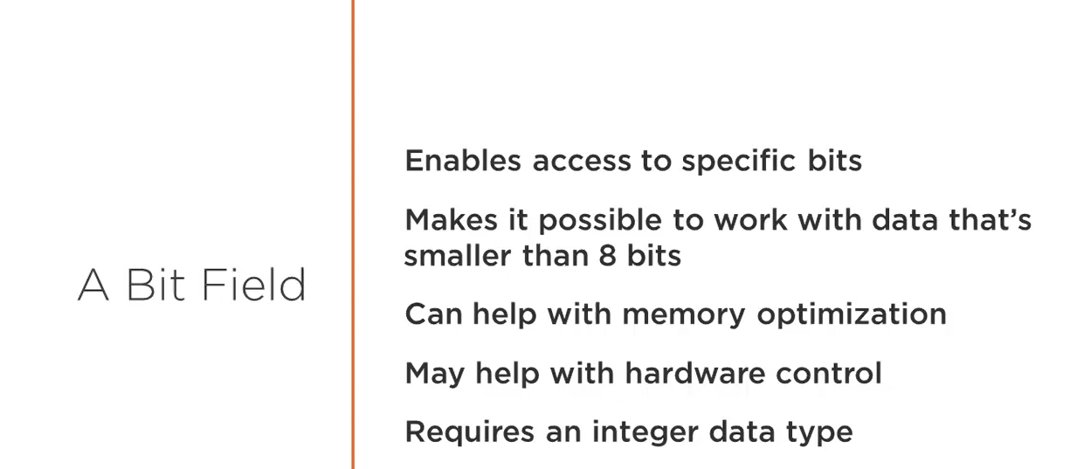

For writing and reading raw-data, **two file I/O functions are fwrite() and fread()**.

* Union:
* **Union** can be defined as a user-defined data type which is a collection of different variables of different data types in the same memory location. The union can also be defined as many members, but only one member can contain a value at a particular point in time.
* They share the same memory location.
* Enum:
* The enum in C is also known as the enumerated type.
* It is a user-defined data type that consists of integer values, and it provides meaningful names to these values.
* The use of enum in C makes the program easy to understand and maintain.
* The enum is defined by using the enum keyword.