**Printf scanf -Assignment**

Q1. WAP With

1a. function readdisplay() to read the following data type only one at a time at run and to display.

1. Char type
2. Integer type
3. Char array of maximum 80 characters
4. Short type
5. Float type

Test data : ‘c’, 8978, “hello”, 8,45.678

‘H’, 254, “hello Hi how”, 256, 145.2678

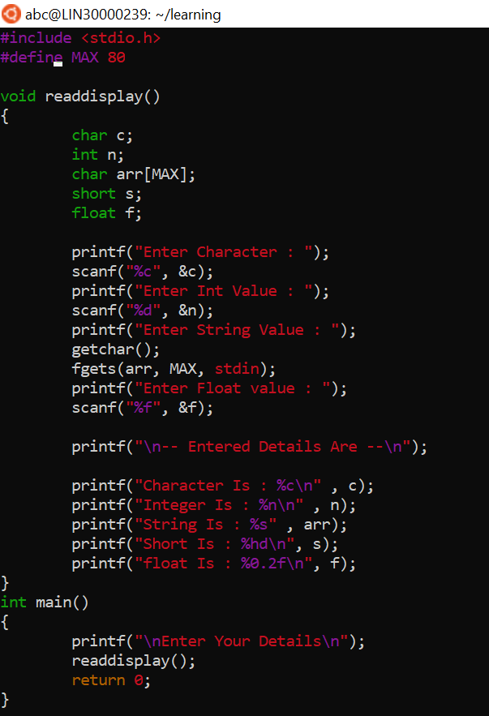

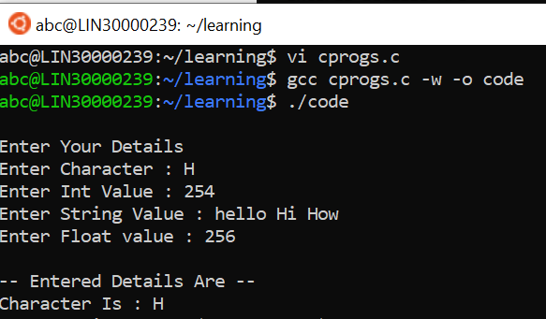

1b. Create a copy of readdisplay() as function readdisplay2() with changes below

Instead of reading 1 data at a time, read all inputs using a single scanf().

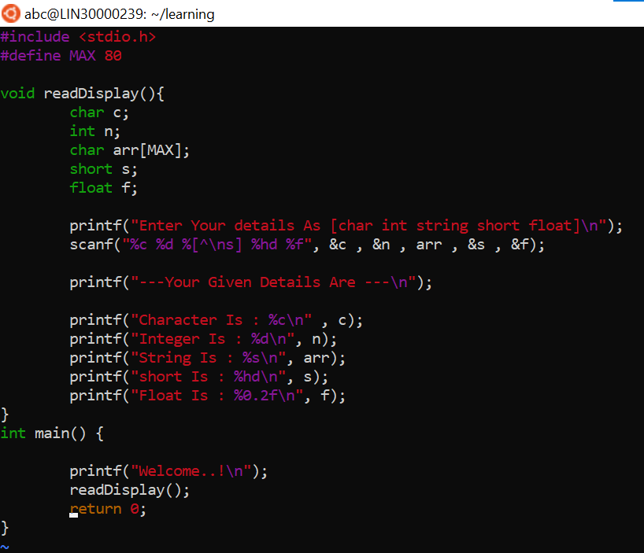

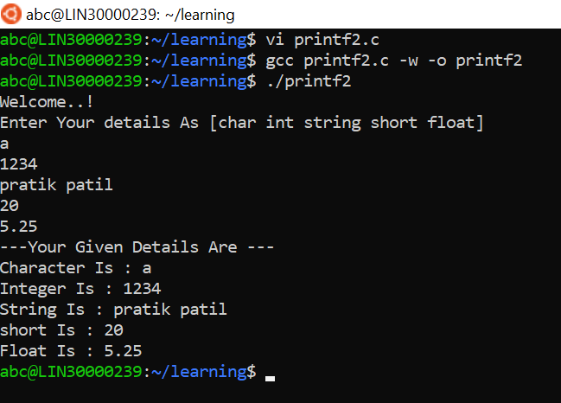

1c. display the char array content in upper case

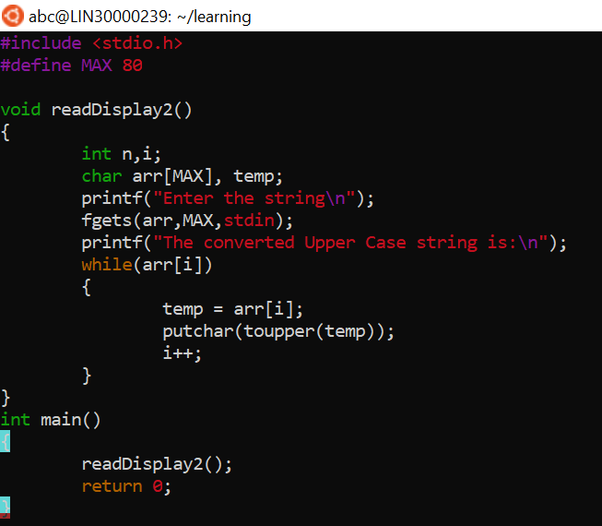

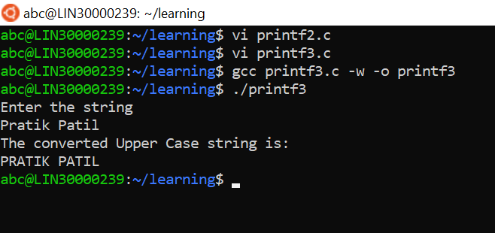

1d. Add code to display the size of each data type mentioned in Q1a and sizeof the variables of each datatype (You may refer sample code in data_type_size.c )

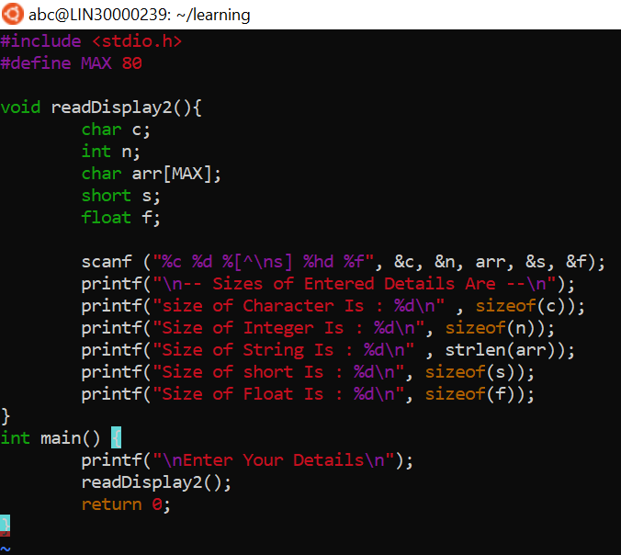

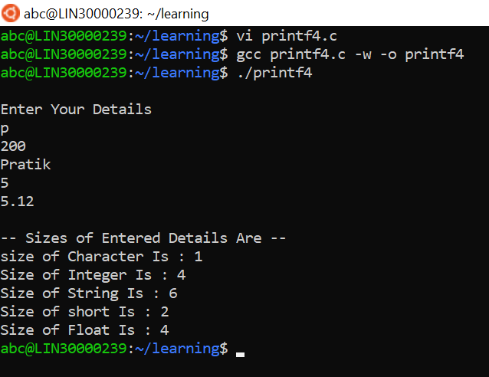

Q2. Try to run the program with code snippet below. Check the output and analyse. Fix  it to get correct result.

#include<stdio.h>

int main()

{

        unsigned long int ul =  200333333334340;

        printf("value is:%d\n", ul);

        return 0;

}

**Answer :-**

The output is invalid of this program and negative value because we have assigned variable ul as unsigned long int and then we are printing the value of ul as **%d** which is used for displaying integer value, so to solve this you must use **“%ld”** in **printf** statement to print the Unsigned Long Int.