**Structure in c**

A structure is **a collection of variables of same or different datatypes**. It is useful in storing or using informations or databases.

Arrays allow to define type of variables that can hold several data items of the same kind. Similarly **structure** is another user defined data type available in C that allows to combine data items of different kinds.

**Define a Structure**

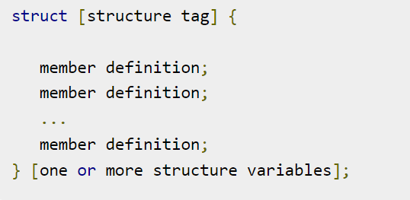

**Array of Structure**

An array of structures is simply **an array in which each element is a structure of the same type**. The referencing and subscripting of these arrays (also called structure arrays) follow the same rules as simple arrays.

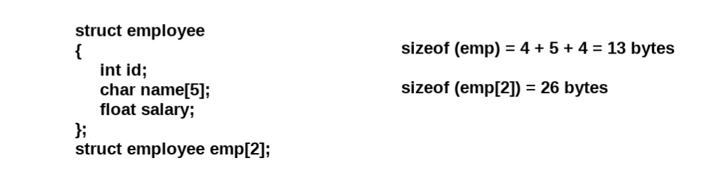

**Structure Pointer**

It is defined as **the pointer which points to the address of the memory block that stores a structure** is known as the structure pointer.

Below is an example of the same:

Example: struct point { int value; }; // Driver Code int main() { struct point s; struct point *ptr = &s; return 0; }

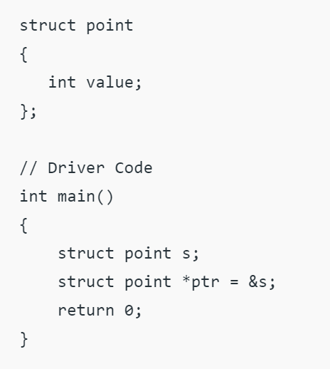

**Unions**

In this tutorial, you'll learn about unions in C programming. More specifically, how to create unions, access its members and learn the differences between unions and structures.

A union is a user-defined type similar to [structs in C](https://www.programiz.com/c-programming/c-structures) except for one key difference.

Structures allocate enough space to store all their members, whereas **unions can only hold one member value at a time**

We use the union keyword to define unions. Here's an example:

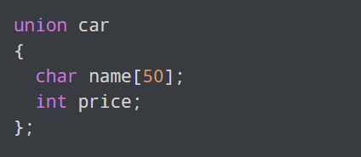

The above code defines a derived type union car.

**Union**

A union is **a special data type available in C that allows to store different data types in the same memory location**. You can define a union with many members, but only one member can contain a value at any given time.

Que

1.what is Structure ?

2. how to declare structure ?

3. What is use of union in C?

4. What is the size of a C union?

5. What is the structure at the pointer?

6. What is the size of struct pointer?

7. How do you pass a structure into a function?