**Grep Assignment**

Q 1. Use any .c file. Using grep command extract and display

a) all lines beginning with #include with line numbers.

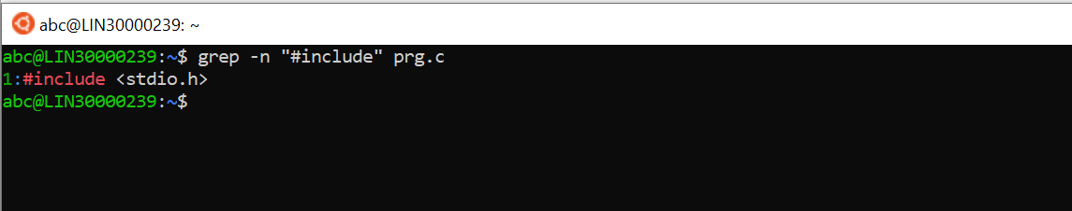

b) display all lines which do not begin with #include

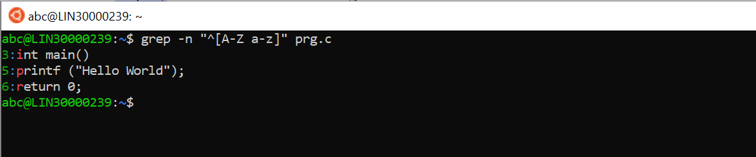

c) display the line number of main()

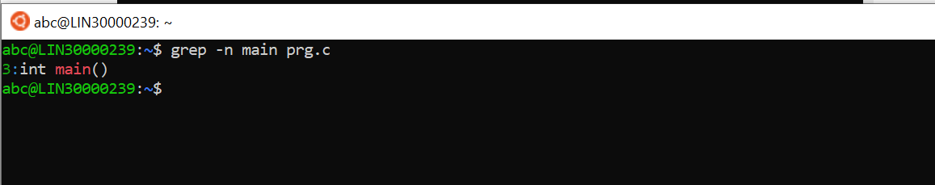

d) extract all lines containing characters of opening and closing parathesis {(,))

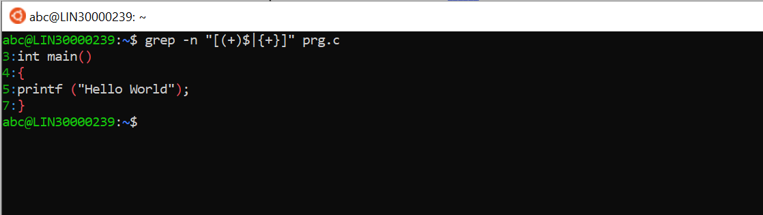

Q 2. Perform the above operations on a set of *.c files

