Vi Editor - Assignments
- Invoke the vi editor with a filename (which is to be created)
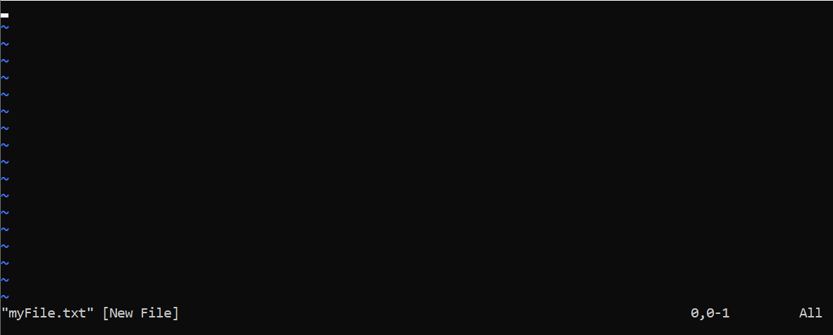
- Type a few lines(at least 10) in the editor. Let one or more lines contain the words given below.
delhi mumbai chennai Mumbai
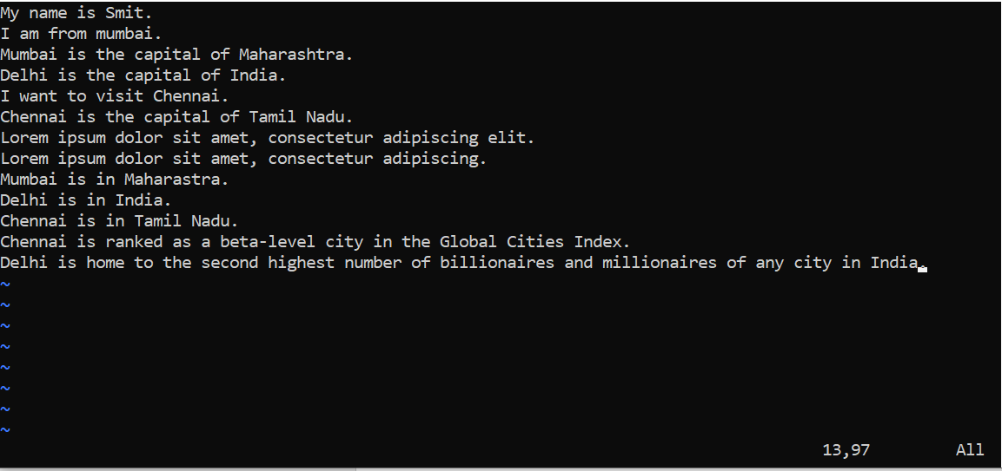

- Save the file without exiting the editor
Command- :w
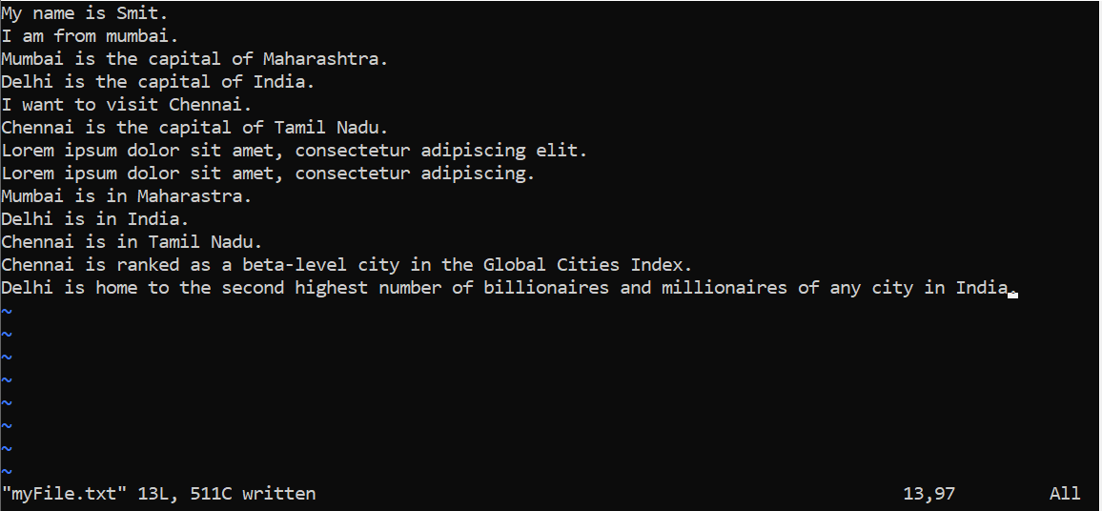
- Navigate quickly to the beginning & end of the file
Navigate quickly to the beginning of the file- :1
Navigate quickly to the end of the file- :$
- Delete first two lines & copy it after the last line.
Delete first two lines- 2dd
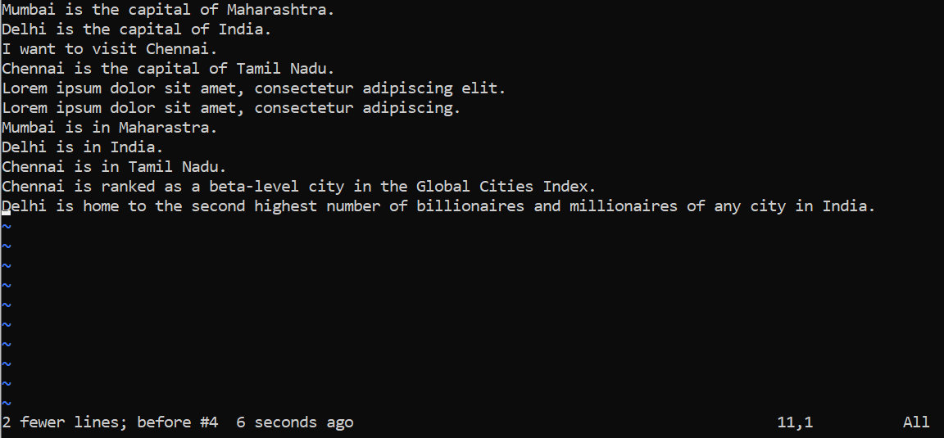

Copy after last line- p
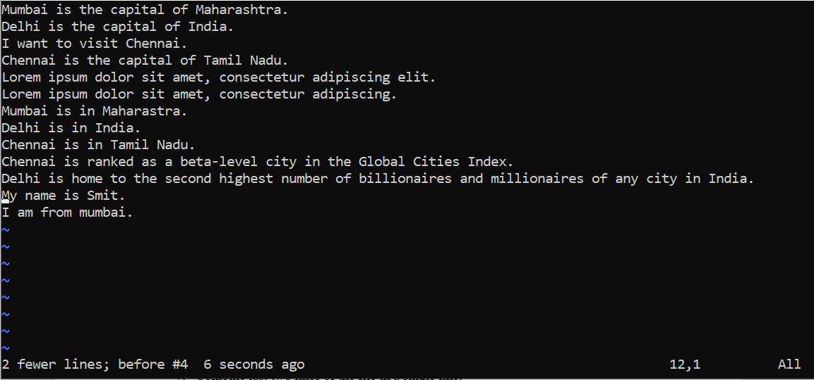
- Now Copy the last two lines & paste them before the first line.
To copy last two lines- 2yy
To paste before first line- P
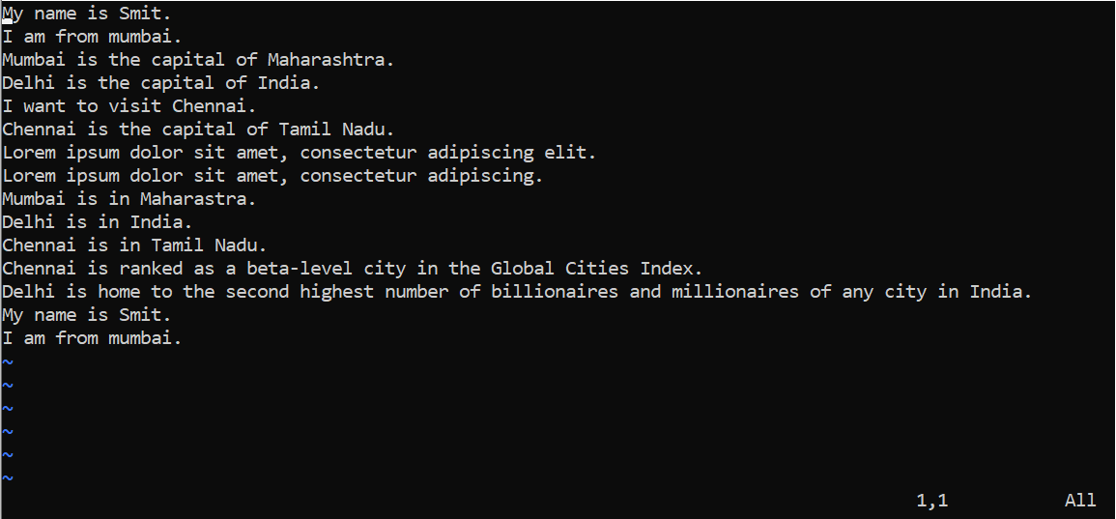

- Combine last two lines of the file in a single line.
Command- J
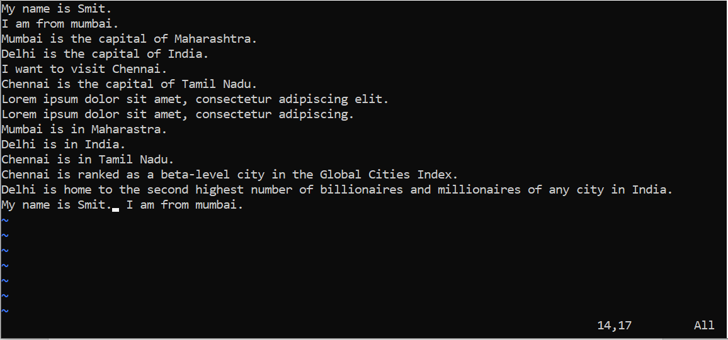
- How will you insert a line before the first line? (Hint: Find such an option in the tutorial document)
Command- R SHIFT ENTER
- How will you paste a yanked buffer before the current line?
Command- P
- Search the document for a string “delhi”
Command- /delhi
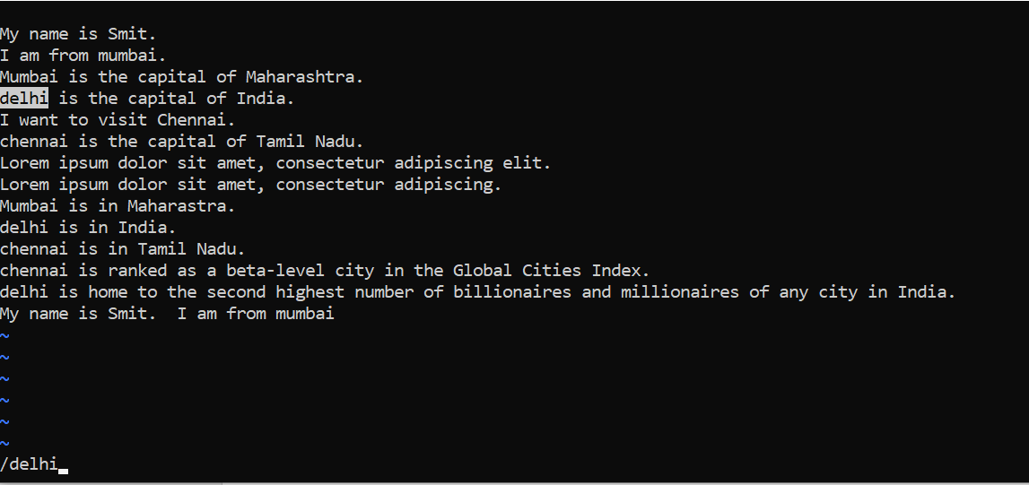
- Replace a single occurrence of “delhi” with “Mumbai”
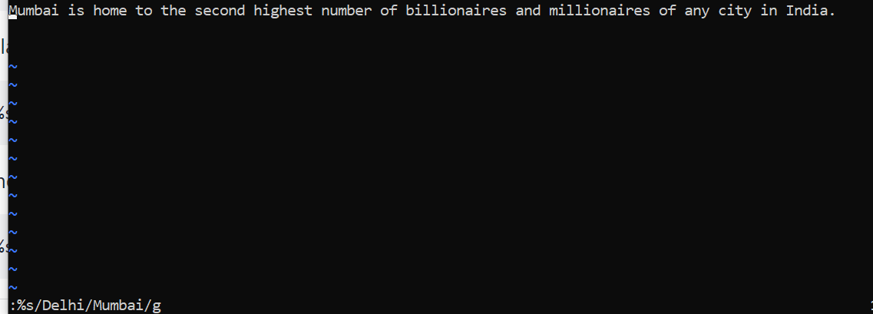
- Replace all occurrences of “delhi” on a particular line with “Mumbai” using one command.
- :6s/delhi/Mumbai/g
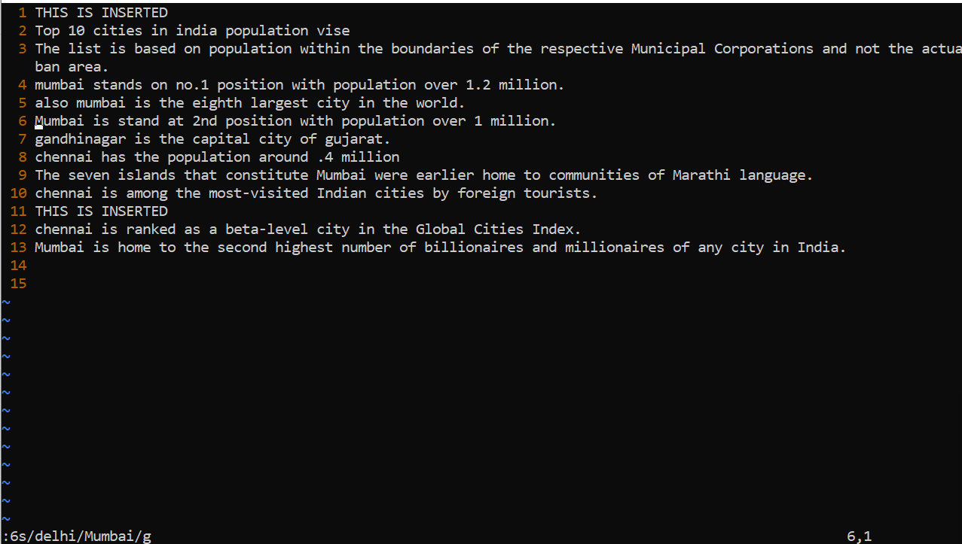

- Replace “delhi” with “mumbai” for the entire document using one command.
- :.,$s/delhi/Mumbai/g
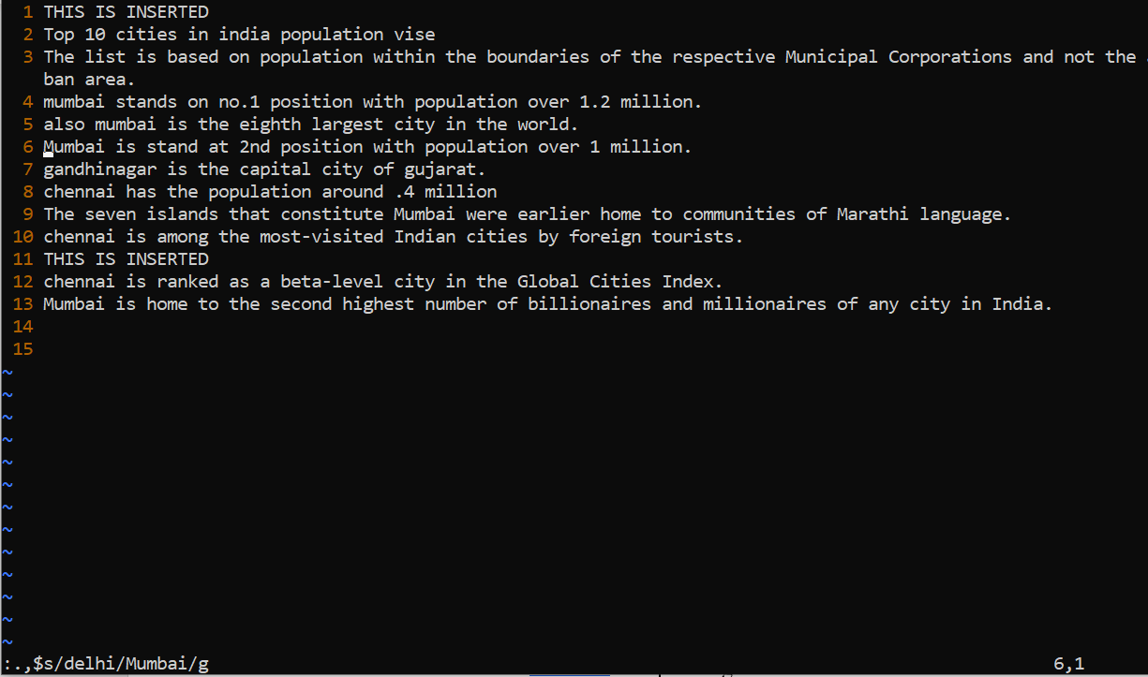
- Replace all occurrences of “delhi” with “mumbai” for part of a document (e.g. line number 13 to 37).
- :13,37s/delhi/Mumbai
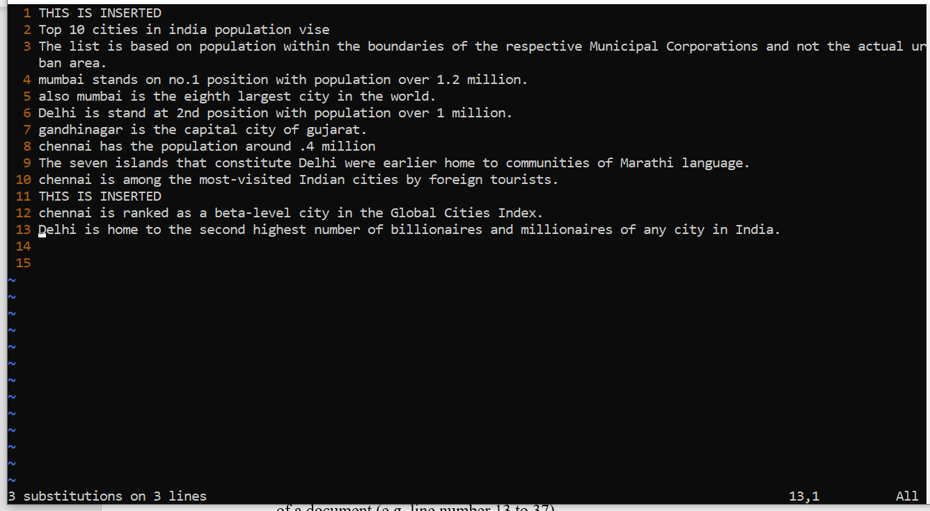
- Undo the above command
- On command mode hit u
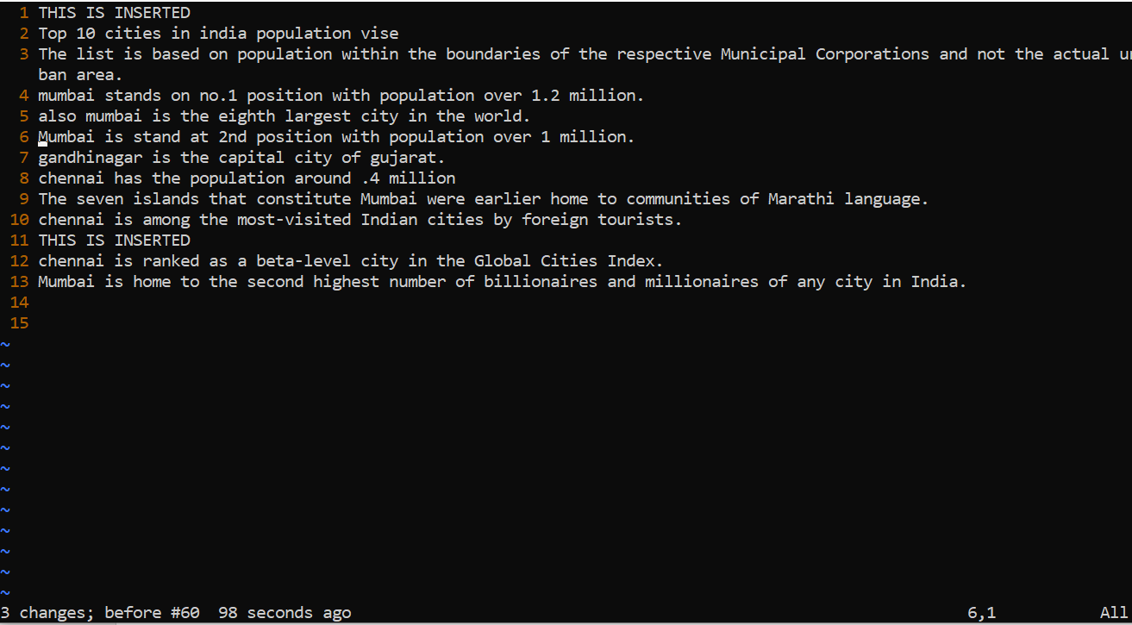
- Replace only the first occurrence of “delhi” with “mumbai” in each line, for part of a document (e.g. line number 13 to 37).
- :13,37s/<delhi>/Mumbai/g
- 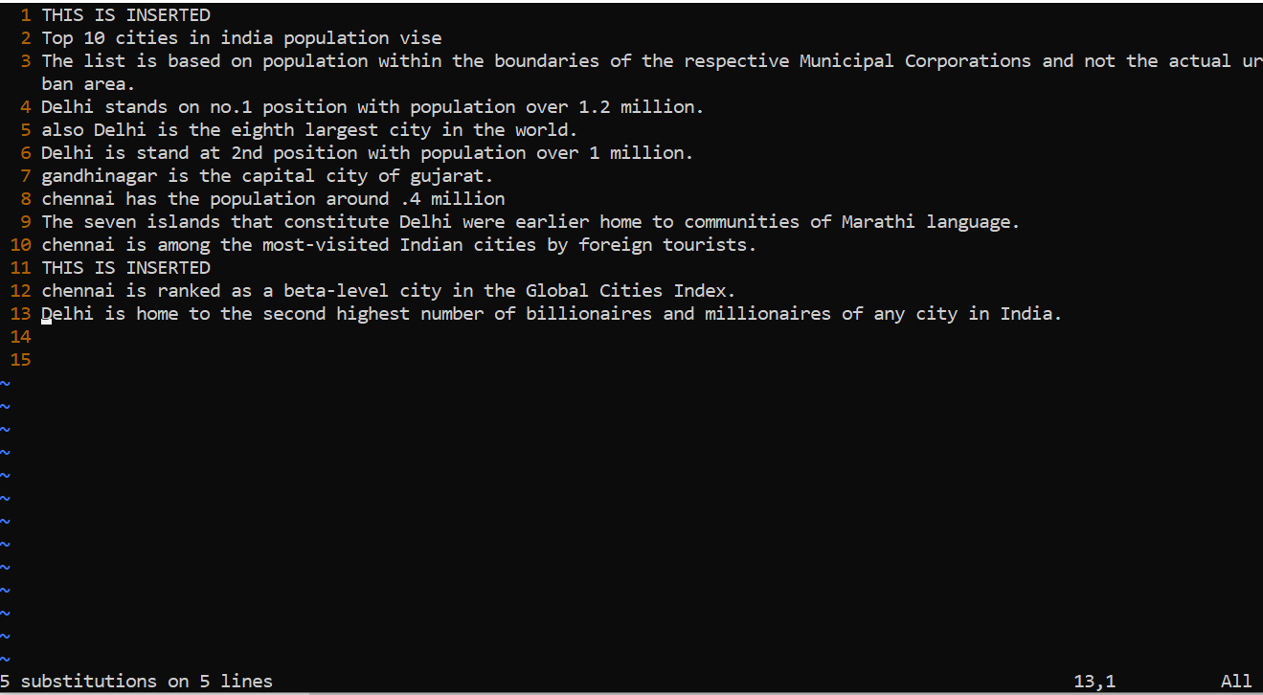
- Undo the above comment. Redo it. Undo it again.
- Press u
- Hold Ctrl and press r
- Press u
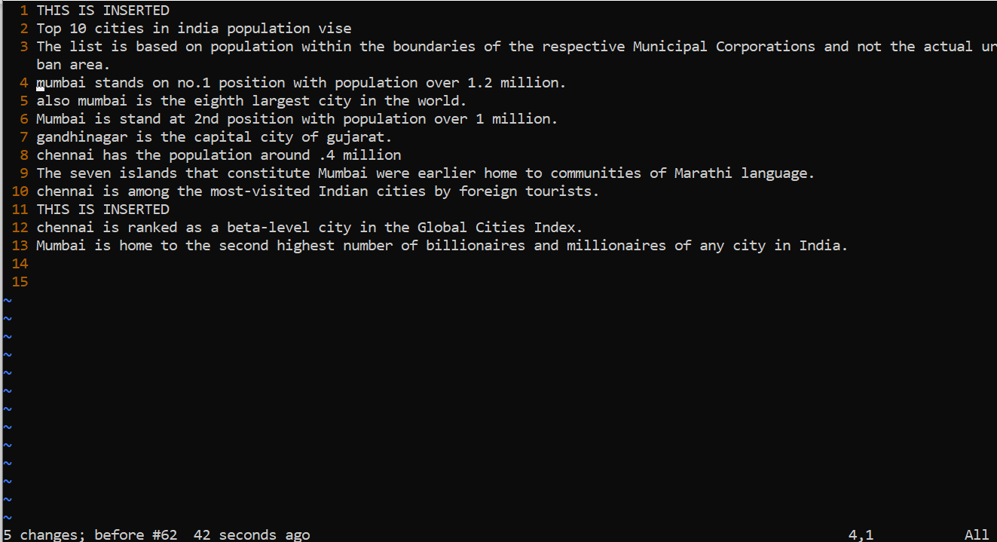
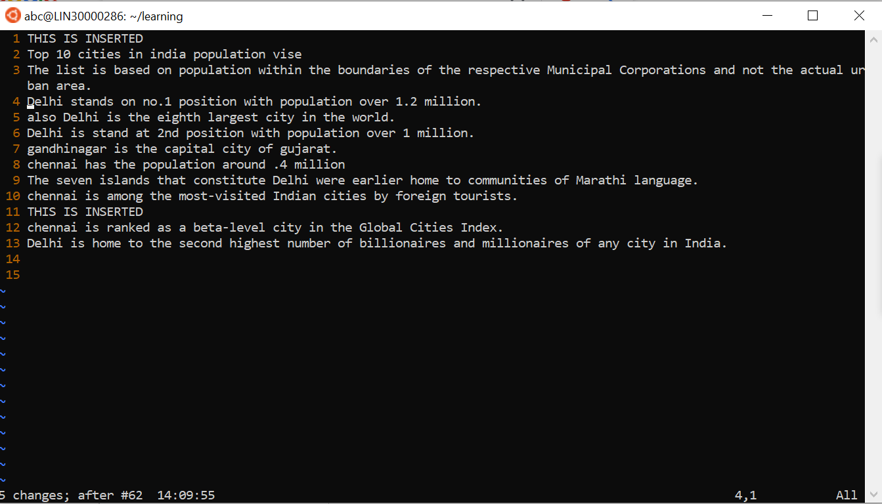
- Replace all occurrences of “delhi” with “mumbai” for complete file interactively.
- :.,$s/delhi\|Delhi/Mumbai/g
- Search for a word backwards. Loop through all matches.
- ?Delhi
- Search for a word forwards. Loop through all matches
- /Delhi
- Join two lines together.
- position the cursor anywhere on the last line and press J to join the two lines
- Enable line numbering and then disable it
- Set nu
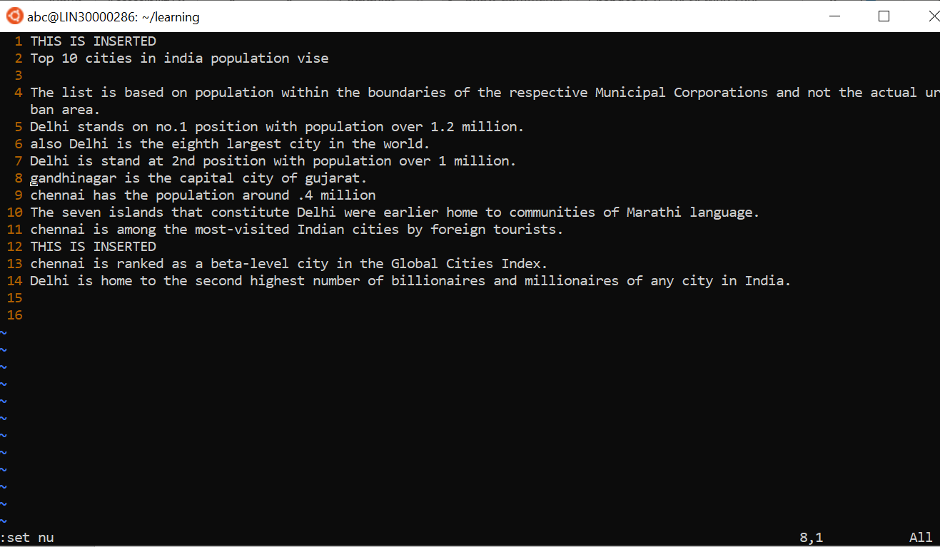
- Make the search case insensitive
- :set ignorecase
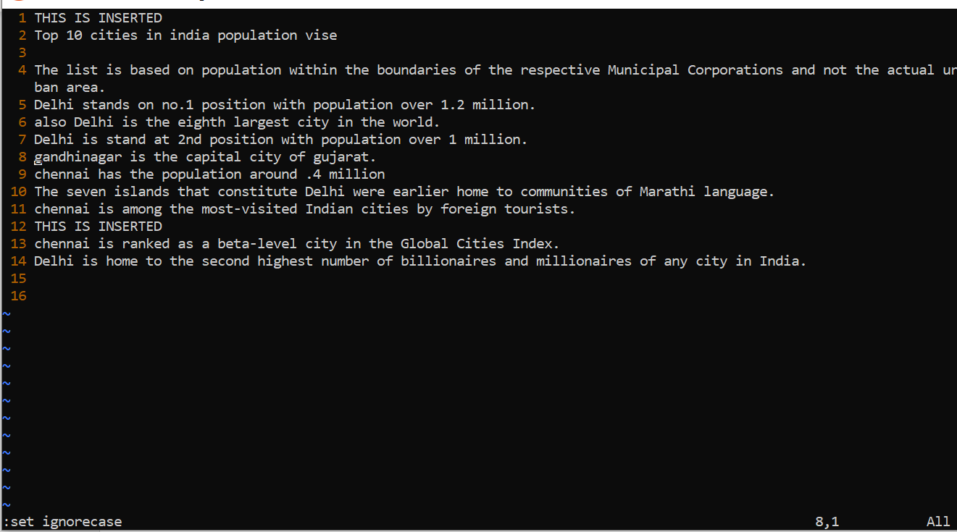
- Delete 4 lines (and then paste them somewhere else)
- By using 4dd
And press p to paste somewhere else
- 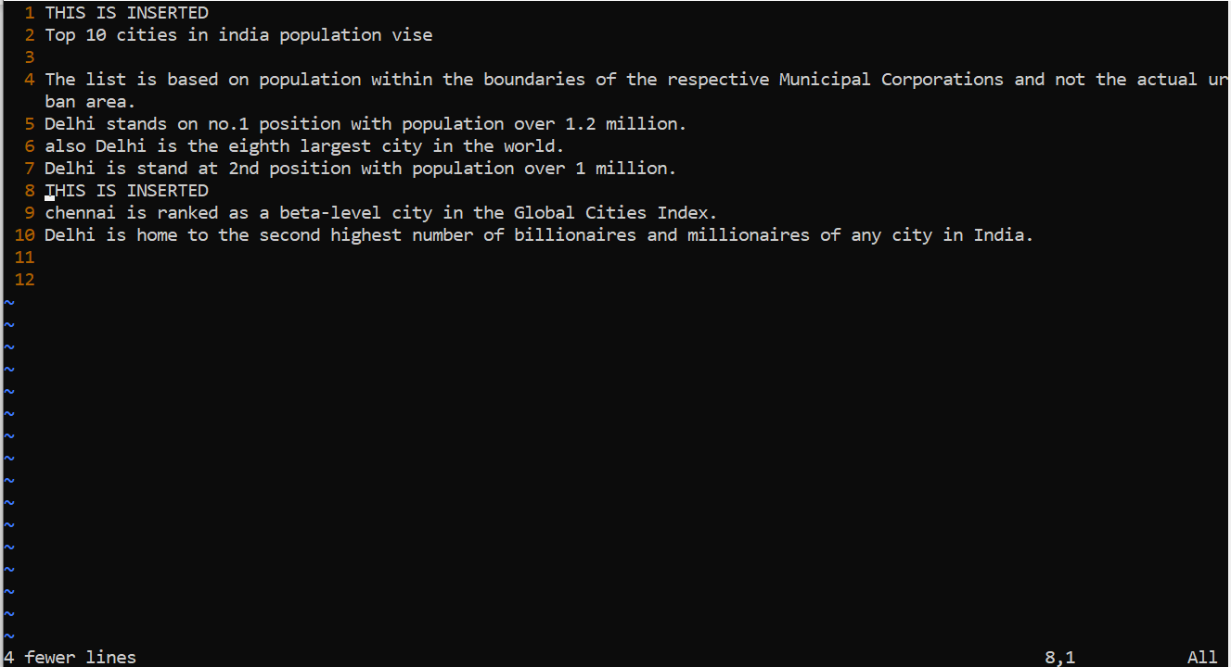
- What is the command to delete part of the line starting from the current cursor position?
  - Press **Esc** come to command mode

  - press **v** enter visual mode

  - **Shift + g** "selects everything from current position to EOF"

  - **DEL** "delete selected"
- What is the command to delete the current word?
dw

