Vi Editor - Assignments
- Invoke the vi editor with a filename (which is to be created)
- vi filename
- Type a few lines(at least 10) in the editor. Let one or more lines contain the words given below.
delhi mumbai chennai Mumbai
- 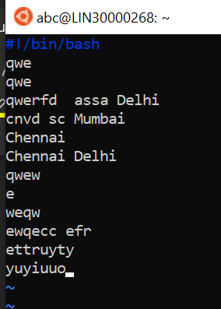
- Save the file without exiting the editor
- switch back to normal mode by pressing Esc , type :w and hit Enter
- Navigate quickly to the beginning & end of the file
- Beginning - type "gg" in command mode.
- End – Shift+g

- Delete first two lines & copy it after the last line.
- type "dd" in command mode.
- Now Copy the last two lines & paste them before the first line.
- Copy – y
Paste - p
- Combine last two lines of the file in a single line.
- Shift+J
- How will you insert a line before the first line? (Hint : Find such an option in the tutorial document)
- Goto first line and click Shift+O
- How will you paste a yanked buffer before the current line?
- Y then P
- Search the document for a string “delhi”
- /Delhi
- Replace a single occurrence of “delhi” with “Mumbai”
- :s/Delhi/Mumbai/g
- Replace all occurrences of “delhi” on a particular line with “Mumbai” using one command
- :4s/Delhi/Mumbai/g
- Replace “delhi” with “mumbai” for the entire document using one command.
- :..$s/Delhi/Mumbai/g
- Replace all occurrences of “delhi” with “mumbai” for part of a document (e.g. line number 13 to 37).
- :3,6s/Delhi/Mumbai/g
- Undo the above command
- u
- Replace only the first occurrence of “delhi” with “mumbai” in each line, for part of a document (e.g. line number 13 to 37).
- :3,6s/<Delhi>/Mumbai/g
- Undo the above comment. Redo it. Undo it again.
- Undo – u
- Redu - r
- Replace all occurrences of “delhi” with “mumbai” for complete file interactively.
- :.,$s/Delhi/Mumbai/g
- Search for a word backwards. Loop through all matches.
- /test
- Search for a word forwards. Loop through all matches
- ?test
- Join two lines together.
- Shift+J
- Enable line numbering and then disable it\
- :set number
- Make the search case insensitive
- :set ic
- Delete 4 lines (and then paste them somewhere else)
- dd
- What is the command to delete part of the line starting from the current cursor position?
- d$
- What is the command to delete the current word?
- dw

