Lab Task
Roll No: 22021519-138
Name: Zohair Ashraf

Q1:
include irvine32.inc
include macros.inc
bsize = 501
.data
getname byte "Enter Name of Patient: ",0
askallocate byte "Do You Want to Allocate a ROOM? [5.Yes 6. No]",0
namearr byte bsize dup(?)
newline byte " ",0dh,0ah,0
personal byte "personal.txt",0
allocate byte "allocation.txt",0
warddb byte "ward.txt",0
err1 byte "Cannot create file",0
filehandler handle ?
filehandler2 handle ?
byteswritten dd ?
stringlength dd ?
rooms dd 5
beds dd 10
trooms dd 1,1,2,2,3,3,4,4,5,5
tbeds dd 1,2,1,2,1,2,1,2,1,2
count dd ?
count2 dd ?
invalid byte "Invalid Choice",0
choice dd 0
change dd 0
change2 dd 0
dataread byte bsize dup(?)
flag dd 0
cout dd 0
.code
main proc
mov edx,offset personal
call createoutputfile
mov filehandler,eax
mov eax,cout
.repeat
mov edx, offset getname
call writestring
mov ecx, bsize
mov edx, offset namearr
call readstring
mov stringlength,eax
mov eax,filehandler
mov edx,offset namearr
mov ecx,stringlength
call writetofile
mov byteswritten,eax
mov eax,filehandler
mov edx,offset newline
mov ecx,2
call writetofile
mov byteswritten,eax
mWrite "Enter CNIC: "
mov ecx, bsize
mov edx, offset namearr
call readstring
mov stringlength,eax
mov eax,filehandler
mov edx,offset namearr
mov ecx,stringlength
call writetofile
mov byteswritten,eax
mov eax,filehandler
mov edx,offset newline
mov ecx,2
call writetofile
mov byteswritten,eax
mov eax,filehandler2
mov edx,offset namearr
mov ecx,stringlength
call writetofile
mov byteswritten,eax
mov eax,filehandler2
mov edx,offset newline
mov ecx,2
call writetofile
mov byteswritten,eax
mWrite "Enter Address: "
mov ecx, bsize
mov edx, offset namearr
call readstring
mov stringlength,eax
mov eax,filehandler
mov edx,offset namearr
mov ecx,stringlength
call writetofile
mov byteswritten,eax
mov eax,filehandler
mov edx,offset newline
mov ecx,2
call writetofile
mov byteswritten,eax
mWrite "Enter Caretaker Name: "
mov ecx, bsize
mov edx, offset namearr
call readstring
mov stringlength,eax
mov eax,filehandler
mov edx,offset namearr
mov ecx,stringlength
call writetofile
mov byteswritten,eax
mov eax,filehandler
mov edx,offset newline
mov ecx,2
call writetofile
mov byteswritten,eax
; ALLOCATE ROOM
call crlf
mov edx,offset askallocate
call writestring
call readint
.if eax==5
dec rooms
dec beds
mov eax,filehandler2
mov edi,offset trooms
mov ebx,change
mov edx,[edi+ebx]
add change,4
;add [edx],ebx
mov ecx,1
call writetofile
mov byteswritten,eax
mov eax,filehandler2
mov edx,offset newline
mov ecx,2
call writetofile
mov byteswritten,eax
mov edi,offset tbeds
mov ebx,change2
mov edx,[edi+ebx]
add change2,4
mov ecx,1
mov eax,filehandler2
call writetofile
mov byteswritten,eax
;add change,1
mov eax,filehandler
call closefile
.endif
mov eax,cout
inc eax
mov cout,eax
.until eax>3
;jmp ward
;.elseif eax==6
; jmp close
;.else
; jmp quit
;.endif
;ward:
call crlf
mWrite "Total Rooms Available Now: "
mov eax,rooms
call writeint
call crlf
mWrite "Total Beds Available Now: "
mov eax,beds
call writeint
call crlf
;close:
mov eax,filehandler2
call closefile
;quit:
exit
main endp
end main

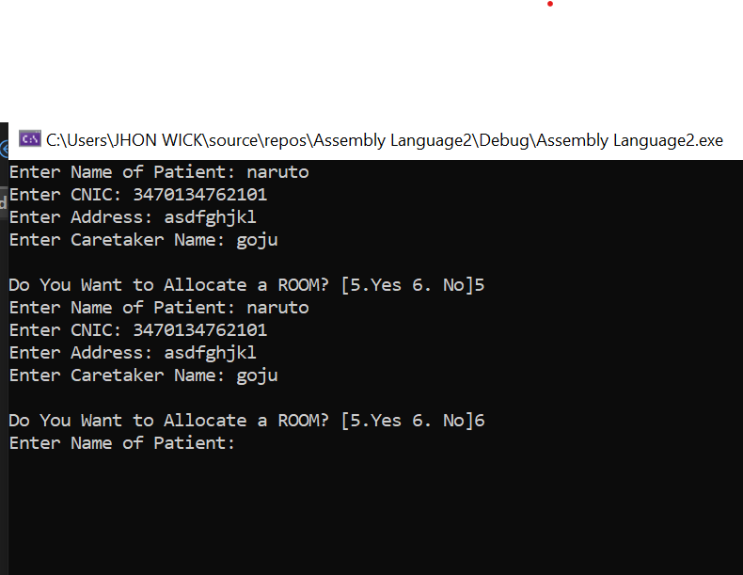

My Observation:
In this program we are gona discuss about patient details that how a hospital takes patients details and how they provide them room facilities of hospital. So, first we take details about name and CNIC and home address and the person who takes care of patient. Then they provide patients caretaker with a form to fill the required details if the patient needs a room in hospital.

Q2:
include irvine32.inc
.data

BufSize=501
.data

filename BYTE "new_FILE1.txt",0
outFile BYTE "my_NEW.txt"
fileHandle HANDLE ?
stringLength DD ?
bytesWritten dd ?
buffer BYTE BufSize DUP(?)
str1 BYTE "CANNOT open file",0dh,0ah,0
str2 BYTE "Bytes Written to File.",0dh,0ah,0

.code
main proc
mov edx,offset filename
call CreateOutputFile
mov fileHandle,eax

mov ecx,BufSize
mov edx,offset buffer
call readstring
mov stringLength,eax

mov eax,fileHandle
mov edx,offset buffer
mov ecx,stringLength
call WriteToFile
mov bytesWritten,eax
call CloseFile

mov edx,offset str2
call writestring
mov eax,bytesWritten
call WriteDec
call crlf
quit:
exit
main endp
end main

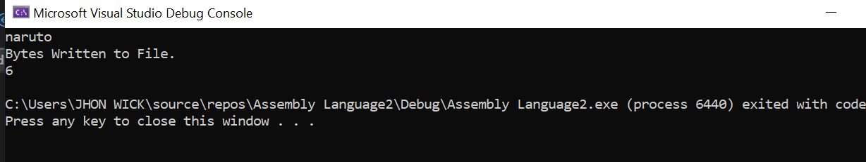

My Observation:
This program creates a file and takes a message from user and stores it in file and displays the number of bytes file contained. It has taken a string type message first and then it writes the bytes of the message in file and displays the bytes written in file.

Q3:

include irvine32.inc
include macros.inc

.data
buffer_size = 500
.data

filename BYTE "myfile.txt",0
filehandle HANDLE ?
msg_enter BYTE "Enter the data: ",0
info BYTE sizeof buffer_size DUP(?)
value DD ?
byteswritten DD ?
.code
main proc
; read from file
mov edx,offset filename
call OpenInputFile
mov filehandle,eax
mov edx,offset info
mov ecx,buffer_size
call ReadFromFile

mov edx,offset info
call writestring
mov eax,filehandle
call CloseFile
exit
main endp
end main

My Observation:
It is a program which just reads the message from the file and shows that the message in the file has been read. And then it closes the file.

