UBER TRIP ANALYSIS

1)upload the 2 excel files to PBI and connect 2 tables using (PUlocationidLocationID) and (DULocationIDLocationID)
2)split the ‘pickuptime’ column so that both dates & time will be in separate columns, click on create new column as shown below and change data type of this column to date
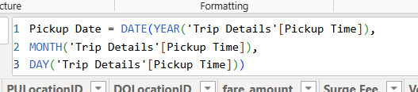

3)we will make another table called CALENDAR, go to ‘Table tools’’New table’ , change datatype to date, and join Trip Details table to CALENDAR TABLE

4)go to Report view and set
Height of canvas =900 px
Width=1600 px & Middle alignment
Canvas background set 20% darker and transparency to 70%

DASHBOARD 1: OVERVIEW ANALYSIS

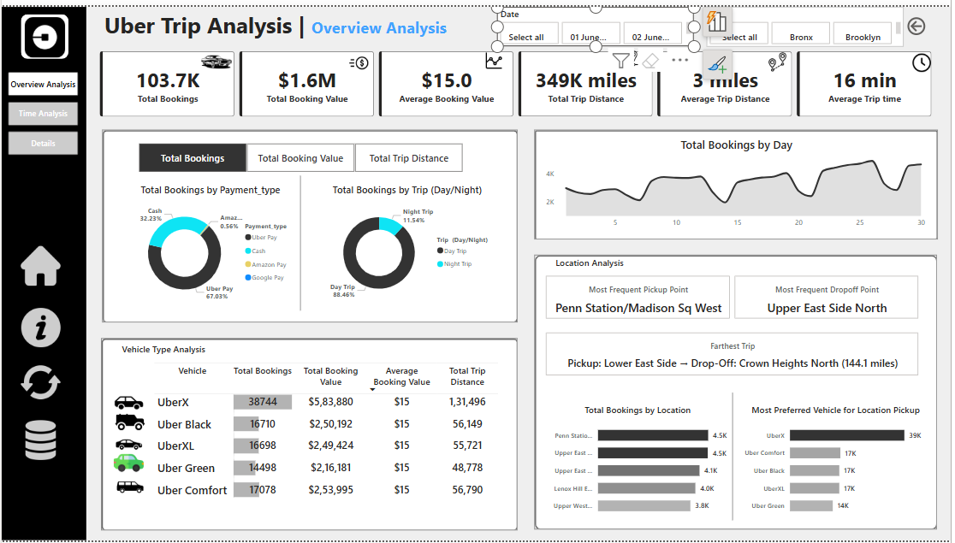

Analyse Uber trip data using Power BI to gain insights into booking trends, revenue, and trip efficiency, helping stakeholders make data-driven decisions.
1)add Rectangle box to left with width=142, colour=black
2)add text box at the top an add title as UBER TRIP ANALYSIS | OVERVIEW ANALYSIS, with seigo bold and 28 size

KPI’s
- Total Bookings – How many trips were booked over a given period?
Total Bookings = COUNT('Trip Details'[Trip ID])

- Total Booking Value – What is the total revenue generated from all bookings?

- Average Booking Value – What is the average revenue per booking?

- Total Trip Distance – What is the total distance covered by all trips?
Total Trip Distance = sum('Trip Details'[trip_distance])
to get the value in miles we use this measure instead of above one
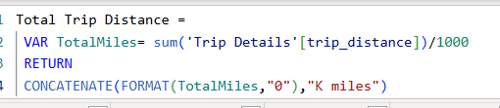

- Average Trip Distance – How far are customers traveling on average per trip?
Average Trip Distance = AVERAGE('Trip Details'[trip_distance])
to get the value in miles we use this measure instead of above one
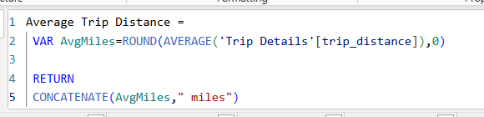

- Average Trip Time – What is the average duration of trips?
Average Trip time = AVERAGEX('Trip Details', DATEDIFF('Trip Details'[Pickup Time],'Trip Details'[Drop Off Time],MINUTE))
- We use below measure in place of above one
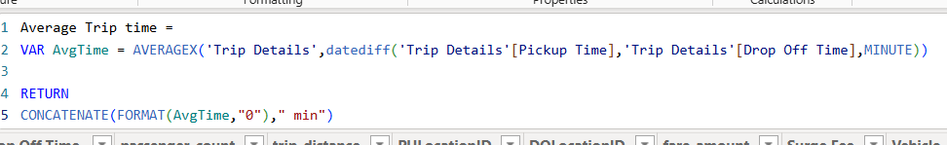

add new card visual and add these 6 KPI’s to the card and set height=120, width=1415
insert the images to each KPI as related
turn on accent bar with width=5
cards border (666666) 1px,
- Shape=rounded rectangle
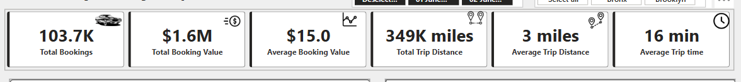

Expected Outcomes:
✔ Identify trends in ride bookings and revenue generation.
✔ Analyse trip efficiency in terms of distance and duration.
✔ Compare booking values and trip patterns across different time periods.
✔ Provide insights to optimize pricing models and improve customer satisfaction.

CHART’s
Create a Measure Selector using a Disconnected Table with the following values:
- Total Bookings
- Total Booking Value
- Total Trip Distance
Then, use a measure to dynamically update the visualizations based on user selection.
- CREATING DYNAMIC MEASURE :
a)Modelling tab new parameter Fields Name as ‘Dynamic Measure’ and select above 3 measures and click create and make it as Tile with single select as option
b) insert rounded rectangle shape with h=325, w=700, 2%rounded corners, color as white, border=#666666, and place dynamic measure in this shape, place this shape below KPIS & to the left
c)

- Donut chart By Payment Type (Card, Cash, Wallet, etc.)
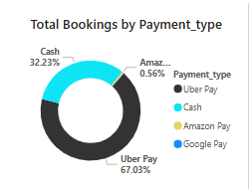
a) Donut chart legend=Payment type, Values=Dynamic Measure, h=215, w=300, Turn off background, legend header=OFF,
b) when we click on Total Trip Distance in dynamic measure we wont get any chart because the measure which we wrote to TTD having CONCATENATE function that converts distance to text so we wont get any chart , now we create new measure as
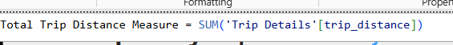
c) add this measure to dynamic measure also

- By Trip Type (Day/Night)

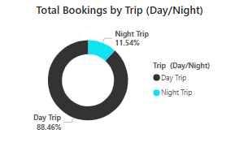

- we should create a new column for this
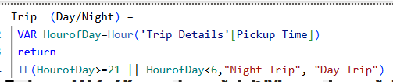
- Ad another donut chart and add this created Trip type to legend

Additional Enhancements:
- Dynamic Title – Update the chart title based on the selected measure.
- Slicers – Add filters for Date, City, and other interactive filters for deeper analysis.
- Tooltips – Show additional details like Average Booking Value or Trip Distance.

4)Vehicle Type Analysis - Grid View in Power BI
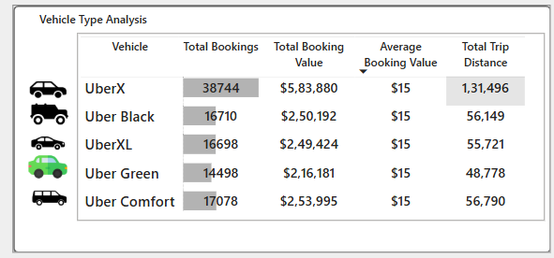
Create a grid table (matrix or table visual) to analyse key performance indicators like Total Bookings, Total Booking Value, Avg Booking Value, Total Trip Distance across different Vehicle Types in Uber trips.
Power BI Implementation:
- Use a Table or Matrix Visual to display Vehicle Type with the KPIs.
- Apply Conditional Formatting to highlight high and low values.
- Enable Sorting & Filtering for user interaction.
- insert a rectangle shape same as done in starting of same size nut set h=300 , below the 1st shape
- Add a matrix visual and add as below with h=245, w=610
Rows=Vehicle
In values= Total Bookings, Total booking value, Avg booking value, Total Trip Distance measure (Rename as Total trip distance after adding)
Turn on Horizontal grid and width=10, color = white, add border at top with grey colour, make all necessary changes like fonts and disable row& column subtotals, middle alignment, after setting up matrix, add car symbols to left of each vehicle type
- Now to add title create a measure
Title for Grid = ”Vehicle Type Analysis” , and add it to card and place it above the matrix by disabling category label and making necessary changes
- Also add data bars to Total booking by conditional formatting
5)Total Bookings by Day
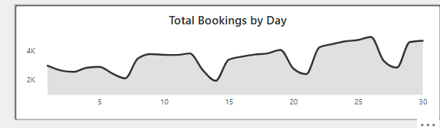
- Detecting trends and fluctuations in daily trip volumes.
- Identifying peak and off-peak booking days.
- Understanding the impact of external factors (holidays, events, weather) on ride demand.
- Supporting strategic planning for resource allocation and pricing adjustments.
a)add an area chart by taking X axis=Day, Y axis= Total Bookings, and gridlines=OFF, Background=OFF, etc.

6) Location Analysis
Understanding trip locations is crucial for optimizing ride distribution, demand forecasting, and operational efficiency. This analysis focuses on:
    - Most Frequent Pickup Point
Adding a measure to find the top most pickup point
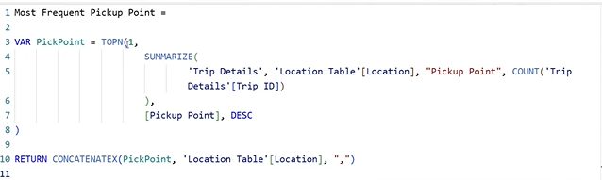
- we are using TOPN(using 1 for only getting top 1 value) to find the top most pickup point and using summarise we are creating a new table for all unique locations and how many times that location is chosen as pickup point by using trip id and ordering based on Pickup point in DESC, and returning the o/p in form of pickup point and that location name
- Identify the most common starting locations for trips.
- Helps in optimizing driver availability and dynamic pricing strategies.
    - Most Frequent Drop-off Point
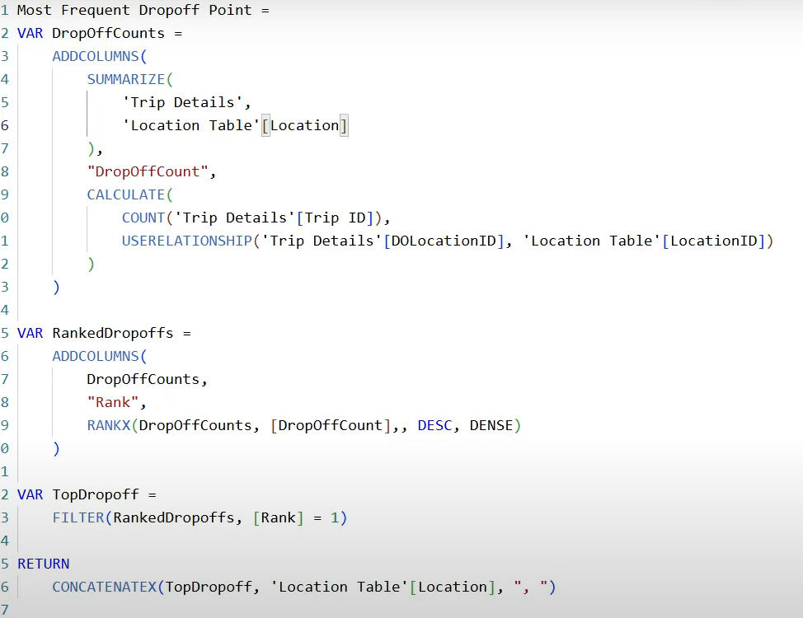 here also we create the same type of measure as common pickup point
- First we are defining a variable “DropOffCounts” to get total count of drops for each location for that first we are using summarize column based on Trip details and 1st column is “location” ,from Location table and second column will be the ‘DropOffCount’ where we calculate the Trip ID by using the relationship that is been inactive so that we can make it active using USERELATIONSHIP ,so here we get a table that has ‘Location Table’[Location] & DropOffCount as 2 columns. Containing unique locations and count of each trip id i.e how may times that location is used as drop location
- Next we create new variable called RankedDropOffs where we are taking the DropOffCount column from the DropOffCounts variable that is created above in DESC order by creating new column & using RANKX function, we also using DENSE because we need to get ranks in consecutive order , by not skipping the rank,if DropOff Count is same for 2 loctions it assigns same rank to them.
- Now we are using another Variable TopDropOff to get the most frequent dropped location
- And at last we are returning the topdropoff and along with the location name , if there are multiple location separate with a comma
- Add this 2 measures to a new card and place it below area chart

- Find the most common drop-off locations.
- Requires activating an inactive relationship in Power BI between Pickup Location and Drop-off Location in the data model.
    - Farthest Trip
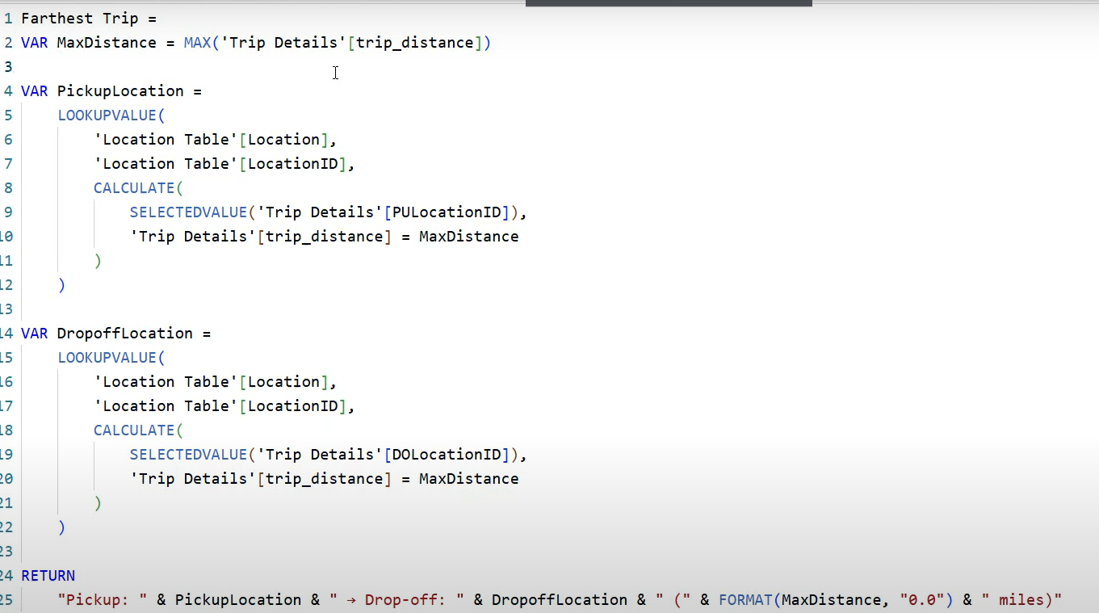
- we are going to write a measure for this , First we are going to define a variable and find the maximum distance
- next we define another variable called “PickupLocation”, it takes 1st argument as which value we would want and 2nd argument is the joining condition b/w 2 tables , and using CALCULATE func to join it on PULocaionID and we are using a filter condition that if trip_distance=MaxDistance then it returns the location
we define a new variable called DropOffLocation & same condition applies for it
we return it using return variable

    - Total Bookings by Location (Top 5)
    - 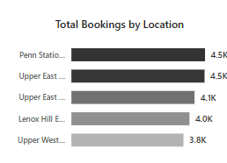
  - Take stack bar ,x axis=Total Bookings, Y axis=Location ,and filter only top5 and make necessary changes, Data labels=ON, legend=OFF
  - Color fx -> gradient field we base this on is ‘Total Bookings’
  - Helps in demand forecasting and optimizing driver availability in high-traffic areas.

    - Most Preferred Vehicle for Location Pickup
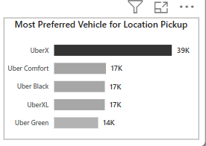
a) Take the same stack bar chart with Y-AXIS=vehicle, X Axis=PULocationID
b) Insert a straight line for separating the shapes of both donut charts & stack bar charts

    - Adding Title
- Write a new measure for adding title for all above created measures & add it above the cards
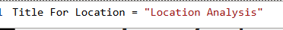

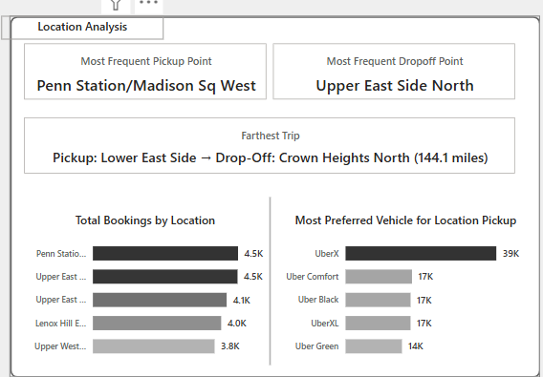

    - We need to add 2 filters
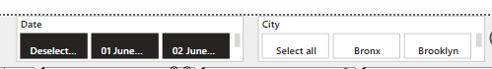
      - Take slicer & add ‘date’ field of ‘calendar’ table to it
      - Turn off slider
      - Give visual border
      - Take another slicer & add ‘city’ of ‘location ‘table

Other Implementation Enhancements for Uber Trip Analysis Dashboard
- Bookmark for Data Details
- Add a "Data Details" bookmark to display a pop-up or side panel explaining:
  - Meaning of key metrics (Total Bookings, Total Trip Distance, etc.).
  - Description of tables used in the analysis.
  - Data source and refresh frequency.
- Clear Slicer Button
- Add a "Clear Filters" button using a blank button with a Reset Slicers action to reset all selections in one click.
- Improves user experience for quick dashboard resets.
- Download Raw Data Button
- Add a button to export raw data in CSV or Excel format.
- Use Power Automate or built-in Power BI Export functionality.
- Enables users to analyse raw data outside Power BI if needed.

DASHBOARD 2: TIME ANALYSIS
To understand trip patterns based on time, Uber needs to analyse ride demand and trends across different time intervals. This dashboard will help in optimizing operations, pricing, and driver availability.
1)Make a duplicate of Overview analysis dashboard to create a new one and remove donut charts, stack bar charts and bring dynamic measure to centre ,
Global Dynamic Measure (Filters All Charts)
A measure selector will be created for:
✔ Total Bookings
✔ Total Booking Value
✔ Total Trip Distance
This dynamic measure will update all visuals based on user selection.
Visualizations:
    - By Pickup Time (10-Minute Intervals) - Area Chart
a)we write a new CC to extract the time component from ‘Pickup Time’
Pickup Hour (HH MM SS) = TIME(HOUR('Trip Details'[Pickup Time]),MINUTE('Trip Details'[Pickup Time]),SECOND('Trip Details'[Pickup Time]))
- If you still see the date ,select the column & change datatype to time
b) now go to report view Nd right click on Pickup Hour (HH MM SS) column new group bin size =10 and in minutes click ok , a bin of Pickup Hour will be created, now take an area chart and x axis= Pickup Hour Bin,, y-axis=Dynamic Measure, and upon scrolling on chart we see a time interval of 10 min each,
c) H=235, w=650 for area chart, turn off title on X & Y axis, turn off gridlines
d)set the color of bar different for 3 measures by gng to lines slect diff color for each measure by clicking on each measure present in dynamic measure
Total Bookings=#118DFF 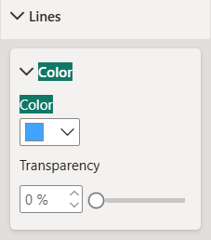
Total Booking Value=#25FB16
Total Trip Distance=#333333
    - Create dynamic title
a)We need to create dynamic title so that title changes accordingly each time when we click on diff measure, we need to write CC in ‘Dynamic Measure’, when we go to table view of dynamic measure we see some of the columns are hidden ,right click on ‘Dynamic Measure’ and click ‘unhide all’,,
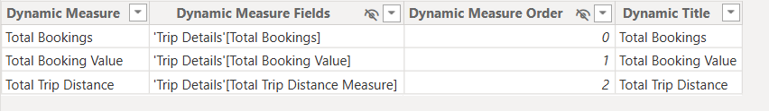
b)Now we create new CC in dynamic measure
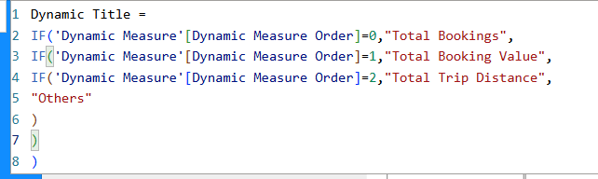
c)create new measure in trip details
Title for Pickup Time = SELECTEDVALUE('Dynamic Measure'[Dynamic Title]) & " by Pickup Time"
now add this to card and place the card above the area chart, so when you click each time the diff measure , the title changes accordingly

    - Total bookings By Day Name - Line Chart
a)in calendar table create new column, that gets us the day
Day Name=FORMAT(‘Calendar Table’[Date], ”ddd”),
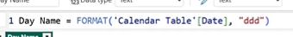
b)take a line chart and add xaxis=day name, y axis= dynamic measure, but here after adding to axes , we get weekdays in random manner, to solve this we create a new column called Day Num, so that week starts from Monday
Day Num=WEEKDAY(‘Calendar Table’[Date],2),
after creating this column, go to report view click on ‘Day Name’ in calendar table column tools sort by columnDay Num, then click on 3 dots present on line chart sort axisensure the tick option is present on ‘day name’ and click ‘sort by ascending ‘
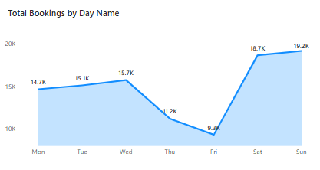
now place it under the area chart and make this chart also area chart and Data Labels=ON,
create a new dynamic measure as created above
and add it to the above of 2nd area chart

4)By Hour and Time - Heatmap (Matrix Grid)

1)Rows: Hours of the Day (0–23) create a new column called ‘Pickup Hour’ ,
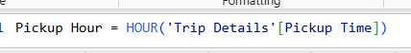
2)Add a matrix , rows=Pickup Hour, columns = Day Name, values=Dynamic measure, h=570, w=545
3)remove column & row subtotals and go to specific column Total booking value display unit=Thousands, Value decimal places=0 ,
4)select trip distance dsip unit=thousands, Value decimal places=0
5) Change the row name to ‘Hour’ and go to cell elements and add background colour differently for each of 3 measures & also add the same colors to the font color also so that the values wont be visible
Total Bookings=#aod1ff, ##41a4ff, #414fb1
Total Booking Value= #B1F8BO, #30E12D, #077413
Total Trip Distance= #CCCCCC, #808080, #333333
5)Take a bar chart
a)Y-axis=Pickup hour, X-axis=Dynamic Measure and add it beside the matrix and set the color same as the matrix colors and remove all legends,title,values row & column labels
b) y axis invert range ON to keep the days in ASC order same as for the matrix shown

create a new measure for heading

- Columns: Days of the Week (Mon-Sun)
- Values: Selected Dynamic Measure (e.g., Total Bookings)
- Highlights peak booking hours across different days.

DASHBOARD 3: DETAILS TAB
To provide in-depth insights and allow users to explore granular data, a Grid Tab will be created. This tab will enable drill-through functionality, allowing users to access detailed records based on selections made in other dashboards.
Features of the Grid Tab:
- Grid Table with Key Fields:
- Displays essential trip details
add a table and add
1)TripID,
2)Pickup Date,
3)Pickup Hour (HH MM SS), rename as ‘Pickup Hour’
4)Vehicle,
5)Payment_type
6)passenger_count rename as ‘no of passengers’
7)Total Trip Distance Measure, rename as ‘Trip Distance’
8)Total Booking Value, rename as ‘Booking value’
9)Location from ‘Location Table’ & rename it as Pickup Location
10)Total Bookings
make all necessary settings and,
- Drill-Through Functionality:
- Users can right-click on a data point from other visuals (e.g., charts, heatmaps) and drill through to this Grid Tab.
1)step1 : go to details dashboard and in page information select drill through and add the 3 measures
Total Bookings, Total booking value, ‘Total trip distance measure’
Step2: now whenever you click on any chart in dashboard1 in that particular tooltip we will see an extra option od ‘drill through’ ,when we hove on that drill through it shows the details dashboard name , when we click it , we will be redirected to that dashboard & a arrow will be created in ‘details’ dashboard so that when you ctrl+click that button you will go back to the page in which we drilled to the details
when we enable drill through a back button( 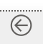) will be created in details page so that when we ctrl + click we will go back to previous page in the report 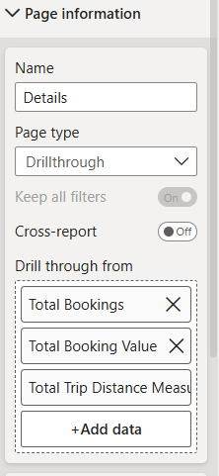
- Displays detailed records related to the selected data point.

Bookmark functionality
Step1: be in details tab & make sure the visual is showing all the records, go to view select ‘bookmarks’ & ‘selection’ add a new bookmark & give it a name ‘show all unfiltered data’
Step2: add an image, click on the image, go to actiontype=bookmark, bookmark=show all unfiltered data,

Page Navigator:
      - Go to buttons navigatorpage navigator

Info button
- Take a text box & add the information regarding the dashboard as shown below,
- Now go to view select ‘bookmark’ & ‘selection’
- Now keeping he text box open , add a bookmark ‘show all data feilds’,
- select I button actionbookmark=’show all data fields
- tun on tooltips & text as : ‘ctrl + click to see all data fields’

Home button:
- When we click on home button we should come
- Now after adding bookmark for info button, hide the text box visual & create a new bookmark ‘show overview dashboard’
- Select home buttionaction bookmark=select overview dashboard
- Tunr on tooltips & keep text as ‘ctrl + click to see overview dashboard’

Reset button:
    - Select reset button action type=clear all selections
- Copy paste these buttons to remaining dashboards , but we need toc hange the titles & we need to create new bookmarks for remaining pages

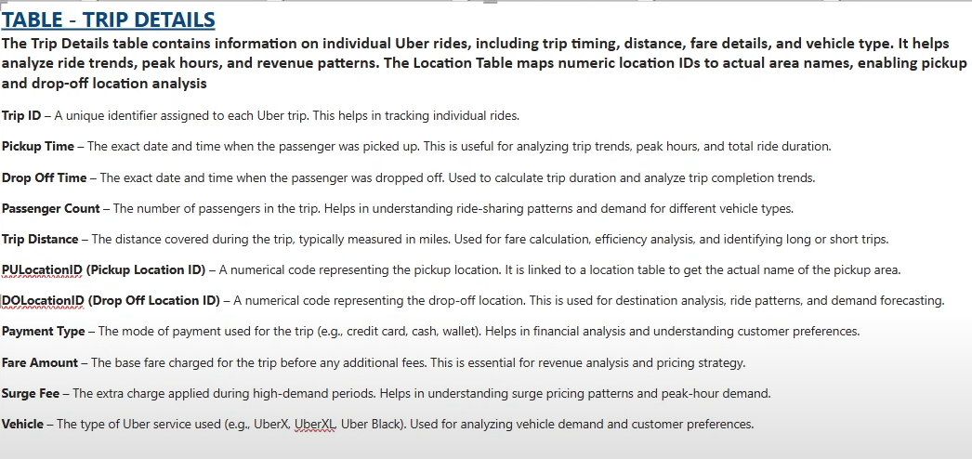

- 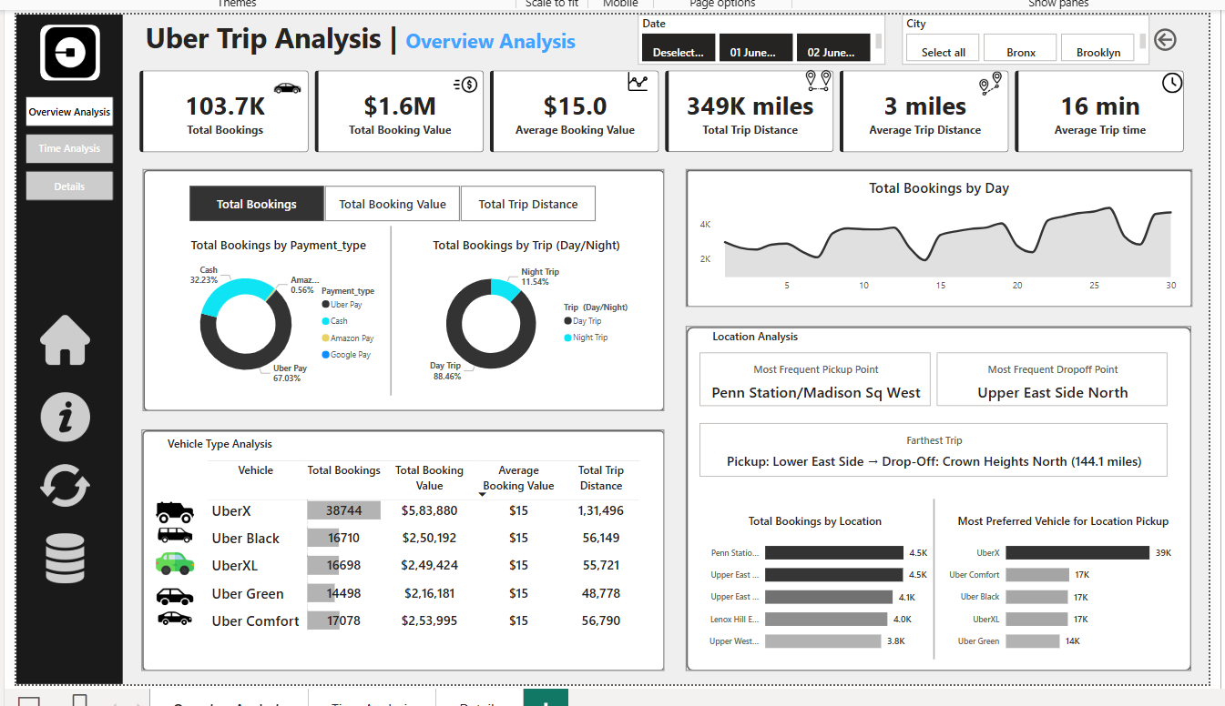

- “Show all data fields “ bookmark

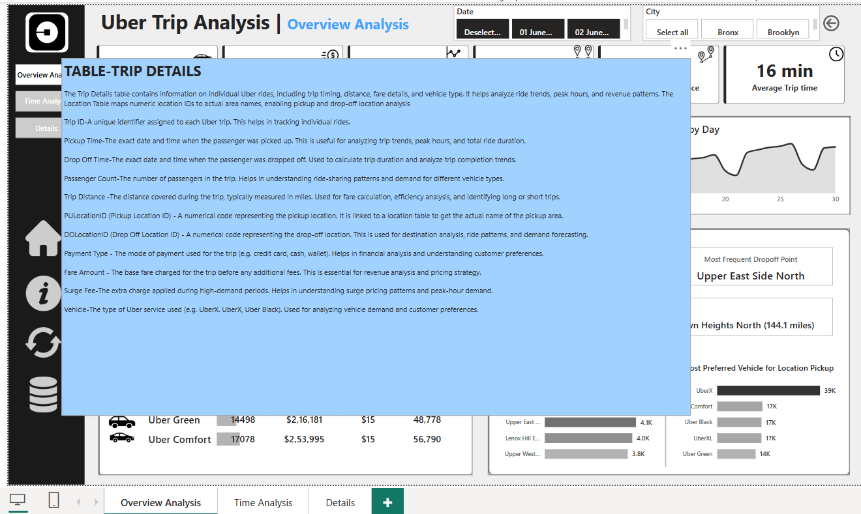
now click on home icon action onbookmark overview dashboard
click on i icon turn on actionbookmark Show all data fields
- Now when we ctrl click on i icon the text box will be appeared & when we again press ctrl click on home button, we will be gng back to overview dashboard
- Add tooltip to home button by keeping “ctrl + click to view overview dashboard”
- Add another tooltip to i button
- For reset button turn on actionclear all slicers
- For data icon we added linked-in profile
- Copy paste all 4 icons to remaining 2 pages
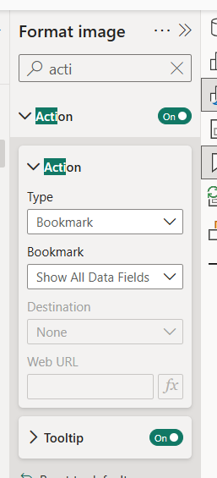
now go to Time Analysis report and there again create the same text box and create new bookmark with title as ‘Show Time Analysis Report’ turn off ‘Text Box’and now update the ‘Show Time Analysis Report’ , and add it to Home button
now turn on Text Boxcreate a new bookmark and name it as ‘Show Trip Details on Time Analysis Dashboard’ and add it to the i button

