From: Doron - R.P.A.PORT LTD
Sent: Tuesday, December 3, 2019 11:42 AM
To: Portuguese Nationality CIP <portuguesenationality@comunidade-israelita-porto.org>
Subject: RE: Re:

Thanks much brothers.

Will go over and fill the documents as required.

Brgds,

Doron Rapaport

Deputy General Director

R.P.A.PORT LTD
Ofer brothers building 3rd floor
Hanamal 2 Str
P.O.B 33378 Zip code 33031
Haifa
Israel
T: +97249111336 M: +972505946974 F: +97248548800
www.rpa-port.com

From: Portuguese Nationality CIP [mailto:portuguesenationality@comunidade-israelita-porto.org]
Sent: Tuesday, December 3, 2019 12:29 AM
To: Doron - R.P.A.PORT LTD <doron@rpa-port.com>
Subject: Re: Re:

Shalom. Approved.
1) Please complete in the word format the form named "Personal details for Certificate"- LINK - with personal data, typed on the computer, not handwritten. Kindly ensure the accuracy of the personal information you provided on the Personal Details Form to avoid delay in the remittance of the certificate. It is crucial that the information on this form is correct since it will be used in the issuance of your certificate. A certificate with incorrect or incomplete data will not be valid. Therefore the applicant must take the greatest care in completing the form.
The Jewish Community of Oporto will digitally sign the certificate. This is a valid certified signature. The Conservatória of Portugal is fully aware of this valid certification procedure. Therefore the Administrative Department will not send the certificate by post. It sends a printable version of the certificate by e-mail to the e-mail addresses provided on the form only. Each applicant must print his/her own certificate and may then proceed with the subsequent steps of the Portuguese Nationality process. The Jewish Community of Porto will not take responsibility for the e-mails not received or automatically sent to the SPAM box by the applicant's e-mail provider. Please add the following e-mail address: comisraelitaporto.adm.commitee@gmail.com
2) Please complete the form named "(ApplicantFullName)_Family_- LINK - with your family tree, typed on the computer, not handwritten, and return it in the PDF format. Make sure to include the applicant's full name in the file's name, by substituting the "(ApplicantFullName)" area. The family tree should include the generations of ancestors known to the applicant. In some cases, this may be only two or three generations, as is likely to be the case for families expelled from ten Arab countries during the twentieth century. In other cases, many more generations may be known, for example in the case of families that immigrated to London and Amsterdam in the sixteenth and seventeenth centuries. It must include the following information for each person mentioned: (I) date of birth, (II) date of death (III) date of marriage and (IV) place of birth. In situations where some data is unknown, even after due research, the corresponding entry should be left blank. Any family tree that is not designed according to these instructions or contains incorrect data will be rejected by the PORTUGUESE STATE. Corrections to the family tree, due to incorrect information provided by the applicant, will take at least 60 days from the date the applicant requests to the Administrative Department. Therefore the applicant must take the greatest care in completing the family tree."
3) Please make a bank transfer to the Jewish Community of Oporto. The fee is €250,00 per applicant and all costs associated with the transfers must be borne entirely by the payer. The Community gives Tzedakah via a vast network of Jewish organisations in many countries and it is promoting the Jewish life and culture in the city of Oporto. The fee must be made by bank transfer to the account of the Jewish Community of Oporto. It is mandatory that you send us the SWIFT document (we only accept the SWIFT proof of payment) with the legible payer's name and transfer date. Write please the applicant’s name in the payment details. Bank: Santander Totta, Branch: Porto, 0018 - Porto Julio Dinis, Rua Júlio Dinis, 818, 4050-322 Porto, Swift code: TOTAPTPL, IBAN: PT 50 0018 000013154515001 80, Account of the Jewish Community of Oporto: 000013154515001 80
P.S. - By determination of the Board of Directors of the Jewish Community of Oporto, from now on, when the reissue of a certificate is requested due to an error attributable to the applicant (who sent the form or family tree with incorrect or incomplete data), the reissue will take at least 45 days. We are overwhelmed with work and cannot afford to waste time as a result of negligently completed forms. The efficiency of our organization depends on the collaboration of the applicants in following our procedures. When our guidelines are not obeyed, an even greater workload falls on us, making our issuing process slower and thus affecting all the applicants - who, for the most part, have government deadlines to comply with.

Doron - R.P.A.PORT LTD <doron@rpa-port.com> escreveu no dia segunda, 2/12/2019 à(s) 08:09:
Good week dear,

Kindly find below and enclosed.
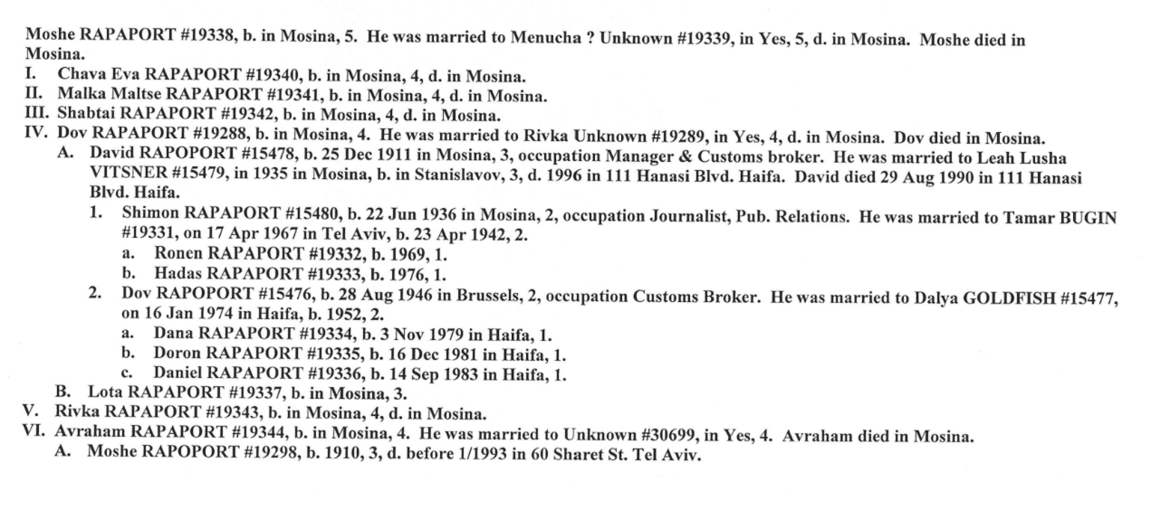

From: Portuguese Nationality CIP [mailto:portuguesenationality@comunidade-israelita-porto.org]
Sent: Monday, December 2, 2019 9:11 AM
To: Doron - R.P.A.PORT LTD <doron@rpa-port.com>
Subject: Re: Re:

Please send a family tree

Doron - R.P.A.PORT LTD <doron@rpa-port.com> escreveu no dia domingo, 1/12/2019 à(s) 12:15:
Enclosed is our family tree + Israeli ID where it is written I am Jewish for proof of Judaism + Our family tree for proof of Judaism + study by RPAPORT center in Jerusalem for proof of Judaism (and family tree in English) & birth certificate.

Thank you

Doron Rapaport

Deputy General Director

R.P.A.PORT LTD
Ofer brothers building 3rd floor
Hanamal 2 Str
P.O.B 33378 Zip code 33031
Haifa
Israel
T: +97249111336 M: +972505946974 F: +97248548800
www.rpa-port.com

From: Portuguese Nationality CIP [mailto:portuguesenationality@comunidade-israelita-porto.org]
Sent: Thursday, November 28, 2019 11:10 PM
To: Doron - R.P.A.PORT LTD <doron@rpa-port.com>
Subject: Re:

Send the birth certificates, family tree and proof of Judaism

Doron - R.P.A.PORT LTD <doron@rpa-port.com> escreveu no dia quinta, 28/11/2019 à(s) 12:01:
Dear respected brothers,

My name is Doron Rapaport, decedent of Spanish exile and RPAPORT /Rapaport family. We are looking to apply for Portuguese nationality and passport and will appreciate your assistance in obtaining the Portuguese Jewish Community confirmation for our family.

We are told our family name is well recognized and qualifies for Portuguese nationality. We are told over the years by respected Rabbis that we are one of three highest priests families and are descended of the high priests'הכהן' .

Your assistance in receiving the confirmation/ certification from the Jewish community in order to proceed with the process will be highly appreciated.

Our family consists of:

(Father) (Mother)
Dov Bernard Rapaport & Dalia Rapaport

(Children)

Dana Rapaport Doron Rapaport Daniel Rapaport

(Marries to) (Not married) (Marries to)
Lior Hinkus Heli Avitan
Children: Children:
Yarden Rapaport Alma Rapaport
Itamar Rapaport Ema Rapaport
Carmel Rapaport
Rom Rapaport

Thank you in advance,

Doron Rapaport

Deputy General Director

R.P.A.PORT LTD
Ofer brothers building 3rd floor
Hanamal 2 Str
P.O.B 33378 Zip code 33031
Haifa
Israel
T: +97249111336 M: +972505946974 F: +97248548800
www.rpa-port.com

--
Sincerely yours,
Nationality Law Committee
Jewish Community of Oporto

Kadoorie Mekor Haim Synagogue (Oporto Synagogue)
Address: Rua de Guerra Junqueiro, 340, Porto, Portugal
Official Website: www.comunidade-israelita-porto.org
Official Blog: jewishcommunityofoporto.blogspot.pt

INFORMATION
Please do not contact us during Shabbat or Yom Tov.
The Jewish Community of Oporto will pursue in court any attempt to falsify documents to obtain a favourable decision. In this regard the organization has lawyers in Europe, America, Israel and other countries to carry out this work of moralization.
CONFIDENTIALITY WARNING
This e-mail and any files transmitted with it are confidential and intended solely for the use of the individual to whom they are addressed. If you have received this e-mail in error please notify the Jewish Community of Oporto and destroy it immediately. This organization has a specialised legal department to prosecute those who may harm the community.

--
Sincerely yours,
Nationality Law Committee
Jewish Community of Oporto

Kadoorie Mekor Haim Synagogue (Oporto Synagogue)
Address: Rua de Guerra Junqueiro, 340, Porto, Portugal
Official Website: www.comunidade-israelita-porto.org
Official Blog: jewishcommunityofoporto.blogspot.pt

INFORMATION
Please do not contact us during Shabbat or Yom Tov.
The Jewish Community of Oporto will pursue in court any attempt to falsify documents to obtain a favourable decision. In this regard the organization has lawyers in Europe, America, Israel and other countries to carry out this work of moralization.
CONFIDENTIALITY WARNING
This e-mail and any files transmitted with it are confidential and intended solely for the use of the individual to whom they are addressed. If you have received this e-mail in error please notify the Jewish Community of Oporto and destroy it immediately. This organization has a specialised legal department to prosecute those who may harm the community.

--
Sincerely yours,
Nationality Law Committee
Jewish Community of Oporto

Kadoorie Mekor Haim Synagogue (Oporto Synagogue)
Address: Rua de Guerra Junqueiro, 340, Porto, Portugal
Official Website: www.comunidade-israelita-porto.org
Official Blog: jewishcommunityofoporto.blogspot.pt

INFORMATION
Please do not contact us during Shabbat or Yom Tov.
The Jewish Community of Oporto will pursue in court any attempt to falsify documents to obtain a favourable decision. In this regard the organization has lawyers in Europe, America, Israel and other countries to carry out this work of moralization.
CONFIDENTIALITY WARNING
This e-mail and any files transmitted with it are confidential and intended solely for the use of the individual to whom they are addressed. If you have received this e-mail in error please notify the Jewish Community of Oporto and destroy it immediately. This organization has a specialised legal department to prosecute those who may harm the community.

