**Kyle Ladin**

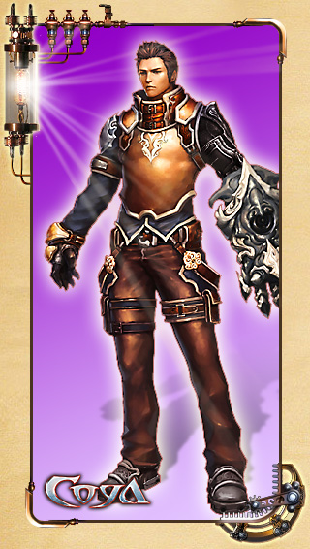

Kyle Ladin - an officer of the republic Evan fighting group "Polaris". He recently turned 26 years old. Kyle - the second son of General Ladin, the hero of the war.

Kyle was a sociable person, who was waiting for a brilliant career.Many would envy such a fate. However, after what happened two years ago, his life has changed ...

**Class Features**

Fighter specializes in close combat. It destroys enemies while in the thick of the battle. This is the destroyer, strength and stamina which allows capturing the opponents and deliver powerful blows.

* The style is most suitable for close combat.
* Prefers to take the enemy in the grip and throw on the ground or with the force of a beat, throwing back.
* Specializes in punches and kicks, requiring great strength.

**Mireille Rinel**

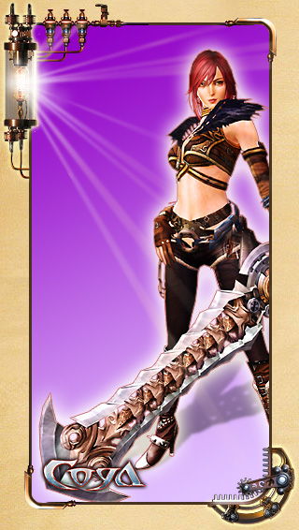

Mireille Rinel - Warrior, which was 21. She is a force of mercenaries, "Gray Fire."

Mireille - a professional who cares about getting the job done at any cost. She is ambitious and seeks recognition and financial well-being. However, its human feelings are as strong as her ambitions.

Her childhood was greatly influenced the formation of her character ...

**Class Features**

This class is characterized by long and rapid combinations of techniques on the ground and in the air.

* Fast attack with the sword.
* Spectator fencing techniques, attack in the air and throws himself through.
* Attack Power warrior is not so great, but the speed and combo attacks make it a formidable opponent.

**Coco Bolo**

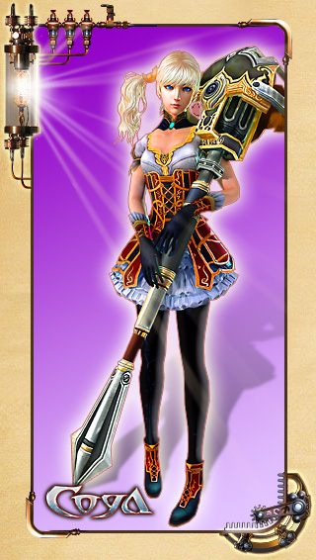

Coco Bolo - fairy girl, barely 15. She is a member of the school of magic "four circles". She has an incredible talent for magic, but it is quite a strange man. Her face never expresses any emotion, and the right and left eyes of different colors.

Magical powers were inherent in Coco, so parents were forced to give it to a baby in the care of the "Four Circles" - for them it represented the magical gift too great a threat ...

**Class Features**

Fairy uses magic attacks from a distance and an attack on the area, quickly destroying opponents.

* Magical attack on the area.
* Class more suitable for fighting at a distance than near.
* Sorceress can save the magical power, and then unleash it on the enemy, killing them instantly.

**Pathan Cromwell**



Vermont church - is the most powerful organization on the whole of the primordial continent. Patan - Battle Priest secret order "Shnikerzayts" at the papal court. When he performs the tasks of the Order, he lives a normal life of a priest.

Baby tossed him to the door of the church, where he found the vicar. The church raised and educated Patan.

At first glance, it may seem like a good-natured and cheerful man, but his appearance - but a mask behind which hides many secrets.

He is currently looking for a friend, who disappeared during the quest of the papal court.

**Class Features**

Some of these use their scythe of death, to weaken the enemy, and the Allies have the advantage in combat, healing and strengthening them.

* Crushing blows Diagon death.
* Recovers HP comrades.
* A powerful attack that weakens enemies - for example, stunning them, throwing, etc.