**Monsters Dungeons forest Ilonda**

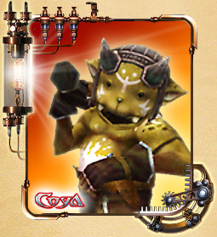

**Demon**

Small and funny demon, who lives alone in the woods. Earlier demons rarely come across on people's eyes, but recently began to meet more and more often, and even joined in the tribes under the leadership of captains.

Demons - sly and mischievous creatures. They often steal people have different valuable things.

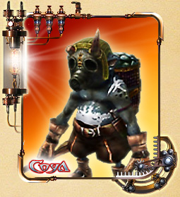

**Kobold**

An evil demon undersized.

Kobold as demons, lived in the woods, avoiding people, but all of a sudden started to attack them, both singly and in groups.

Kobolds are eager for the good of others, and, like demons, stealing valuables from people.

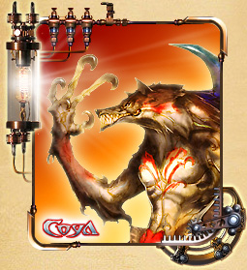

**Werewolf**

In the era of empire Mado when magic played an important role in people's lives, wizards experimented a lot over nature, and werewolves - the result of one such experiment.

The werewolf can not become either man or wolf. Many believe that werewolves are deprived of reason.

Werewolves live in forests and are sometimes combined with the wolves to attack people.

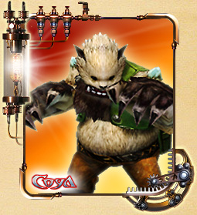

**Shadow**

About the shadows a lot of rumors.

Some say that they are descendants of the legendary sovomedvedey, others - that is the product of a magical experiment. To say exactly how or where you come there shadow, nobody can.

Shadows - born fighters, and some of them manage to learn how to communicate with people. It is said that during the war of shadows Grold used as soldiers.

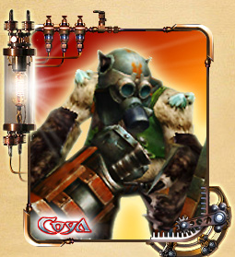

**Storm Shadow**

Assault shadows armed and protected by armor.

They first appeared during the war with Groldom - commanders of the shadows began to arm and wearing armor.

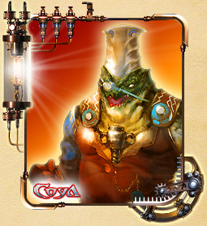

**Hammerman**

Huge, more than two meters in height, the monster. Instead, the right hand has a big steam hammer. At first glance it looks like a goblin, but the striker is much stronger and more dangerous.

It is said that he commands the goblins. No one knows the real name of this monster, but because of his hands-hammer is most frequently referred to as blacksmith.

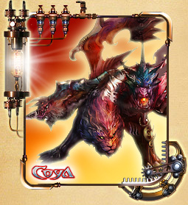

**Chimera (Boss Monster)**

This monster assembled from the body parts of monsters. Chimera appearance depends on what kind of monsters have been used in its creation, but in any case it is dire. It is said that in the era of Mado chimeras were the guardians of the Empire.

**Dungeons Monsters in the catacombs-Ilan Dishes**

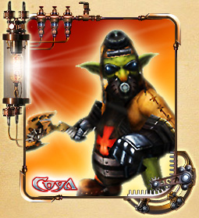

**Goblin**

A small green-evil monster.

Goblins - intelligent creatures, but compared to the people weak and stunted.Therefore, they work together and attack in groups. They usually live in caves and underground passages, but now for some reason settled in the catacombs beneath the Ilan-dish.

All goblins, regardless of what tribe they are very clever and interested in cars.That's why adults goblins themselves construct a weapon, armor, and equipment.

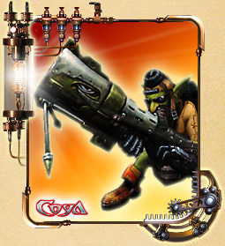

**Steam Goblin**

Steam goblins use modern guns and can attack from a distance.

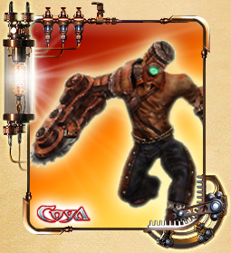

**Bionic zombies**

Unknown organization creates biological soldiers of the kidnapped and killed during the war, people. Bionic zombie - one of those soldiers.

As life in the zombie supported with magical energy, it is not easy to kill. And the mechanisms built into their bodies, are formidable weapons.

Zombies blindly obey his master, who has returned to their lives.

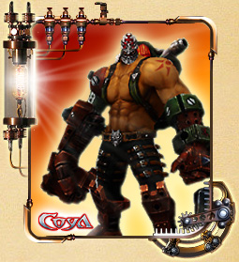

**Steam ogre**

Steam ogres - dangerous enemies, because they are armed and protected by armor, and their rage and cruelty - a rarity even for ogres.

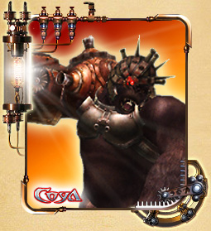

**Steam humanoid (Monster Boss)**

This artificial monster's got a Grolde, having forbidden ritual magic saturation.The raw material served as a gorilla. It was implanted steam engine, increasing its natural destructive force.

Because of the influence of forbidden magic and pain that brings implanted in the body zeplarovy engine, this monster is always furious and ready to break all their legs.

**Dungeons Monsters Fort Brukshel**

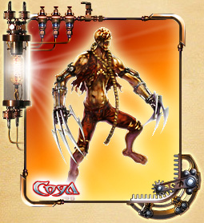

**Zombie fighter**

Unknown organization creates biological soldiers of the kidnapped and killed during the war, people. Zombie fighter - one of those soldiers.

As life in the zombie supported with magical energy, it is not easy to kill. And by the hands of zombies attached a deadly weapon.

Zombies blindly obey his master, who has returned to their lives.

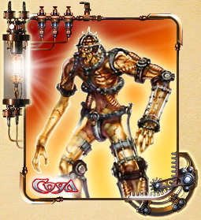

**Zombie Warrior**

Unknown organization creates biological soldiers of the kidnapped and killed during the war, people. Zombie Warrior - one of those soldiers.

As life in the zombie supported with magical energy, it is not easy to kill. And these zombies are further protected by strong armor.

Zombies blindly obey his master, who has returned to their lives.

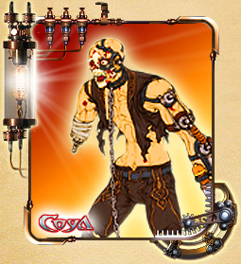

**Zombie Scout**

Unknown organization creates biological soldiers of the kidnapped and killed during the war, people. Zombie fighter - one of those soldiers.

As life in the zombie supported with magical energy, it is not easy to kill.Scouts use ranged weapons, allowing them to attack from a distance.

Zombies blindly obey his master, who has returned to their lives.

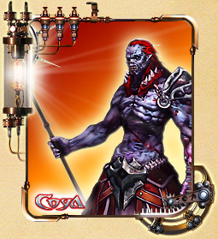

**Necromancer**

Necromancers learn and use the forbidden magic.

Other magical community shunned necromancers and wizards and their dark art. From the use of forbidden magic of the body necromancers rot and warp, and their shape resembles a human.

Necromancers Grold support, so they are becoming more and more.

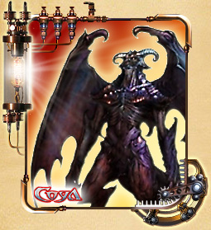

**Gargoyle**

Gargoyle Lord breathed life into stone sculptures decorating the fort Brukshel, and so did these monsters.

These monsters are well protected from the attacks - because they are made of stone. The gargoyles are like walking on the ground and fly, which makes the battle with them is even harder.

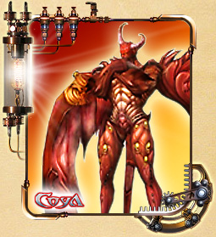

**Lord of the gargoyles**

Gargoyle Lord of the underworld called followers of the cult of Circe.

This is a powerful sorcerer, able to animate stone gargoyles and bend them to his will.

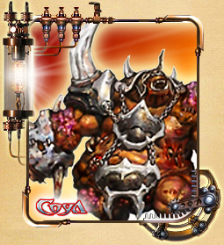

**Butcher**

Butcher - it's a monster, assembled from pieces of dead bodies of other creatures.

This is a huge monster has incredible strength, but extremely low intelligence.This creature looks decayed truly awful.

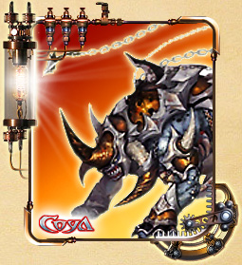

**Rhino**

Rhinoceros - is one of the results of the experiments wizards Grolda. Magic gave it the shape of a monstrous beast.

Rhino intelligence similar to a dog's, because to create it used the genetic material and the body of a dog.

Like other man-made monsters, body Rhino contains various tools and weapons, allowing a distance to hit the target with three harpoons.

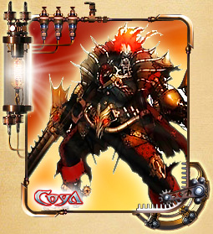

**Rudolf Hess**

Rudolf Hess was once a man and groldskim general. However, wanting to gain immortality, he agreed to take part in the magic experiment. The experiment was a success, and Rudolf half turned into a zombie.

In order to become more powerful, Rudolph built into your body a variety of mechanisms.

Since he became a zombie on their own, Rudolph kept his mind, reason and free will.

**Dungeons Monsters Canyon Kolka**

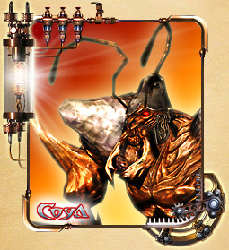

**Soldiers deserted lohantov**

Lohanty desert - it had a primitive mind insects that inhabit the desert canyon Kolka. They live in tribes and lead savage life. As a weapon lohanty use spears and crossbows, as well as its poisonous sting.

This territorial creatures that attack anyone who comes into their territory.Therefore, they are a threat to everyone who goes into the canyon Kolka.

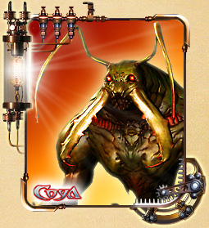

**Kleshnegromila**

Kleshnegromila - one of the original inhabitants, the canyon Kolka. For unknown reasons, until now, many residents are subject to the canon Kleshnegromile.

It is easy to confuse with the usual giant ant. However, unlike ants Kleshnegromila can dig into the ground. This ability helps him to hide from the enemy or unexpected attack from the ground.

A traveler passing through the canyon Kolk should try not to make a noise - or risk being attacked Kleshnegromily!

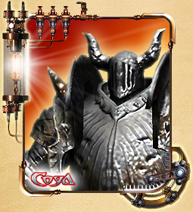

**Stone statue**

In the canyon Kolk is a lot of abandoned churches, and each church - many statues.

One day, some mysterious force has breathed life into the statues, they came down from his seat and began to wander the desert canyon lands Kolka.

However, they have not awakened mind - a sense of duty which force them to defend their land. So they attack anyone who comes into their territory.

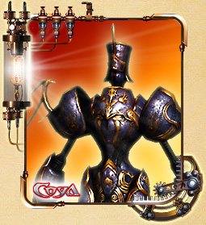

**Shlemonosny horror**

Shlemonosny horror - one of the guards canyon Kolk, armed with sword, shield and the power of lightning.

Once he was standing guard in the canyon Kolka ancient temple, but the temple is now destroyed and Shlemonosny horror remained in the canyon, carrying death reckless adventurers.

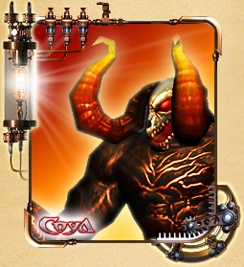

**Phantom of the fire**

Fiery spirit generated by the searing heat of the desert.

His body was collected from the remaining skeletons in the canyon Kolk, and the face is chilling horror.

He spews fire and can ignite the ground around him, making him fight even more difficult.

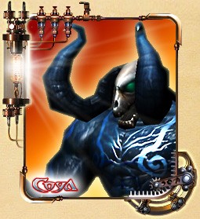

**Phantom of the wind**

Fierce winds, undivided prevailing in the desert, have created these air ghosts.

They are created from parts of corpses, collected together by powerful vortices.

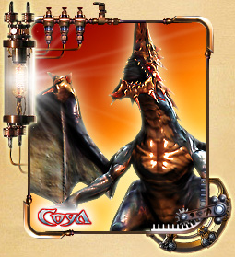

**Screaming Beast**

One of the fiercest creatures that live in the canyon Kolka.

That thing looks like a dragon with great wings, and is able to publish a terrible scream. During that it got its name - Screaming beast.

The beast is able to spew fire from the mouth and knocks his enemies with the tail. Run away from the screaming beast is almost impossible, because the wings allow it to make short flights.

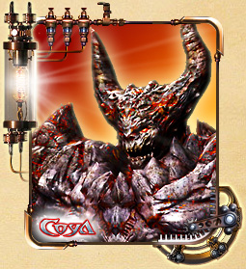

**Weak avatar Circe**

Avatar, called the priests of Circe, for the protection of the Secret Base.

However, the soldiers patrolling the canyon Kolk, prevented the complete ritual, and avatar Circe came into this world weak and unstable.

However, the picture was a giant in the desert lands of the canyon Kolk, bringing terror to all the inhabitants of the canyon.

**Dungeons Monsters Secret Base**

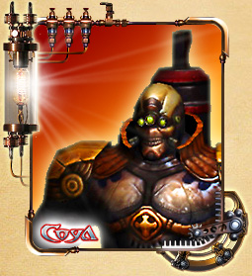

**Guardian of the Secret Base**

Grolda soldiers sent to guard the secret base.

Their bodies are enhanced by biological technology, and they are armed with sophisticated weapons, making them faster and more dangerous than ordinary soldiers.

Depending on the level of improvement, they are divided into guards and elite soldiers onrushey.

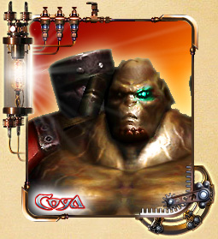

**Thanatos**

Cyborg-mutant created using forbidden magic and using biological weapons.

Thanatos was the largest Grolda soldier. Wizards decided that his body is the best fit for their experiment, in which the features of Thanatos distorted beyond recognition, and the body was swollen to an enormous size.

The experiment was successful, but Thanatos was completely insane.

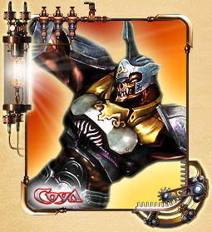

**Skeleton**

Fighting vehicle, created enchanting a mechanical golem, working on the engine zeplarovom Dr. Charles.

Golem is made up of complex mechanical devices and is fueled by magic, so it is not easy to destroy. His head, arms and torso inside a devastating weapon, and the legs are replaced wheel, allowing the skeleton of moving extremely quickly.

The skeleton performs without thinking embodied in his orders, so when I met him it is recommended to run without looking back.

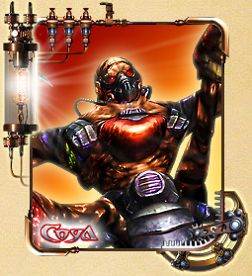

**Octopus**

The result of a failed attempt to create a hybrid of man and machine.

He has three mechanical legs for increased mobility, and the body redone to be more effective in combat.

Scientists Grolda planned to form groups of these creatures, but were unable to suppress excessive aggressiveness Octopus. In addition, intelligence Octopus was too low, so that they can act as a team.

As a result, the experiment was considered a failure, and all created Octopus sent to guard the secret base.

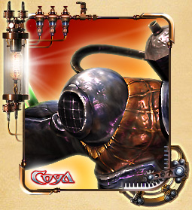

**Deep bully**

Deep thugs guarded secret base at the same time experiencing zeplarovy engine in combat.

Most deep thugs responsible for biological experiments, some of them are engaged in the work of the experimental objects or important documents.

Deep thugs with maniacal zeal to their work, so the battle may be even more dangerous than the guards.

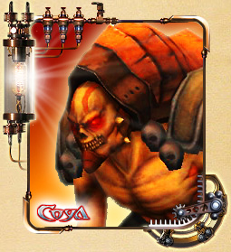

**Reaper**

Reaper - it's a monster, which combines a forbidden magic and divine powers.The combination of light and dark energy gives him incredible power. This is the only established during the experiments being able to use bio-weapons fire.

Reaper no memory and blindly ordered him to perform. Zeplarovy engine allows him to fight both on the ground and in the air.

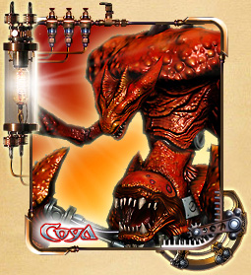

**Belberos**

Belberos - is the pinnacle of the work of scientists and magicians Secret base to create a bio-weapon. Four legs allow it to move with great speed and powerful body with huge blades in place of hands inspires opponents fear.Belberosa planned to be used for terrorist operations, but the heroes discover the secrets of the base and destroy the monster.