**The system of PvP game Soul**

PvP system in the "Soul" on the server allows players to fight each other, setting some opportunities in the game in addition to raising the level. So even when you can not fight in the dungeons because of fatigue character, you can always hone their skills in duels!

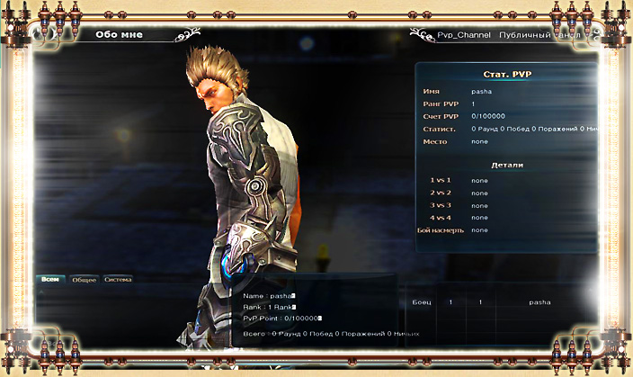

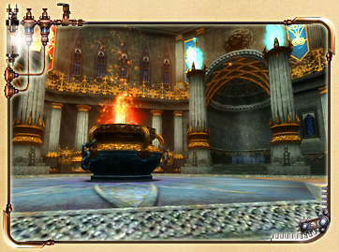

**Terms of PvP**

* Participants: Players level 10 and above
* Teams: fights from "1 to 1" to "4 by 4"
* Rules: fight to the death
* Variety: friendly battle and rating tournaments
* Fatigue: Fatigue system is not used
* Awards for Guild: Guild may participate in the capture of the territories, thereby increasing your level and increasing the number of participants.

**PvP modes**



**Fight to the death**

In this mode, the player wins or the team that destroyed all rivals. The winner must win two out of three rounds.



**Survival**

The winner is the player who kills in the allotted time, the largest number of competitors and the survivors.



**Capture the Flag**

Players are divided into two teams (red and blue), and won by the team that manages to capture the enemy base located on the flag.



**Failure mode**

To win, you need to destroy a certain object on the basis of the enemy.

PvP Arena