transdocx.py

.docx document translator

The program translates paragraphs of docx documents while maintaining the original content

Your Google token should be in the file my_token.json

Change your language in target variable.

If you need to translate pdf files, I recommend [pdf2doc.com](https://pdf2doc.com) for conversion to docx document.

# Starting the program:

## ## How to install? ##

```bash

git clone https://github.com/rapdan/transdocx

pip install -r requirements.txt

```

## ## Create the Authentication Credentials ##

You need to first generate a JSON Key File through the Google Developers Console. https://console.cloud.google.com/apis/credentials

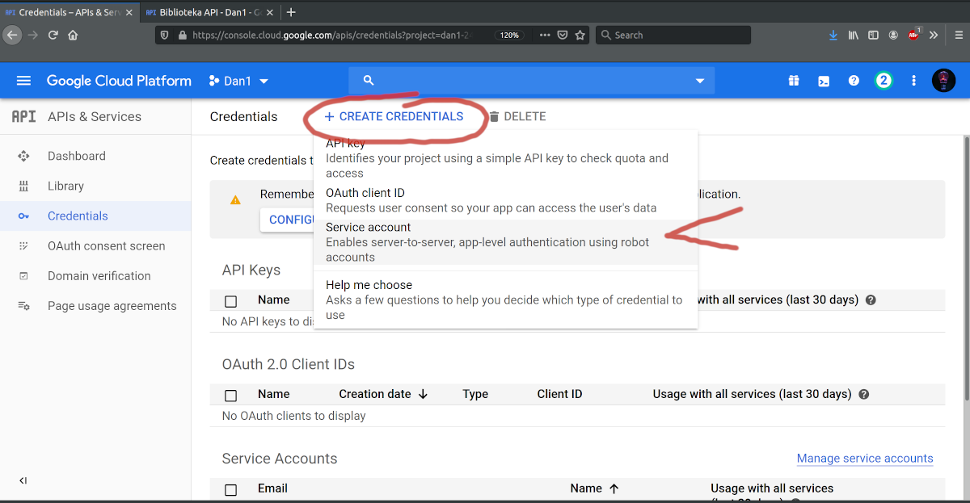

Fill the form and choose a “JSON” key type:

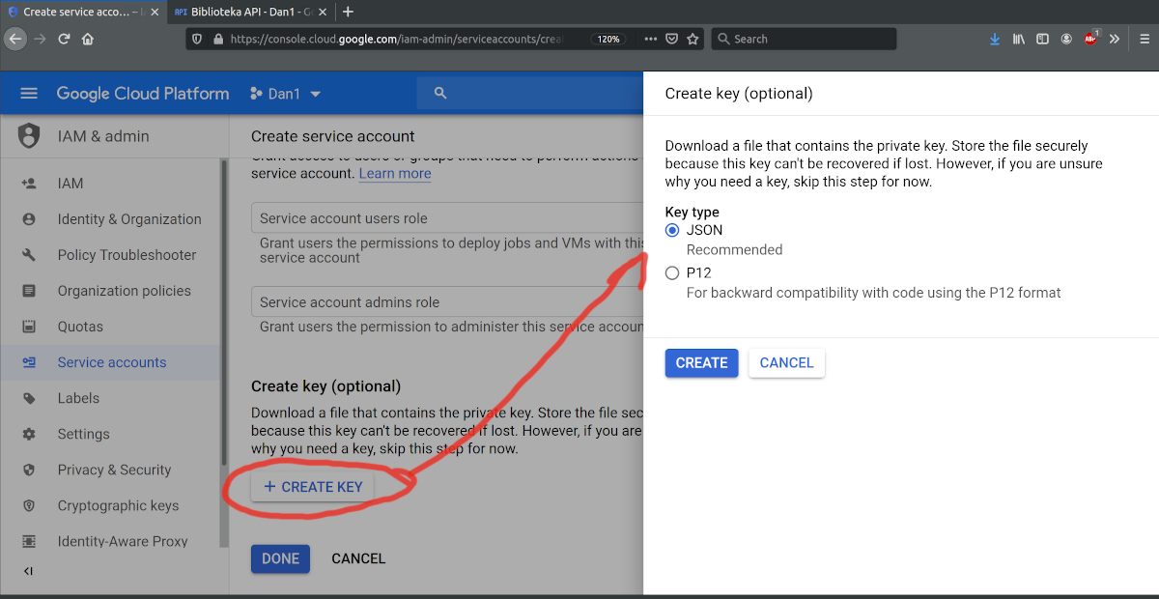

Save a “JSON” key as my_token.json in program directory.

## ## How to translate? ##

```python

python transdocx.py document_name.docx

```

(the document_name.docx must be in the program directory)

The result is saved with the prefix target e.g pl-document_name.docx