OS – Project 4

I implement the data structure of the graph with a vector of lists like in the precedent exercice.

The funtions of the graph for find a euler circuit, build a graph, add a new edge... are in Graph.hpp and Graph.cpp.
For find if the graph contain an Euler circuit I use DFS.
In the file main.cpp I implement the main that receives argument with getopt and a function that generate a random graph.

Exercice 5:
I provide the entire output of the valgrind on the github url.
I found here 3 problems:
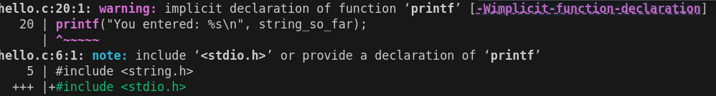
1. The code doesn’t countain include of stdio.h:

2. Memory leak:
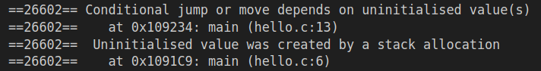
3. Uninitialised value:
here:

Exercice 6:
We need to use 2 terminals here. In the first one, we run Valgrind on the program and in the second the gdb and we open a pid for the valgrind.
First :
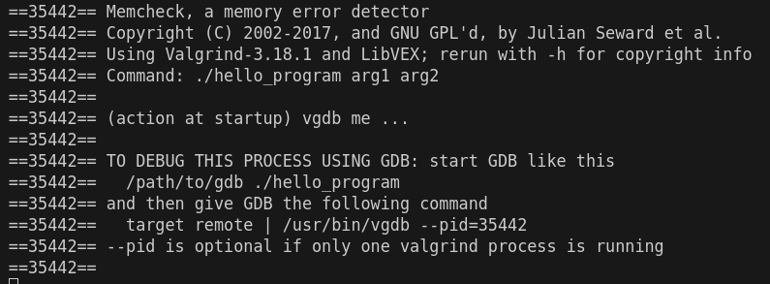

Second:
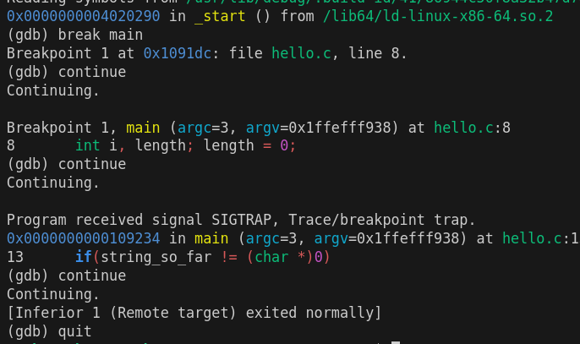
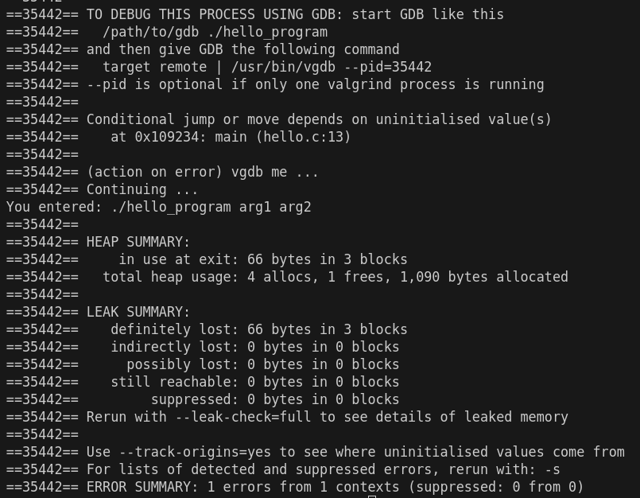

Exercice 7:

The race condition in this program arises because multiple threads are accessing and modifying the shared variable accum without synchronization. This leads to undefined behavior, as different threads can simultaneously read and write to accum, which is unsafe without proper locking mechanisms like with mutex.

1.Data Race on Read:
- Thread 4 is reading from the shared variable accum.
- This read operation occurs without holding any locks, which means there is no guarantee that another thread isn’t writing to accum at the same time.
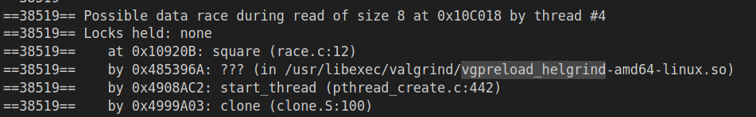
2.Conflicting Write Operation:
- Thread 3 had previously written to the same shared variable accum at the same memory location. Again, this happens without holding any locks, creating a race condition when another thread is accessing the same variable at the same time.
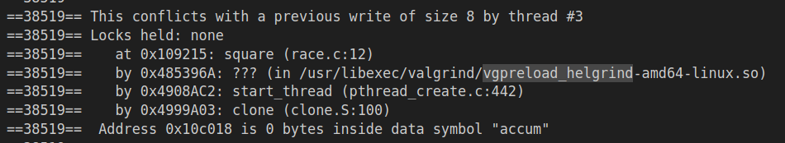

3.Data Race on Write:
- Thread 4 is also writing to accum at the same memory location. Since Thread 3 had just written to the same location, this results in a write-write race. Both threads are trying to update the shared variable simultaneously, which can cause unpredictable results.
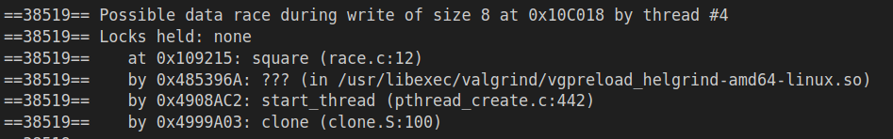
4.Conflict with Previous Write:
- Helgrind detected that this write operation by Thread 4 conflicts with the write operation by Thread 3 at the same memory address .
