COHEN Raphaël A20432518

Model description for phase 3

- Model for Williams and Bush are the same.
- I used dropouts to avoid overfitting. (Only used for training, not test to have consistent outputs once the network is trained.)
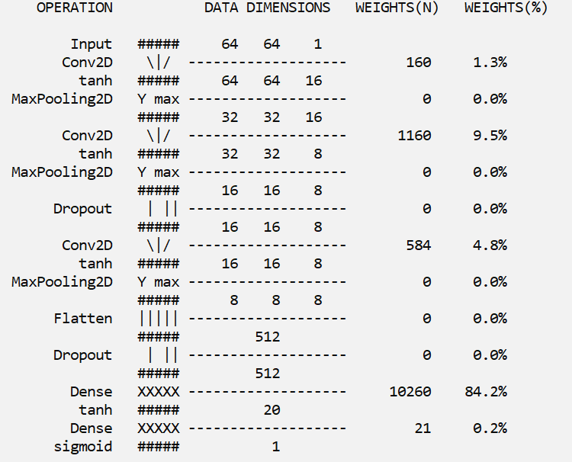
- I used weights (for classes) when training to compensate for the unbalanced dataset.

