TECHNICAL REPORT
VECTRA-X
Uncertainty-Aware Triage Intelligence for Vector-Borne Disease Response in Resource-Limited Humanitarian Settings
FIT Competition 2026 | Track IV: AI-based Vector-Borne Disease Prediction
Evidence generated from a self-contained notebook and the official CSV

Executive Summary
VECTRA-X reframes vector-borne disease prediction as an operational triage problem. The system preserves co-infection, separates pre-lab and lab-aware information, exposes target leakage, communicates uncertainty, and converts model outputs into transparent review and resource-prioritization queues.
Primary finding
Extra Trees ranked first by training-only OOF macro PR-AUC. On the untouched holdout, calibrated PRE_LAB performance reached macro F1 0.535, micro F1 0.851, and macro PR-AUC 0.582. These aggregate scores conceal major rare-label false-negative risk.

Safety limitation
Yellow fever recall was 0/3 and typhoid recall was 1/7. VECTRA-X is therefore a competition decision-support prototype, not a diagnostic system, and requires prospective multi-center validation.

1. Humanitarian Problem and Intended Use
During outbreaks, frontline teams must prioritize patients while laboratory tests, beds, and qualified staff are limited. A prediction alone does not answer who should be reviewed first, when the model is uncertain, or how capacity constraints change the queue.
VECTRA-X supports triage prioritization and confirmatory-test allocation. Its intended users are health workers and humanitarian response coordinators. It does not recommend treatment or replace clinician assessment.

2. Related Work and Research Gap
Clinical prediction studies for febrile and vector-borne illness often focus on one disease or force mutually exclusive classes. This is poorly matched to a cohort in which 158 of 300 patients have more than one active label.
The research gap addressed here is stage-aware, leakage-audited, multi-label triage with uncertainty and operational prioritization. The methodology draws on multi-label stratification, probability calibration, conformal prediction, decision-curve analysis, TRIPOD+AI reporting, and WHO guidance on responsible AI for health.

3. Data and Problem Formulation
Property | Observed value | Methodological consequence
Patients | 300 | Use uncertainty intervals and repeated validation
Raw variables | 109 | Audit schema, missingness, and feature timing
Health centers | 2 | Run leave-one-center-out stress tests
Multi-label patients | 158 | Use multi-label rather than multi-class learning
Active labels | 5 | Report macro and per-label metrics
Dataset checksum | 365344fe8ce55328... | Trace evidence to the submitted CSV

4. Leakage-Safe Methodology
The outer multi-label stratified holdout is created immediately after target extraction. Data-driven schema decisions, category discovery, missing-indicator selection, imputation, model selection, threshold optimization, calibration, and conformal thresholds use training data only.
- PRE_LAB uses demographics, symptoms, history, and available vital signs.
- LAB_AWARE adds ordered laboratory and rapid-test information.
- FULL includes target-restatement risks and is reported only as a leakage demonstration.
All notebook results are recomputed from the official CSV. The submitted notebook does not read project modules, configuration files, processed data, saved models, or prior artifacts.

5. Model Comparison and Selection Rationale
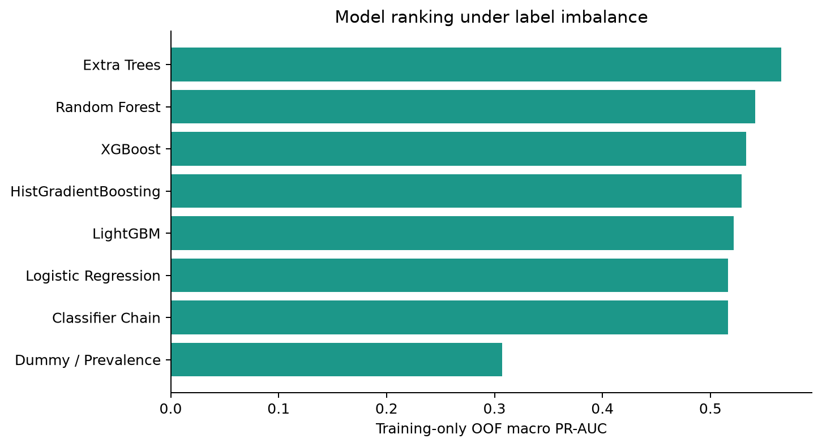
Figure 1. Training-only OOF model ranking by macro PR-AUC.
Model | OOF PR-AUC | Runtime | Why included | Main limitation
Extra Trees | 0.566 | 22.4s | Strong small-tabular benchmark, low variance | Feature effects are less direct
Random Forest | 0.541 | 21.6s | Robust nonlinear bagging | Larger and less calibrated
XGBoost | 0.533 | 5.2s | Strong tabular ranking performance | External dependency and tuning sensitivity
HistGradientBoosting | 0.529 | 14.6s | Efficient regularized boosting | Binary relevance required
LightGBM | 0.521 | 4.7s | Fast boosting with flexible leaves | Can overfit tiny rare-label samples
Logistic Regression | 0.516 | 0.7s | Stable, interpretable linear baseline | Misses nonlinear interactions
Classifier Chain | 0.516 | 0.6s | Models label dependence | Order-sensitive and less stable for rare labels
Dummy / Prevalence | 0.307 | 0.5s | Base-rate reference | No patient discrimination

Macro PR-AUC is the initial selection metric because label prevalence is highly imbalanced and the metric evaluates ranking without fixing a threshold. Final triage suitability also considers recall, false negatives, calibration, stability, number-needed-to-review, and resource demand.

6. Held-Out Results
Track | Macro F1 | Micro F1 | Macro recall | Macro PR-AUC
PRE_LAB | 0.591 | 0.782 | 0.792 | 0.589
LAB_AWARE | 0.613 | 0.815 | 0.740 | 0.595
FULL | 0.662 | 0.843 | 0.754 | 0.682

The FULL track is highest, but its gain is not operationally valid because it contains post-diagnosis or target-restatement information. LAB_AWARE is a confirmation-support context. PRE_LAB remains the honest early-triage track.
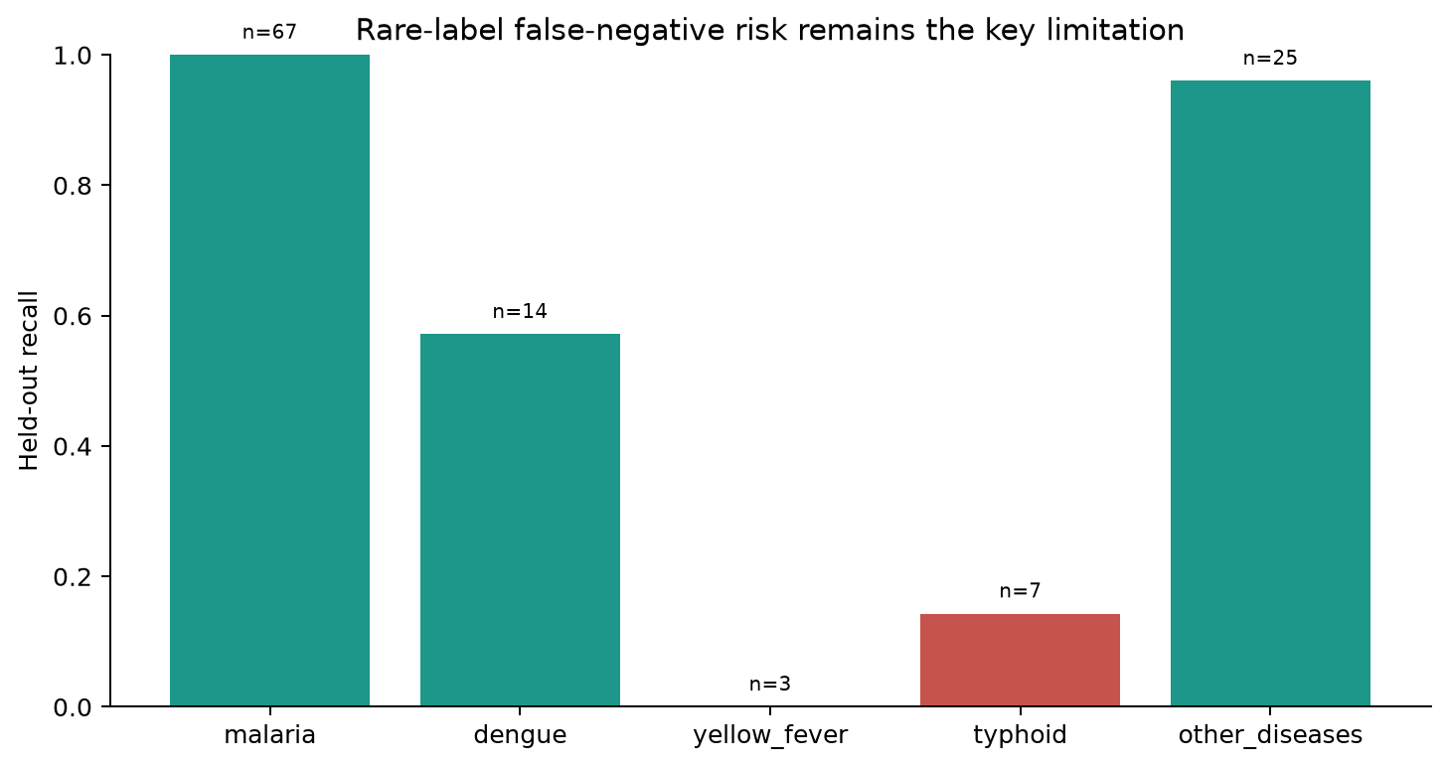
Figure 2. Held-out recall with positive support counts.
Label | Support | Precision | Recall | F1 | FNR
malaria | 67 | 0.870 | 1.000 | 0.931 | 0.000
dengue | 14 | 0.471 | 0.571 | 0.516 | 0.429
yellow_fever | 3 | 0.000 | 0.000 | 0.000 | 1.000
typhoid | 7 | 1.000 | 0.143 | 0.250 | 0.857
other_diseases | 25 | 1.000 | 0.960 | 0.980 | 0.040

7. Metric Rationale for Real-World Triage
Question | Metric | Why it matters
Can the model rank rare diseases? | Macro PR-AUC | Resists dominance by common labels
Which diseases are missed? | Per-label recall and FNR | Makes false negatives visible
How much review work is created? | Precision and number-needed-to-review | Connects flags to staff burden
Can probability guide priority? | Brier score and calibration error | Tests probability trust
Is testing policy useful? | Decision-curve net benefit | Compares model, test-all, and test-none
Will evidence transfer? | Repeated CV, bootstrap CI, center transfer | Exposes sampling and facility instability

No single metric is treated as a clinical utility score. The recommended candidate is reviewed as a Pareto trade-off across discrimination, safety, probability trust, stability, and operational burden.

8. Calibration, Uncertainty, and Caution Sets
Label | Support | Brier raw | Brier calibrated | ECE raw | ECE calibrated
malaria | 67 | 0.109 | 0.114 | 0.064 | 0.075
dengue | 14 | 0.130 | 0.126 | 0.087 | 0.081
yellow_fever | 3 | 0.036 | 0.037 | 0.049 | 0.000
typhoid | 7 | 0.104 | 0.078 | 0.105 | 0.049
other_diseases | 25 | 0.049 | 0.015 | 0.161 | 0.010

Calibration is label-dependent and may worsen some estimates. Predictive entropy, top-two margin, and maximum probability form an uncertainty gate. Label-wise positive-class conformal sets are presented as a caution mechanism, not as a joint multi-label coverage guarantee.
Label | Test positives | Coverage | Inclusions
malaria | 67 | 1.000 | 77
dengue | 14 | 0.929 | 36
yellow_fever | 3 | 1.000 | 77
typhoid | 7 | 0.286 | 11
other_diseases | 25 | 0.960 | 24

9. Explainability, Fairness, and Robustness
Permutation importance explains model behavior globally. It does not establish medical causality. Subgroup metrics are warning diagnostics because support is small. Center transfer is a stronger stress test of deployment risk.
Test Center | N Test | Macro F1 | Recall Dengue | Recall Yellow Fever | Recall Typhoid
CMA de DO | 147 | 0.350 | 0.000 | 0.000 | 0.000
CMA de DAFRA | 153 | 0.368 | 0.000 | 0.000 | 0.000

Generalization warning
Performance across facilities is materially weaker for rare labels. A future deployment would require facility-specific validation, recalibration, drift monitoring, and a human override pathway.

10. Triage and Resource Workflow
The prototype separates four outputs: disease predictions, uncertainty, triage priority, and recommended human action. Tiers are Routine, Clinical Review, Confirmatory Test Priority, and Urgent Response.
Resource | Demand | Capacity | Unserved
rapid_tests | 33 | 50 | 0
beds | 7 | 12 | 0
staff_review_slots | 49 | 80 | 0

Policy | Total flags | True-positive flags | Number needed to review | Flags per patient
performance | 119 | 100 | 1.19 | 1.55
safety | 122 | 100 | 1.22 | 1.58
operational | 106 | 93 | 1.14 | 1.38

These are workflow simulations, not observed clinical outcomes. Their purpose is to make the sensitivity-workload trade-off visible to decision makers.

11. Ethics, Privacy, and Limitations
- VECTRA-X does not replace clinician assessment or provide treatment recommendations.
- Rare-label estimates are unstable, especially yellow fever and typhoid.
- Public dashboard exports use generated case IDs and exclude UUIDs and truth labels.
- Fairness estimates are warning diagnostics, not evidence of equity.
- Conformal coverage is label-wise and approximate under small calibration samples.
- Triage weights and resource policies require clinician and humanitarian-operations co-design.

12. Conclusion and Recommendations
VECTRA-X demonstrates a defensible humanitarian workflow around an honest pre-lab model. Its strongest contribution is not an aggregate score; it is the combination of multi-label framing, leakage control, uncertainty-aware human review, and transparent resource prioritization.
Before operational use, the next steps are prospective temporal and multi-center validation, larger rare-label cohorts, facility recalibration, clinician usability testing, and outcome-based resource optimization.

Appendix A. Confidence Intervals
Metric | Estimate | 95% CI low | 95% CI high | Bootstrap draws
macro_f1 | 0.535 | 0.446 | 0.626 | 500
micro_f1 | 0.851 | 0.794 | 0.904 | 500
macro_recall | 0.535 | 0.460 | 0.622 | 500
macro_pr_auc | 0.582 | 0.518 | 0.728 | 500

Appendix B. Reproducibility
The executed notebook used Python 3.12.6, random state 42, and CSV SHA-256 365344fe8ce553288f952c6d32771cdde2b7c633006538ddb1d6c82de325efb1. It was verified in a clean folder containing only the notebook and CSV.
The notebook exports fresh model comparison, held-out metrics, per-label metrics, confidence intervals, calibration, conformal, fairness, center transfer, resource trade-offs, privacy-safe patient records, and an execution manifest.

References
1. World Health Organization. Global vector control response 2017-2030. 2017.
2. World Health Organization. Ethics and governance of artificial intelligence for health. 2021.
3. World Health Organization. Dengue: guidelines for diagnosis, treatment, prevention and control. 2009.
4. World Health Organization. WHO guidelines for malaria. Continuously updated.
5. Sechidis K, Tsoumakas G, Vlahavas I. On the stratification of multi-label data. ECML PKDD, 2011.
6. Read J, Pfahringer B, Holmes G, Frank E. Classifier chains for multi-label classification. Machine Learning, 2011.
7. Niculescu-Mizil A, Caruana R. Predicting good probabilities with supervised learning. ICML, 2005.
8. Vovk V, Gammerman A, Shafer G. Algorithmic Learning in a Random World. Springer, 2005.
9. Angelopoulos AN, Bates S. Conformal prediction: a gentle introduction. Foundations and Trends in Machine Learning, 2023.
10. Vickers AJ, Elkin EB. Decision curve analysis. Medical Decision Making, 2006.
11. Collins GS et al. TRIPOD+AI statement. BMJ, 2024.
12. Wolff RF et al. PROBAST. Annals of Internal Medicine, 2019.
13. Lundberg SM, Lee SI. A unified approach to interpreting model predictions. NeurIPS, 2017.
14. Chen T, Guestrin C. XGBoost. KDD, 2016.
15. Ke G et al. LightGBM. NeurIPS, 2017.
16. Obermeyer Z et al. Dissecting racial bias in a population health algorithm. Science, 2019.

