create database Programa;

use Programa;

create table Programa (

idPrograma int primary key,

nome varchar (40),

genero varchar (30),

emissora varchar (20) );

select * from programa;

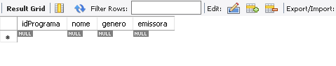

insert into programa values

(1,'Faustão','entreterimento','Globo'),

(2,'The noite','humor','SBT'),

(3,'Praca e nossa','humor','SBT'),

(4,'Zorra total','humor','Globo'),

(5,'Jô','entreterimento','Globo'),

(6,'Jornal da globo','jornalismo','Globo'),

(7,'Jornal da record','jornalismo','Globo');

select * from programa;

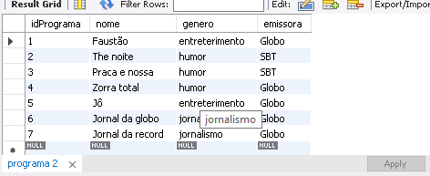

select * from programa where emissora ='Globo';

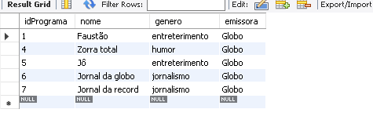

select * from programa where genero ='humor';

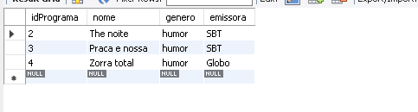

select * from programa order by genero;

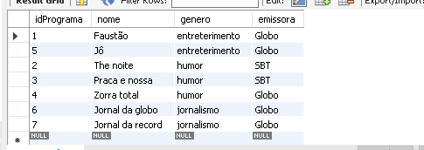

select * from programa order by nome desc;

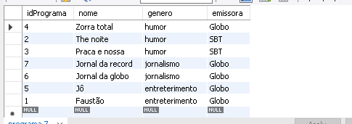

select * from programa where nome like '%o';

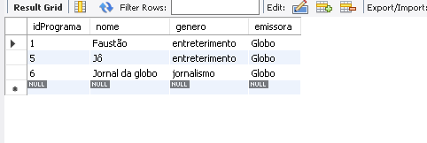

select * from programa where genero like 'j%';

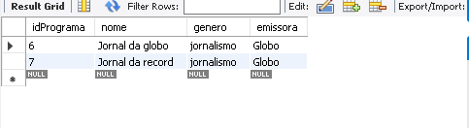

select * from programa where emissora like '_B%';

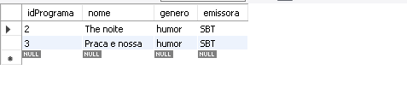

select * from programa where nome like '%a_';

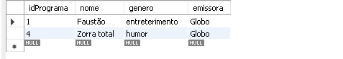

update programa set emissora = 'band' where idPrograma =4;

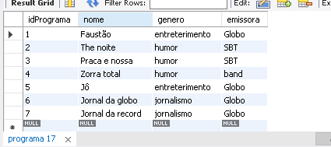

delete from programa where idPrograma =4;

select * from programa;

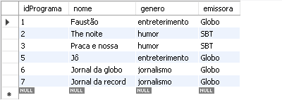

drop table programa;

