**Report**

*Image processing of the microscope photo*

I have done this work in python, with the libraries *numpy* and *cv2*.

**Objective**: extract the period of the crystal striations.

**Workflow**

1. First, I loaded the image into the program

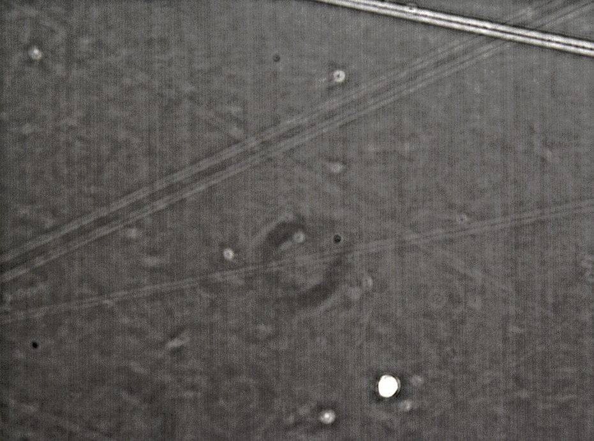

Figure 1 Original image

1. I applied on the image a Sobel x-axis kernel to emphasis the x-edges. Then, I rotated (manually) the image, such that the striations lines will be parallel to the image borders.

Because of the rotation, I also had to resize the image to get the largest possible area crop window within the rotated image (see explanation images below).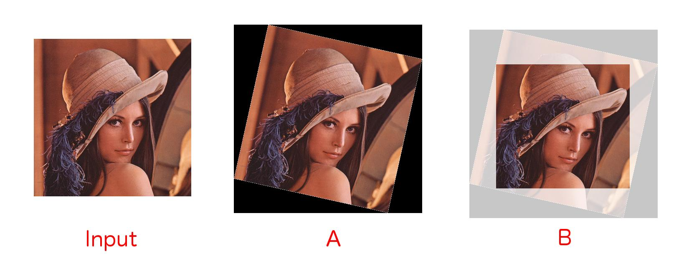

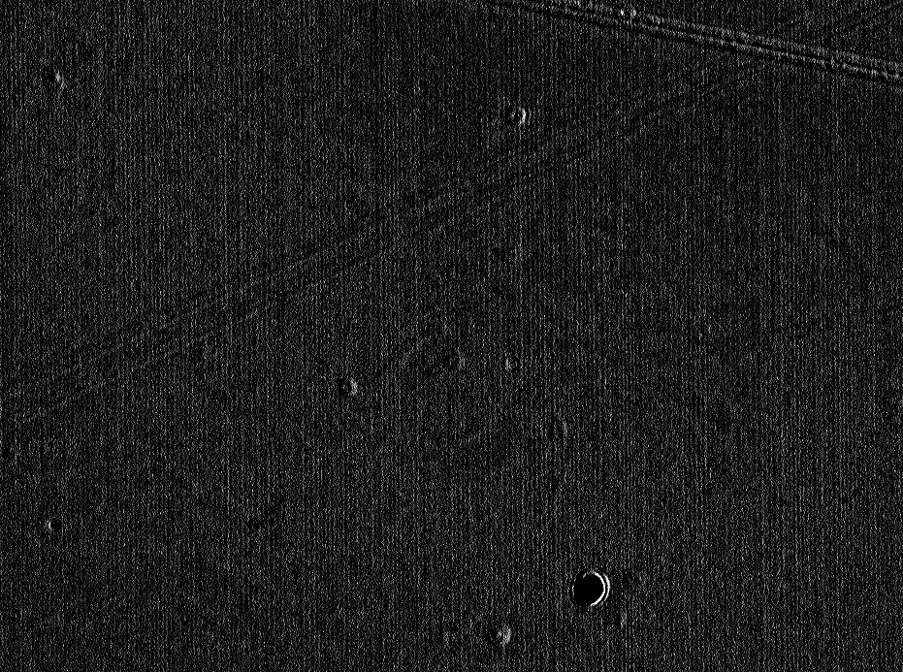

Figure 2 Filtered and rotated image

1. I summed each line of the image to get a unique line of pixel, which represent the y-average of the image. You can see below the summed image (I duplicated the line on the y-axis).



Figure 3 Summed image

1. Now we can perform a Fourier transform on this line. We get the next graph:

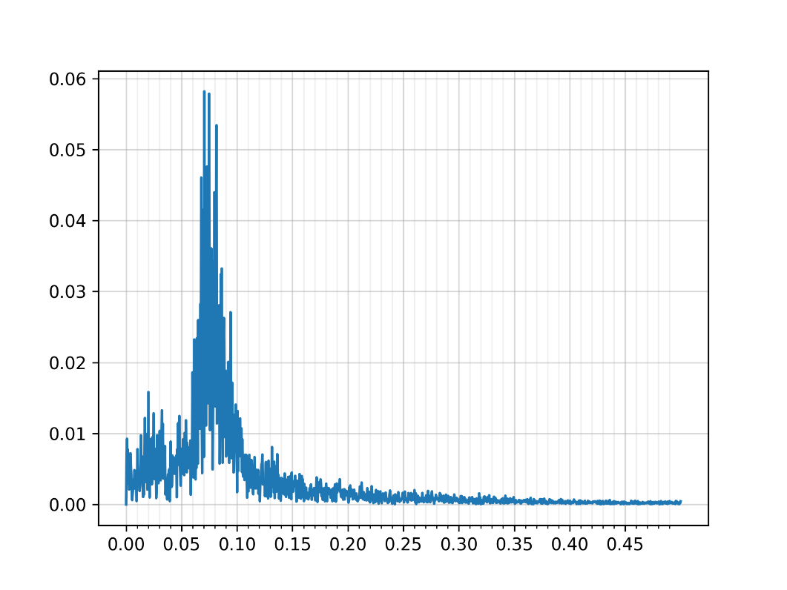

Figure 4 Frequency decomposition of the summed image

**Analysis**

We can read a maximum peak at . This value corresponds to the pixels, not to the real distance. Then we need to convert it.

According to the microscope, the scale is

The period we computed is

Then the actual period is