Agpoon, Rey Carlos

Guisama, Raphael John Gabriel

Python Solution – Problem 1

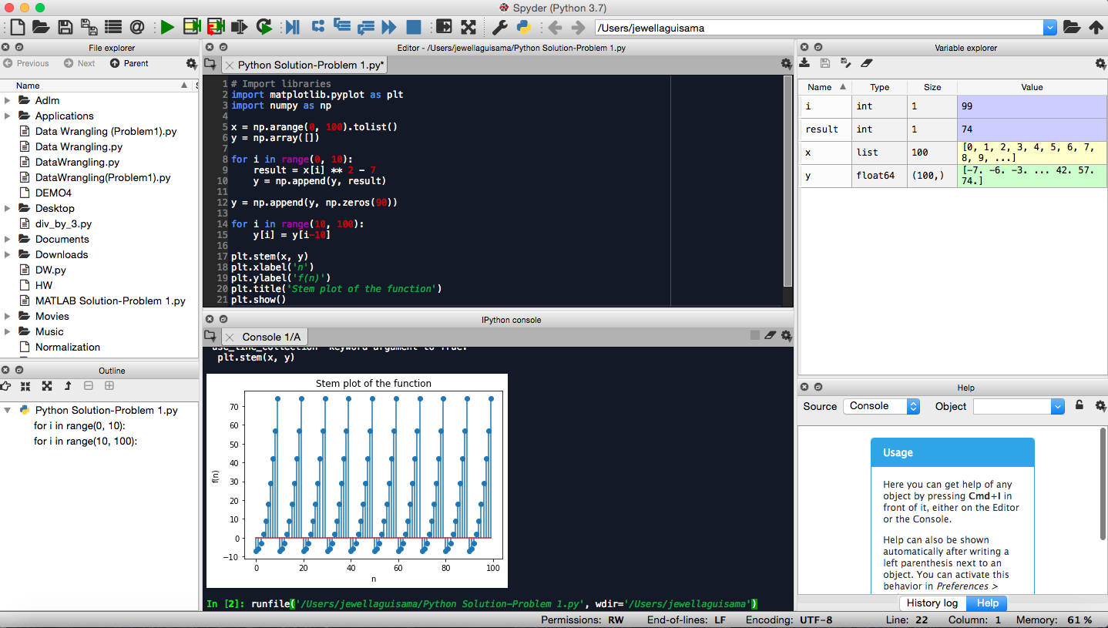

The plot of the function has varying and increasing values of f(n) depending on the value of n that is the same per interval of ten. As the value of n increases by ten, the graph from the starting point repeats until the final value of n but all of which has the same graph.