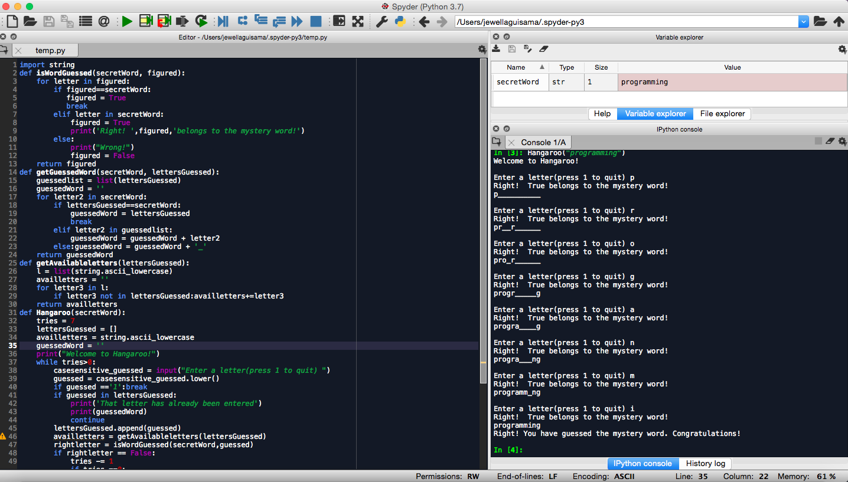

Raphael John Gabriel F. Guisama

2ECE-D

ENG2112-Experiment 6(Hangaroo Game)

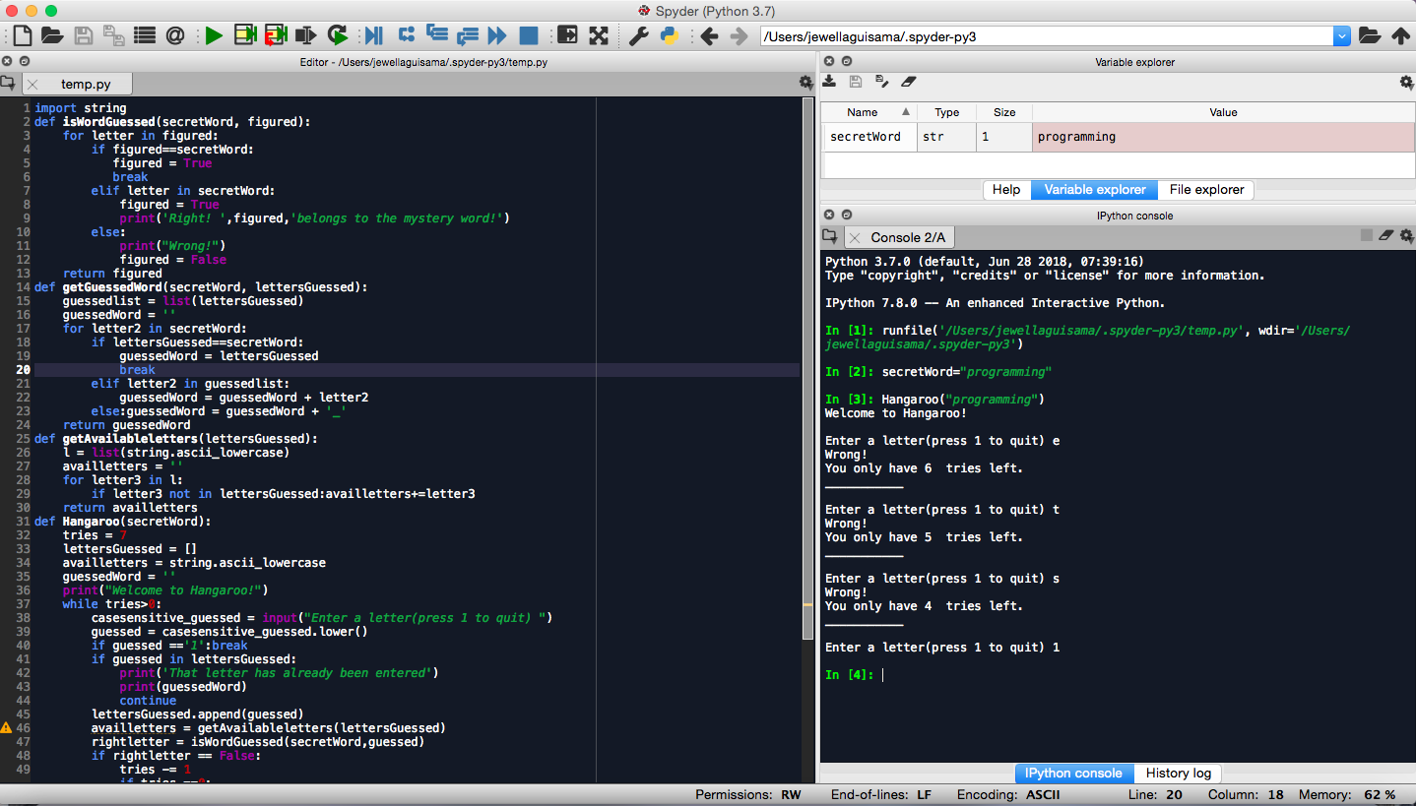

Raphael John Gabriel F. Guisama

2ECE-D

ENG2112-Experiment 6(Hangaroo Game)