Raphael John Gabriel F. Guisama

2ECE-D

ENG2112: Programming Assignment (NUMPY)

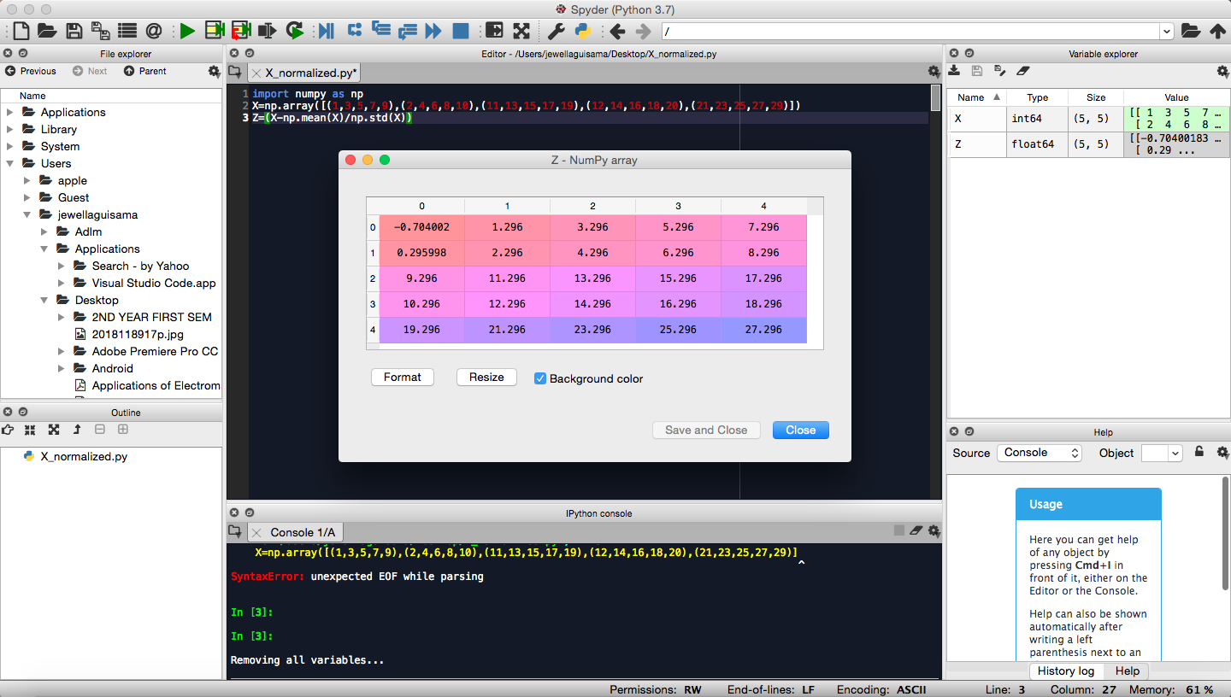Problem#1:Normalization

Problem#2: 10x10 ndarray

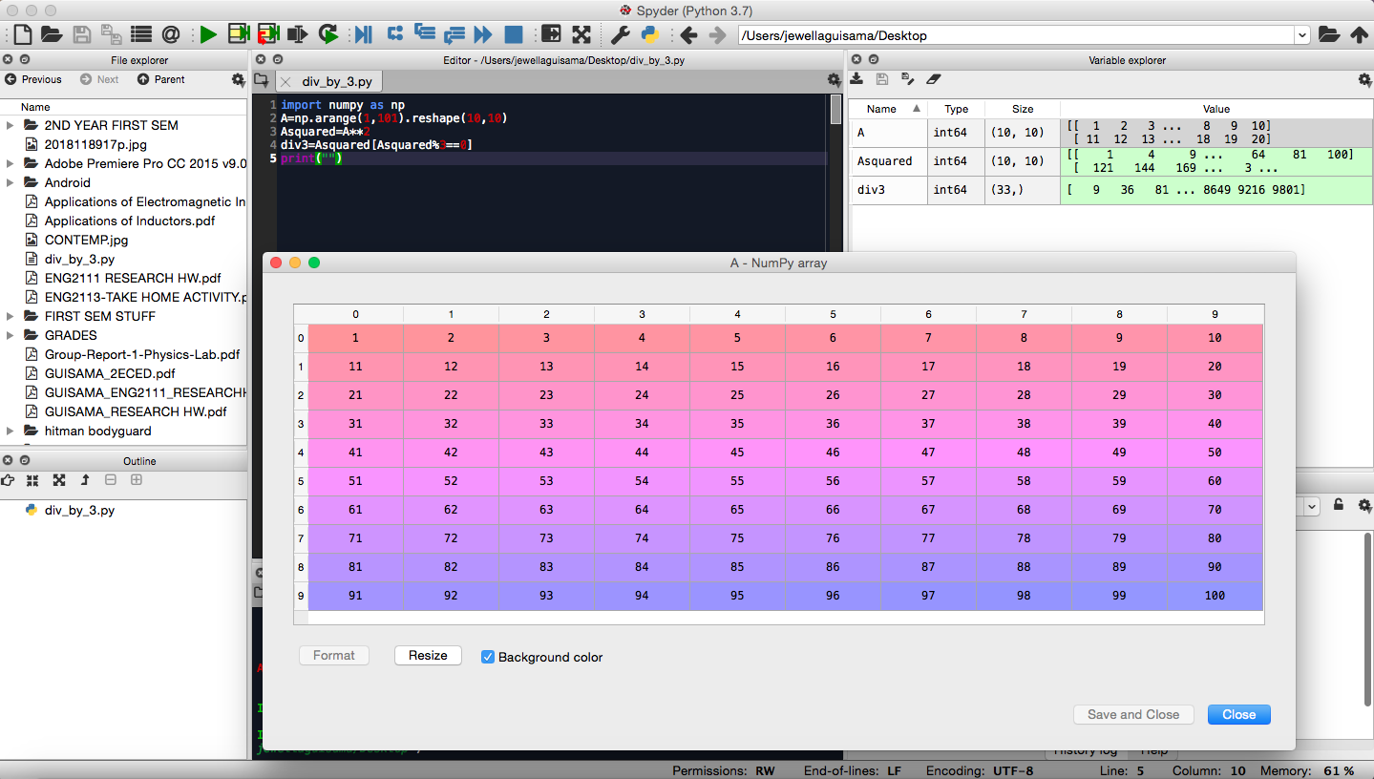

10x10 Matrix of First the 100 Integers

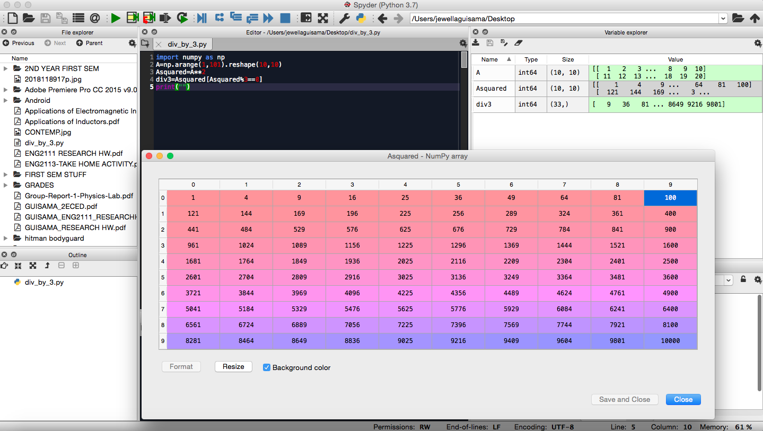

10x10 Matrix of the Square of the First 100 Integers

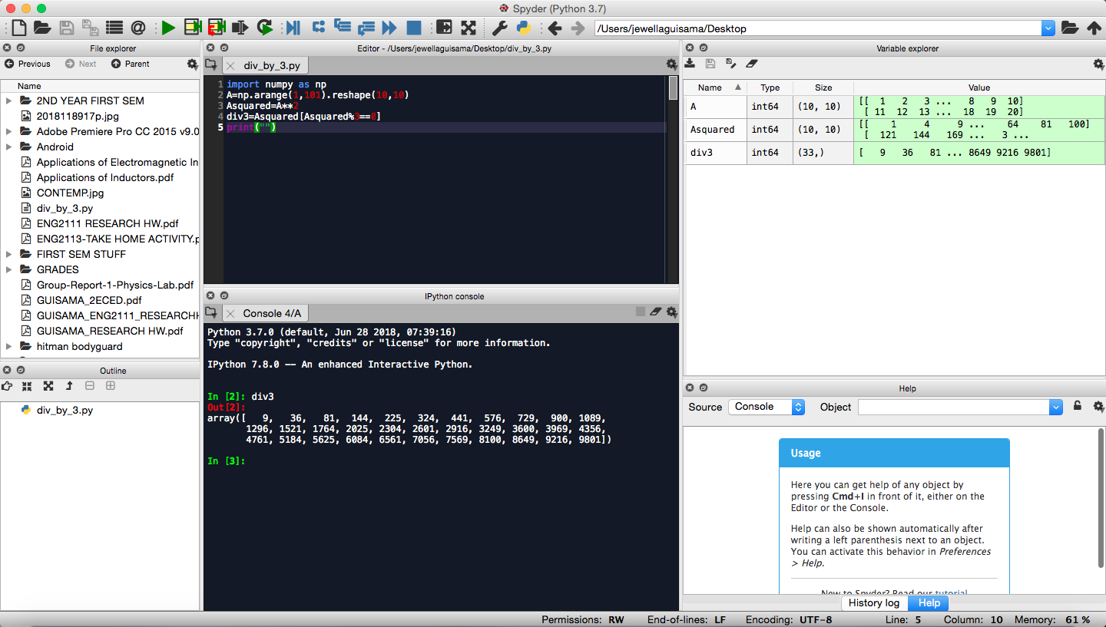

Array that displays the elements of the matrix that are Divisible by 3