Raphael John Gabriel F. Guisama

2ECE-D

ENG2112: Programming Assignment (PANDAS)

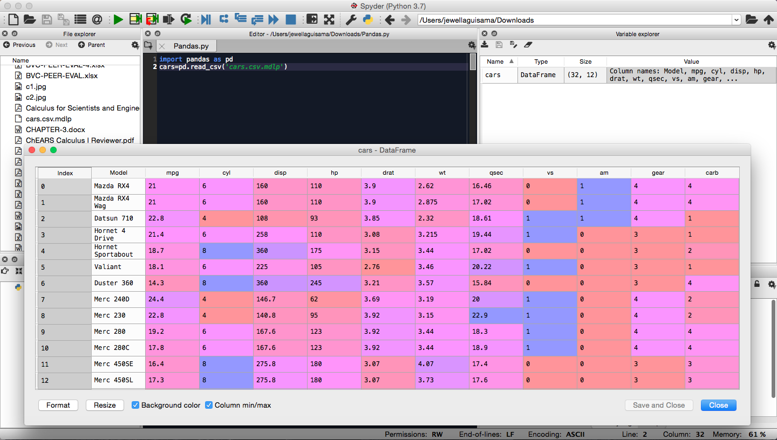Problem#1: (a). Load .csv file and (b). display the first five and last five rows of the resulting cars

(a). Load .csv file

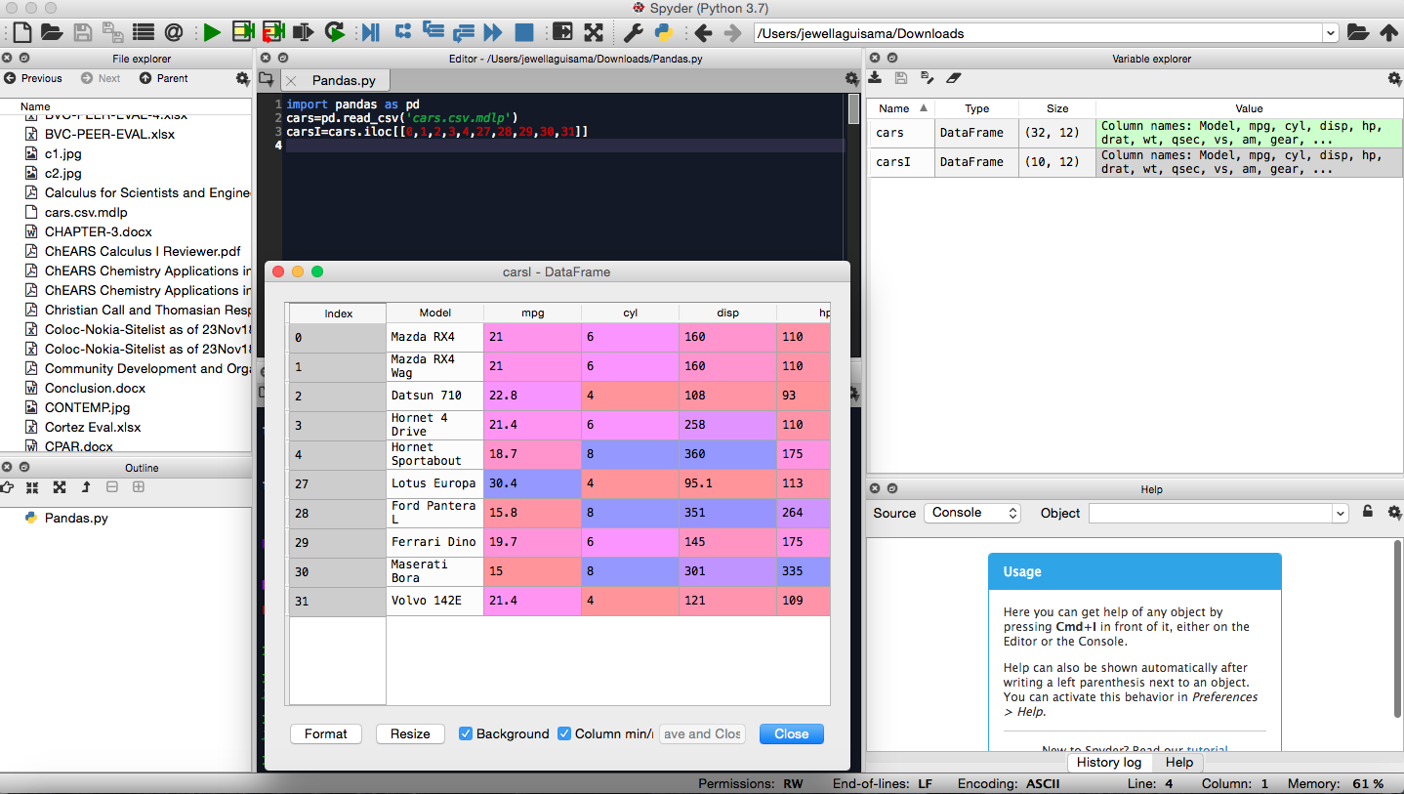(b). Display the first five and last five rows of the resulting cars

Problem#2:

(a). Display the first five rows with odd-numbered columns of cars

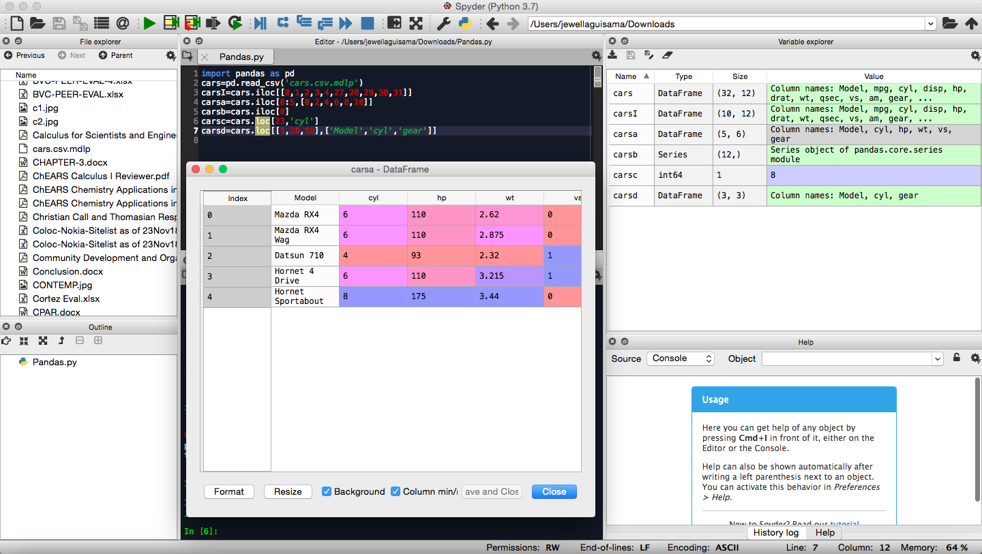

(b). Display the row that contains the ‘Model’ of ‘Mazda RX4’.

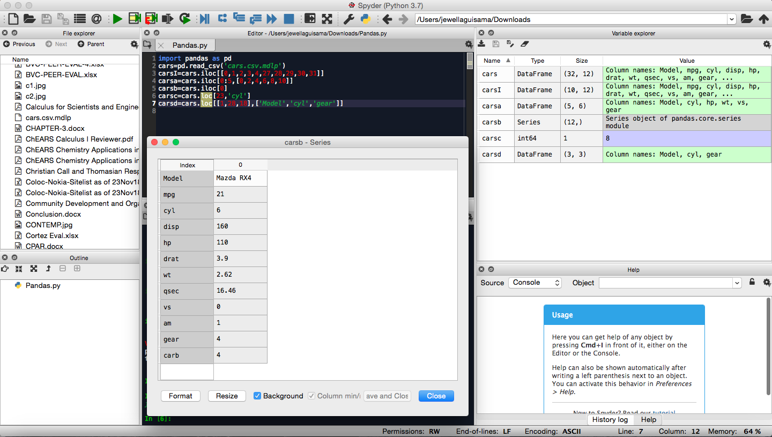

(c). How many cylinders (‘cyl’) does the car model ‘Camaro Z28’ have?

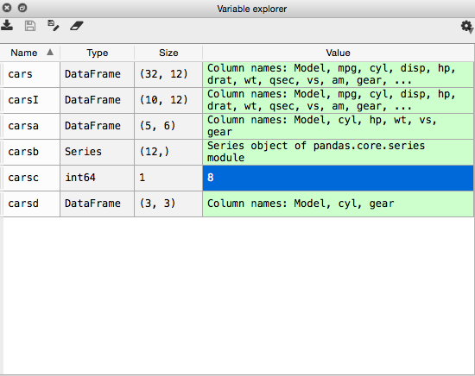

(d). Determine how many cylinders and what gear type do the car models ‘Mazda RX4 Wag’, ‘Ford Pantera L’, and ‘Honda Civic’ have.

